**DigitalCompanion implementation plan and request**

We are building a proof-of-concept system that demonstrates an augmented reality-based app (the DigitalCompanion) that can connect customers having issues with MFPs and similar devices to instructional videos or live remote assistance. The live assistance component will take advantage of proprietary FXPAL technology that can augment the user's experience as well as automatically archive important portions of the live teleconference for future use.

We plan to build a web-based administrative infrastructure for customers and remote assistants that is accessible on both mobile and desktop devices. We will also build a web-based chatbot interface that connects to native modules for live video and augmented reality teleconference support. All components will interact with a server API to get and set metadata, and they will take advantage of a WebRTC server to establish connections and archive clips (see architecture diagram below).

We will work with the FXA team to gather data for the chatbot flow. Also, in order to demonstrate the system independently of the chat system, we will build mechanisms to allow authenticated users to connect with one-another directly.

We have expertise on the project to engineer most components: Laurent Denoue, Chelhwon Kim, and Yulius Tjahjadi will work on building the web- and server-components, and Scott Carter will build the user interface architecture (in addition to architecting the system and managing the project). Laurent, Chelhwon, Yulius, and Scott will also further refine and integrate FXPAL proprietary technology into the system.

This project also requires a UX designer but this resource is not currently assigned to the project. This is necessary for successful transfer to FXA. The work (see breakdown below) is estimated to require two weeks worth (~80 hours) of UX consultant hours. The consultant should:

* Help design the interaction flow for different stakeholders (customers, remote assistants, and other users).
* Create high fidelity wireframes that we can use to explore different design approaches (and determine the best one to use).
* Create graphic elements that convey a consistent look-and-feel spanning the web- and native-portions of the mobile app as well as the desktop web.
* Work with the development team to ensure that all graphic elements follow guidelines appropriate for each target mobile or web platform.
* Help with any interstitial pilots of the application.

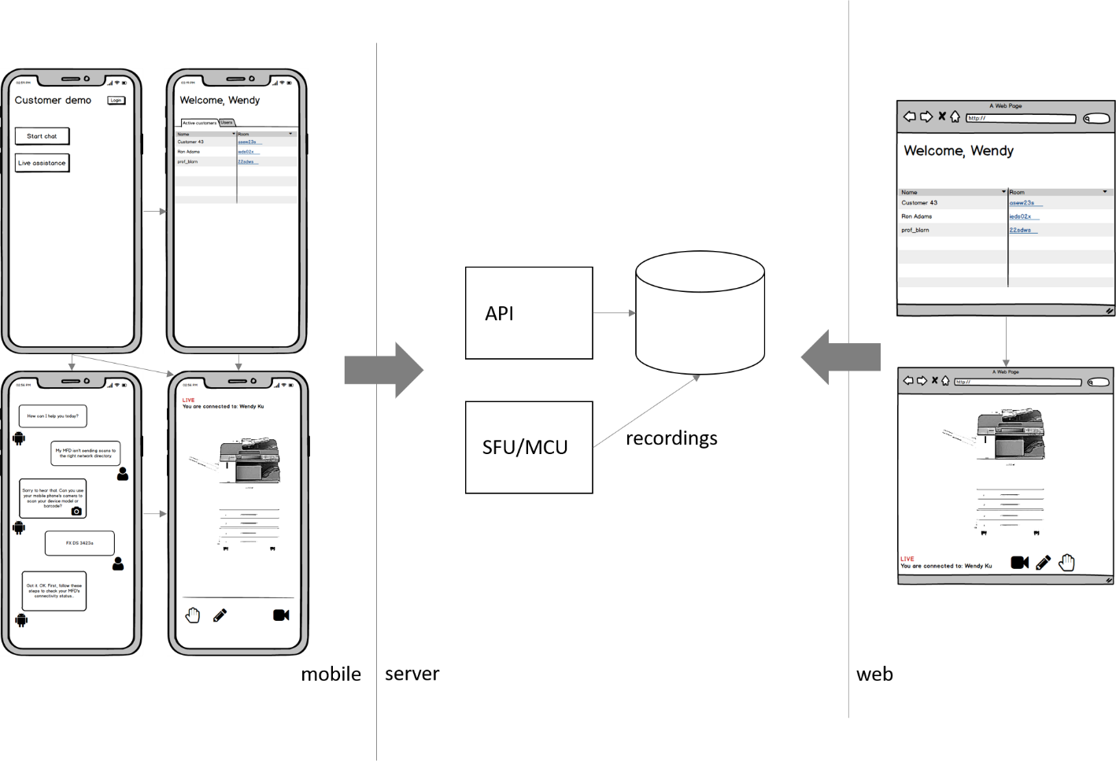

Note that app and desktop systems will include more screens than are shown here. See (<https://github.com/FXPAL/remote-assistance/wiki/>) for more details.