# STAFF PERFORMANCE MONITORING AND APPRAISAL SYSTEM

SYSTEM USER`S MANUAL

VERSION 0.0.2 (internally accepted), 24th October, 2016



CLIENT: NATIONAL PLANNING AUTHORITY

Table of Contents

STAFF PERFORMANCE MONITORING AND APPRAISAL SYSTEM 1

1.0 General Information 4

1.1 System overview 4

1.2 Organization of the user manual 4

2.0 System Summary 5

2.1 System Configuration 5

2.2 User Access Levels 5

2.3 Contingencies 5

4.1.2 Login interface display two 7

4.1.3 Forgot password interface 8

4.1.5 Contact support interface 9

4.2 Start up Highlights 10

4.2.1 Dashboard screen interface 10

4.2.3 Top menu bar 11

4.2.4 Right top bar icons 11

4.2.5 Profile name self-help menu 12

4.3 Resource requests module 13

4.3.1 Resource request menu 13

4.3.1 Add resource category form 13

4.3.2 View resource categories 14

4.3.3 Requisition form 14

4.3.3 Sent requests view 16

4.3.5 Received requests view 19

4.3.5 Forwarded requests view 20

4.3.6 Edit and delete actions 20

4.4 Memo module 22

4.4.1 Memo compose view 22

4.4.2 Memo inbox view 23

4.4.3 Memo details 24

4.4.4 Memo actions 24

4.4.5 Memo reply form 26

4.4.6 Forward memo 26

4.4.7 Sent memo view 27

4.5 Organizational structure 27

4.5.1 Add organization units 28

4.5.2 Add position form 28

4.6 User management module 29

4.6.1 Add user form 29

4.6.3 Menu accessibility permission setting. 29

4.6.4 Actions in user management 30

4.7 Staff management module. 33

4.7.1 Employees view 33

4.7.2 Staff employment details 34

4.7.3 Staff position details 35

4.7.4 Staff Contract information 36

4.7.5 Staff next of kin`s details 37

4.7.6 Staff dependent’s details 38

4.7.7 Staff bank details 39

4.7.8 Staff education details 39

4.7.10 Staff`s contact information 40

4.7.11 Staff `s medical information 41

4.7.12 Staff personal information 41

4.7.13 Full staff user profile 42

4.7.14 Menu navigation list 43

4.7.15 Create a new menu 43

4.7.16 Menu view to edit 44

5.0 Reporting 45

# **1.0 General Information**

General Information section explains in general terms the system and the purpose for which it is intended.

## **System overview**

Staff performance monitoring and appraisal system (SPMAS) is a web based mobile system, which monitors and appraises NPA staff members basing on their timely performance. The system is composed of five key modules which include: Leave, Work plans, Appraisal, Memos and Resource requests. It also achieves its main goal by assessing or evaluating the amount of executed staff work plans within a given period of time against the staff`s expected output. The level of work plan activities accomplished by a staff are equated to his/her performance. The system is also equipped with complementary modules which include: user management, organizational structure, system settings, employee management, reports and dashboards that enhance its operations. SPMAS is a mobile web based system with high browser compatibility.

## **1.2 Organization of the user manual**

The User Manual consists of five sections: General Information, System Summary, Getting Started, Using the System, and Reporting.

General Information section explains in general terms the system and the purpose for which it is intended.

System Summary section provides a general overview of the system. The summary outlines the uses of the system`s software requirements, system’s configuration, user access levels and system’s behavior in case of any contingencies.

Getting Started section explains how to get SPMAS and initial registration in case you are a new staff.

The System section provides a detailed description of system functions.

Reporting section describes in what way information collected by the application are presented and how to access the information.

# **2.0 System Summary**

System Summary section provides a general overview of the system. The summary outlines the uses of the system’s software requirements, system’s configuration, user access levels and system’s behavior in case of any contingencies.

## **2.1 System Configuration**

SPMAS operates on all internet enabled computing devices and on all operating systems. It is compatible in all browsers. The system requires constant connection to internet in order to operate efficiently in saving and retrieving data from the database, SPMAS can be used immediately without any further configuration.

## **2.2 User Access Levels**

Everyone can use the system as long they are fully registered and recognized employees of NPA. All staff members are accorded customized passwords upon completion of registration.

## **2.3 Contingencies**

In case of power outage data is not saved in internal memory of the operating device (except the files that are stored in external storage folder). In case there is no Internet connection available. The system will equally be offline and hence hard to be accessed.

**3.0 Getting Started**

Section explains how to get SPAMS and how to access the system. The section presents briefly system menu.

**3.1 Logging In**

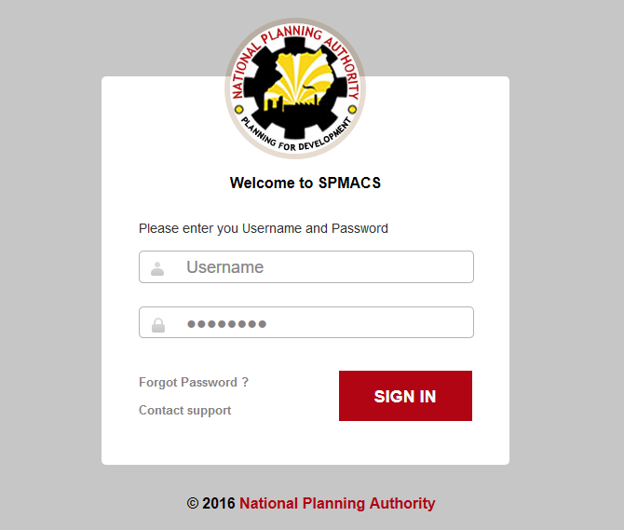Upon completion of registration into the system, every staff is given a username and password to access the internal functionality of the system. In case he/she forgets their login particulars, extra support help is availed to them as shown figure 1

Figure 1: Login screen

**3.2 System Menu**

SPAMS consists of 10 menu tabs. The first tab represents the global dashboard highlighting quick insights of the internal communications and events, the second menu bar represents the leave module for staff, the third menu bar represents the memos, the forth menu bar handles the requisition of resources, the fifth menu handles the planning of work plans of staff, the sixth menu bar handles the appraising of staff basing on their work plans, the seventh menu represents the organization structure of NPA, the eighth menu bar is used for managing user groups in NPA, the employee management menu bar is for managing NPA employees and finally the system setting menu bar for configuring system settings.

**3.3 Changing User ID and Password**

User ID and password can be changed only by contacting the system administrator.

**3.4 Exit System**

SPAMS can be closed by logging out of the system. The user session will automatically expire hence needing one to login afresh.

**4.0 Using the System (Tutorial)**

This section provides a detailed description of system functions and a step by step walk through of the system operation.

**4.1 Login module**

**4.1.1 Login interface display one**

This is the first login interface displayed for all registered staff members.

It consists of the username and password text fields, that staff input their access details.

Figure 2: Login empty screen

### 4.2.1 Dashboard screen interface

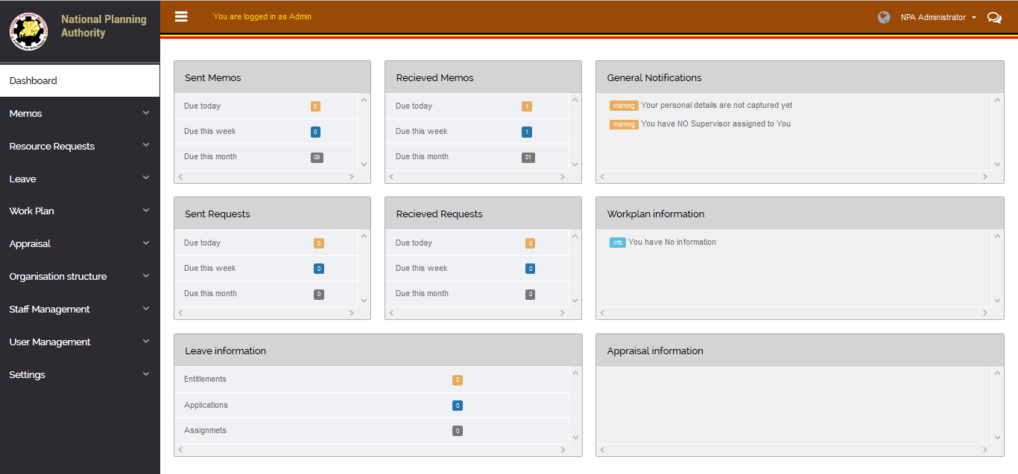

On login, the user landing page is the Dashboard. It is divided into three sections that is to say the top profile bar, Left navigation menu and the main body where all the pages and their content from the various modules is displayed.

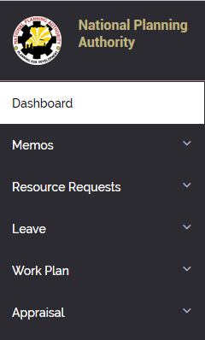 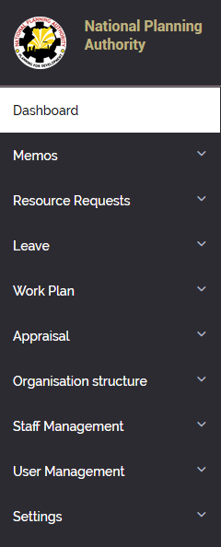

The administrator menu comes with extra admin privileges like system settings and configuration for each module.

## 4.3 Resource requests module

### 4.3.1 Resource request menu

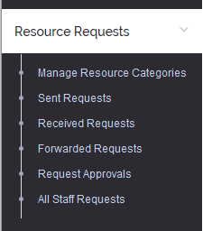

### 4.3.1 Add resource category form

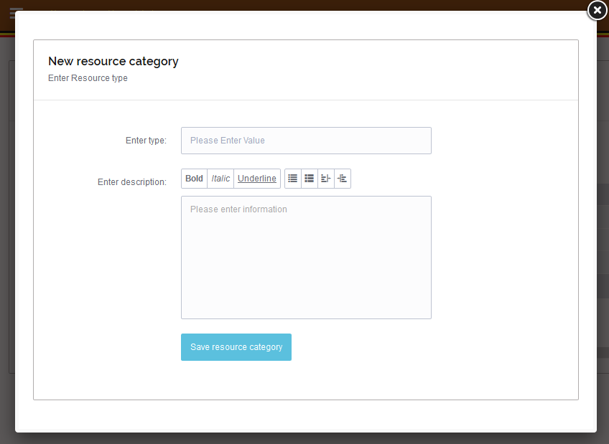

Figure 11: Add resource form

The add resource form enables a relevant authority (system administrator) to add a resource category/ type to the system. A resource addition could be due to staff demand such as project facilitation, repairs, office etc.

### 4.3.2 View resource categories

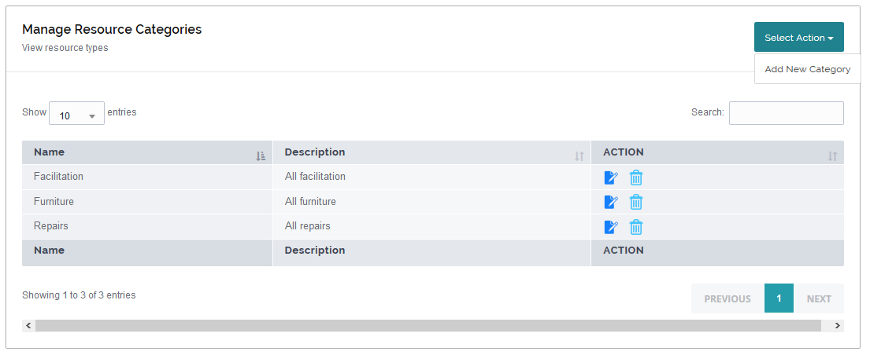

Figure 12: Resource category view

The resource`s view displays all available resource categories to the system users. After resource addition by the system administrator, all added resource categories are made available to the staff members. The view shows the resource category name, the description of the resource category and the actions that can be taken on the resource category. The top right corner has a “Select action” button which enables user to add a resource category.

### 4.3.3 Requisition form

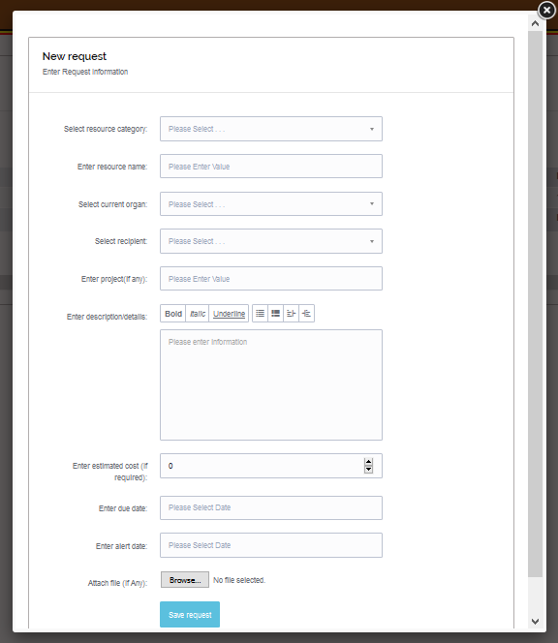

Figure 14: Requisition form

The requisition form is availed to all staff members. A staff member is able to select a resource category, input the resource name say airtime, select their correct department, the person to forward to the request, the project under which the requestor is serving or operating (if any), the description of the request, the due date when the resource must be provided and the alert date of notification concerning the resource availability and adding attachments to justify the reasons for the request.

### 4.3.3 Sent requests view

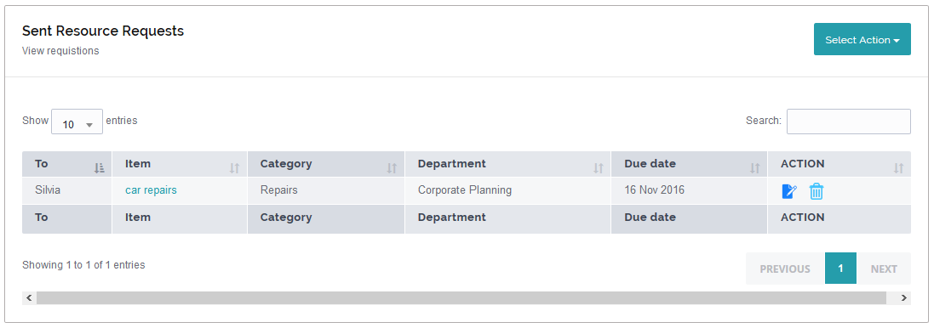

Figure 13: Sent request view

The sent request view displays all sent requests by a staff. The view is available to all staff members. The view shows the request made, the department of the resource requestor, the resource description, whom it is addressed to, the alert date, the request status (approved, denied or forwarded), the date on which the request was made and the actions to be taken on the request. The user can further go ahead and click the name of the resource name of the request to view the details of the request and also track the current location(office) of their request as shown in the figure below.

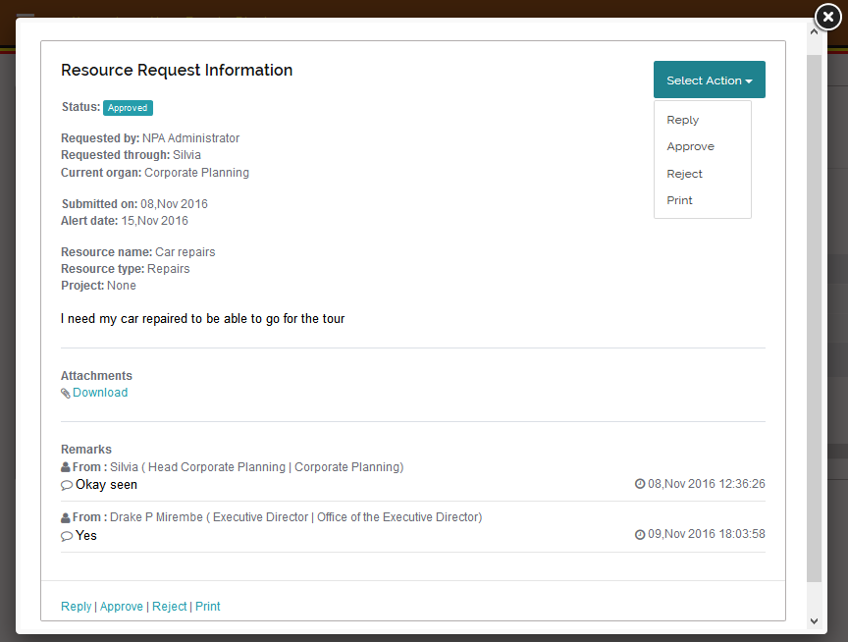

The request information includes all the details of the request, attachments and the response from each user who receives and responds to the request. The recipient can either reply, forward, accept, approve and print the request. These actions can either be accessed from the “Select action” dropdown button in the right corner or the bottom of the pop up screen. The figures below show the reply form and forwarding form.

The Resource Request Reply form

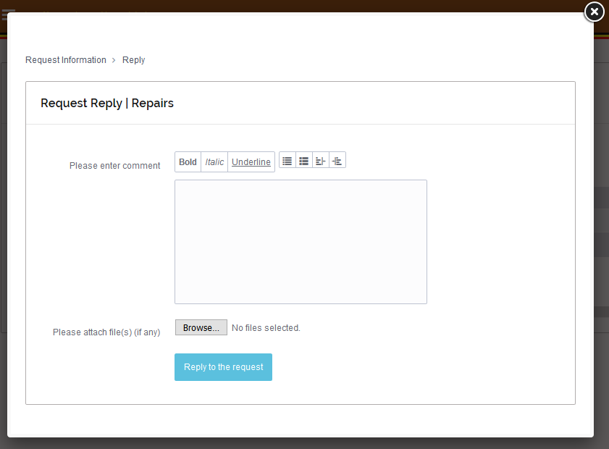

This enables the respondent to provide a comment and an attachment (if any) back to the person who sent the request.

The Resource Request Forward form

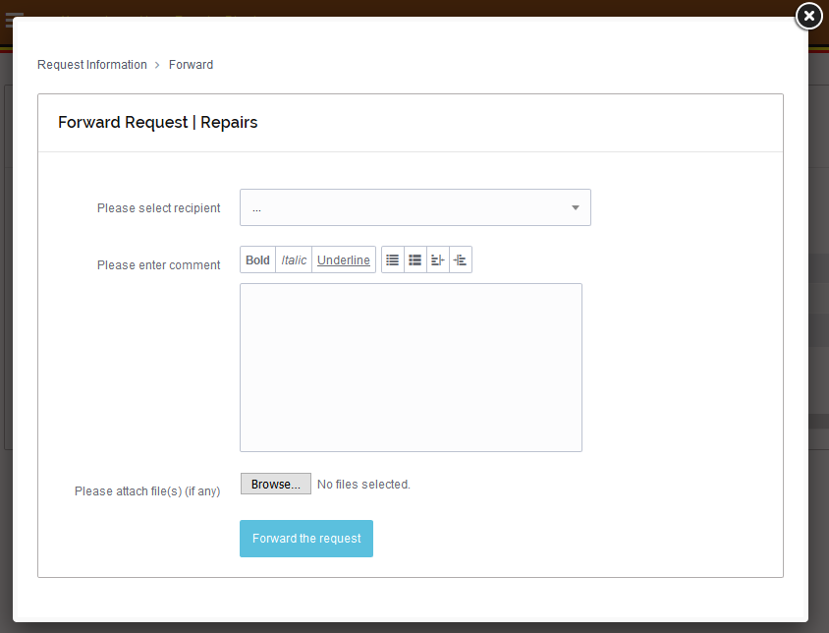

This enables the respondent to provide a comment and an attachment (if any) and send the request to another person who is not the sender of the request.

The Resource Request Acceptance form

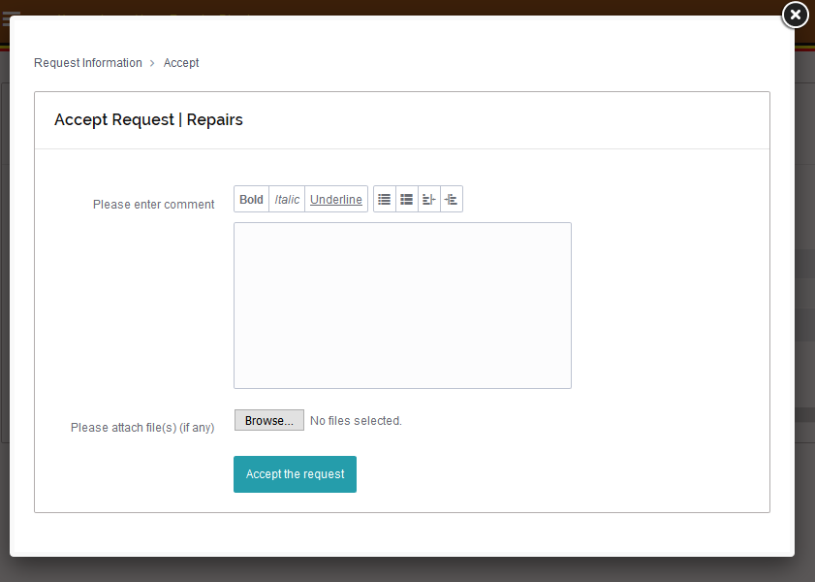

This enables the respondent to provide a comment and an attachment (if any) and authorise the request to another person who is not the sender of the request but the person to approve the request.

The Resource Request Approval form

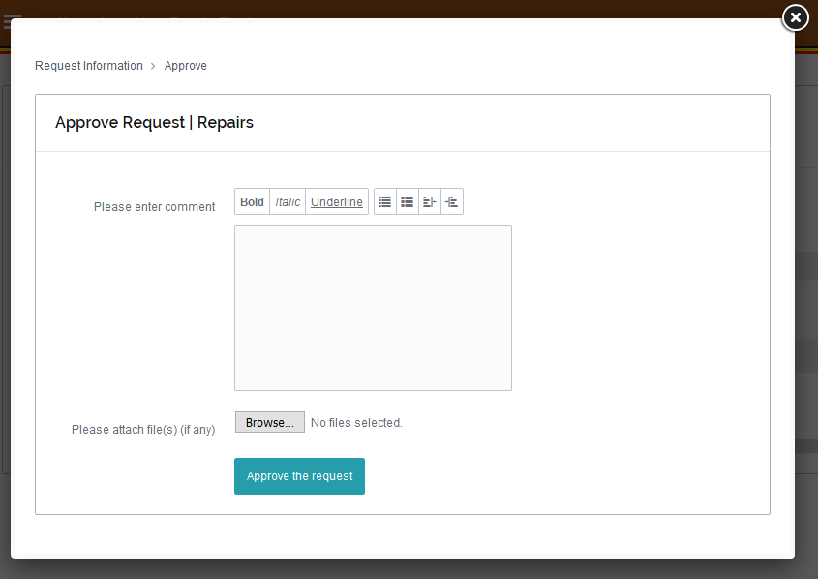

This enables the respondent to provide a comment and an attachment (if any) and approve the request to allow the requestor to obtain the request by forwarding it to the resource provider or printing out the request information for proof.

### 

### 4.3.5 Received requests view

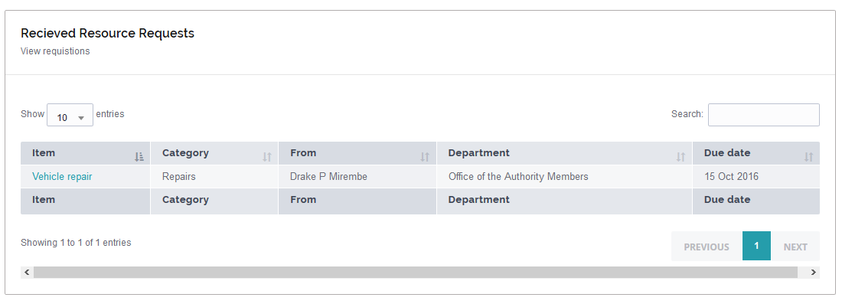

Figure 15: Received requests view

### 4.3.5 Forwarded requests view



### 4.3.6 Edit and delete actions

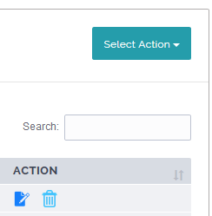

Search Field

Delete Icon

**Search field:** This enables the user to make a quick search through the displayed view.

**Delete Icon**: On click, this helps a system use delete an entry from the system **BUT** after serious consideration.

**Edit Icon**: On click, this helps a system use to edit a specific entry to the best of his/her satisfaction

Edit Icon

Figure 16: Delete and edit

4.3.7 Page navigation

**Previous**: On click, a staff is able to go to the previous page

**Next: on click**, a staff is able to go to the next page

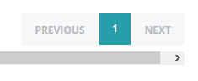

Figure 17: Page navigation

## 4.4 Memo module

### 4.4.1 Memo compose view

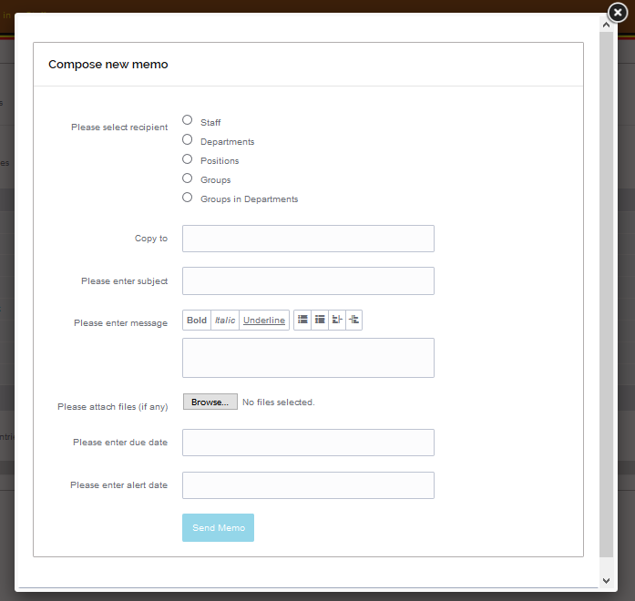

Figure 18: Memo compose

The compose view is availed to all the staff members. Each memo is generated with an automatic memo identifier. A memo can be sent to an individual, department, positions and groups. the fields available include: the person the memo is being sent to, the subject of the memo, the message in detail, the due date on which the memo is expected to have been acted on and the alert date prior to action memo. The form also enable staff to attach files to be sent along with the memo.

### 4.4.2 Memo inbox view

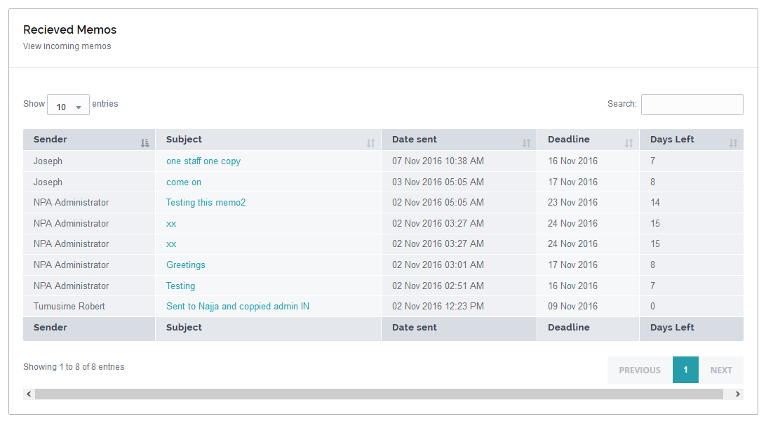

Figure 19: Inbox

The memo inbox view displays all the incoming memos. The view also shows the senders of the specific memos, the subjects of those memos, the dates on which the memos are sent, the days to action of specific memos and the due dates on which staff members expect action on memos to been taken.

### 4.4.3 Memo details

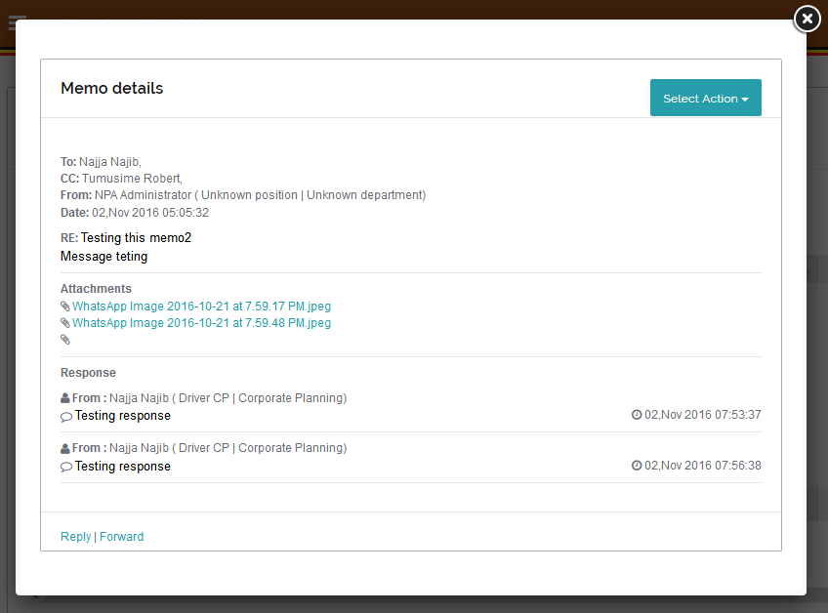

Figure 20: Details

This view displays all the details of a specific memo. The details include the sender, the subject of the memo, the message, the attachments and the responses to the memo. Actions available on the memo include forwarding a memo, replying to a memo and downloading an attachment.

### 4.4.4 Memo actions

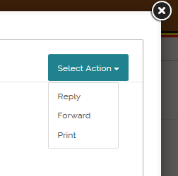

**Download**: the link downloads the file attachment

**Forward**: the memo is forwarded to staff

**Reply**: the reply is sent to the specific memo sender

**The print** icon displays a PDF print view of a file.

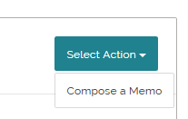

The compose icon directs a staff to the memo compose form

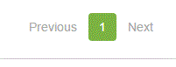

**Previous**: On click, a staff is able to go to the previous page

**Next: on click**, a staff is able to go to the next page

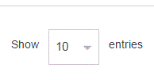

Show entries: A system user is able to select the number of entries he or she wants to display at ago



The delete icon enables a system user to delete a specific entry.

### 4.4.5 Memo reply form

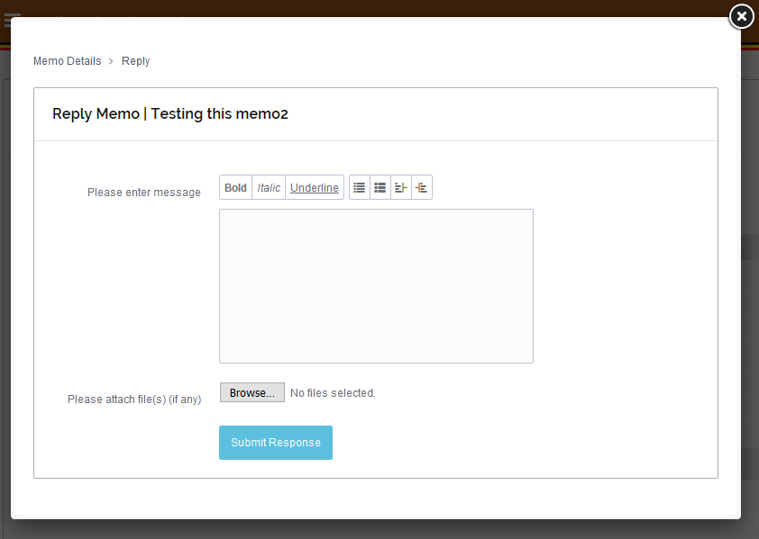

Figure 21: Reply memo

The form is availed to all staff members, it comes along with the exact subject of the memo being replied to, the memo subject and the text area to input the message, and a file attachment (if any).

### 4.4.6 Forward memo

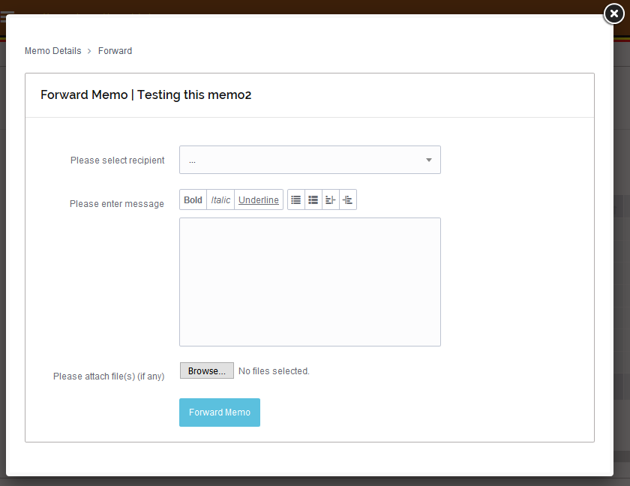

Figure 22: Forward memo

The memo forward form is also availed to all system users. The form is composed of a recipient text field, message or text area for inputting text and the file attachments (if any).

### 4.4.7 Sent memo view

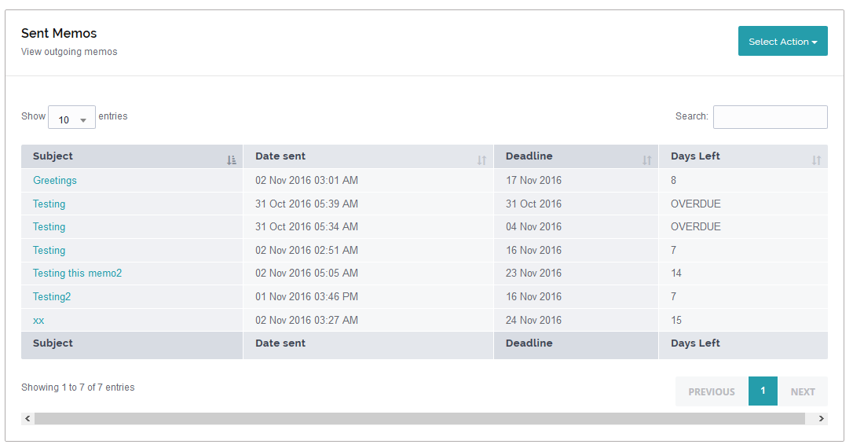

Figure 23: Sent memos

The sent memo view displays all sent memos of a specific staff. The view displays the subject of the memo, the message in detail, the response or read status of the memo, and the date on which the memo was sent.

### 4.5 Organizational structure

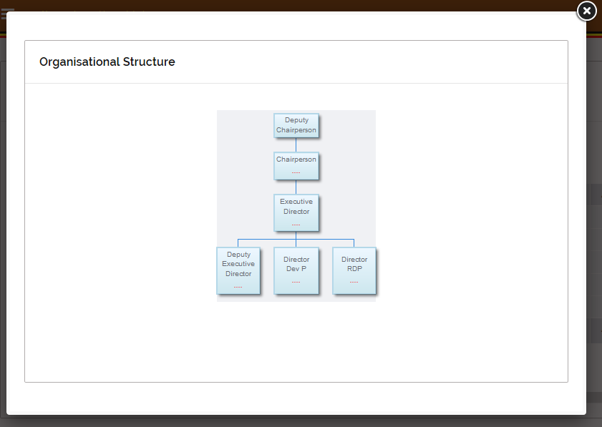

Figure 24: Organizational structure

The organization structure view displays the structure of the authority`s departments and directorates. The same is done for the expanded board. It is a top to bottom form of structure starting with the board chairman to last employee

### 4.5.1 Add organization units

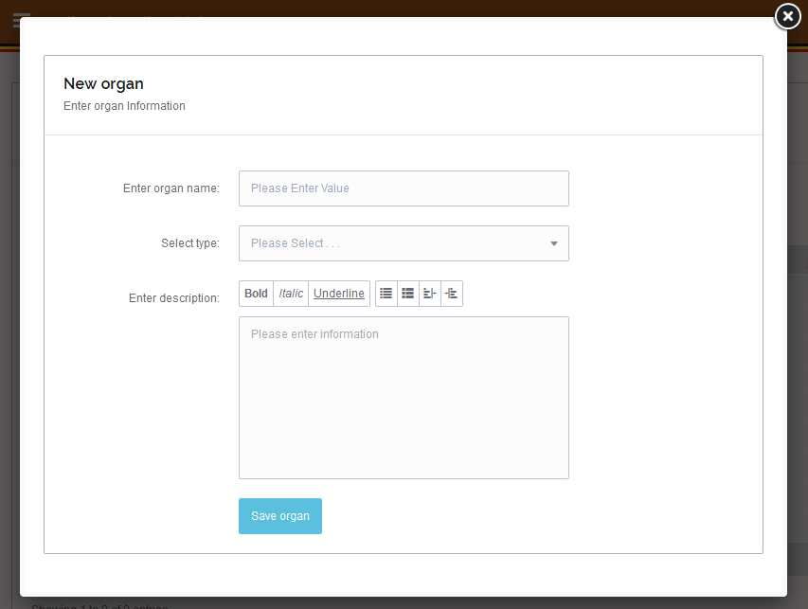

Figure 25: Add organizational unit

The form enables the system administrator to add an organizational unit to the system. It consists of the name of the organizational unit, the organizational unit type that is to say directorate, unit, department, office and sectors. The form includes the description of the organizational unit.

### 4.5.2 Add position form

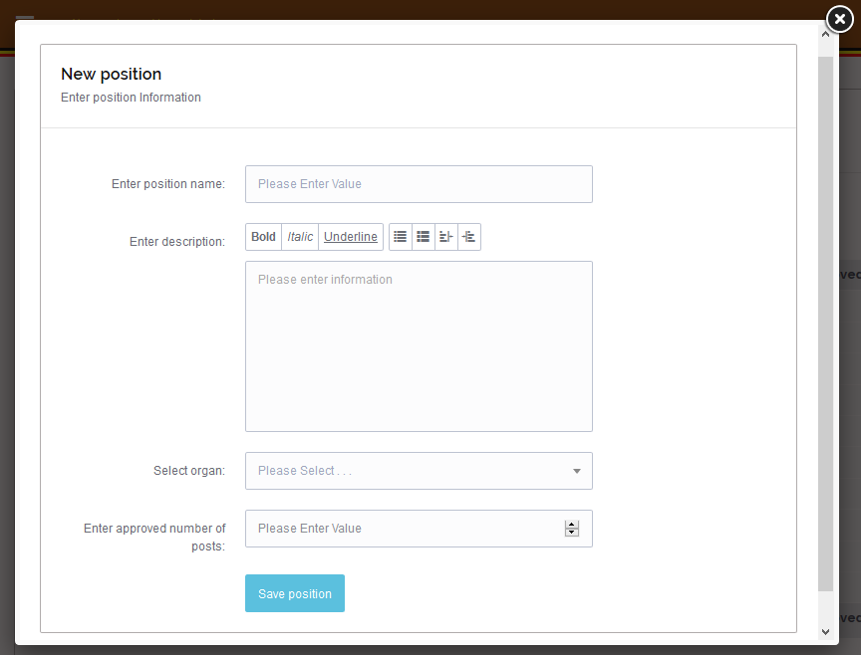

Figure 26: Add position

The form is availed to the system administrator to add a position in the organization unit. The administrator describes the position and the roles attached to that position. For example a position director and all the roles of the director described.

## 4.6 User management module

### 4.6.1 Add user form

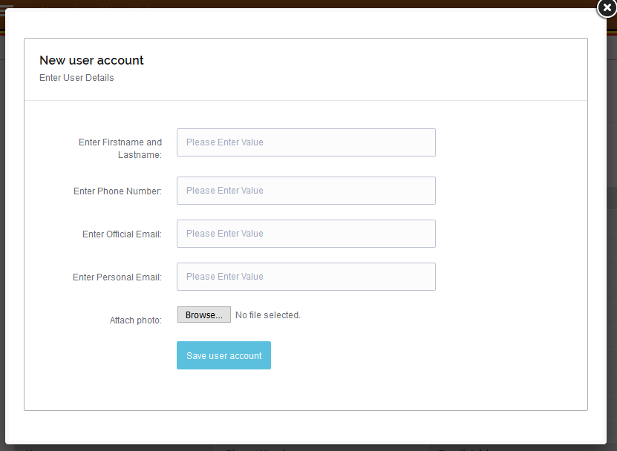

Figure 28: Add user

The form is only availed to the administrator while creating a specific user`s account of a new staff. The staff personal details are captured as shown in the form above. Every form auto generates a password which is subject to change according to the staff preference. File attachment is provided to enable staff profile picture to be uploaded to the system server.

### 4.6.3 Menu accessibility permission setting.

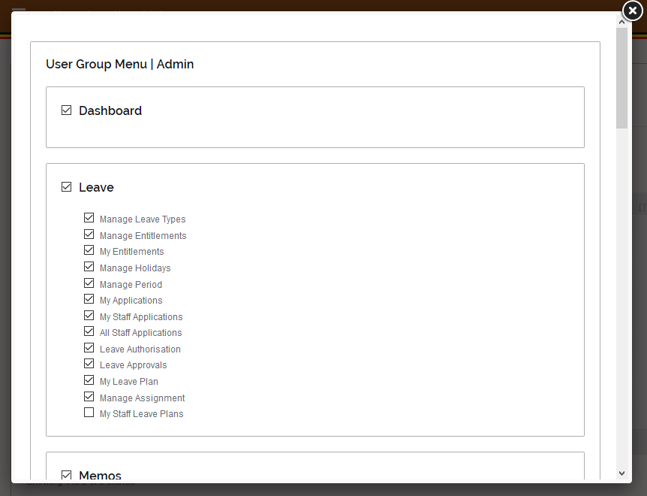

This view gives the administrator privileges to set the kind of menus to be accessed by different users. The menus are checked and saved to grant accessibility permissioned. The view is also only availed to the system administrator.

### 4.6.4 Actions in user management

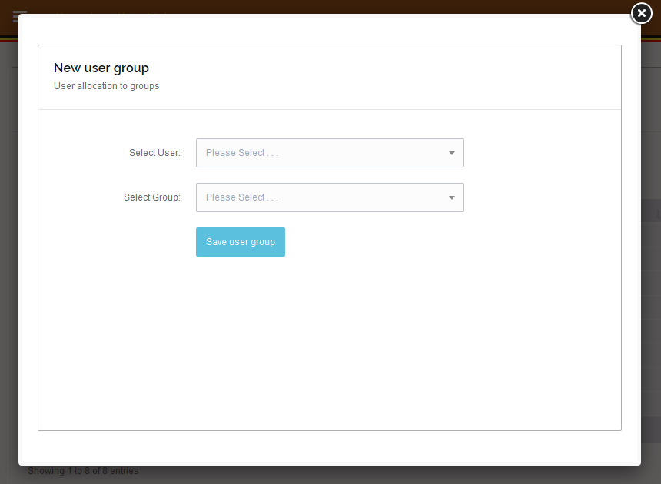

Figure 30: Edit or delete user group

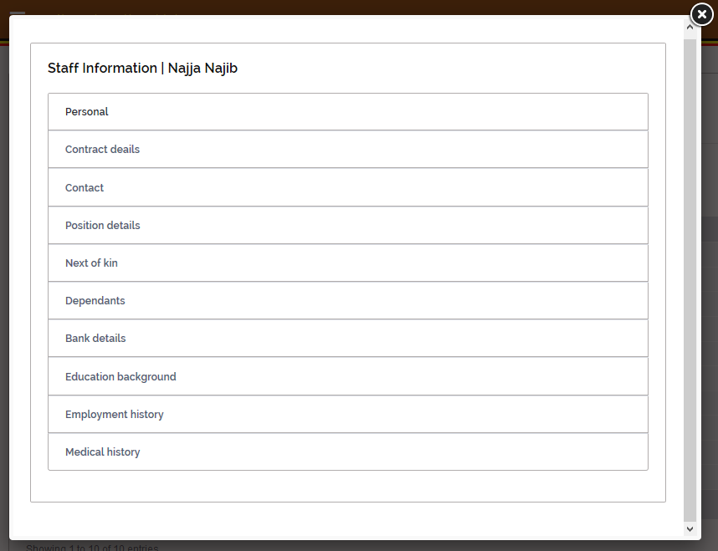

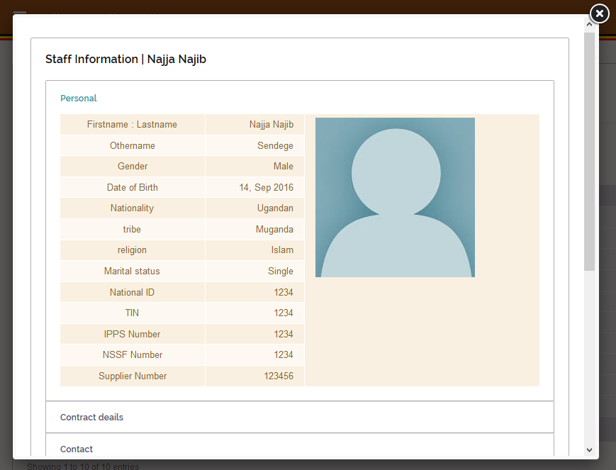

The green icon is a profile pic icon. On click, the system user is able to see his or her profile in details

## 4.7 Staff management module.

This module is availed to the human resource personnel incharge of keeping staff recoards. Its also where all the staff members are allocated superviosers.

### 4.7.1 Employees view

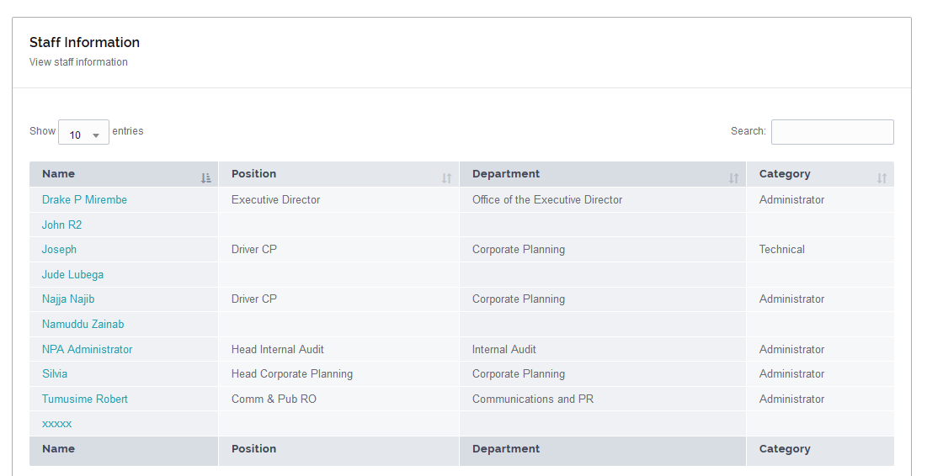

Figure 32: All employees view

The employee`s view is availed to the human resource personnel. It’s the human resource personnel to add or remove an information concerning any staff with the help of the available actions.

### 4.7.2 Staff employment details

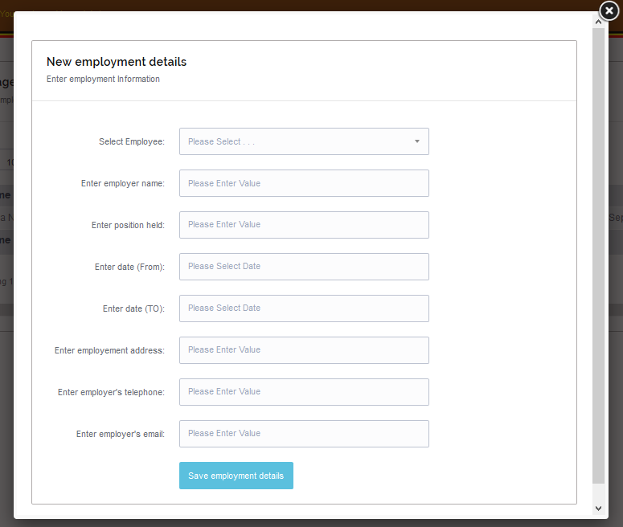

Figure 33: Former employee information

This view is availed to the staff to input all information concerning their previous employment as shown in figure 33 above

### 4.7.3 Staff position details

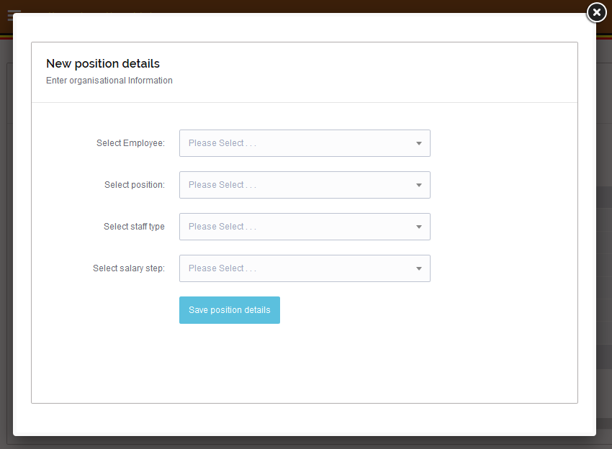

Figure 34: Organizational profile

This view (figure 34) is also availed to staff to input their organization profile details. The details include the department in which the staff belong, the positions they hold, the roles they play.

### 4.7.4 Staff Contract information

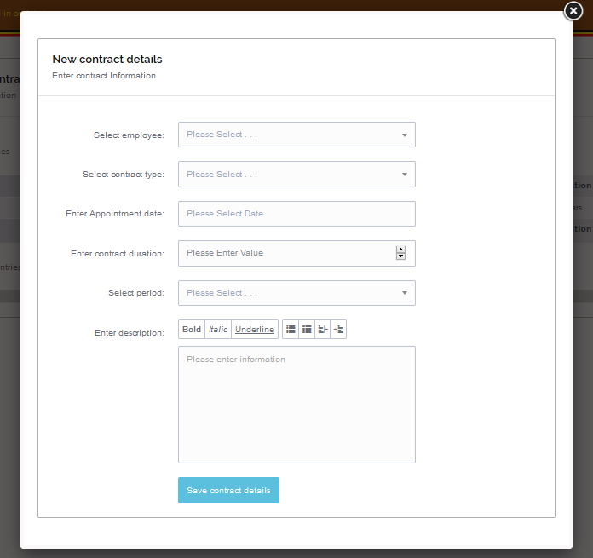

Figure 35: employee`s contract information

The above view (figure 35) is also availed to the staff to input their employment contract information of the current employment. The staff input their contract type, the appointment date, the duration of the contract, the period the contract is taking and the description of the contract.

### 4.7.5 Staff next of kin`s details

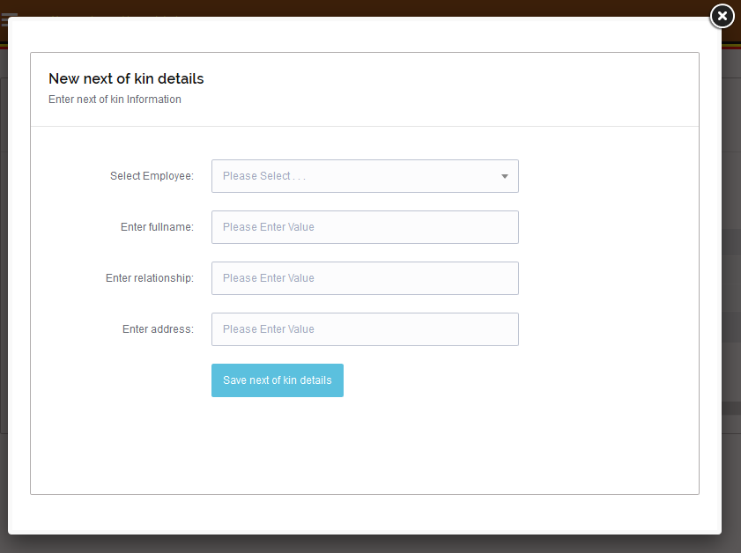

Figure 36: Next of kin`s information

The view above (figure 36) is also availed to all the staff. The staff input their next of kin`s full name, the relationship they have with them, the address of the next of kin and finally the profile photo of the next of kin.

### 4.7.6 Staff dependent’s details

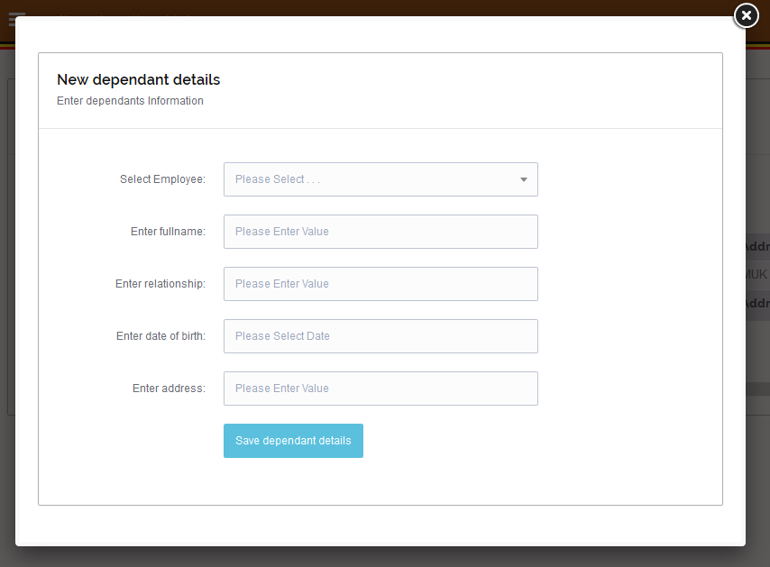

Figure 37: Dependent’s information

The view above (figure 37) is availed to the staff during registration. The staff input the full names of their dependent`s, the relationship they have with the dependent`s, the date of birth of the dependents and the dependent`s addresses

### 4.7.7 Staff bank details

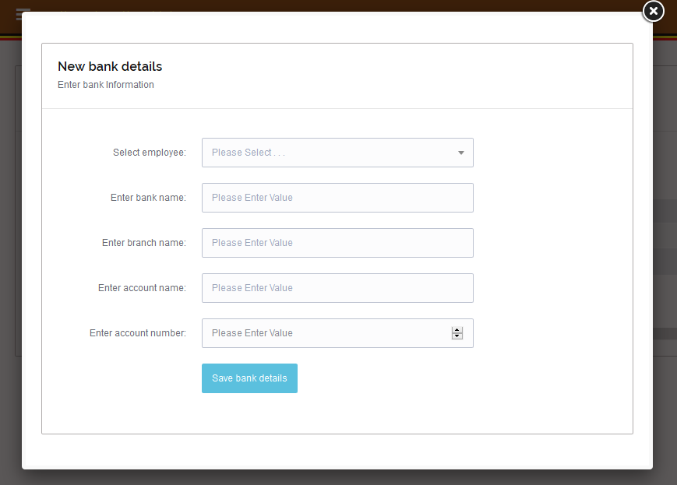

Figure 38: Employee`s bank information

The view above (figure 38) is made available to all the staff. The staff input their bank particulars like the bank name, the bank branch name, the staff`s account number.

### 4.7.8 Staff education details

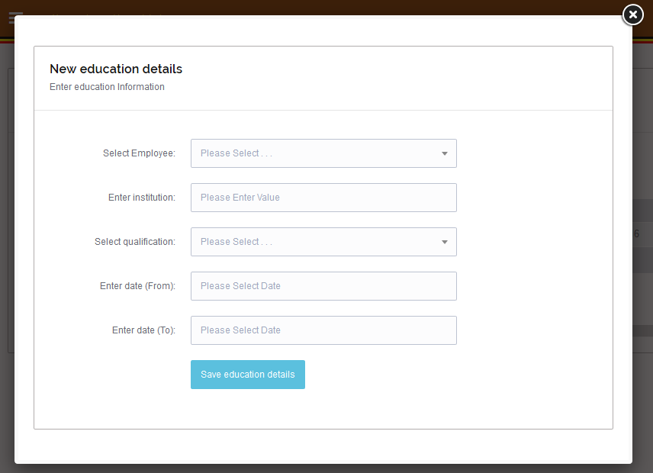

Figure 39: Employee`s education information

The view above (figure 39) is availed to all staff. The staff input their education details and also attach all the necessary transcripts and certificates.

### 4.7.10 Staff`s contact information

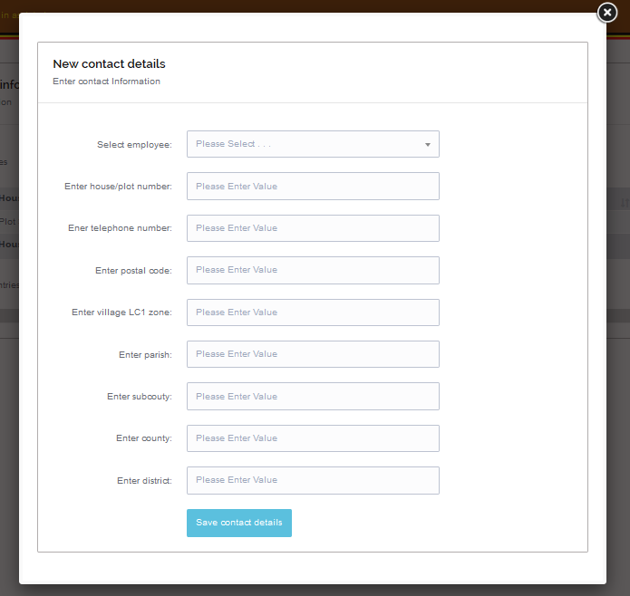

Figure 40: Staff`s profile information

The view above (figure 40) is availed to all staff. The view contains multiple fields into which the staff input all their contact or address information. For example email, postal address and so on.

### 4.7.11 Staff `s medical information

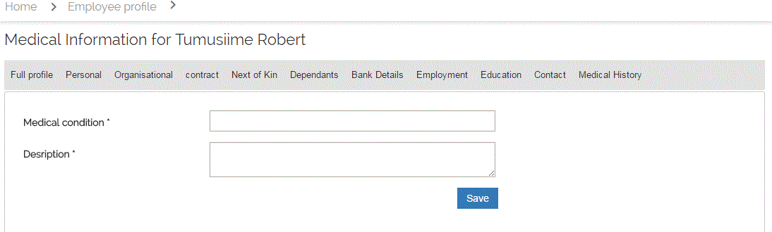

Figure 41: Medical information

The view above (figure 41) is availed to all the staff. They input their medical conditions and their descriptions.

### 4.7.12 Staff personal information

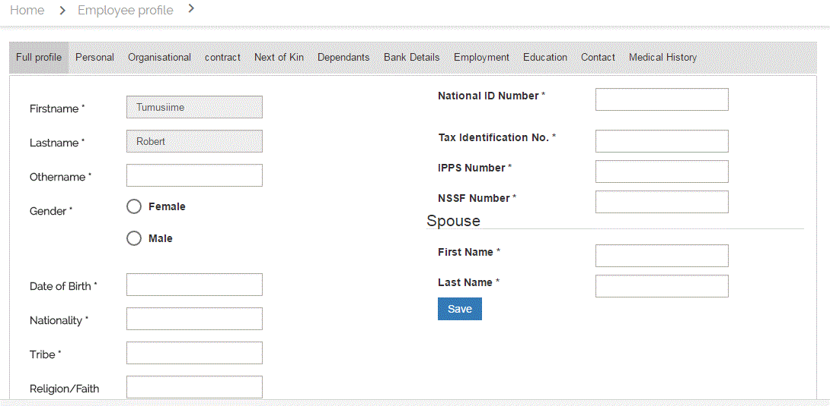

Figure 42: personal information

The view above (figure 42) is availed to all staff during registration. All staff fill in this form so as a user profile is generated for them respectively.

### 4.7.13 Full staff user profile

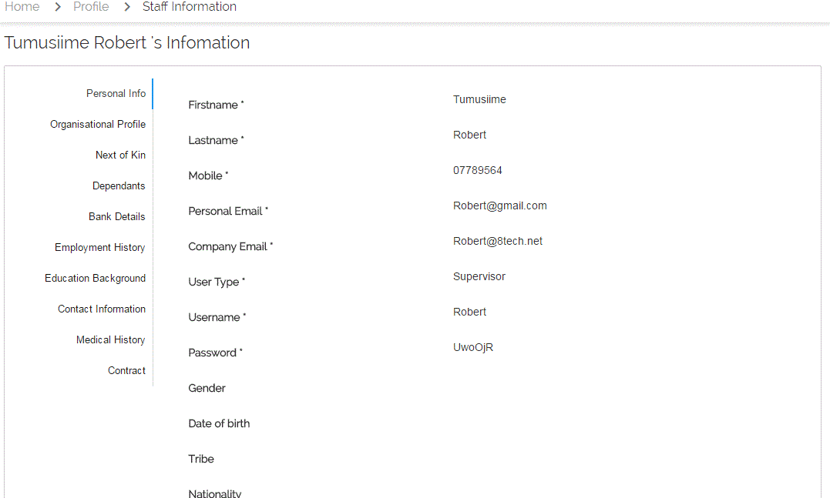

Figure 43: Staff profile

The staff profile is displayed in the view above (figure 43). The profile is generate automatically from the input staff information. The full profile is available to all the system users.

System settings menu

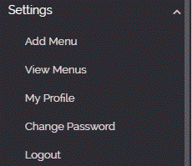

### 4.7.14 Menu navigation list

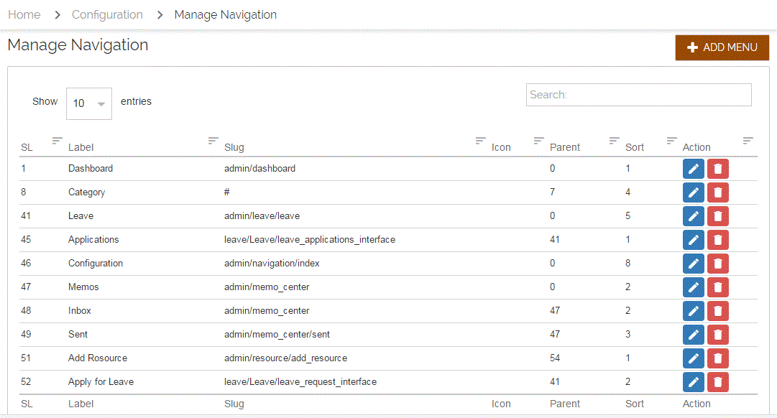

Figure 44: All menu list

The view above displays all the views assigned to different staff basing on their roles and responsibilities. The view is available to the system administrator only

### 4.7.15 Create a new menu

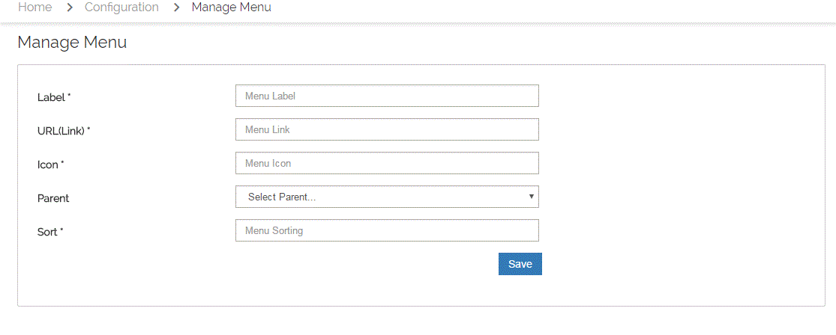

Figure 45: New menu

The view above is only availed to the system administrator. The administrator uses it to create an assign a new menu to a staff. The fields involved in menu creation include the menu label, the URL, the menu icon, the parent under which the menu is to be located.

### 4.7.16 Menu view to edit

Actions

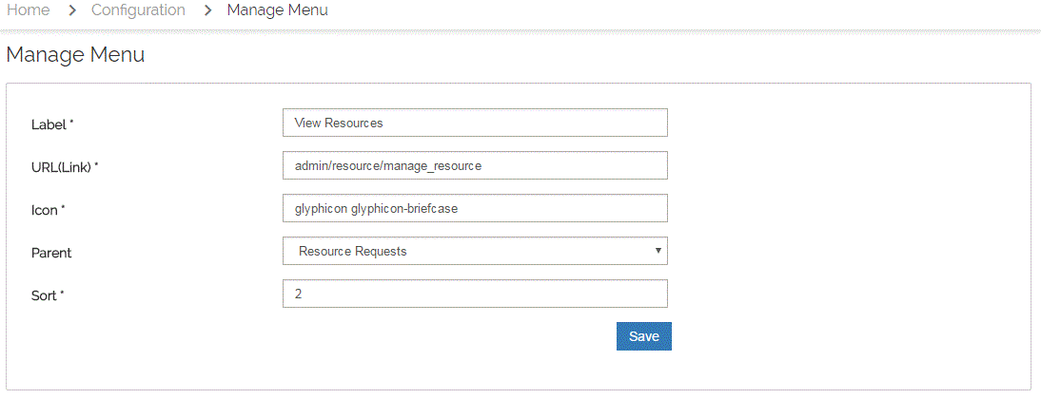 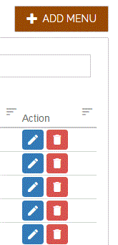

On clicking the edit button or icon, the manage view screen is displayed for one to edit any information that needs to be edited.

# 5.0 Reporting

Reporting section describes in what way the information collected by the system is presented and how to access the information.