
ACTIVITY REPORT
Seed Tracking and Tracing System.

Date: 17th August 2023
Time: 9:00am to 1:00pm
Title of Project:
THE NATIONAL SEED TRACKING AND TRACING SYSTEM.
Background of the activity:
Access to quality seeds accounts for about 40% of the likely crop yields in farmer’s fields. This also highly relies on quality and adaptability of the varieties to the different growth environments. Tracking (following the seed production sequence from the breeder’s fields through to certified/quality declared (QDS) seed; and even to sales) and tracing (following a seed sale backward sequence from certified/quality declared (QDS) seed back to Breeders’ seed production lots and fields); are important aspects of quality assurance in the seed value chain. These are inherent in the Uganda’s Seed and Plant Regulations 2016 and are an essential aspect of protecting seed users from counterfeit seeds.

The National Seed Strategy (MAAIF 2016) emphasized the development of an Integrated Seed Sector Management Information System (ISSMIS). This required development of digital tools and various web services to make it information about seed production and delivery accessible to seed sector stakeholders, in a timely manner. Developing a digital seed tracking and tracing systems (STTS) is one component of the ISSMIS to facilitate the regulation of the production and supply of quality seeds in the market.

We understand that, Seed Tracking and Tracing Systems (STTS) involves proper registration of; the seed source (seed growers and merchants), seed production field (garden), seed lots at each seed producers (packages), and seed packs with the use of unique seed field/lot identifiers. Tracking is particularly aimed at; identification, preservation and quality assurance; while tracing is aimed at solving problems faced by the product non-conformance to standards at any point along the seed production and supply value chain.
Objective of the activity
The objective of the activity was to identify the data the is required to be pre-entered in the system, discuss the format and also go through the data entry points with National Seed Certification Service team.
Sub-activities implemented and venue(s):
Venue: - NSCS Seed Lab. (Kawanda)
The session involved the following sub-activities.
- Understanding STTS and allow the system user roles and what they can and cannot do.
- A detailed review of the inspector user role.
- Identifying data entry points (Like crops, varieties, inspection schedules, deadline for submission of planting returns and seed labels)
- Review of import and export permits and reports
- How to add, manage, and assign user roles in the system.
Key outputs/Key results:
- Agree upon the different data points and type of data required in the system
- Sample import permit report to be incorporated
- Identification of all the required crops and varieties in the system.
Training Comments: -
- NSCS team to compile data of all the crops, varieties and inspection types required for the system
- Eight to work on import and export permits to make them printable and exported from the system.
- ISSD and NSCS to organize a two or three-day workshop for data entry of crops, varieties, inspections, inspectors with guidance from 8Tech.
- To ensure that before the next user training all the required data in the system is available and well cleaned.
- Eight to ensure that the system is updated and perfectly working before the data entry workshop.
- MAAIF will bring onboard the IT team to learn and help on the system administration role.
Name of Project Lead: Mbabazi Isaac

IMAGES:
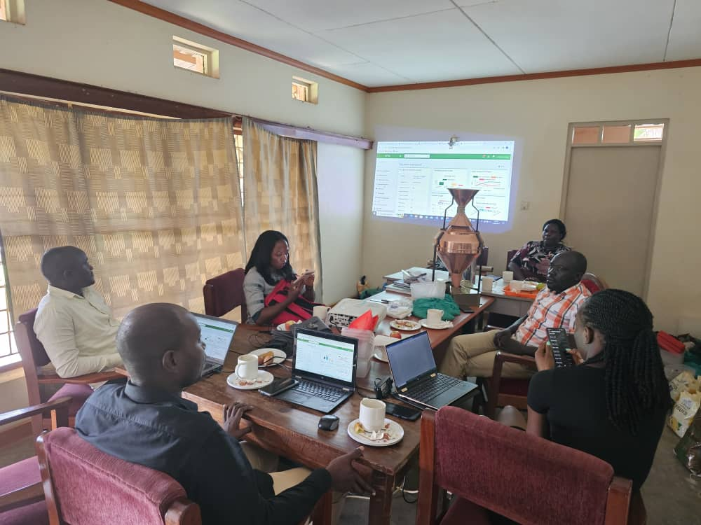
Review of STTS with NCSC team in Kawanda

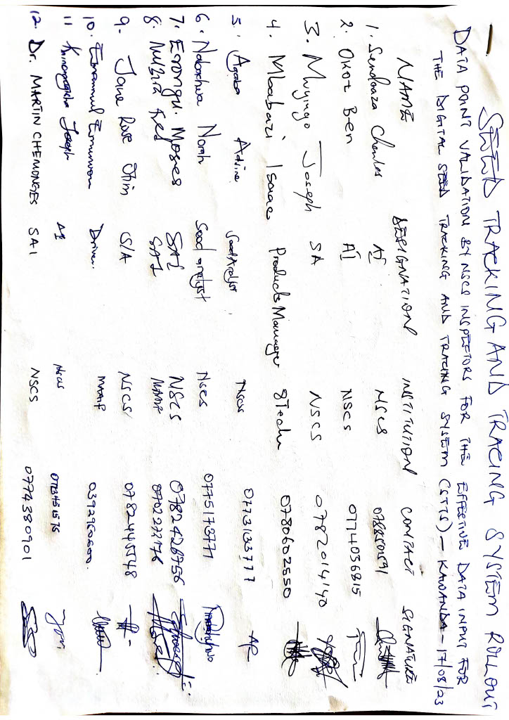
Registration and attendance

