**CSC160 Programming Fundamental II – Section 3’s Programming Assignment**

Feel free to add your own enhancements to this assignment

**A high-level outline of Basketball Scoreboard App:**

**BB Terms:** https://www.basketball-reference.com/about/glossary.html

* player
  + name
  + number
  + one point shots
  + two point shots
  + three point shots
  + foul
  + constructor
  + setters & getters
  + display player info
* team
  + team name
  + unknown number of players
  + constructor
  + setters & getters
  + display team info
* scoreboard
  + main
    - allow setting the team and player's name
    - while loop to keep track of each team's player shots & foals
  + Multiple methods to keep main short and sweet ☺

# Program requirements:

1. Use multiple classes the build on each other
2. Use of private fields and public methods
3. Use of both default and/or overload constructor
4. Use of setters and getters
5. Use of JavaDoc and proper documentation (including GitHub repository & README.md)
6. Clean code & user interface

# How to submit the assignment:

1. Attach all of your .java class files
2. Attach your console output as a TEXT file (not image, Word, etc) plus reflection (GBU)

**Helpful references:**

* Use the Traffic Controller code as a good references.

# UML Diagram

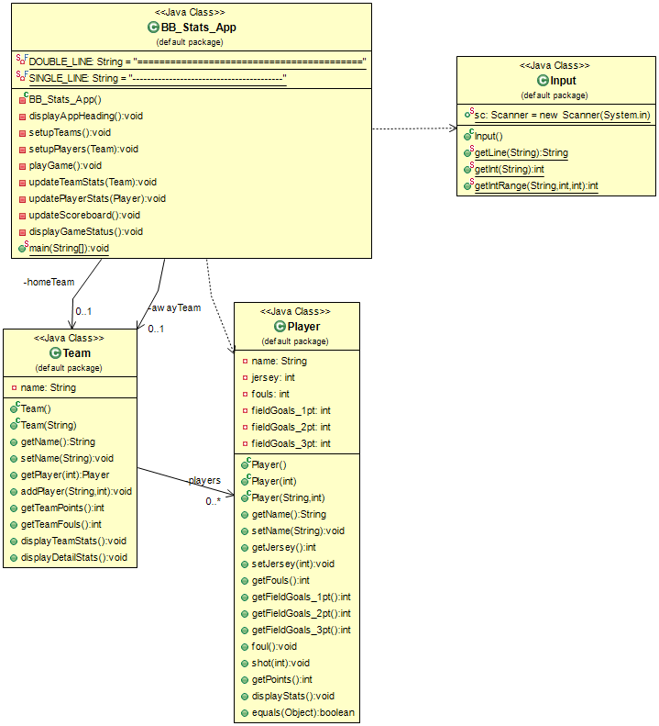

# Console Input/Output

=========================================

Welcome to the BB Scoreboard App

=========================================

Enter the HOME Team name: Cat

Enter Cat player's name or 'q' to quit: Kitty

Enter Kitty jersey number: 10

Enter Cat player's name or 'q' to quit: Tabby

Enter Tabby jersey number: 10

Jersey #10 already assigned to Kitty!

Unable to add player!

Enter Cat player's name or 'q' to quit: Tabby

Enter Tabby jersey number: 20

Enter Cat player's name or 'q' to quit: q

-----------------------------------------

Enter the AWAY TEAM name: Dog

Enter Dog player's name or 'q' to quit: Doug

Enter Doug jersey number: 11

Enter Dog player's name or 'q' to quit: Frank

Enter Frank jersey number: 22

Enter Dog player's name or 'q' to quit: q

=========================================

Game Started!

=========================================

-----------------------------------------

Main Menu

-----------------------------------------

0 = End Game

1 = Enter Cat Team's Stats

2 = Enter Dog Team's Stats

3 = Display Game Stats

-----------------------------------------

Menu Choice: 1

-----------------------------------------

Enter Cat's Jersey # 10

-----------------------------------------

Enter #10 Kitty Stats

-----------------------------------------

0 = foul

1 = free throw

2 = 2pt field goal

3 = 3pt field goal

-----------------------------------------

Enter Stat Type: 3

-----------------------------------------

#10 Kitty Fouls=0 Points=3

-----------------------------------------

Team Cat Fouls=0 Points=3

Team Dog Fouls=0 Points=0

-----------------------------------------

Main Menu

-----------------------------------------

0 = End Game

1 = Enter Cat Team's Stats

2 = Enter Dog Team's Stats

3 = Display Game Stats

-----------------------------------------

Menu Choice: 2

-----------------------------------------

Enter Dog's Jersey # 33

Invalid #, please try again!

Enter Dog's Jersey # 11

-----------------------------------------

Enter #11 Doug Stats

-----------------------------------------

0 = foul

1 = free throw

2 = 2pt field goal

3 = 3pt field goal

-----------------------------------------

Enter Stat Type: 0

-----------------------------------------

#11 Doug Fouls=1 Points=0

-----------------------------------------

Team Cat Fouls=0 Points=3

Team Dog Fouls=1 Points=0

-----------------------------------------

Main Menu

-----------------------------------------

0 = End Game

1 = Enter Cat Team's Stats

2 = Enter Dog Team's Stats

3 = Display Game Stats

-----------------------------------------

Menu Choice: 3

-----------------------------------------

Jersey Name Fouls 1pt 2pt 3pt Total

====== =============== ===== === === === =====

10 Kitty 0 0 0 1 3

20 Tabby 0 0 0 0 0

Jersey Name Fouls 1pt 2pt 3pt Total

====== =============== ===== === === === =====

11 Doug 1 0 0 0 0

22 Frank 0 0 0 0 0

-----------------------------------------

Main Menu

-----------------------------------------

0 = End Game

1 = Enter Cat Team's Stats

2 = Enter Dog Team's Stats

3 = Display Game Stats

-----------------------------------------

Menu Choice: 0

-----------------------------------------

Team Cat Fouls=0 Points=3

Team Dog Fouls=1 Points=0

# Helpful Player Class Code:

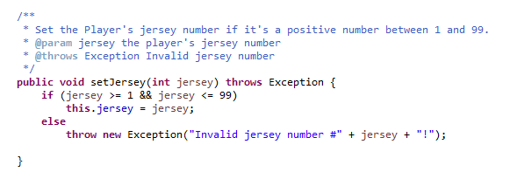

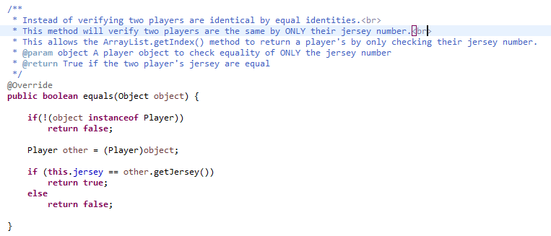

# Helpful Team Class Code:

