# PROPOSAL_TITLE2.jpg In the present electoral system of Pakistan, the National Assembly is elected directly by the people of Pakistan. The Election Commission of Pakistan is a constitutionally established institution responsible for holding elections countrywide. The diagram below shows how the commission holds an election in the country.

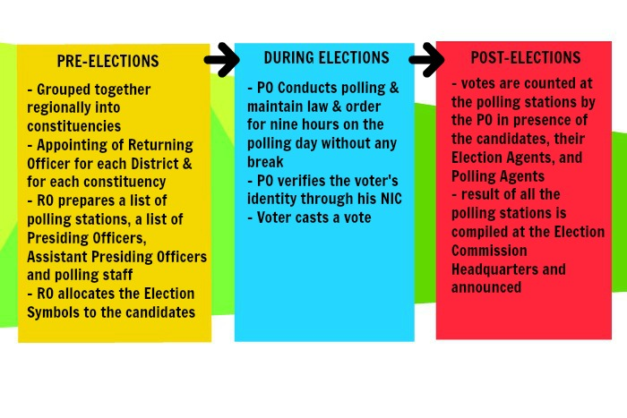

Unfortunately, there hasn’t been a single election in Pakistan that has escaped the slogans of rigging and corruption. Moreover, the manual electoral system is time consuming and resource consuming. Printing ballots, buying ballot boxes and hiring staff increase the total cost. There is no proper and reliable database of result maintained either. All the records are saved in files, which can easily be misplaced.

There is a dire need for automation of the system in order to make the election free and fair and remove doubts of possible rigging.

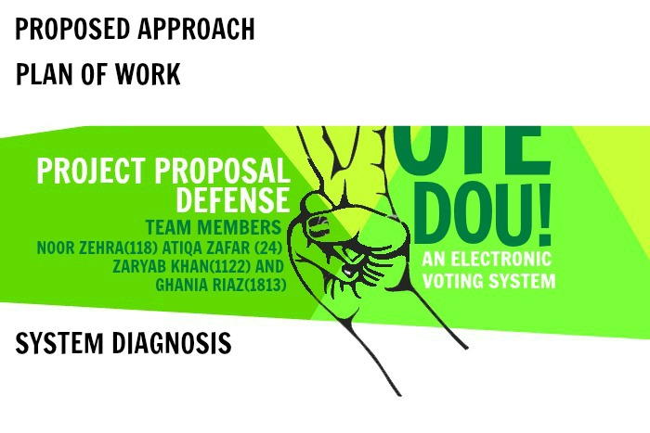

Our proposed project, Vote Dou consists of an electronic voting system that shall automate the process of **casting a vote** and **counting votes. 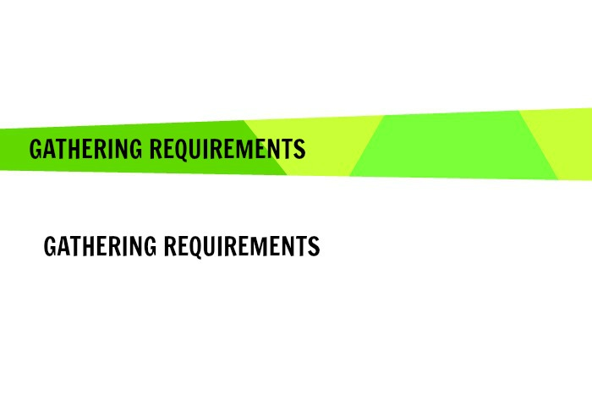**

Our Requirement engineering process involves **scenarios, ethnography and interviewing the stakeholders of the electoral system** to find out about the application domain, the services that the system should provide and the system’s operational constraints. The developers of the system have themselves voted in their respective constituencies in Elections 2013 and through ethnography, they have already gathered the requirement abstraction of the system. Moreover, the team plans to interview the other stakeholders of the system that are officers working for the Election Commission Pakistan.

Once the process of Requirement gathering is complete, the team shall prepare the **SRS document** specifying the functional and non-functional requirements and the System Constraints in more details.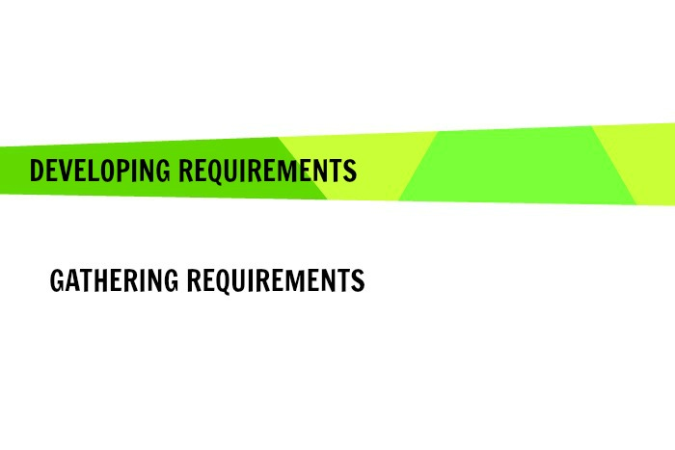Through ethnography and scenarios, the team has decided to centre their development along the following lines.

There shall be two **interfaces**, designed for the Administrator and the Voter respectively. The Voter Interface will run on the electronic voting machines located at the polling stations and will be used to cast a vote. The Administrator interface will allow the administrator/Election Commission Officer to manage elections, candidates and voters, view the information and print reports.

Here is how the election shall proceed with Vote Dou:

1. The database administrator (DBA) creates a new election.
2. The Election Commission Pakistan is responsible for entering the information of the constituencies, election candidates and eligible voters.
3. The database administrator starts the time for voting
4. Voters come to the polling booth to cast their votes into the system containing our software in a secure region.
5. The database administrator ends the time for casting a vote
6. The election officer tally’s the result and announces the winners of each constituency and also the winners of the overall general election.

As understood from above, there are three types of **users** that will operate the software as follows. Each of these users will be provided a **username and password** (or any other login detail) to access the system.

1. The database administrator - The DBA plays the administrative role in the system. He manages the election details in the database and grants different access rights to users.
2. The election officer -The election commission is entrusted with the job of inserting details about the election candidates, the eligible voters and the constituencies. It can filter the results by Constituency or Party Name and generate a report to announce results.
3. The Voter - The voter shall login into the system using his CNIC number. If verified, he can cast a vote and submit it. Every voter can cast only one vote.

Our E-voting system, Vote Dou shall offer a corruption free electoral system for the seats in the national assembly of the Parliament. This revolutionary concept shall change the history of Pakistani politics for ever. 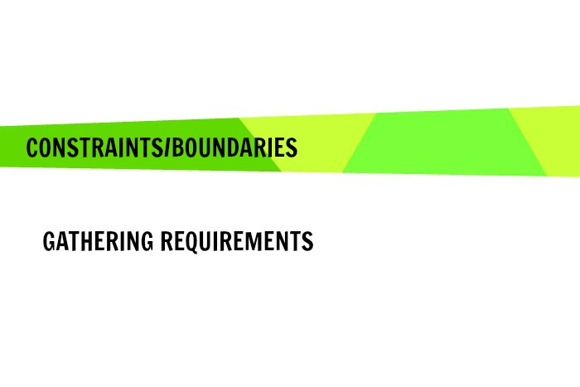-Time Constraint: The system needs to be developed and tested in the month of December. Hence, the developer team has decided to produce a prototype of the Pakistan E-voting System that only counters the National Assembly Elections. The Electoral System of Pakistan further holds elections of the Provincial Assemblies, the Senate and the Prime Minister. The scope of our semester project shall be, therefore, the election of National Assembly only.

-This project shall not allow i-voting that is voting from one's personal computer, mobile phone, television via the internet.



Our proposed database project is to provide a set of reliable, easy-to-use and secure tools that allow voters to cast ballots while the election commission collects votes and outputs the final result. Each of our four team members will work on one of these aspects.

**