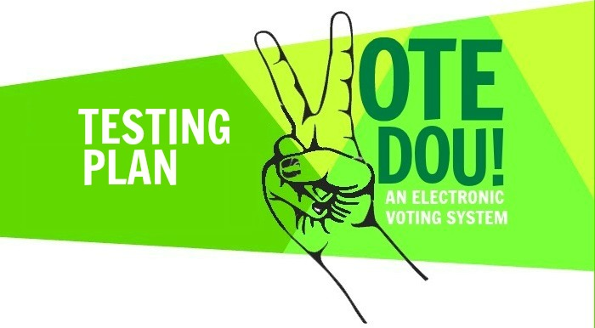Prepared by:

Noor Zehra 00118 12besenzehra@seecs.edu.pk

Zaryab Khan 01122 12besezkhan@ seecs.edu.pk

Ghania Riaz 01813 12besegriaz@ seecs.edu.pk

Atiqa Zafar 00024 12beseazafar@ seecs.edu.pk

Instructor: Sir Awais Shibli

Course: SE200 Software Engineering

Lab section: BESE 3B

Contents

1. Introduction

1.1. Test Plan Objectives

2. Scope

2.1. Data Entry

2.2. Reports File Transfer

2.3. File Transfer

2.4. Security

3. Test Strategy

3.1. System Test

3.2. Performance Test

3.3. Security Test

3.4. Automated Test

3.5. Stress and Volume Test

3.6. Recovery Test

3.7. Documentation Test

3.8. Beta Test

3.9. User Acceptance Test

4. Environment Requirements

4.1. Data Entry workstations

4.2 Main Frame

5. Test Schedule

6. Control Procedures

6.1 Reviews

6.2 Bug Review meetings

6.3 Change Request

6.4 Defect Reporting

7. Functions to Be Tested

8. Resources and Responsibilities

8.1. Resources

8.2. Responsibilities

9. Deliverables

10. Suspension / Exit Criteria

11. Resumption Criteria

12. Dependencies

12.1 Personnel Dependencies

12.2 Software Dependencies

12.3 Hardware Dependencies

12.3 Test Data & Database

13. Risks

13.1. Schedule

13.2. Technical

13.3. Management

13.4. Personnel

13.5 Requirements

14. Tools

15. Documentation

16. Test Cases for three modules

Revisions

| **Version** | **Primary Author(s)** | **Description of Version** | **Date Completed** |
| --- | --- | --- | --- |
| 1.0 | Atiqa Zafar  Ghania Riaz  Noor Zehra  Zaryab Khan | This Test Plan contains Test Strategy & Functions to Be Tested for Vote Dou 1.0. | 6/01/14 |

1. Introduction

Vote Dou 1.0 is an electronic voting system that will automate the process of casting a vote and counting votes. It is presented as an alternative to the existing parliamentary voting procedure present in Pakistan. The software test department has been tasked with testing the Vote Dou 1.0 system.

Vote Dou 1.0 provides a set of tools that allow voters to cast ballots while the election commission collects votes and outputs the final result. It performs the following functions:

* It implements a user access right policy through user identity authentication at login. Each user is provided with a username, a password and different access rights according to the roles of the Administrator, Election Commission Officer and the Voter.
* It provides the administrator with an easy-to-understand interface to manage elections. A new election session can be created or an existing one can be edited using an election ID. Information about the constituencies, candidates and voters can be inserted, edited and deleted.
* The Voter Interface runs on the electronic voting machines located at the polling stations and is used to cast a vote by the voter.
* It provides the Election Commission officer with a user-friendly interface to view the election information and compute the results. The officer can filter the results by Constituency or Party Name and generate a report to announce results.
* The administrator can create a backup of an election session and store all the information about the contesting candidates, voters, constituency results and final results.

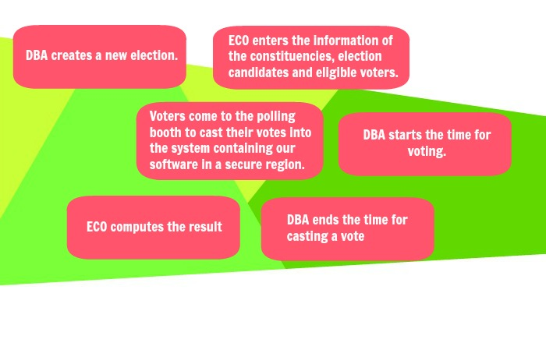

* 1. **Test Plan Objectives**

This Test Plan for Vote Dou 1.0 supports the following objectives:

* Define the activities required to prepare for and conduct System, Beta and User Acceptance testing.
* Communicate to all responsible parties the System Test strategy.
* Define deliverables and responsible parties.
* Communicate to all responsible parties the various Dependencies and Risks

2. Scope

**2.1. Data Entry**

In the pre-voting phase the database administrator (DBA) creates a new election and enters the information of the constituencies, election candidates and eligible voters using the information provided by the Election Commission of Pakistan. Hence, Vote Dou 1.0 should allow the database to enter election information from Windows compatible PC workstations running Windows XP or higher.

The system will be menu driven and will provide error messages to help direct the administrator through various options.

**2.2. Reports**

The system will allow the administrator and Election Commission Officer to print the following types of reports. These reports are:

1. The Election Turnout Report of every constituency
2. The Candidate Result of every Party
3. The Candidate result of every Election
4. The Party Result of every Assembly, i.e. National Assembly, Punjab Assembly, Sindh Assembly etc.

**2.3. File Transfer**

The Vote Dou software will be distributed over a network of clients connected to a central computer, known as a server where the database shall reside.

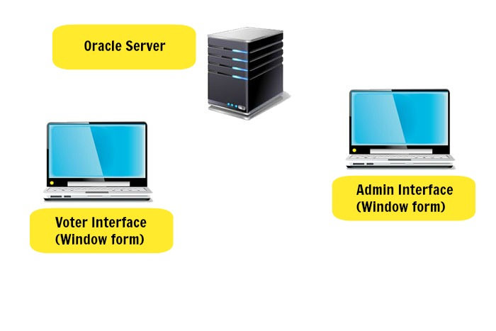

Once the information about the election session, the candidates, the voters and the constituencies is entered into the LAN database, the Vote Dou system will allow the admin to start an election session. Voters can access database stored on the server from across a network of client computers and cast their votes over a period of eight hours. Eventually, the admin stops the election session. The voters can no longer cast a vote.

Thus, the database administrator, election commission officer and the voter will login to the system from different locations and all of the users will be accessing the database concurrently. The SQL Server shall handle the concurrent requests of several users into the database effectively.

**2.4. Security**

Logging in to the Vote Dou software shall require user identity authentication. The system should be password protected with utmost care being taken by the ECO, ensuring that the passwords are provided only to the required individuals. As an improvement to the user identity authentication process, Fingerprint of the users can be scanned to log in to the system. The scanned finger prints is matched against the finger print of the specific individual stored in the NADRA database. A scanning device is needed to acquire the finger print and will be connected to the voting terminal that runs Vote Dou.

3. Test Strategy

The test strategy consists of a series of different tests that will fully exercise the Vote Dou system. The primary purpose of these tests is to uncover the systems limitations and measure its full capabilities. A list of the various planned tests and a brief explanation follows below.

**3.1. System Test**

The System tests will focus on the behavior of the Vote Dou system that is shown in the following use case diagram.

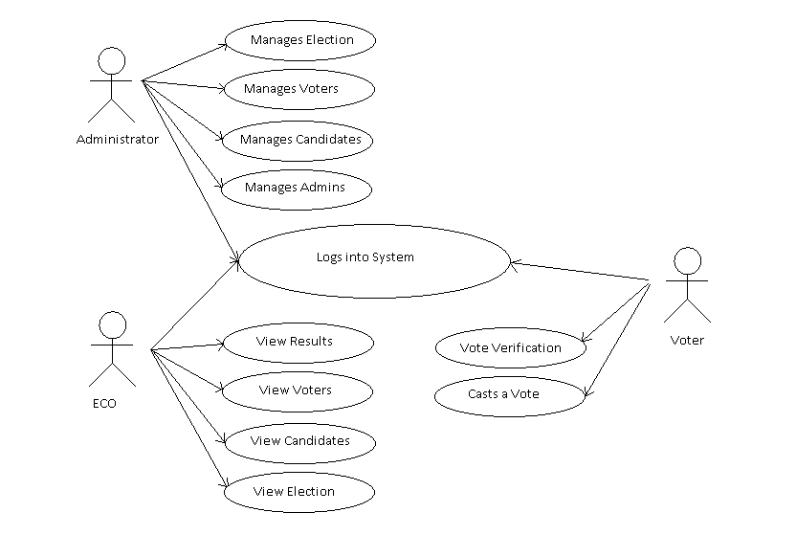

User scenarios will be executed against the system as well as screen mapping and error message testing. Overall, the system tests will test each of these use cases and the integrated system and verify that it meets the requirements defined in the requirements document.

**3.2. Performance Test**

Performance test will be conducted to ensure that the Vote Dou system’s response times meet the user expectations and does not exceed the following performance criteria.

* It should not take more than 1 second for the system to direct the user to another page.
* The login time should not exceed more than 3 seconds.
* The scanning of thumb prints should recognize the correct user within 5 seconds of scanning.
* The Vote Dou software should update the election results every 10 minutes which would determine the leading candidates from the different constituencies on the Election Day.
* The voting time should strictly follow the schedule of voting hours after which the voters will not be allowed to vote.
* The Vote Dou software should be compatible with windows 7 and windows 8 and should not require more than 300mb of hard disk space, 1 GB ram, and a dual core 1 GHz processor.
* The database should have sufficient memory so as to store all of the data necessary. This may vary with the scope of use of the product.

During these tests, response times will be measured under heavy stress and/or volume.

**3.3. Security Test**

Security tests will determine how secure the Vote Dou system is. The tests will verify that unauthorized user access to confidential data is prevented.

An instance is the Test Cases for the **Login for admin/voters/ECO.** Logging in to the Vote Dou software requires user identity authentication. The following test cases perform security testing of the login process.

|  |  |  |  |
| --- | --- | --- | --- |
| **Sr. no** | **Test Case** | **Test Data** | **Expected Test Result** |
| 1 | Correct Username and Password for admin ,for voter , for eco | Any combination of correct username and password from database | Show Respective logged in screen |
| 2 | Incorrect username and correct password | Any password matches the password from database and username doesn’t match any of the username | Error Message: Incorrect Username |
| 3 | Correct username, incorrect password | Any username matches the username from database and password doesn’t match any of the password | Error Message: Incorrect Password |
| 4 | Username and password does not belong to a same person | Write password of a person and username of a different person | Error Message: Incorrect username or password |
| 5 | Only writes username | Write any username | Error Message: Enter Password |
| 6 | Only writes password | Write any password ,leaving the textbox of username empty | Error Message: Enter Username |
| 7 | Click on login button without writing username and password | Click login without writing username and password | Error Message: Enter username and password first |
| 8 | Incorrect Username and password | Write any combination of username and password in which both doesn’t belong to the database. | Error Message: Incorrect username and password |

**3.4. Automated Test**

A suite of automated tests will be developed to test the basic functionality of the Vote Dou system and perform regression testing on areas of the systems that previously had critical/major defects. The tool will also assist us by executing user scenarios thereby emulating several users.

**3.5. Stress and Volume Test**

We will subject the Vote Dou system to high input conditions and a high volume of data during the peak times. This will test the system for extreme values of input. For example, The System will be stress tested using twice the number of expected voters casting a vote.

**3.6. Recovery Test**

Recovery tests will force the system to fail in a various ways and verify the recovery is properly performed. This tests the robustness of the system.

It is crucial that the system does not produce unwanted results in the case of a system failure and that that all election data is recovered after a system failure. All database transactions must be carried out using COMMIT and ROLLBACK statements and locking to ensure data consistency. Thus in case of a failure, all processing transactions should be rolled back and there should be no loss of information or data corruption in any situation. The probability for data corruption on failure should be 0. It should not take more than 5 minutes for the system to restart in case of a failure (preferably 3 minutes) as time plays an important part in the process of an election.

**3.7. Documentation Test**

The following user documentation components will be delivered along with the software to the client to ensure that all the services provided by the system can be clearly understood.

* An administrator user manual for the administrator giving an introduction to the product version and its interface. The working of all the menus and buttons will be stated so that he can understand the system’s functionality and work his way around the interface. A help section will be added.
* An Election Commission Officer manual to facilitate the officer to log in to the system using his username & password, to view the information about the candidates, voters and constituencies, to compute the election results and to generate reports. The working of all the menus and buttons will be stated so that he can understand the system’s functionality and work his way around the interface. A help section will be added.
* A voter manual consisting of two pages to help the voter understand the interface and cast the vote properly. A helpline number will be provided on the manual to call in case of an emergency.

Tests will be conducted to check the accuracy of the user documentation. These tests will ensure that no features are missing, and the contents can be easily understood.

**3.8. Beta Test**

The Election Commission Office will beta tests the Vote Dou system and will report any defects they find. This will subject the system to tests that could not be performed in our test environment.

**3.9. User Acceptance Test**

Once the Vote Dou system is ready for implementation, the Election Commission Office will perform User Acceptance Testing. The purpose of these tests is to confirm that the system is developed according to the specified user requirements and is ready for operational use.

4. Environment Requirements

**4.1. Data Entry workstations**

At the Election Stations, the Administrator/ECO Interface of the system is run on a computer with 300mb of hard disk space, 1 GB ram, and a dual core 1 GHz processor. It must be accompanied by a Visual Display Screen, a typing device (i.e. Keyboard), a pointing device (i.e. mouse or digital pen) and a Network attached printer. The computer must be attached to the LAN Network and must have an uninterrupted access to the main database.

Few user ids and passwords must be created by the automation tool to emulate admin, ECO and voters.

**4.2 Polling station computer terminals**

At the polling stations, the Voter interface of the system is run on a computer with 300mb of hard disk space, 1 GB ram, and a dual core 1 GHz processor. It must be accompanied by a Visual Display Screen, a typing device (i.e. Keyboard) and a pointing device (i.e. mouse or digital pen). The computer must be attached to the LAN Network and must have an uninterrupted access to the main database.

A scanning device must be installed at every polling station.

5. Test Schedule

* Ramp up / System familiarization 1/01/14 - 1/15/14
* System Test 2/16/14 - 3/26/14
* Beta Test 2/28/14 - 3/18/14
* User Acceptance Test 3/29/14 - 4/03/14

6. Control Procedures

**6.1 Reviews**

The project team will perform reviews for each Phase.

* Requirements Review
* Design Review
* Code Review
* Test Plan Review
* Test Case Review
* Final Test Summary Review

A meeting notice, with related documents, will be emailed to each participant.

**6.2 Bug Review meetings**

Regular weekly meeting will be held to discuss reported defects. The development department will provide status/updates on all defects reported and the test department will provide addition defect information if needed. All member of the project team will participate.

**6.3 Change Request**

Once testing begins, changes to the Vote Dou system are discouraged. If functional changes are required, these proposed changes will be discussed with the entire team. The team will determine the impact of the change and if/when it should be implemented.

**6.4 Defect Reporting**

When defects are found, the testers will complete a defect report on the defect tracking system. The defect tracking Systems is accessible by testers, developers & all members of the project team. When a defect has been fixed or more information is needed, the developer will change the status of the defect to indicate the current state. Once a defect is verified as FIXED by the testers, the testers will close the defect report.

7. Functions to Be Tested

The following is a list of functions that will be tested:

1. Logging into the system using Username & password

1. Add/update an administrator
2. Search / Lookup an administrator using Admin ID
3. Add/update election commission officer
4. Search / Lookup an ECO using ECO ID
5. Add/update election session
6. Search / Lookup an election session using session ID
7. Add/update a constituency
8. Search / Lookup a constituency using constituency ID
9. Add/update a candidate
10. Search / Lookup a candidate using candidate ID
11. Add/update a voter
12. Search / Lookup a voter using CNIC of the voter
13. Cast a vote
14. Escape to return to Main Menu
15. Security features
16. Scaling to 10000 voter records
17. Error messages
18. Individual Candidate Result Computation
19. Individual constituency Result Computation
20. Individual Party result Computation
21. National Assembly Result computation
22. Each Provincial Assembly Result computation
23. Election session Turnout report Generation
24. Report Printing
25. Screen mappings (GUI flow). Includes default settings
26. Logging out
27. Closing the Application
28. About Pages

A Requirements Validation Matrix will “map” the test cases back to the requirements. See Deliverables.

8. Resources and Responsibilities

The Test Lead and Project Manager will determine when system test will start and end. The Test lead will also be responsible for coordinating schedules, equipment, & tools for the testers as well as writing/updating the Test Plan, Weekly Test Status reports and Final Test Summary report. The testers will be responsible for writing the test cases and executing the tests. With the help of the Test Lead, the Election Commission Officers will be responsible for the Beta and User Acceptance tests.

**8.1. Resources**

The test team will consist of:

* A Project Manager : Noor Zehra
* A Test Lead : Zaryab Khan
* Testers : Atiqa Zafar & Ghania Riaz
* The Election Commission officers

**8.2 Responsibilities**

|  |  |
| --- | --- |
| Project Manager | Noor Zehra shall be responsible for Project schedules and the overall success of the project. |
| Lead Developer | Atiqa Zafar shall represent the development team. |
| Test Lead | Zaryab Khan shall ensures the overall success of the test cycles. He will coordinate weekly meetings and will communicate the testing status to Noor. |

9. Deliverables

|  |  |  |
| --- | --- | --- |
| **Deliverable** | **Responsibility** | **Completion Date** |
| Develop Test cases | Test Lead, Testers | 2/11/14 |
| Test Case Review | Test Lead, Dev. Lead, Testers | 2/12/14 |
| Develop Automated test suites | Testers | 3/01/14 |
| Requirements Validation Matrix | Test Lead | 2/16/14 |
| Obtain User ids and Passwords for Vote Dou database | Test Lead | 1/27/14 |
| Execute manual and automated tests | Testers & Test Lead | 4/26/14 |
| Complete Defect Reports | Everyone testing the product | On-going |
| Document and communicate test status/coverage | Test Lead | Weekly |
| Execute Beta tests | ECO | 4/18/14 |
| Document and communicate Beta test status/coverage | ECO | 4/18/14 |
| Execute User Acceptance tests | ECO | 5/03/14 |
| Document and communicate Acceptance test status/coverage | ECO | 5/03/14 |
| Final Test Summary Report | Test Lead | 5/05/14 |

10. Suspension / Exit Criteria

If any defects are found which seriously impact the test progress, the Test Lead may choose to Suspend testing. Criteria that will justify test suspension are:

1. Hardware/software is not available at the times indicated in the project schedule.
2. Source code contains one or more critical defects, which seriously prevents or limits testing progress.
3. Assigned test resources are not available when needed by the test team.

11. Resumption Criteria

If testing is suspended, resumption will only occur when the problem(s) that caused the suspension has been resolved. When a critical defect is the cause of the suspension, the “FIX” must be verified by the test department before testing is resumed.

12. Dependencies

**12.1 Personnel Dependencies**

The test team is required to develop, perform and validate tests. The Election Commission is needed to provide few officials for beta and user acceptance testing.

**12.2 Software Dependencies**

The source code must be unit tested and provided within the scheduled time outlined in the Project Schedule.

**12.3 Hardware Dependencies**

Ten Personal Computers (with specified hardware/software) as well as the LAN environment need to be available during normal working hours. Any downtime will affect the test schedule.

**12.3 Test Data & Database**

Test data (mock election information) & database should also be made available to the testers for use during testing.

13. Risks

**13.1. Schedule**

The schedule for each phase is very aggressive and could affect testing. A slip in the schedule in one of the other phases could result in a subsequent slip in the test phase. Close project management is crucial to meeting the forecasted completion date.

**13.2. Technical**

As the system plays a very significant role in the national elections, a system crash means that the software is unavailable to cast and submit a vote at a polling station. This will affect the whole voting process and cause inconvenience to both the voters and the election commission officers. Hence, the system must be properly tested using validation and defect checks and all the errors should be debugged before deployment.

**13.3. Management**

Management support is required so when the project falls behind, the test schedule does not get squeezed to make up for the delay. Management can reduce the risk of delays by supporting the test team throughout the testing phase and assigning people to this project with the required skills set.

**13.4. Personnel**

Due to the aggressive schedule, it is very important to have experienced testers on this project. Unexpected turnovers can impact the schedule. If attrition does happen, all efforts must be made to replace the experienced individual

**13.5 Requirements**

The test plan and test schedule are based on the current Requirements Document. Any changes to the requirements could affect the test schedule and will need to be approved by the Project lead.

14. Tools

The J-Unit testing will be used to help perform unit testing the Vote Dou system.

15. Documentation

The following documentation will be available at the end of the test phase:

* Test Plan
* Test Cases
* Test Case review
* Requirements Validation Matrix
* Defect reports
* Final Test Summary Report

16. TEST CASES

1. **Login Test Case:** Logging in to the Vote Dou software requires user identity authentication. The following test cases perform security testing of the login process.

|  |  |  |  |
| --- | --- | --- | --- |
| **Sr. no** | **Test Case** | **Test Data** | **Expected Test Result** |
| 1 | Correct Username and Password for admin ,for voter , for eco | Any combination of correct username and password from database | Show Respective logged in screen |
| 2 | Incorrect username and correct password | Any password matches the password from database and username doesn’t match any of the username | Error Message: Incorrect Username |
| 3 | Correct username, incorrect password | Any username matches the username from database and password doesn’t match any of the password | Error Message: Incorrect Password |
| 4 | Username and password does not belong to a same person | Write password of a person and username of a different person | Error Message: Incorrect username or password |
| 5 | Only writes username | Write any username | Error Message: Enter Password |
| 6 | Only writes password | Write any password ,leaving the textbox of username empty | Error Message: Enter Username |
| 7 | Click on login button without writing username and password | Click login without writing username and password | Error Message: Enter username and password first |
| 8 | Incorrect Username and password | Write any combination of username and password in which both doesn’t belong to the database. | Error Message: Incorrect username and password |

1. **Vote Casting Test cases:** During elections, a voter shall login into the system using his CNIC number, Session Id and password. If verified, he can cast a vote and submit it. Every voter can cast only one vote. The following test cases perform system testing of the vote casting process.

|  |  |  |  |
| --- | --- | --- | --- |
| **Sr. no** | **Test Case** | **Test Data** | **Expected Test Result** |
| 1 | Voter enters correct session ID, CNIC Number and password and he is casting his vote for the first time. | Any combination of correct username and password from database | Show Respective logged in screen |
| 2 | Voter enters correct session ID, CNIC Number and password and he has already casted his vote once. | Any combination of correct username and password from database | Error Message: You have already casted a vote. |
| 3 | Voter enters incorrect session ID, correct CNIC Number and correct password and he is casting his vote for the first time. | Any CNIC number that matches the CNIC number from database  And incorrect session ID that does not match the session ID of the provided CNIC | Error Message: Incorrect User |
| 4 | Voter enters correct session ID, incorrect CNIC Number and correct password and he is casting his vote for the first time. | Any Session ID that matches the Session IDs from database  And incorrect CNIC that does not match the CNIC of the provided Session ID | Error Message: Incorrect User |
| 5 | Voter enters correct session ID and CNIC Number and incorrect password and he is casting his vote for the first time. | Any combination of correct CNIC & Session ID but incorrect password that does not match the password of the provided user | Error Message: Incorrect Password |
| 6 | Voter selects a candidate but doesn’t submit his Vote. Clicks on OK button. | Select a Candidate and Click OK without submitting vote | Error Message: You haven’t submitted your vote. |
| 7 | Voter doesn’t select a candidate and doesn’t submit his Vote either. Clicks on OK button. | Click OK without selecting a candidate, nor submitting vote | Error Message: Are you sure you don’t want to cast a vote? Yes/No |
| 8 | Voter doesn’t select a candidate but submits his Vote. | Submits a vote without selecting a candidate | Error Message: You haven’t selected a candidate. |

1. **Add Candidate Test Cases:** When a new candidate is to be added, Information about the Candidate such as his First name, Last name, CNIC, Party ID, Constituency ID and Session ID is entered into the database. The Application automatically generates a Candidate ID using sequence for every entry in the Main Table.

|  |  |  |  |
| --- | --- | --- | --- |
| **Sr. no** | **Test Case** | **Test Data** | **Expected Test Result** |
| 1 | Enter a textual data into the First Name | Enter Correct Data, Click OK | Record Added |
| 2 | Enter a numeric data into the First Name | Enter a numeric data into the First Name and Correct Data, Click OK | Error Message: Incorrect First Name |
| 3 | Enter a textual data into the Last Name | Enter Correct Data, Click OK | Record Added |
| 4 | Enter a numeric data into the Last Name | Enter a numeric data into the Last Name and Correct Data, Click OK | Error Message: Incorrect Last Name |
| 5 | Enter a CNIC in correct format: 45505-9879877-0 | Enter Correct Data, Click OK | Record Added |
| 6 | Enter an incorrect CNIC:  MSKAD-KJ, 45678-0987654-345 | Enter an incorrect CNIC:  MSKAD-KJ, 45678-0987654-345 and Correct Data, Click OK | Error Message: Incorrect CNIC |
| 7 | Enter a Party ID of an existing Party | Enter Correct Data, Click OK | Record Added |
| 8 | Enter an incorrect Party ID of a non-existing Party | Select an incorrect Party ID of a non-existing Party and Enter Correct Data, Click OK | Combo box should not allow you enter incorrect Party ID |
| 9 | Enter a Constituency ID of an existing Constituency | Enter Correct Data, Click OK | Record Added |
| 10 | Enter an incorrect Constituency ID of a non-existing Constituency | Select an incorrect ID of a non-existing Constituency and Enter Correct Data, Click OK | Combo box should not allow you enter incorrect Constituency ID |
| 11 | Enter a Session ID of an existing session | Enter Correct Data, Click OK | Record Added |
| 12 | Enter an incorrect Session ID of a non-existing Session | Select an incorrect ID of a non-existing Session and Enter Correct Data, Click OK | Combo box should not allow you enter incorrect Session ID |
| 13 | Leave a field empty, Click Add | Leave a field empty and enter Correct Data, Click OK | Error message: a required field has been left empty |
| 14 | Insert all correct data, Click Add | Enter Correct Data, Click OK | Record Added |