
Prepared by:
Noor Zehra 00118 12besenzehra@seecs.edu.pk
Zaryab Khan 01122 12besezkhan@ seecs.edu.pk
Ghania Riaz 01813 12besegriaz@ seecs.edu.pk
Atiqa Zafar 00024 12beseazafar@ seecs.edu.pk

Instructor: Sir Awais Shibli
Course: SE200 Software Engineering
Lab section: BESE 3B
Teaching Assistant: Mariam Amir & Farhan Humayun
Date: Monday, 23rd December 2013

Contents
Revisions iii
1 Introduction 4
1.1 Document Purpose 4
1.2 Product Scope 4
1.3 Intended Audience and Document Overview 4
1.4 Definitions, Acronyms and Abbreviations 5
1.5 Document Conventions 5
1.6 References and Acknowledgments 5
2 Overall Description 6
2.1 Product Perspective 7
2.2 Product Functionality 8
2.3 Users and Characteristics 8
2.4 Operating Environment 8
2.5 Design and Implementation Constraints 9
2.6 User Documentation 9
2.7 Assumptions and Dependencies 10
3 Specific Requirements 11
3.1 External Interface Requirements 11
3.2 Functional Requirements 17
3.3 Behaviour Requirements 25
4 Other Non-functional Requirements 26
4.1 Performance Requirements 26
4.2 Safety and Security Requirements 26
4.3 Software Quality Attributes 27
Appendix A – Data Dictionary 29
Appendix B - Group Log 30

Revisions
Version | Primary Author(s) | Description of Version | Date Completed
1.0 | Atiqa Zafar  Ghania Riaz  Noor Zehra  Zaryab Khan | This Test Plan contains <> for Vote Dou 1.0. It also specifies <>. | 6/01/14

Introduction

Vote Dou 1.0 is an electronic voting system that will automate the process of casting a vote and counting votes. It is presented as an alternative to the existing parliamentary voting procedure present in Pakistan.

This section of the SRS contains the purpose of this document, the scope of the proposed electronic voting system, the intended audience of this document and the definitions of the terms coming in the afterward sections of this document.

Document Purpose
The purpose of this SRS Document is to list down the functional and non-functional requirements for Vote Dou 1.0 gathered through scenarios, ethnography and interviewing the stakeholders of the electoral system. It also specifies the application domain, system boundaries and operational constraints.

This document, therefore, ensures that the team understands the services that the system should provide and the operational constraints of the system. The information is organized in such a way that the developers will not only understand the boundaries within which they need to work, but also what functionality needs to be developed and in what order. This helps breaking the deliverables into smaller components and designing the system. An added advantage of this document is that it may help evolution and development of future versions of Vote Dou.

Product Scope
In the present electoral system of Pakistan, the National Assembly is elected directly by the people of Pakistan. The Election Commission of Pakistan is a constitutionally established institution responsible for holding elections countrywide. Unfortunately, there hasn’t been a single election in Pakistan that has escaped the slogans of rigging and corruption. Moreover, the manual electoral system is time consuming and resource consuming. Printing ballots, buying ballot boxes and hiring staff increase the total cost. There is no proper and reliable database of result maintained either. All the records are saved in files, which can easily be misplaced. There is a dire need for automation of the system in order to make the election free and fair and remove doubts of possible rigging.

Vote Dou is an electronic voting system that is presented as an alternative to the existing parliamentary voting procedure present in Pakistan. Vote Dou is a project that could help the Pakistani electoral system get rid of corruption and rigging by replacing the ballot paper with a computer connected to the Vote Dou database that can record a voters vote and send the information over to the database.

Intended Audience and Document Overview
The Intended Audience of this document will be the development team, the client and the Course Instructor Sir Awais Shibli who has assigned this project to the development team as their semester project of Software Engineering course.

As aforementioned, this document specifies the functional and non-functional requirements of the system, the application domain and the operational constraints so that the development team can clearly understand what the system does and under what constraints the system needs to be developed. The document is structured into four sections and two appendices. The first section introduces the reader to the system and the use of the document. It specifies the purpose and the format of the document. It also mentions all the terms necessary to properly interpret the SRS, including acronyms and abbreviations.

The next section “2 Overall Description” describes the product scope and its functionality by mentioning the application domain of the system (operating environment), the intended users of the system and the constraints imposed on design and implementation of the system. The functionality of the system, briefly touched in this section, is further explained in the third section “3 Specific Requirements”.

The third section is of great importance to the development team as it specifies the proposed interface, functional requirements and the behavioural requirements. This section is considered in the design phase of the software development to design the interface and the functionality of the proposed system.

The fourth section “4 Non-functional Requirements” specifies what is required from the system in terms of the performance, Safety and Quality.

This document must be read section-wise to grasp a better understanding of the proposed system.

Definitions, Acronyms and Abbreviations
DBA Database Administrator
ECO Election Commission Officer
IEEE Institute of Electrical and Electronic Engineers
SRS Software Requirements Specifications
PA Provincial Assembly
NIC National Identity card
NA National Assembly

Document formatting Conventions
This document uses the IEEE formatting requirements. It uses the font style Calibri and size 11 throughout the document. The text is single spaced and maintains the 1’’ margins. Every section and subsection name is bold-faced for clarity.

References and Acknowledgments
Official Website: Election Commission of Pakistan ecp.gov.pk/
Official website: Pakistan Elections 2012-2013 elections.com.pk/
Wikipedia page: Election Commission of Pakistan wikipedia.org/wiki/Election_Commission_of_Pakistan

Overall Description

Product Perspective
Vote Dou is an electronic voting system that automates the existing parliamentary voting procedure of Pakistan. In the existing system, the National Assembly and the Provincial Assemblies are elected directly by the people of Pakistan. The Election Commission of Pakistan is a constitutionally established institution responsible for holding elections countrywide. The diagram below shows how the commission holds an election in the country.
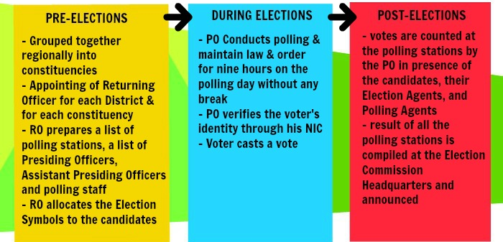
Unfortunately, there hasn’t been a single election in Pakistan that has escaped the slogans of rigging and corruption. The manual electoral system is further time consuming and resource consuming.
Vote Dou is a project that could help the Pakistani electoral system get rid of corruption and rigging by replacing the ballot paper with a computer connected to the Vote Dou database that can record a voter’s vote and send the information over to the database. The software not only helps cast electronic votes but it also helps to set up elections, manage constituencies, manage the candidates contesting on these constituencies and determine the results on the Election Day. Vote Dou is based on the idea that a computer integrated to the Vote Dou database will be set up at each polling booth where the voters will vote their candidates participating from their respective constituencies.

The GUI will be user friendly allowing the uneducated voters to easily cast their votes too.
The voters CNIC will be checked before their vote is casted and their thumb print taken too as a precaution. Once the voter enters the polling booth, they will log in to their account using the username (their CNIC number) and the password provided to them by the election officials. The polling continues on the Election Day in the time allocated for the election after which the polling stops and the election results are generated. The voters, election commission officers and database administrator will have different access rights defined according to their roles. The following diagram illustrates how the system interacts with its external environment and the way the system is put to use:
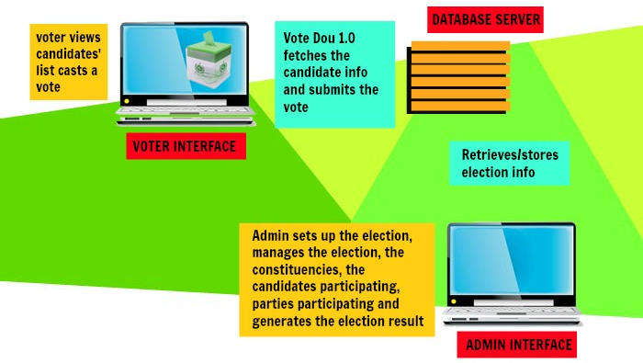

Product Functionality
Vote Dou 1.0 provides a set of tools that allow voters to cast ballots while the election commission collects votes and outputs the final result. It performs the following functions:

- It implements a user access right policy through user identity authentication at login. Each user is provided with a username, a password and different access rights according to the roles of the Administrator, Election Commission Officer and the Voter.

- It provides the administrator with an easy-to-understand interface to manage elections. A new election session can be created or an existing one can be edited using an election ID. Information about the constituencies, candidates and voters can be inserted, edited and deleted.

- The Voter Interface runs on the electronic voting machines located at the polling stations and is used to cast a vote by the voter.

- It provides the Election Commission officer with a user-friendly interface to view the election information and compute the results. The officer can filter the results by Constituency or Party Name and generate a report to announce results.

- The administrator can create a backup of an election session and store all the information about the contesting candidates, voters, constituency results and final results.

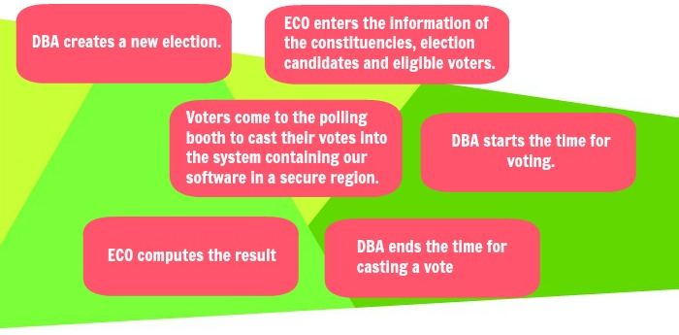
The Diagram of the system shows how the election shall proceed with Vote Dou and how the above mentioned functions relate to each other.

Users and Characteristics
There are three types of users that will operate the software as follows. Each of these users will be provided a username and password to access the system.
- The database administrator - The DBA plays the administrative role in the system. He manages the election details in the database and grants different access rights to users.
- The election officer -The election commission is entrusted with the job of inserting details about the election candidates, the eligible voters and the constituencies. It can filter the results by Constituency or Party Name and generate a report to announce results.
- The Voter - The voter shall login into the system using his CNIC number. If verified, he can cast a
a vote and submit it. Every voter can cast only one vote.

Operating Environment
Vote Dou 1.0 will be implemented using C# Windows Forms at the frontend and SQL at the backend. The database will be present at the Oracle Server. Presently, the application can only be run on a computer with Windows Operating System. It doesn’t support other hardware platforms such as smartphones or tablets. A simple diagram that shows the major components of the overall system and external interface is shown below:

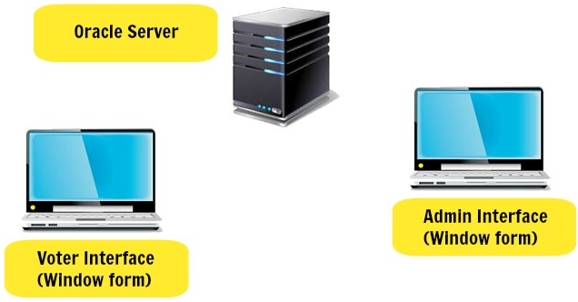

Design and Implementation Constraints
- Time Constraint: The system needs to be developed and tested in the month of December. Hence, the developer team has decided to use already learnt concepts of C# programming language to design the interface of the program and SQL to create the database.

- Security considerations: Vote Dou shall not allow i-voting. I-voting is voting from one's personal computer, mobile phone, television via the internet. As i-voting doesn’t ensure the validity of a person’s vote, the Vote Dou software shall not provide the facility of online voting. Polling booth shall be guarded with security personnel that would prevent any external threats from disrupting the process of voting.

-Hardware limitations: Vote Dou 1.0 is a working prototype implementation of the actual e-voting system. Presently, it cannot avail the finger print user authentication procedure to secure user logins due to unavailability of scanners. In the future versions, the development team can either utilize the scanning devices already available in the market or write a program to scan and match a picture captured using a digital camera.

User Documentation
The following user documentation components will be delivered along with the software to the client to ensure that all the services provided by the system can be clearly understood.

- An administrator user manual for the administrator giving an introduction to the product version and its interface. The working of all the menus and buttons will be stated so that he can understand the system’s functionality and work his way around the interface. A help section will be added.

- An Election Commission Officer manual to facilitate the officer to log in to the system using his username & password, to view the information about the candidates, voters and constituencies, to compute the election results and to generate reports. The working of all the menus and buttons will be stated so that he can understand the system’s functionality and work his way around the interface. A help section will be added.

- A voter manual consisting of two pages to help the voter understand the interface and cast the vote properly. A helpline number will be provided on the manual to call in case of an emergency.

Assumptions and Dependencies
- It is assumed that NADRA shall provide the DBA with all the required information about the candidates and voters.

- It is assumed that the Election Commission of Pakistan will place a computer at every Polling booth.

- It is assumed that the Polling booths shall be guarded with security personnel that would prevent any external threats from disrupting the process of voting.
- It is assumed that Election Commission of Pakistan will recruit ECO who have know-how of the system. And it will be arrange orientation programs for newly recruited officers to help them understand the new system. The development team will provide an ECO Manual along with the product delivery.

Specific Requirements

External Interface Requirements

User Interfaces
When the application is run, a splash screen containing the product name and version is displayed on the computer screen. It is followed by a login form requiring the username & password.

- Login Form requiring username & password
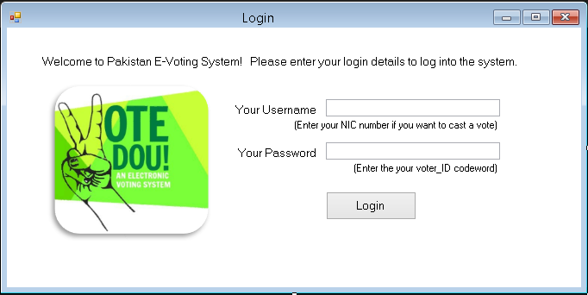
The form border style is Fixed Tool Window and the start position is centre screen. When the user has entered correct login details, he presses the “Login” button and logs into the system. If he fails to provide the correct username or password, an error message is generated notifying the user that the password/username he has entered is incorrect. The user presses the “Ok” button and is directed back to the login form.

Depending on the username entered, any of the user interfaces are opened. There are three interfaces, designed for the Administrator, the ECO and the Voter respectively. The Voter Interface will run on the electronic voting machines located at the polling stations and will be used to cast a vote. The Administrator interface will allow the administrator to manage elections, candidates and voters and compute results. The ECO interface will allow the ECO to view the information and print reports.

Each interface between the software product and the user consists of a number of menus and submenus as listed below.

The File menu is common to all Interfaces. It allows the user to log out or close the application. When the user clicks on “Log out”, a message box appears asking if the user wants to exit. Two message box buttons are displayed, namely Yes or No. If the user clicks on “Yes”, the application closes. If the user clicks on “No”, he is directed back to the previous Windows form.
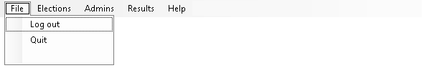

Similarly, the Help Menu is provided in all the interfaces. It has three submenus as shown below. Clicking on the “About Vote Dou” option directs you to the form containing information about the product. Clicking on the “About The Developer” option directs you to the form containing information about the developers. Clicking on the “Contact” option directs you to the form containing email address or phone numbers where you can contact to take further help.


- Administrator Interface
It consists of the following Menus & Submenus:

- Elections
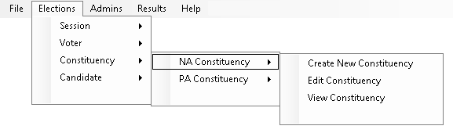

- Create/Edit/View Election Session(s)
- Create/Edit/View Voter(s)
- Create/Edit/View NA Constituency(s)
- Create/Edit/View PA Constituency(s)
- Create/Edit/View NA Candidate(s)
- Create/Edit/View PA Candidate(s)

- Administrators


- Create/Edit/View Admin(s)
- Create/Edit/View EC Officer(s)

- Compute Results
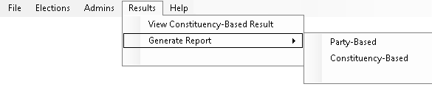
- View Constituency-Based Result (triggered)
- Generate Reports
- Constituency based
- Party Based

- Voter Interface
  - Cast-a-vote window will show the Voter Name, Constituency, NIC Number and radio buttons next to each Candidate name and party symbol. Once the voter has checked a specific radio button and clicked “Submit Vote” button, a message box appears confirming his vote.
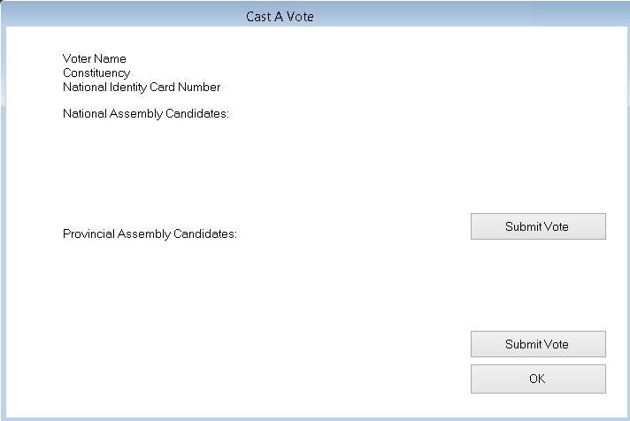

  - Submission Confirmation window (shows the casted vote, confirms submission and exits session)

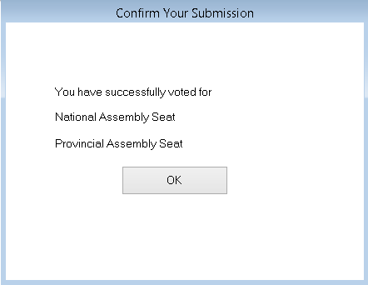

- Election Commission Officer Interface

- View Election Information
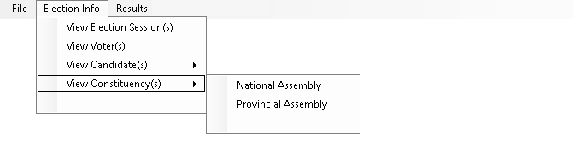
- View Election Session(s)
- View Voter(s)
- View NA Constituency(s)
- View PA Constituency(s)
- View NA Candidate(s)
- View PA Candidate(s

- View Election Results

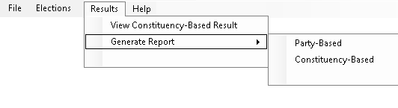
- View Constituency-Based Result (triggered)
- Generate Reports
- Constituency based
- Party Based

Hardware Interfaces
Vote Dou 1.0 is composed of the following hardware interfaces:

- At the polling stations, the Voter interface of the system is run on a computer with 300mb of hard disk space, 1 GB ram, and a dual core 1 GHz processor. It must be accompanied by a Visual Display Screen, a typing device (i.e. Keyboard) and a pointing device (i.e. mouse or digital pen).
- At the Election Stations, the Administrator/ECO Interface of the system is run on a computer.
- The database is placed on the server computer. The database server should have sufficient memory so as to store all of the data necessary. This may vary with the scope of use of the product.
- A scanning device must be installed at every polling station.

Software Interfaces
The software requirement for the development of Vote Dou 1.0 are Windows Operating System, Visual Studio 2013 (or previous versions) to design the windows forms using C# and SQL server management studio to create the database and store information.

Vote Dou 1.0 runs on a computer with the windows 7 and windows 8 Operating System.

Communications Interfaces
Protocols- The project is based on the use of an oracle database. The server will be connected to the oracle database and all the data will be stored on it. The clients will connect to oracle database and the clients will fetch data from the oracle database via queries. Oracle Net enables connections from traditional client/server applications to Oracle Database servers.
Oracle Net, a component of Oracle Net Services, is a software layer that resides on the client and the Oracle Database server. It is responsible for establishing and maintaining the connection between the client application and server, as well as exchanging messages between them, using industry-standard protocols. It enables a network session from a client application to an Oracle Database server. Once a network session is established, Oracle Net acts as the data courier for both the client application and the database server. It is responsible for establishing and maintaining the connection between the client application and database server, as well as exchanging messages between them. Oracle Net is able to perform these jobs because it is located on each computer in the network.
The figure below shows how Oracle Net enables a network connection between a client and a database server. Oracle Net is layered on top of a network Oracle protocol support—rules that determine how applications access the network and how data is subdivided into packets for transmission across the network. In this illustration, Oracle Net communicates with the TCP/IP to enable computer-level connectivity and data transfer between the client and the database server.

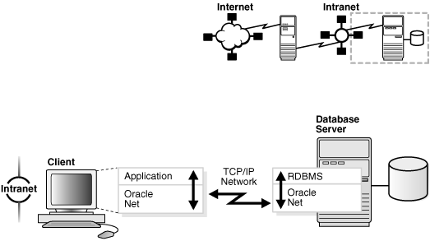

Security: Data access and secure transfer of data are important considerations when deploying the oracle based project. Granting and denying access to a database is crucial for a secure network environment.
Oracle Connection Manager can be configured to grant or deny client access to a particular database service or a computer. By specifying filtering rules, you can allow or restrict specific client access to a server, based on the following criteria:
- Source host names or IP addresses for clients
- Destination host names or IP addresses for servers
- Destination database service names
- Client use of Oracle Advanced Security

An application gateway controls traffic between internal and external networks and providing a single checkpoint for access control and auditing. As a result, unauthorized Internet hosts cannot directly access the database inside a corporation, but authorized users can still use Internet services outside the corporate network. This capability is critical in Internet environments to restrict remote access to sensitive data. The database server can be configured with access control parameters in the sqlnet.ora configuration file. These parameters specify whether clients are allowed or denied access based on the protocol.

Functional Requirements

User Login
Logging in to the Vote Dou software shall require user identity authentication. The system should be password protected with utmost care being taken by the ECO, ensuring that the passwords are provided only to the required individuals. As an improvement to the user identity authentication process, Fingerprint of the users can be scanned to log in to the system. The scanned finger prints is matched against the finger print of the specific individual stored in the NADRA database. A scanning device is needed to acquire the finger print and will be connected to the voting terminal that runs Vote Dou.

Pre-voting phase
In the pre-voting phase the database administrator (DBA) creates a new election and enters the information of the constituencies, election candidates and eligible voters using the information provided by the Election Commission of Pakistan. This phase constitutes of a number of functionalities as shown in the use case below:
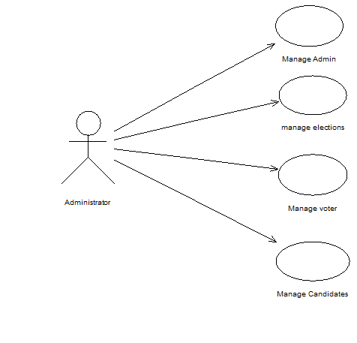

- The Manage Administrator Module – deals with inserting and editing users of the system. There are three types of user of the Vote Dou system, namely the Administrator, the Election commission Officer and the Voter. Information about these users (such as the User_ID, First Name, Last Name, Address, NIC Number & Contact Number) is stored in the main database. The DBA is given the privilege to add new users and assign specific privileges to the users, edit the existing users and view the users based on different filters, that is, He can filter/sort/search the users by a specific name or role or user_ID .

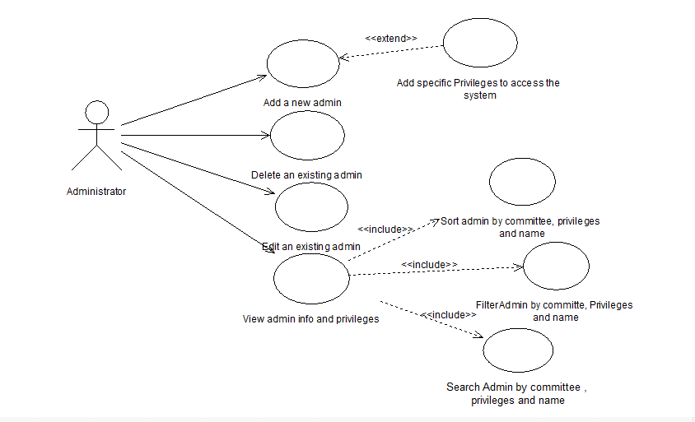

Pre-condition:
Administrator login to the system,
Administrator data already recorded.
Actor: Administrator

- The Manage Elections Module- manages information about the Election Session. Every Election Session has an Identification ID and year. The Administrator can create a new session or modify an existing one. Once the elections have taken place and the results have been computed, he can also view the winning candidates, the winning parties or the result of each constituency based on a certain Election_ID.
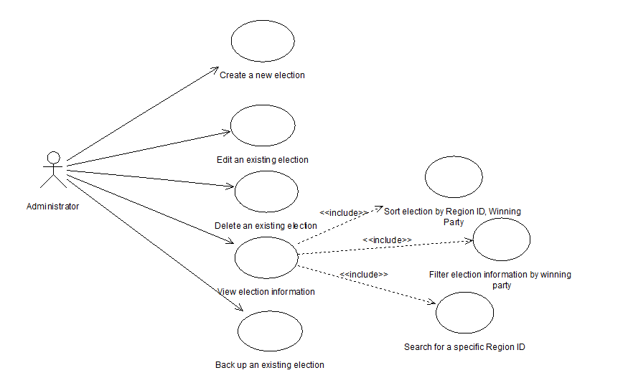
Pre-condition:
Administrator login to the system,
Election data already recorded.
Actor: Administrator

- The Manage Voter Module-deals with the insertion and modification of Voter information. Every voter is a registered adult citizen of the country. His NIC number, name, Date of Birth, Father name, Address, NA constituency ID, PA constituency ID, Election_ID, NA Vote and PA Vote is stored in the database. The administrator can add, edit and delete a voter. Both the administrator and the ECO can view the voter list or search for a specific voter using any of his attributes.

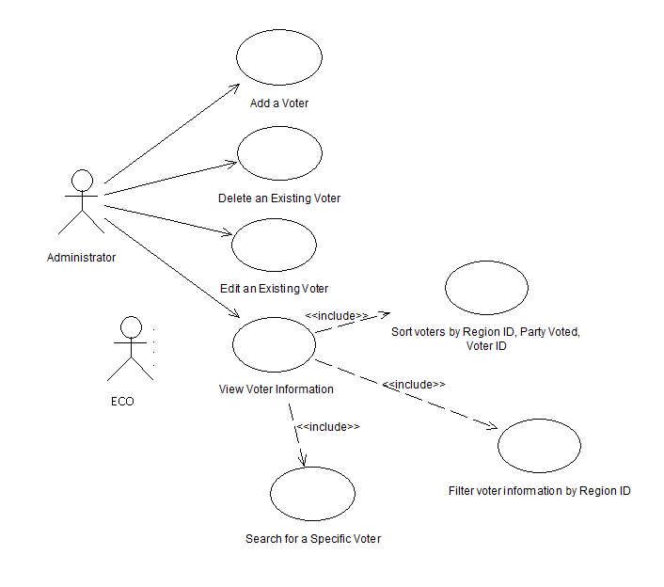

Pre-condition:
System Login,
Voter data already recorded.
Actor: Administrator, Election Commission Officer

- The Manage Candidate Module -deals with the insertion and modification of Candidate information. Every Candidate ‘s Candidate ID, Constituency ID, NIC number, name, Party ID, Number of Votes and session ID is stored in the database. The administrator can add, edit and delete a Candidate. Both the administrator and the ECO can view the Candidate list or search for a specific Candidate using any of his attributes.
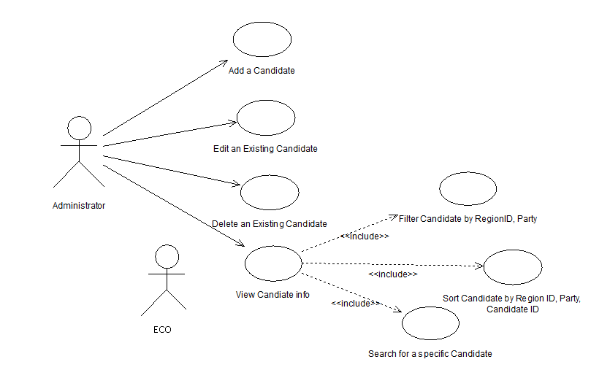

Pre-condition:
Successful log into the system,
Candidate data already recorded.
Actor: Administrator, ECO

Voting & Post-Voting phase
In the voting phase, the database administrator starts the time for voting. Voters come to the polling booth to cast their votes into the system containing our software in a secure region. Eventually, the database administrator ends the time for casting a vote. The ECO/Administrator then compute the final results. This phase constitutes of a number of functionalities as shown in the use case below:
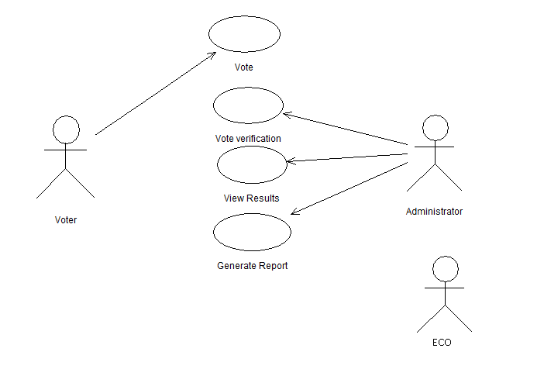

- Submit a Vote Module- comprises of three other use cases, namely System Login, Voter verification and Vote Cast. When a voter enters his username (NIC number), his identity is verified through a password provided by the ECO or through scanning his finger print. The entered information is matched against the stored data and the access is granted to the voter. The voter interface lists down the candidate list of his particular constituency and asks him to submit a vote. The voter casts a vote and logs out. The casted vote is stored against the voter ID in the database and cannot be re-casted.

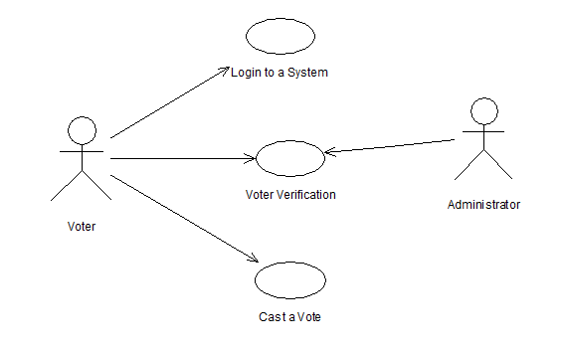

Pre-condition: Voter is registered before in the system
Actor: Administrator, Voter

- Result Management Module-manages the result. In Vote Dou 1.0, the constituency based result is automatically computed after a specific time interval using triggering. Both the administrator & the ECO can view the triggered results or generate a report by filtering the information according to constituencies or parties.

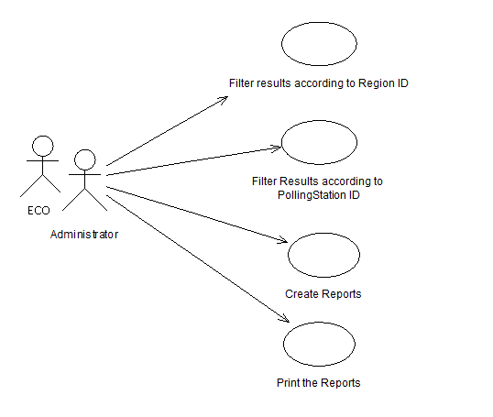

Pre-condition:
Successful login to the system,
Election data already recorded.
Actor: Administrator, ECO

Behaviour Requirements

Use Case View
The following use case diagram encapsulates the entire system and all possible actors. Each of these use cases have been defined in the previous section 3.3.

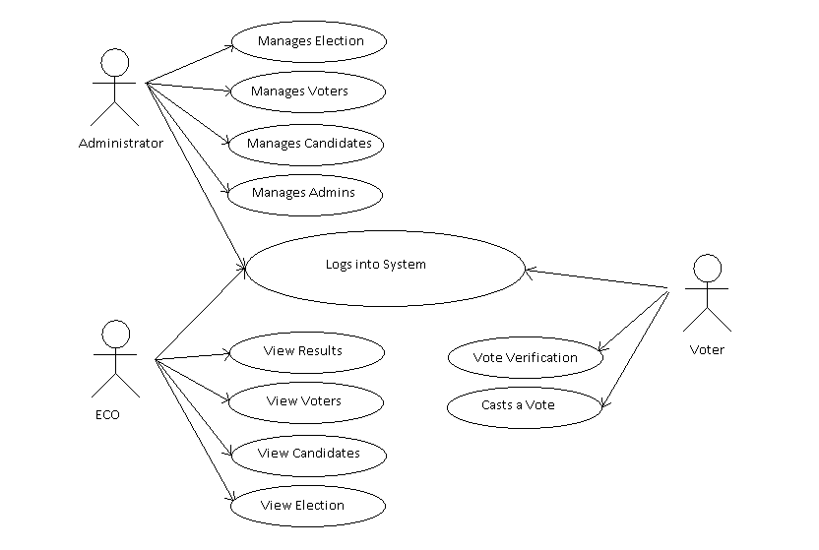

Other Non-functional Requirements

Performance Requirements
Time is a key factor on the polling day as there are thousands of voters waiting for their turn to vote on the polling day. The system should be responsive and hence the following measures should be taken:

- It should not take more than 1 second for the system to direct the user to another page.
- The login time should not exceed more than 3 seconds.
- The scanning of thumb prints should recognize the correct user within 5 seconds of scanning.
- The Vote Dou software should update the election results every 10 minutes which would determine the leading candidates from the different constituencies on the Election Day.
- The voting time should strictly follow the schedule of voting hours after which the voters will not be allowed to vote.
- The Vote Dou software should be compatible with windows 7 and windows 8 and should not require more than 300mb of hard disk space, 1 GB ram, and a dual core 1 GHz processor.
- The database should have sufficient memory so as to store all of the data necessary. This may vary with the scope of use of the product.

Safety and Security Requirements
The idea of Vote Dou was to provide a fair ground to all the candidates contesting in the general elections. Hence, it is very important that the candor of the elections is not compromised.

POSSIBLE LOSS THAT COULD RESULT FROM PRODUCT USE

- If the login process is not password protected, the validity of a person’s vote will not be ensured. Hence, Logging in to the Vote Dou software shall require user identity authentication. The system should be password protected with utmost care being taken by the ECO, ensuring that the passwords are provided only to the required individuals. As an improvement to the user identity authentication process, Fingerprint of the users can be scanned to log in to the system. The scanned finger prints is matched against the finger print of the specific individual stored in the NADRA database. A scanning device is needed to acquire the finger print and will be connected to the voting terminal that’s runs Vote Dou.
- If the database is hacked, confidential information about the voter can be leaked or fake votes can be casted. Hence, Preventive measures should be taken to ensure that hacking into the Vote Dou database is impossible.
- Vote Dou shall not allow i-voting. I-voting is voting from one's personal computer, mobile phone, television via the internet. As i-voting doesn’t ensure the validity of a person’s vote, the Vote Dou software shall not provide the facility of online voting. Polling booth shall be guarded with security personnel that would prevent any external threats from disrupting the process of voting.

EXTERNAL REGULATIONS

Vote Dou must not violate the ISO security standards and it must be in compliance with the ACM/IEEE ethical standards.

SECURITY REQUIREMENTS

- Password protected login. Password to be provided to each user with different access rights according to the roles of the Administrator, Election Commission Officer and the Voter. (Requirement)
- The passwords generated should contain a minimum of 7 alpha-numeric characters.
- Integrating a finger scanning device with the software that checks the user’s finger print against the finger print of the user that is stored in the NADRA database. (Recommended)
- Complete protection to safeguard the data against malicious users that may attempt to hack into the database and manipulate the election results. Experts in security and hacking must be asked to check for any loop holes in the security.

Software Quality Attributes

RELIABILITY
The system’s availability and data integrity cannot be jeopardized at any cost. As the system plays a very significant role in the national elections, a system crash means that the software is unavailable to cast and submit a vote at a polling station. This will affect the whole voting process and cause inconvenience to both the voters and the election commission officers. Hence, the system must be properly tested using validation and defect checks and all the errors should be debugged. The mean time to failure should not be less than 2400 hours.
It is very important that that the software ensures data integrity as well. All database transactions must be carried out using COMMIT and ROLLBACK statements and locking to ensure data consistency. Moreover, a complete protection must be provided to safeguard the data against malicious users that may attempt to hack into the database and manipulate the election results. Experts in security and hacking must be asked to check for any loop holes in the security.

ROBUSTNESS
It is crucial that the system does not produce unwanted results in the case of a system failure. In case of a failure, all processing transactions should be rolled back and there should be no loss of information or data corruption in any situation. The probability for data corruption on failure should be 0. It should not take more than 5 minutes for the system to restart in case of a failure (preferably 3 minutes) as time plays an important part in the process of an election.
During the testing phase, test cases should be modeled to perform defect testing using correct inputs, extreme inputs (maximum/minimum values) and incorrect data with known errors. This will check how the system will cope with errors during execution.

ADAPTABILITY
Vote Dou 1.0 will be presented as an alternative to the existing parliamentary voting procedure present in Pakistan. Hence, its adaptability to the working domain is significant. As there will be both educated people and uneducated people using the software, it is very important that the software provides a simple user interface. The interface must only demand basic operations such as entering the NIC number and clicking on the respective candidate of the constituency belonging to a certain party from both the national and provincial assemblies.
The voters will be using this software for the first time during the elections so it is necessary that the voters adapt to the system easily and quickly. They should not make a mistake while casting their votes electronically. The average number of people to make a successful poll before a voter error occurs should be 10000. The mean time taken for the voter to cast the vote after logging in should be 45 seconds.

MAINTAINABILITY
An important requirement is maintainability and evolution of the system. Vote Dou 1.0 must be designed and implemented in such a manner that it is adaptable to both software and hardware upgrades. Hardware upgrades may include scanning devices to implement the finger print security system. Software upgrades may include expanding the functionality or adding a firewall.
This flexibility to change can be implemented using classes and inheritance.

Appendix A – Data Dictionary

SRS Document | Software Requirements Specification is a document containing functional and non-functional requirements and operational constraints.
E-voting | E-voting is an electronic voting system that encompasses both electronic means of casting a vote and electronic means of counting votes
I-voting | I-voting is voting from one's personal computer, mobile phone, television via the internet.
DBMS | Database Management system
DBA | Database Administrator
OS | Operating system
ECO | Election Commission officer
IEEE | Institute of Electrical and Electronic Engineers
SQL | Structured Query language
C# | C sharp is a multi-paradigm programming language.
PA | Provincial Assembly
NA | National Assembly
Constituency | A region
Interface | Medium between two environments
Functional Req | A functional requirement defines a function of a system or its component.
Non functional Req | A non-functional requirement is a requirement that specifies criteria that can be used to judge the operation of a system, rather than specific behaviors.
Constraint | a limitation or restriction.

Appendix B - Group Log
Our proposed database project is to provide a set of reliable, easy-to-use and secure tools that allow voters to cast ballots while the election commission collects votes and outputs the final result. Each of our four team members decided to work on one of these aspects.
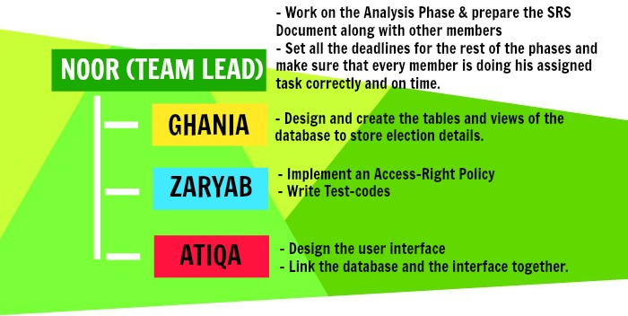

Our Requirement engineering process involved scenarios, ethnography and interviewing the stakeholders of the electoral system to find out about the application domain, the services that the system should provide and the system’s operational constraints. The developers of the system have themselves voted in their respective constituencies in Elections 2013 and through ethnography, they have already gathered the requirement abstraction of the system.
Once the process of Requirement gathering was complete, the team prepared the SRS document specifying the functional and non-functional requirements and the System Constraints in more details. Atiqa Zafar compiled the Section 2 of the document, Ghania Riaz penned down the functional requirements and prepared section 3 and Zaryab Khan prepared Section 4. Noor Zehra prepared Section 1 and compiled each of their works into the final SRS document. Each of the members proofread the final document.

