

Use Case View
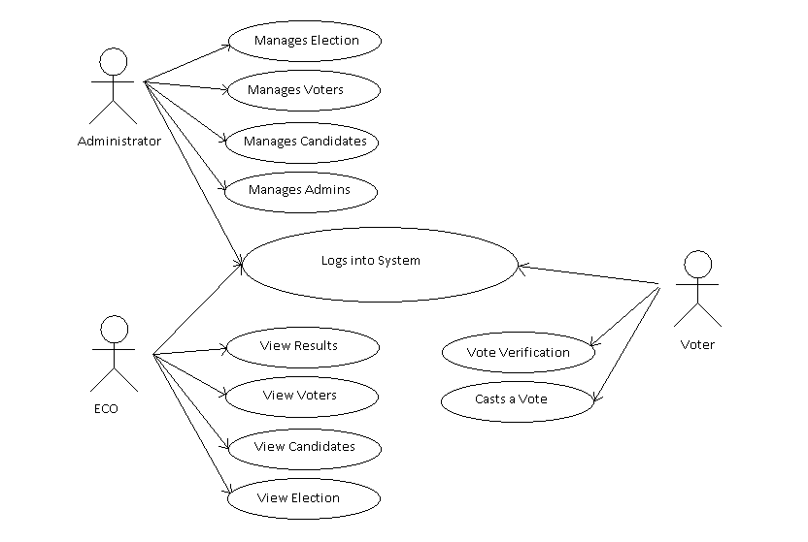
The following use case diagram encapsulates the entire system and all possible actors. Each of these use cases have been defined further.

User Login
Logging in to the Vote Dou software shall require user identity authentication. The system should be password protected with utmost care being taken by the ECO, ensuring that the passwords are provided only to the required individuals. As an improvement to the user identity authentication process, Fingerprint of the users can be scanned to log in to the system. The scanned finger prints is matched against the finger print of the specific individual stored in the NADRA database. A scanning device is needed to acquire the finger print and will be connected to the voting terminal that runs Vote Dou.

Pre-voting phase
In the pre-voting phase the database administrator (DBA) creates a new election and enters the information of the constituencies, election candidates and eligible voters using the information provided by the Election Commission of Pakistan. This phase constitutes of a number of functionalities as shown in the use case below:
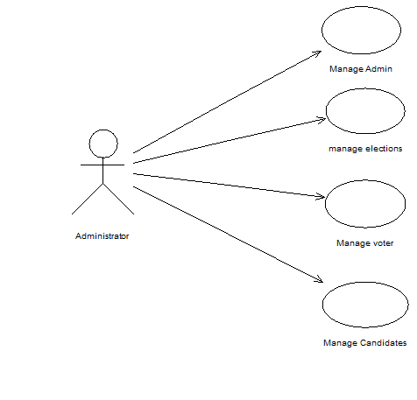

- The Manage Administrator Module – deals with inserting and editing users of the system. There are three types of user of the Vote Dou system, namely the Administrator, the Election commission Officer and the Voter. Information about these users (such as the User_ID, First Name, Last Name, Address, NIC Number & Contact Number) is stored in the main database. The DBA is given the privilege to add new users and assign specific privileges to the users, edit the existing users and view the users based on different filters, that is, He can filter/sort/search the users by a specific name or role or user_ID .

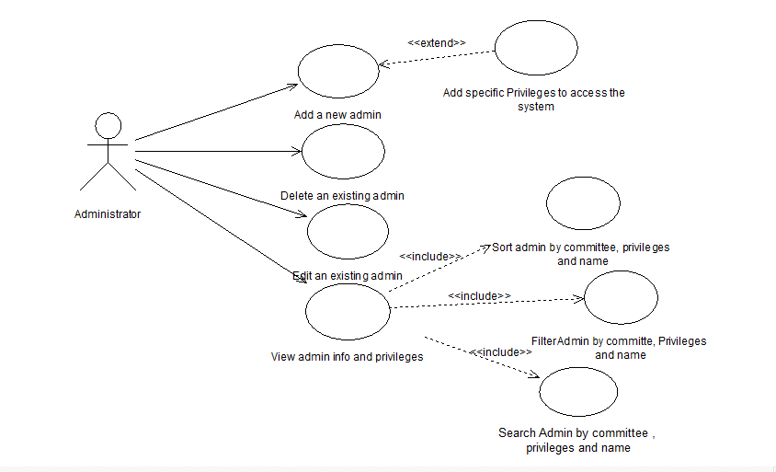

Pre-condition:
Administrator login to the system,
Administrator data already recorded.
Actor: Administrator

- The Manage Elections Module- manages information about the Election Session. Every Election Session has an Identification ID and year. The Administrator can create a new session or modify an existing one. Once the elections have taken place and the results have been computed, he can also view the winning candidates, the winning parties or the result of each constituency based on a certain Election_ID.
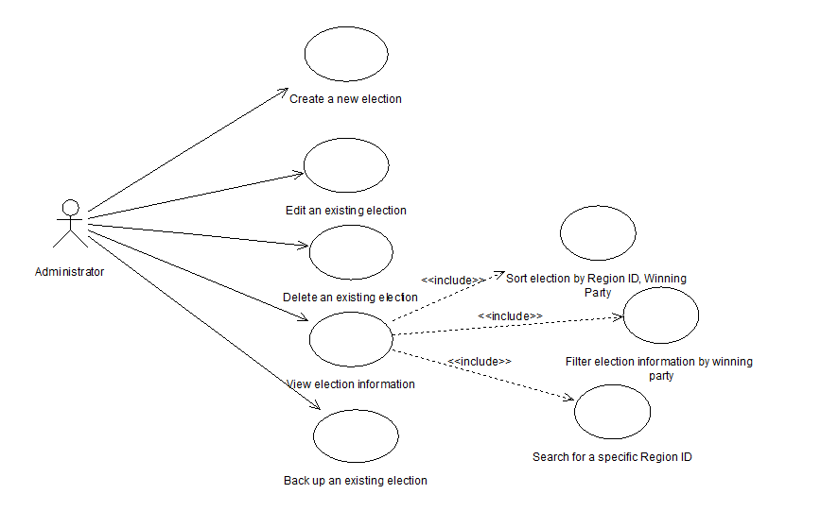
Pre-condition:
Administrator login to the system,
Election data already recorded.
Actor: Administrator

- The Manage Voter Module-deals with the insertion and modification of Voter information. Every voter is a registered adult citizen of the country. His NIC number, name, Date of Birth, Father name, Address, NA constituency ID, PA constituency ID, Election_ID, NA Vote and PA Vote is stored in the database. The administrator can add, edit and delete a voter. Both the administrator and the ECO can view the voter list or search for a specific voter using any of his attributes.

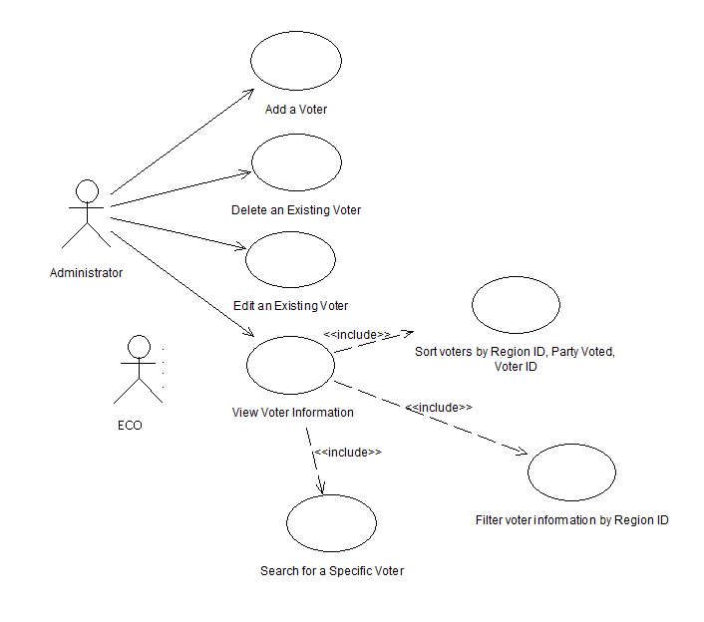

Pre-condition:
System Login,
Voter data already recorded.
Actor: Administrator, Election Commission Officer

- The Manage Candidate Module -deals with the insertion and modification of Candidate information. Every Candidate ‘s Candidate ID, Constituency ID, NIC number, name, Party ID, Number of Votes and session ID is stored in the database. The administrator can add, edit and delete a Candidate. Both the administrator and the ECO can view the Candidate list or search for a specific Candidate using any of his attributes.
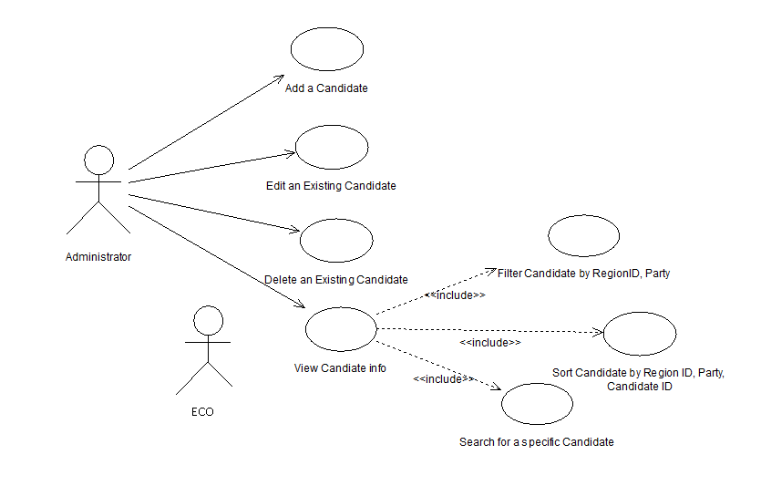

Pre-condition:
Successful log into the system,
Candidate data already recorded.
Actor: Administrator, ECO

Voting & Post-Voting phase
In the voting phase, the database administrator starts the time for voting. Voters come to the polling booth to cast their votes into the system containing our software in a secure region. Eventually, the database administrator ends the time for casting a vote. The ECO/Administrator then compute the final results. This phase constitutes of a number of functionalities as shown in the use case below:
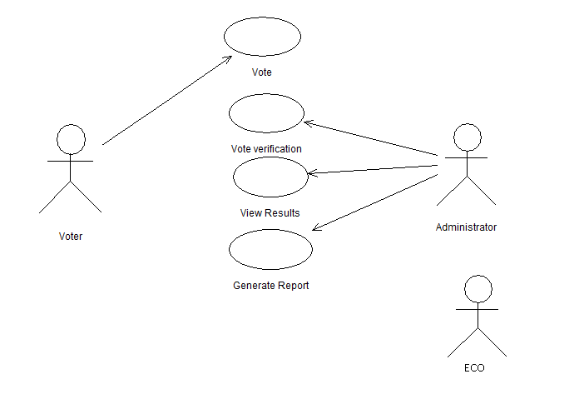

- Submit a Vote Module- comprises of three other use cases, namely System Login, Voter verification and Vote Cast. When a voter enters his username (NIC number), his identity is verified through a password provided by the ECO or through scanning his finger print. The entered information is matched against the stored data and the access is granted to the voter. The voter interface lists down the candidate list of his particular constituency and asks him to submit a vote. The voter casts a vote and logs out. The casted vote is stored against the voter ID in the database and cannot be re-casted.

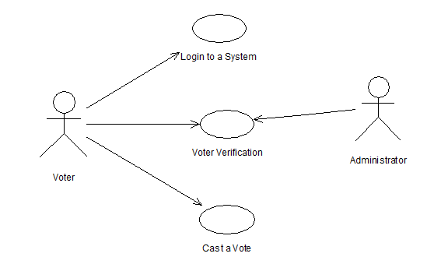

Pre-condition: Voter is registered before in the system
Actor: Administrator, Voter

- Result Management Module-manages the result. In Vote Dou 1.0, the constituency based result is automatically computed after a specific time interval using triggering. Both the administrator & the ECO can view the triggered results or generate a report by filtering the information according to constituencies or parties.

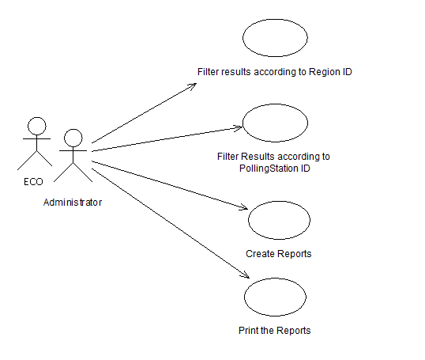

Pre-condition:
Successful login to the system,
Election data already recorded.
Actor: Administrator, ECO

