**UI Overview**

This document provides a comprehensive overview of the user interface (UI) for the Hotel Reservation Web Application. The application is designed to offer users a seamless experience in searching, booking, and managing hotel reservations. The interface is intuitive, user-friendly, and organized into clearly defined sections and components.

**Main Pages and Components**

1. **Landing Page**

* The landing page serves as the entry point for users to start their hotel search journey. It consists of two primary sections.

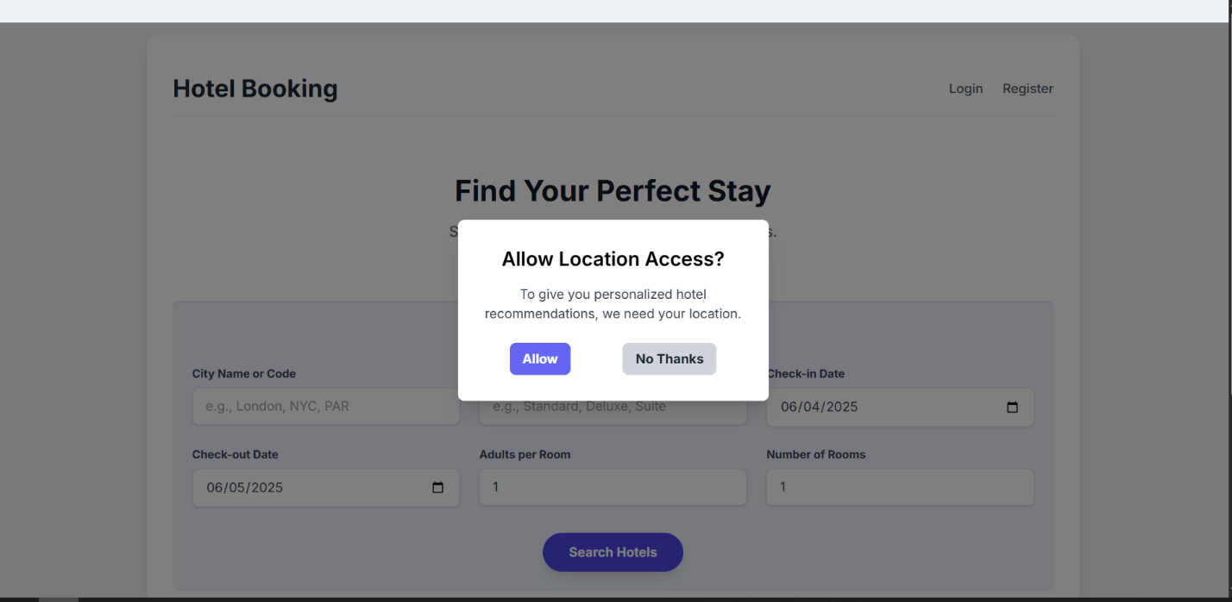

***Figure 1-1:*** *Popup for granting permission from the user to access the location*

* 1. **Search for Reservation (Figure 1-2)**
     + **Header Section:** Contains the "Hotel Booking" title on the left and "Login" and "Register" links on the right.
     + **Main Heading:** "Find Your Perfect Stay" prominently displayed.
     + **Subheading:** "Search for hotels and rooms that fit your needs."
     + Search **Form:** A clean, well-organized form with the following fields:
       - City Name or Code (input field with placeholder)
       - Room Type (Optional) (input field with placeholder)
       - Check-in Date (date picker with calendar icon)
       - Check-out Date (date picker with calendar icon)
       - Adults per Room (number input)
       - Number of Rooms (number input)
       - "Search Hotels" button (prominent purple button)

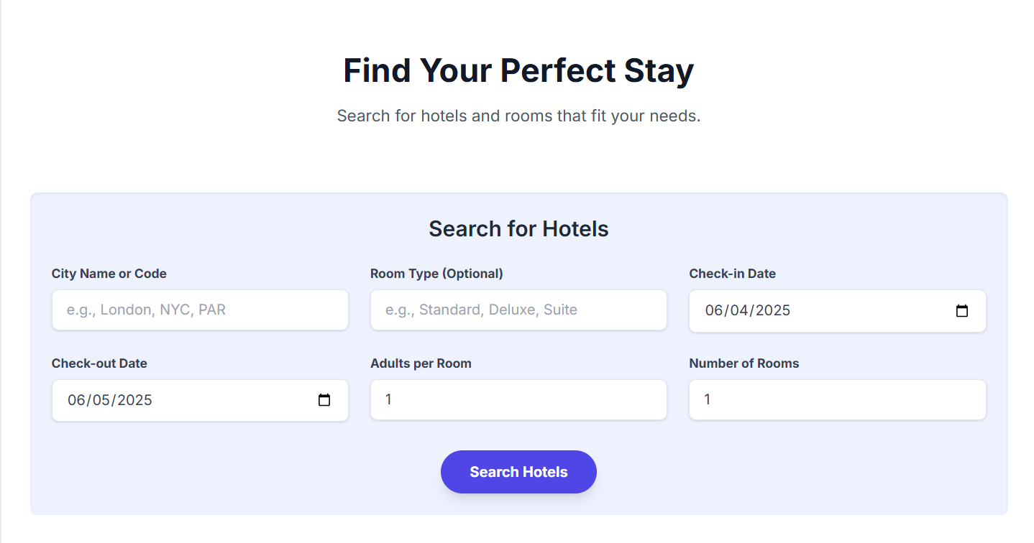

***Figure 1-2:*** *Home Page (Index) which contains the Search Hotel section as shown.*

* 1. **Recommendation System (*Figure 1-3*)**
     + **Heading:** "Recommended Hotels for You"
     + **Content Section:** Displays personalized hotel recommendations (powered by AI and the usage of Location “***Figure 1-1***”). Initially shows a message: "No recommendations found at this time. Please use the search bar."

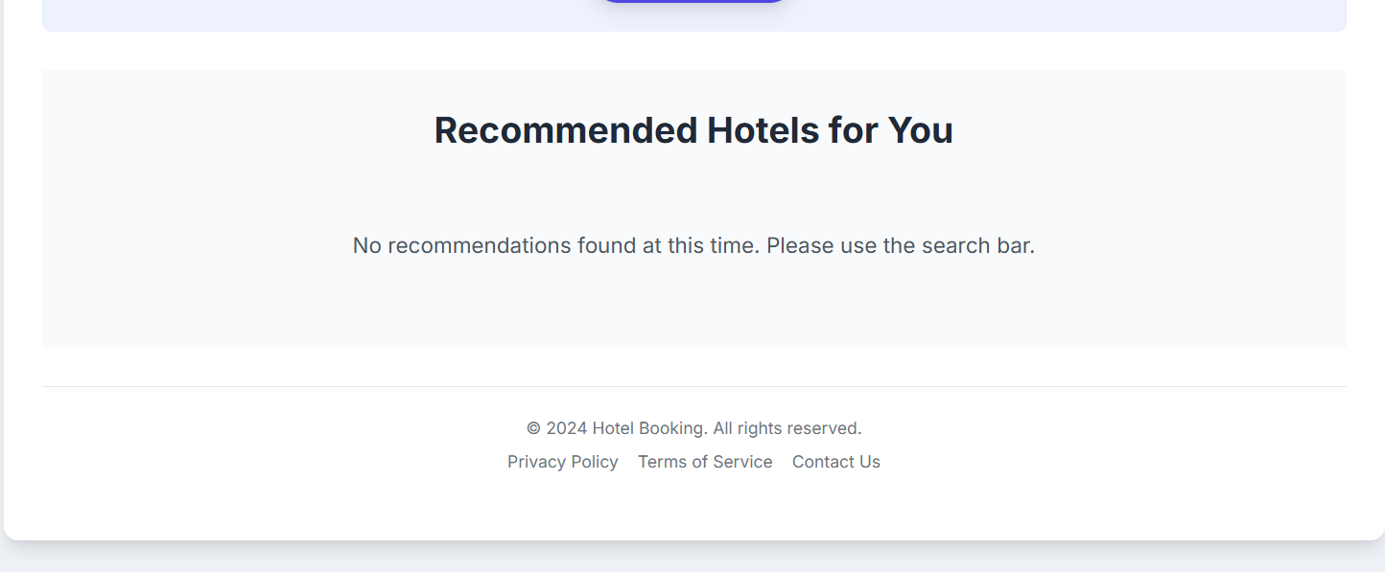

***Figure 1-3:*** *Recommendation That works when enabling Location or after searching*

1. **Search Results Page**

* After performing a search, users are presented with available hotel rooms matching their criteria (*Figure 2-1*).

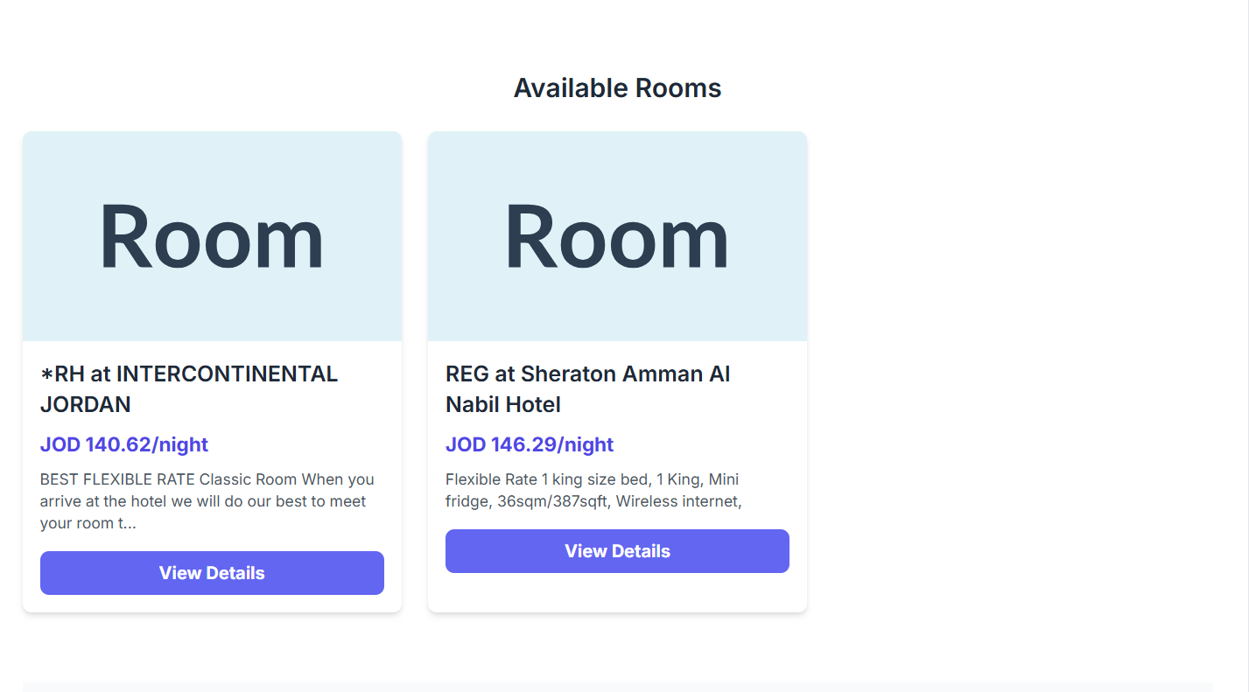

***Figure 2-1:*** *Searching results in the Home Page, after a successful search*

* Heading: "Available Rooms"
* Room Cards: Each card displays:
  + Room Cards: Each card displays:
  + Hotel name and location
  + Price per night (in JOD)
  + Room description and amenities
  + "View Details" button

1. **Reservation Details Page**

* After selecting "View Details" from the search results, users access a dedicated page with key reservation information (*Figure 3-1, 6, 7*)

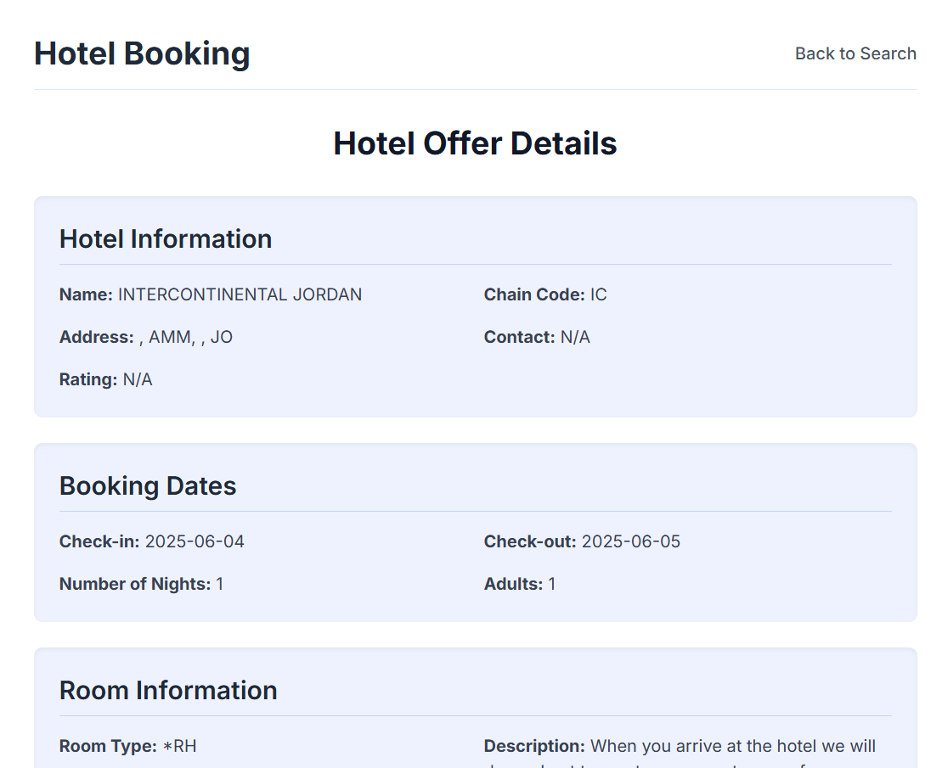

***Figure 3-1:*** *Booking View Page Details of the obtained offer*

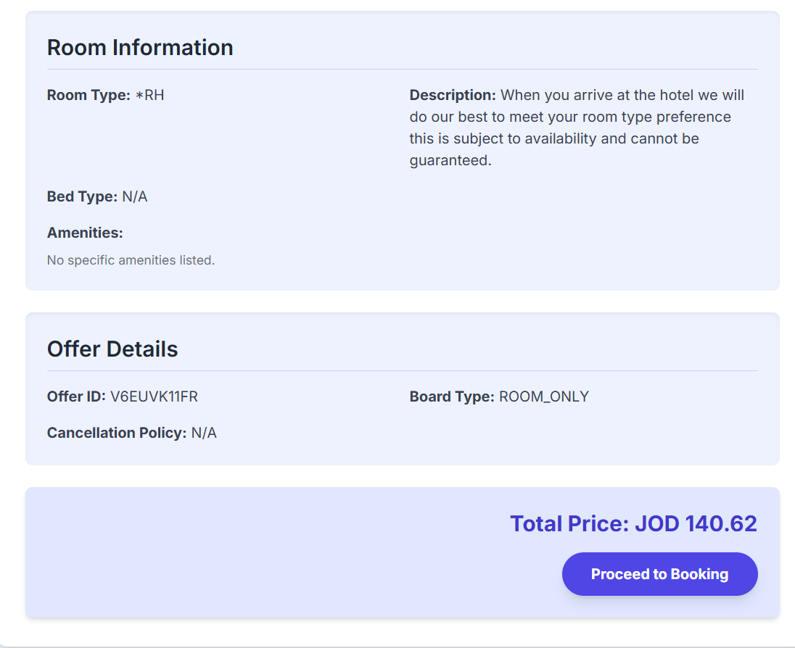

***Figure 3-2:*** *Pricing and Button to procced Booking in the details page*

* **Hotel Information:** Displays the hotel's name, address, and contact details.
* **Booking Dates:** Shows check-in and check-out dates, along with the number of nights and guests.
* **Room Details:** Includes room type, description, and available amenities.
* **Pricing:** the total price with a clear call-to-action button to "Proceed to Booking".

This page consolidates all necessary details in an organized format, enabling users to review their selection before committing to the booking process.

1. **Authentication Flow**

Before completing the booking, users must authenticate:

* **Guest Checkout (*Figure 4-1)*:** Users may proceed without an account by providing essential contact information.
* **Login Option (*Figure 4-2)*:** Users can enter their email and password to log in.
* **Register Option (*Figure 4-3)*:** New users can create account with personal details.

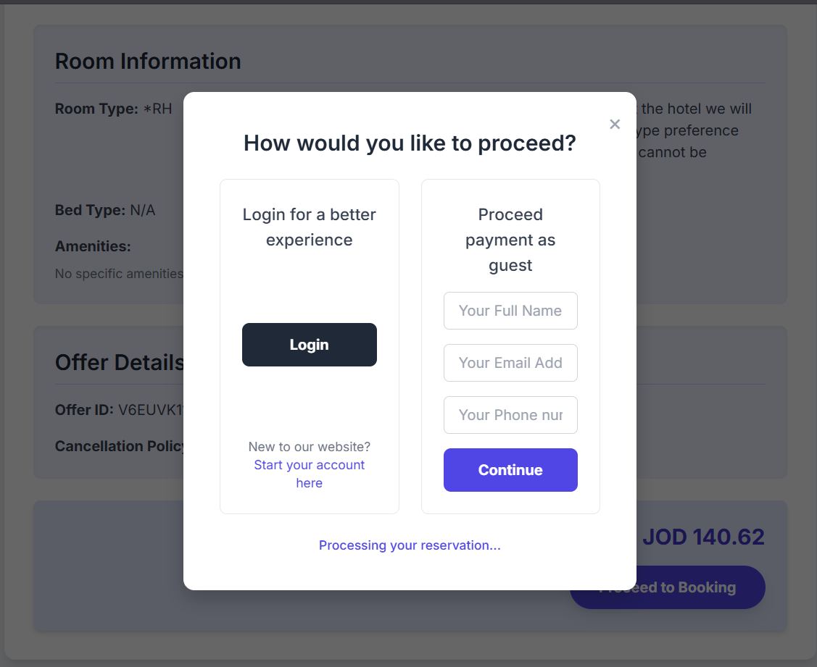

***Figure 4-1:*** *Popup Shows two options for the user either continue as guest or login.*

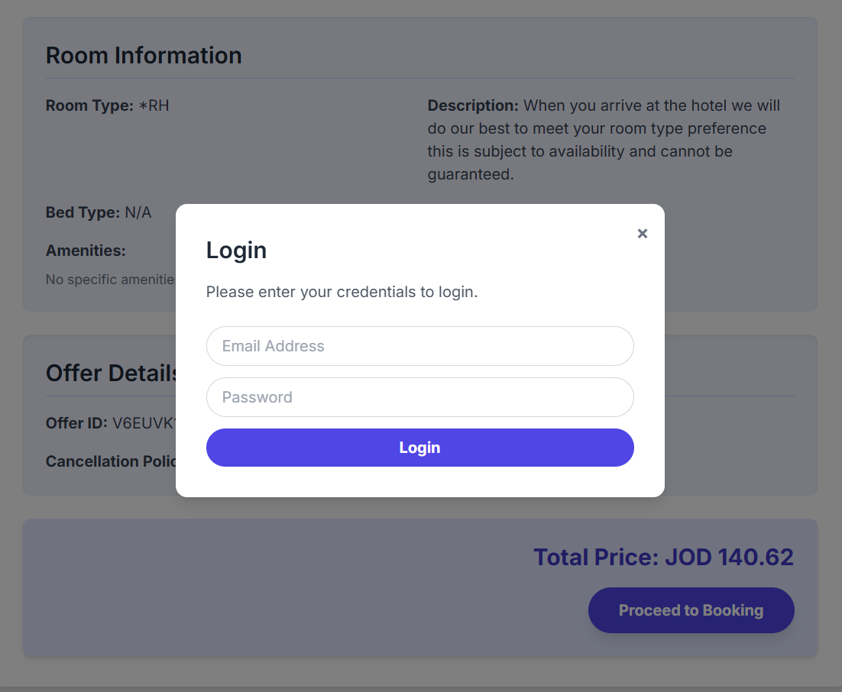

***Figure 4-2:*** *Login Popup that showed after the user choice.*

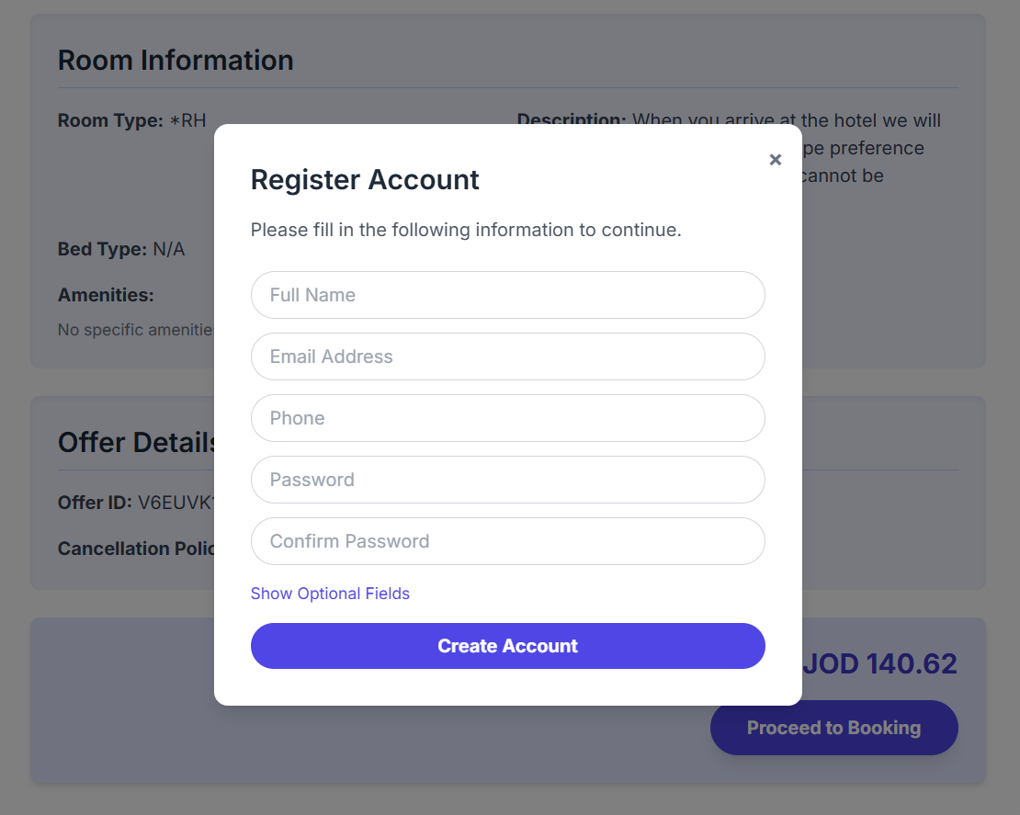

***Figure 4-3:*** *Register Popup that showed after the user choice.*

1. **Payment Page**

On the payment page, users:

* Enter Payment Details (*Figure 5-1)*: Including card information, expiration date, and security code.
* Review Trip Summary (*Figure 5-2)*: Confirms booking dates, guests, and total cost.
* Complete Booking (*Figure 5-2)*: Click "Confirm & pay" to finalize the reservation.

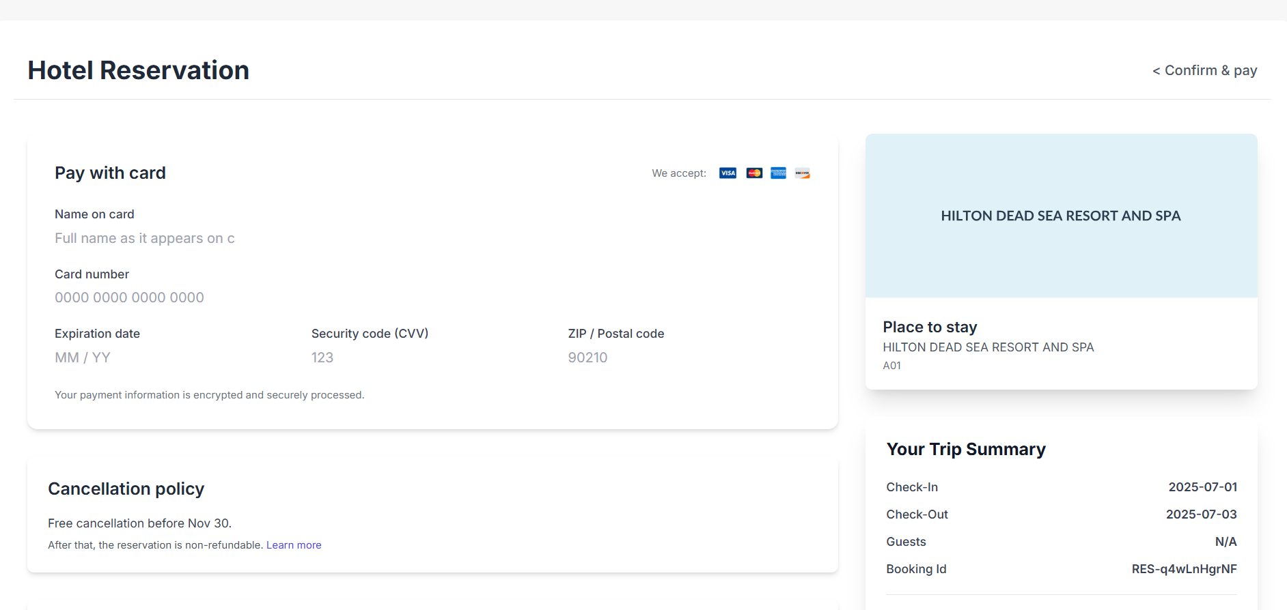

***Figure 5-1:*** *Payment Method Inputs in the Payment Page.*

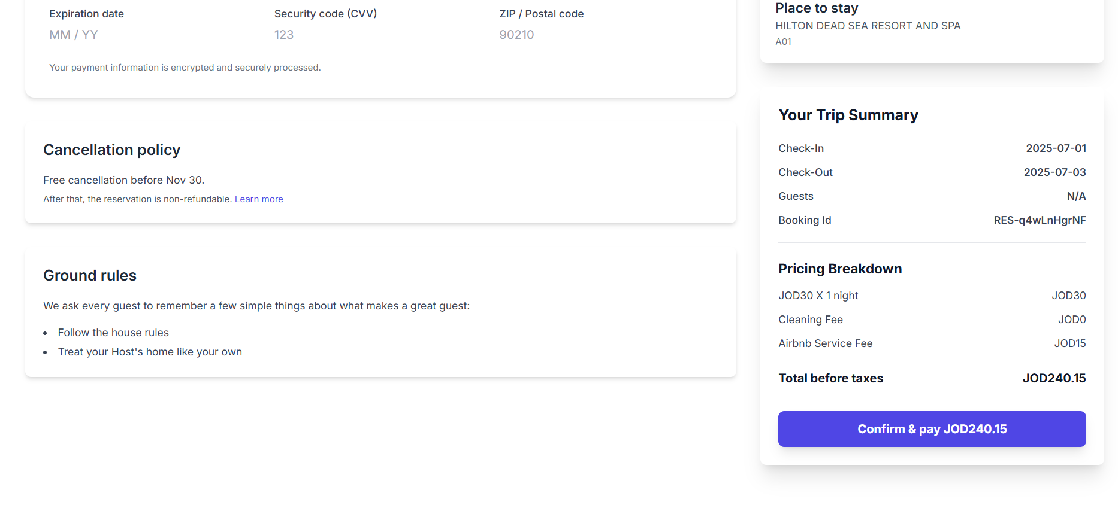

***Figure 5-2:*** *Payment Button and More Info of the offer being booked.*

These steps ensure a secure and straightforward payment process, allowing users to complete their booking with confidence.

1. **Confirmation and Dashboard**

After completing the payment, users receive confirmation and access to their dashboard:

* **Payment Confirmation (*Figure 6-1)*:** A pop-up confirms successful payment and provides a link to view reservation details.
* **Successful Payment Page (*Figure 6-2)*:** Displays a success message and offers a button to view bookings.
* **User Dashboard *(Figure 6-3)*:** For logged-in users, it includes:
  + **Navigation Panel:** To access different sections like profile, viewed offers, and running bookings.
  + **Profile Section:** To update personal information.
  + **Recent Offers (*Figure 6-4)*:** Shows recently viewed hotel offers.
  + **Running Bookings (*Figure 6-4*):** Displays current bookings with their status.

This setup ensures users can easily manage their reservations and personal details.

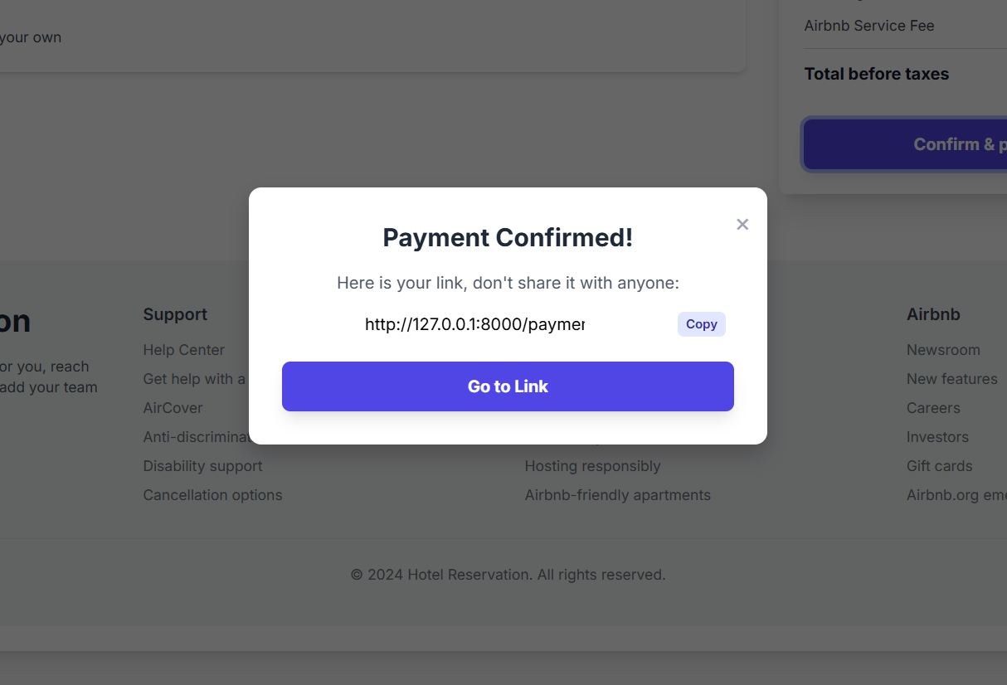

***Figure 6-2:*** *Popup to inform the user at the Payment Page after successful payment process .*

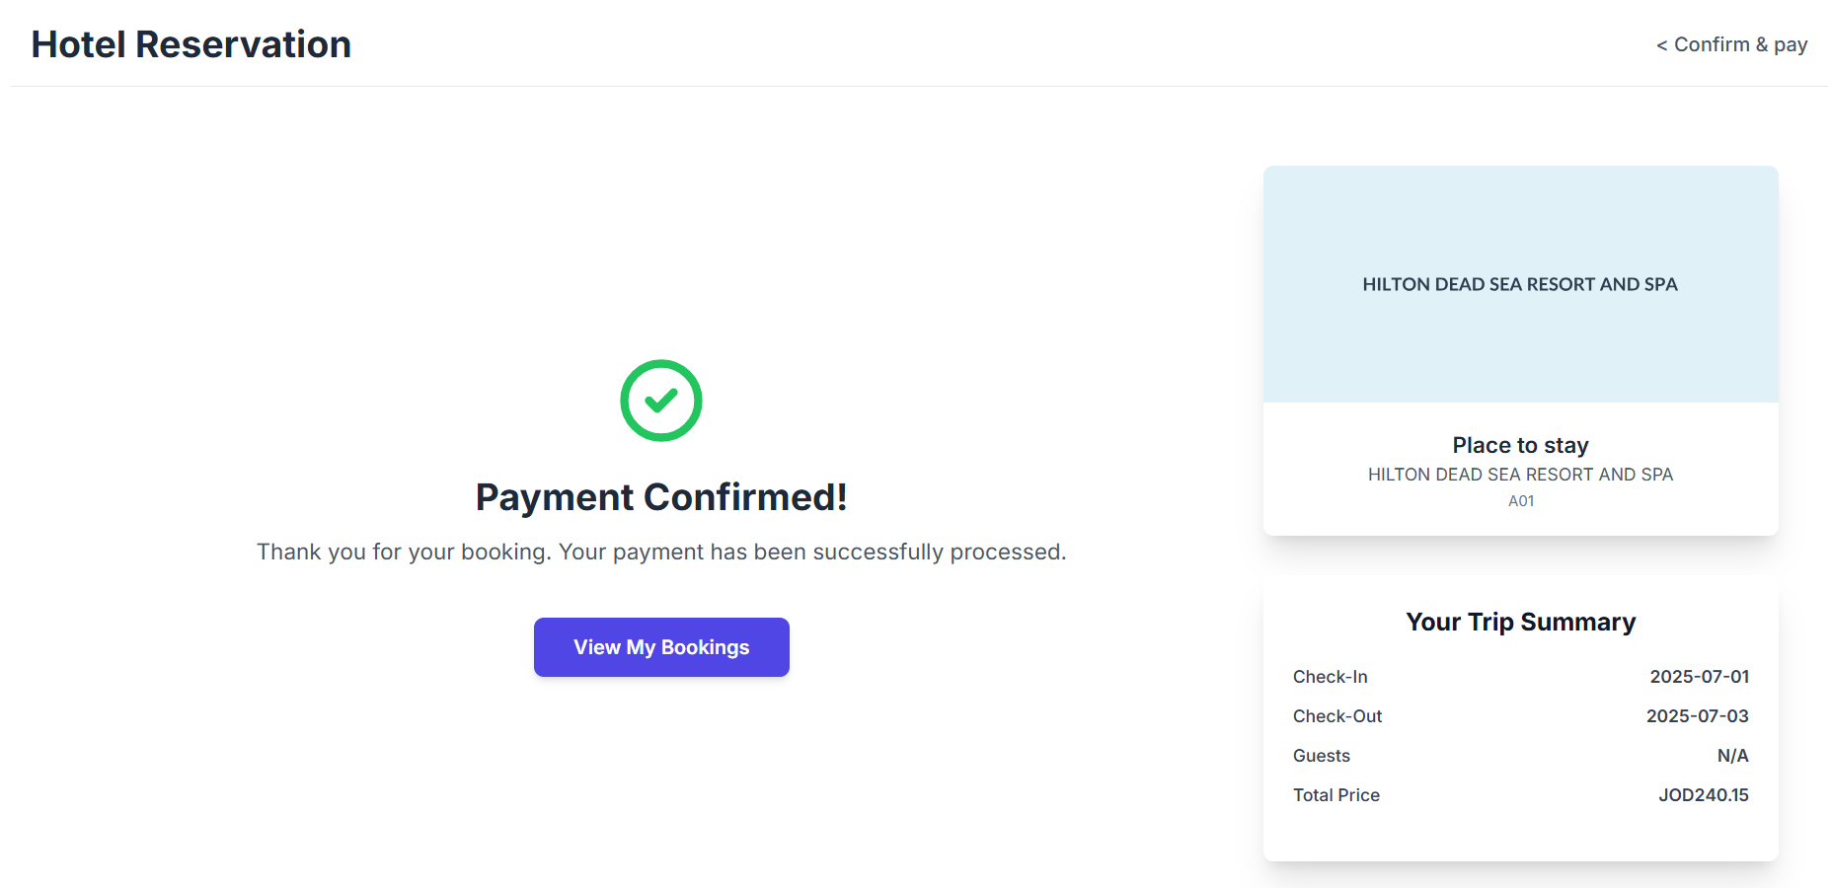

***Figure 6-3:*** *Confirmation Payment Page can be accessed via the link that has special Token .*

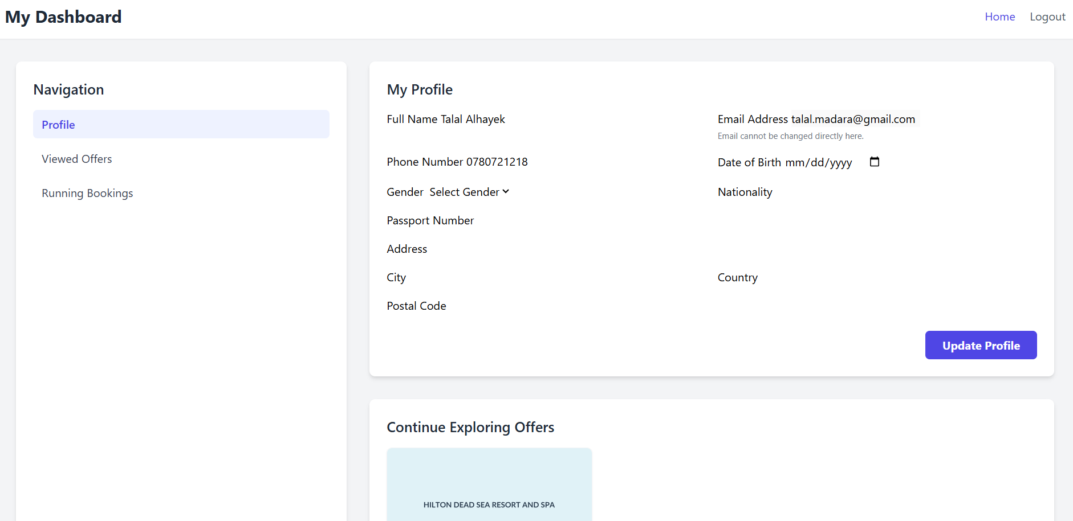

***Figure 6-4:*** *First Part of the User Dashboard that included Profile Settings.*

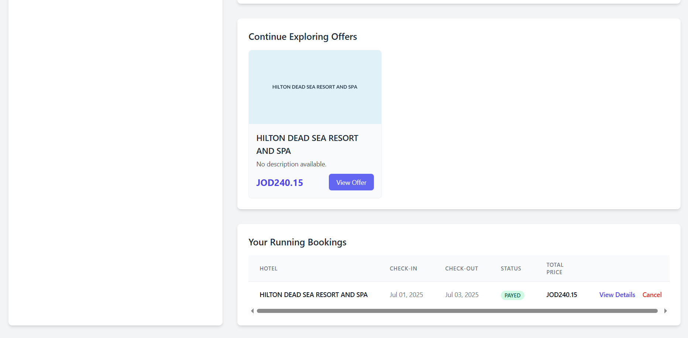

***Figure 6-5:*** *Second Part of the User Dashboard that included Running Bookings along with their own status and Continuing Exploring Offers.*