KIIT SAP CENTRE OF EXCELLENCE — CAPSTONE PROJECT REPORT
Procure-to-Pay (P2P) Cycle | SAP MM | Yash Manufacturing Pvt Ltd | April 2026
Field | Details
Student Name | Yash Pandey
Roll Number | 23053367
Course / Batch | SAP ABAP developer
SAP Module | SAP MM — Materials Management

1. Problem Statement
Before SAP, Yash Manufacturing Pvt Ltd (electronics manufacturer, Pune — INR 250 Cr turnover, 1,200+ employees) relied on manual, paper-based procurement causing serious failures:
- No centralized data — stock levels and pending orders invisible in real time.
- Communication gaps — purchase requests lost/duplicated, causing production halts.
- Invoice errors — without 3-way matching, duplicate or incorrect payments were common.
- Slow approvals — a single purchase could wait 5–7 days for manual sign-off.
These challenges led Yash Manufacturing to implement SAP MM to streamline the entire Procure-to-Pay cycle.

2. Objective
Map the complete P2P cycle in SAP MM step by step; configure organizational structures (Company Code YM01, Plant PL01, Purchasing Org PO01); demonstrate each transaction with document outputs; present a real-life business scenario; and build a custom ABAP dashboard (YASH_P2P_DASHBOARD, T-Code: ZP2P_DASH) for live P2P monitoring.

3. Solution & Key Features

3.1 SAP MM P2P Implementation — 7 Steps
Step | Process | T-Code | Document Generated
1 | Vendor Master Creation | XK01 | Vendor ID — V-1001 (Electronica Components Ltd, GSTIN, 30-day payment terms)
2 | Material Master Creation | MM01 | Material RM-CW-001 — Copper Wire 2.5mm | ROH | INR 450/KG | Plant YM01
3 | Purchase Requisition | ME51N | PR-2024-00123 — 500 KG, delivery in 10 days; digital approval >INR 50K
4 | Purchase Order | ME21N | PO-4500001234 — 500 KG × INR 460 + GST 18% = INR 2,71,400; emailed to vendor
5 | Goods Receipt | MIGO | Mat.Doc 5000012345 — stock 50→550 KG; Dr. Inventory / Cr. GR/IR INR 2,30,000
6 | Invoice Verification | MIRO | 3-way match passed; Dr. GR/IR + Input GST / Cr. Vendor INR 2,71,400
7 | Vendor Payment | F110 | NEFT INR 2,71,400; Dr. Vendor / Cr. Bank — vendor account fully cleared

3.2 ABAP Program: YASH_P2P_DASHBOARD (T-Code: ZP2P_DASH)
Custom ABAP report reading live data from EKKO, EKPO, EKET, MSEG, RBKP, RSEG via INNER JOIN. Selection screen with obligatory Company Code and optional Plant/Date filters. Auto-classifies each PO line as 'PO Open — GR Pending', 'Partial GR', 'GR Complete', or 'Invoice Posted'. ALV Grid output with 14 columns, traffic-light icons, zebra striping, sort/filter/Excel export toolbar.
4. Screenshots
The screenshots below illustrate the complete execution flow of the custom ABAP program: selection screen → source code → ALV output → P2P process flow diagram.

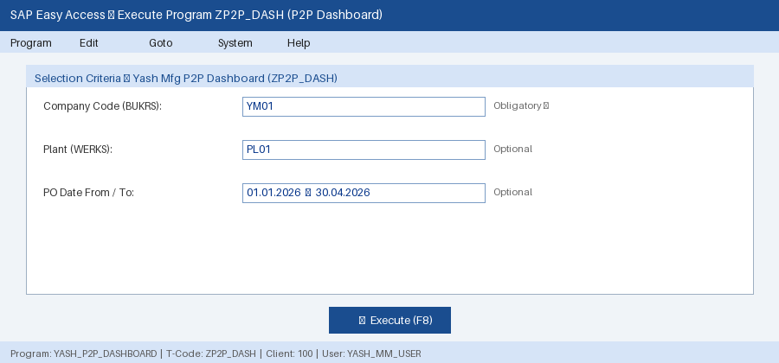
Figure 1: Selection Screen — ZP2P_DASH (Company Code obligatory; Plant and Date range optional)

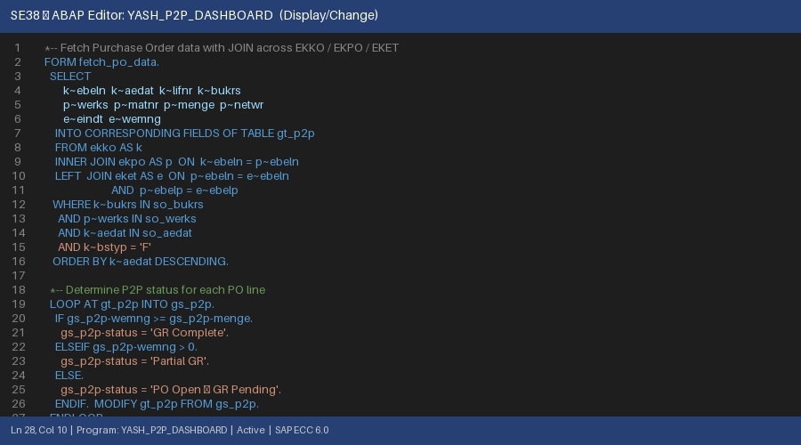
Figure 2: SE38 ABAP Editor — Open SQL SELECT with INNER JOIN across EKKO / EKPO / EKET
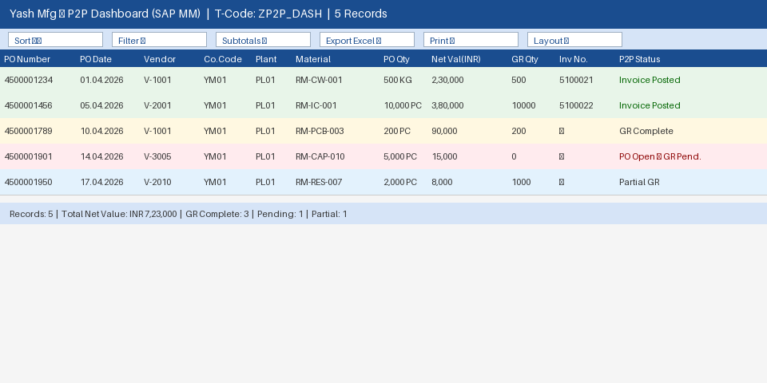
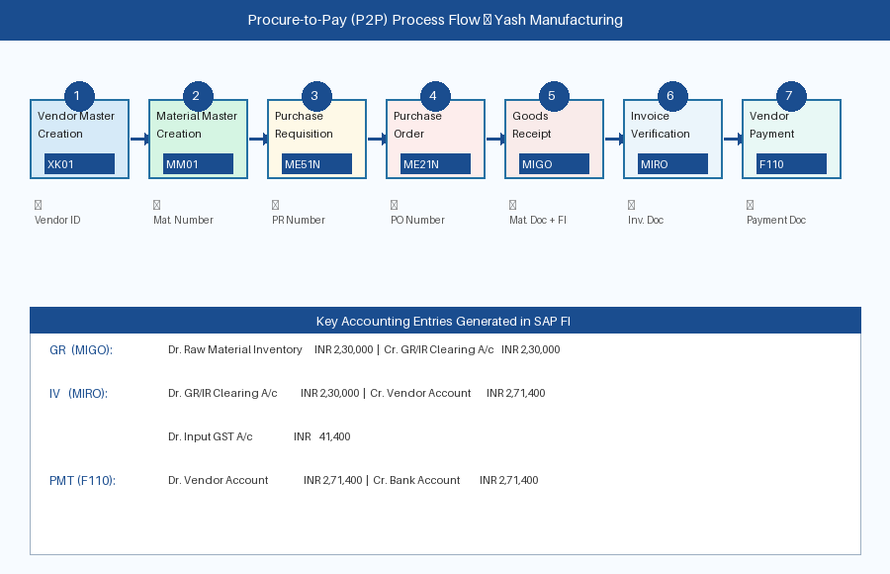
Figure 4: P2P Process Flow — All 7 Steps with T-Codes and SAP FI Accounting Entries

5. Technology Stack
Component | Details
ABAP | Core language; SE38 / ABAP Workbench; SAP ECC 6.0 & S/4HANA compatible
Open SQL / JOIN | INNER + LEFT JOIN across EKKO, EKPO, EKET, MSEG, RBKP, RSEG — single DB call
ALV Grid | REUSE_ALV_GRID_DISPLAY (slis) — zebra layout, column optimisation, Excel export
SAP MM Tables | MARA, MAKT, MARC, MARD — used in supplementary ZMM_MATERIAL_INVENTORY_REPORT
SELECTION-SCREEN | SELECT-OPTIONS with OBLIGATORY (Company Code); optional Plant and Date range
Platform | SAP ECC 6.0 — forward-compatible with SAP S/4HANA

6. Unique Technical Highlights
- Single JOIN Query: All 6 SAP tables joined in one SELECT — eliminates multiple DB round-trips, HANA-optimised.
- Auto P2P Status Logic: Each PO line auto-classified into 4 statuses comparing WEMNG vs MENGE; upgraded to 'Invoice Posted' on RBKP match.
- DEFINE Macro Field Catalog: add_col macro fills all 14 ALV columns compactly — clean, maintainable ABAP pattern.
- Language-Safe Description Join: MAKT joined with SY-LANGU in ON clause — language filtering at DB level, supports multilingual SAP.
- Supplementary OO ALV (ZMM_MATERIAL_INVENTORY_REPORT): Uses modern CL_SALV_TABLE class — SAP-recommended for new S/4HANA development.

7. Advantages of SAP P2P at Yash Manufacturing
Advantage | Impact
Efficiency | PR-to-PO reduced from 5–7 days to under 24 hrs; MRP auto-generates PRs
Accuracy | Invoice discrepancy: 12% → below 1% via 3-way matching; GST auto-calculated
Automation | F110 batch payment replaces 3 full-time AP clerks doing manual processing
Real-Time Visibility | Live dashboards — open POs, pending GRs, stock levels, overdue payments
Audit & Compliance | Full PR→Payment trail with timestamps; GST audit prep: weeks → days

8. Challenges & Limitations
- Implementation Complexity: 8-month rollout — blueprint, config, testing, data migration, training, parallel-run.
- High Cost: SAP licenses, hardware, implementation partner fees, and AMC run into several crores.
- User Adoption: Factory staff required role-specific training and 3-month post-go-live hypercare.
- Data Quality: Wrong valuation classes on 15 materials during migration caused incorrect G/L postings.
9. Real-Life Business Scenario
Yash Manufacturing receives a client order for 200 Industrial Control Panels. MRP identifies a shortfall of 10,000 ATmega328P Microcontrollers (RM-IC-001) against zero stock:

P2P Step | Action | SAP Accounting Entry
PR (ME51N) | MRP auto-creates PR-2024-00456 for 10,000 pcs, Plant PL01, 15-day lead time | Auto-approved (<INR 5L)
PO (ME21N) | Chip World India V-2001: INR 38/pc × 10,000 + GST 18% = INR 4,48,400 | PO-4500001456 emailed
GR (MIGO) | Day 7: 10,000 ICs received and accepted at warehouse | Dr. Inventory 3,80,000 | Cr. GR/IR 3,80,000
IV (MIRO) | Invoice INR 4,48,400 entered — 3-way match passes | Dr. GR/IR + Input GST | Cr. Vendor 4,48,400
PMT (F110) | Day 30: NEFT payment via automatic payment run | Dr. Vendor | Cr. Bank 4,48,400 — Cleared

10. Conclusion
This project demonstrates how SAP MM transforms procurement at Yash Manufacturing from a reactive, paper-based function into a strategic, automated, and fully auditable P2P process. The custom ABAP program YASH_P2P_DASHBOARD (T-Code: ZP2P_DASH) provides management a single-screen, real-time view of all seven P2P steps — from open Purchase Orders to paid invoices — drawing live data from six SAP tables with zero manual aggregation.

11. Future Scope
- SAP S/4HANA Migration — Move from ECC 6.0 to S/4HANA within 3 years for embedded analytics and Fiori mobile approvals.
- SAP Ariba Integration — Supplier self-service portal for e-invoicing, PO visibility, and payment tracking.
- AI-Powered Procurement — Intelligent vendor suggestion, predictive delivery timelines, AI invoice anomaly detection.
- GST e-Invoicing (IRP) — Auto-generate IRN numbers via SAP-IRP integration for 100% GST compliance.
— End of Report | Procure-to-Pay (P2P) in SAP MM | Yash Manufacturing Pvt Ltd | April 2026 —

