hey i am a computer science student of 3rd year, and something i want to know about in the cyber security as it is my domain and i want to learn it properly i was learning abouth the SSL certificates , http and https
i know that in the http the data we send is not encrypted so in the internet it travels in the readable form and if the breach happens in between then it can be read and data theft can happen, in the https it is encrypted so it does not become a problem
i want to know that how the network in which the data is flowing can be breached like what are the things and methodology does attacker uses to attack the network in between as like data is not flowing all the time n that an attacker attacks any time and he gets the data, attacker needs to have any thing so that when data travels it gets caught in between
how this all happens and what types of attacks can happen like data also travels through the wifi router so if someone hacks the wifi and data transfer is happening via http then data can be compromised?
this is all for the studying purpose and not any wrong intentions so please explain properly
Show more
10:38 pm
Great topic for a CS student! Let me give you a thorough breakdown of how network attacks work in practice — both conceptually and technically.
The core idea behind attacking "data in transit" is that an attacker needs to position themselves somewhere along the path the data travels. This is broadly called a Man-in-the-Middle (MitM) attack. Let's visualize the full landscape:

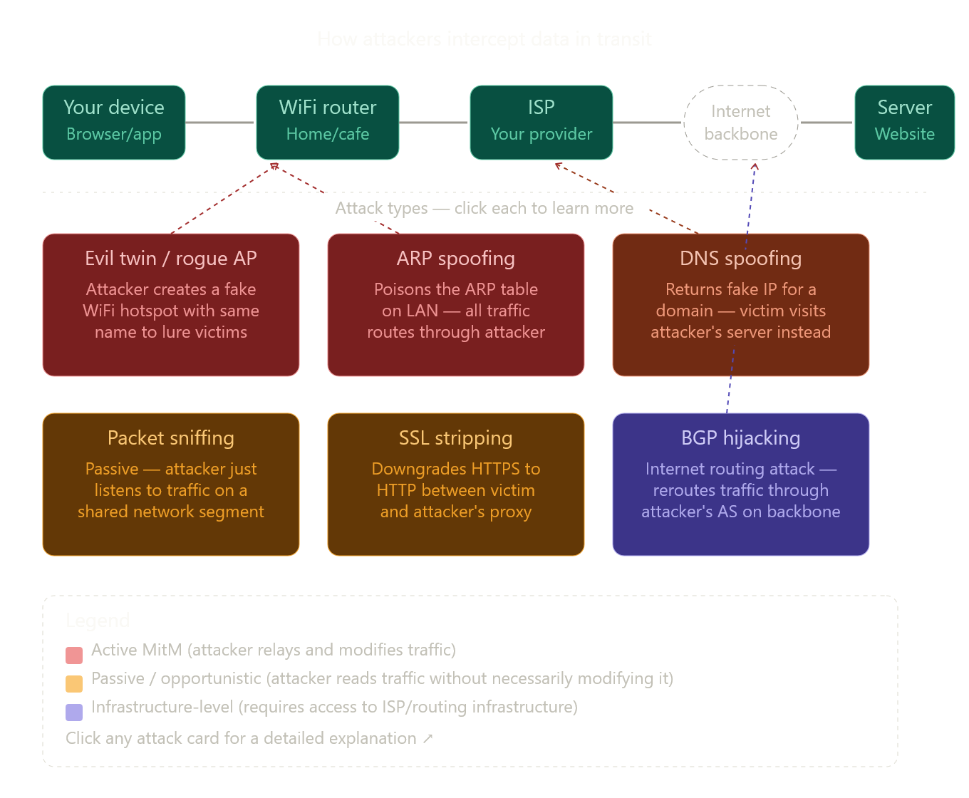
Now let me walk you through each attack type properly.

1. The core problem — why does the attacker need to "be in the path"?
Data doesn't travel in a single wire from your laptop to Google. It hops through many devices: your WiFi router → your ISP's routers → internet exchange points → the destination server. An attacker has to position themselves on one of these hops. There are two ways to do that:
Passive positioning — the attacker can already see the traffic (e.g., they're on the same WiFi network as you and WiFi is a broadcast medium).
Active positioning — the attacker tricks your device or the network into sending traffic through the attacker's machine instead of the legitimate next hop.

2. Attack types explained
ARP Spoofing — the classic LAN attack
ARP (Address Resolution Protocol) is how your device finds the MAC address of the router. Your laptop asks "who has IP 192.168.1.1?" and the router replies "that's me, MAC address AA:BB:CC...". ARP has no authentication — anyone on the same LAN can reply.
An attacker runs a tool (like arpspoof or ettercap) that continuously sends fake ARP replies to your laptop saying "the router's IP? That's me!" and sends fake replies to the router saying "your client's IP? That's me too!" Now all traffic flows through the attacker's machine, which just forwards it along — completely invisible to you. This is the most common attack on local networks.
Evil Twin / Rogue Access Point
Your phone and laptop try to auto-connect to known WiFi names. An attacker sets up a hotspot with the same SSID as a cafe's WiFi ("CafeWifi") and broadcasts a stronger signal. Your device connects to the attacker's hotspot instead. Now every packet you send goes through the attacker's device before reaching the internet. Tools like hostapd and airbase-ng are used for this.
Packet Sniffing
This is purely passive. On an unencrypted WiFi network, all packets are broadcast over radio waves — anyone nearby with a WiFi card in monitor mode (using tools like Wireshark or tcpdump) can capture every packet. If you're visiting an HTTP site at a cafe, someone at the next table could literally read your login form submission as plain text. No active attack needed.
SSL Stripping
This is clever. When you type example.com in your browser, your first request is actually HTTP (not HTTPS). Only after the server redirects you does HTTPS kick in. A MitM attacker (who already positioned themselves via ARP spoofing, for example) intercepts that first HTTP request, maintains an HTTPS connection to the real server themselves, but serves you HTTP. You see the site normally but your traffic is unencrypted to the attacker. The tool sslstrip automates this. The defense is HSTS (HTTP Strict Transport Security), which tells browsers to always use HTTPS for a domain.
DNS Spoofing
DNS translates google.com → 142.250.x.x. If an attacker can intercept or poison the DNS response, they can make google.com resolve to their own server's IP. Your browser then connects to the attacker's fake server thinking it's Google. This is why HTTPS is critical — even if DNS is spoofed, the attacker can't produce a valid SSL certificate for google.com (assuming you check certificate warnings).
BGP Hijacking
This is an infrastructure-level attack. BGP (Border Gateway Protocol) is how entire networks announce which IP ranges they "own" on the internet. If an attacker controls an ISP or can inject fake BGP announcements, they can redirect huge chunks of internet traffic through their network. This has happened in the real world (e.g., traffic briefly rerouting through China Telecom). Mostly relevant for nation-state actors.

3. Your WiFi scenario — answered directly
Yes, your instinct is correct. If someone compromises the WiFi router (by knowing the admin password, exploiting a vulnerability, or setting up a rogue AP), and you're visiting HTTP sites, they can read everything. The attacker doesn't need to "wait" — they just capture all traffic in real time. They could use a tool like Wireshark on the router or their own device to see every HTTP request and response, including cookies, form data, and session tokens.

4. Why HTTPS stops most of this (but not all)
Even if an attacker is a perfect MitM (all your traffic goes through their machine):
- With HTTPS, the data is encrypted with TLS. They see only ciphertext — useless.
- They cannot decrypt it without the server's private key.
- They cannot forge the server's certificate without the CA's private key.
However, HTTPS doesn't protect you if:
- The attacker tricks you into accepting a fake certificate (social engineering, or exploiting a misconfigured system).
- They perform SSL stripping before HTTPS kicks in (mitigated by HSTS).
- The attacker is the DNS resolver and redirects you to their server, which has a legitimately issued certificate for a look-alike domain (e.g., g00gle.com).

5. Key concepts worth studying next
The TLS handshake — how your browser and server establish an encrypted channel (public key cryptography, certificate chain of trust, session keys). Understanding this deeply will clarify exactly what an attacker sees vs. can't see at each layer.
Certificate Pinning — apps that hardcode the expected certificate to prevent fake cert attacks.
Wireshark — install it and capture your own local traffic. Seeing HTTP vs HTTPS packets side-by-side makes everything click. Capture on loopback and visit an HTTP site — you'll see your data in plaintext.
Click any of the attack cards in the diagram above for a deeper dive on that specific technique.
How does a web server receive and process HTTP requests?
10:52 pm
Great question — this is fundamental to understanding everything from web development to the security vulnerabilities we just discussed. Let me build up the full picture step by step.
The lifecycle of an HTTP request
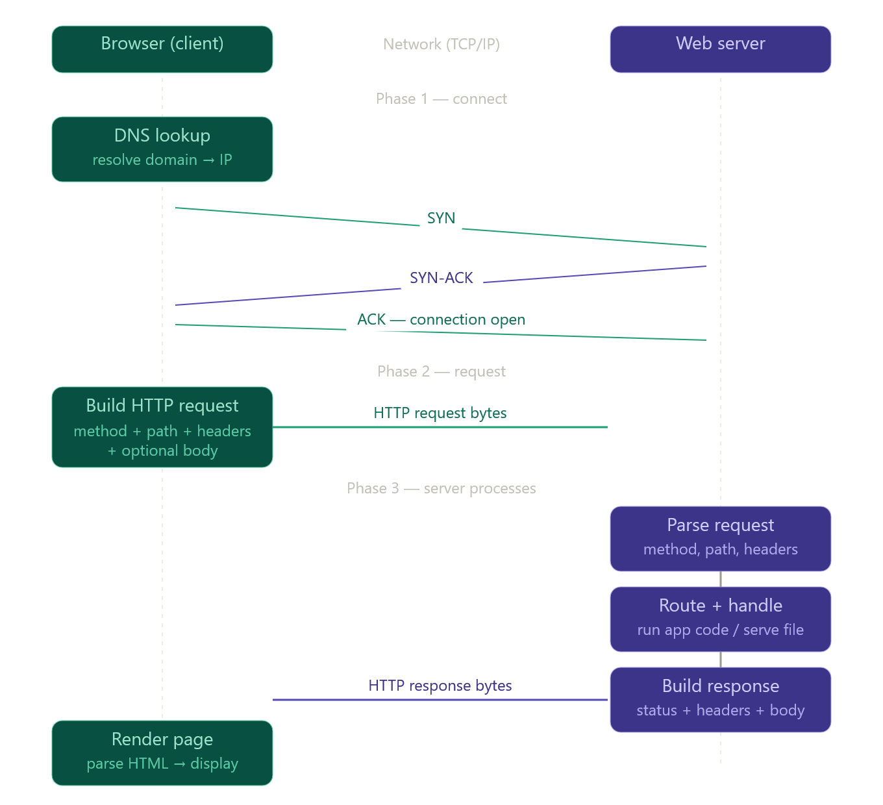
When your browser visits a website, a lot happens before a single pixel appears on screen. There are really three phases: TCP connection, HTTP exchange, and response processing. Let's walk through each one.
Now let's understand what's actually inside each of these steps.

Phase 1 — TCP connection (before HTTP even starts)
HTTP runs on top of TCP. Before any HTTP bytes are sent, the browser and server must open a TCP connection via the 3-way handshake:
- Browser sends SYN — "I want to connect"
- Server replies SYN-ACK — "ok, I'm ready"
- Browser sends ACK — "great, let's go"
Only after this does the HTTP request go out. This is why even a tiny HTTP request has some latency — you always pay for at least one round trip before data flows.
For HTTPS, a TLS handshake happens on top of this, adding more round trips. This is why HTTP/2 and HTTP/3 exist — they reduce this overhead significantly.

Phase 2 — What an HTTP request looks like
An HTTP request is just plain text bytes with a specific format. Here's a real one:
GET /login HTTP/1.1
Host: example.com
User-Agent: Mozilla/5.0
Accept: text/html
Cookie: session=abc123
The structure is: request line (method + path + version), then headers (one per line, Key: Value), then a blank line, then an optional body (for POST/PUT requests containing form data or JSON).
The most important parts are the method (what action — GET fetches a resource, POST sends data, DELETE removes something, etc.) and the path (which resource on the server, like /login or /api/users/42).

Phase 3 — What the server actually does
Now the interesting part for your cybersecurity studies. When those bytes arrive at the server:
The server software (like nginx, Apache, or Node.js) sits on port 80 (HTTP) or 443 (HTTPS) listening for incoming TCP connections. When bytes arrive, it reads them off the socket and parses the HTTP format — extracting the method, path, headers, and body.
Then it hands the request to the application layer — this is where your web framework (like Django, Express, Spring) takes over. It matches the path to a route handler (e.g., the /login path maps to your loginController function). The application code runs — it might query a database, check session tokens, apply business logic — and eventually produces a response.
The response is also just text bytes:
HTTP/1.1 200 OK
Content-Type: text/html
Set-Cookie: session=xyz789
Content-Length: 1452

<html>...
Status code first (200 = OK, 404 = not found, 301 = redirect, 500 = server error), then headers, then the body (HTML, JSON, an image, etc.).

Why this matters for security
Everything we talked about earlier in the MitM context maps directly here. The attacker who intercepts HTTP traffic sees exactly these raw bytes — including the Cookie: header (which is how you stay logged in), any POST body with your password, and all the response data. With HTTPS, all of this becomes encrypted ciphertext that looks like random noise to anyone intercepting it.
The Host: header is particularly interesting — it's how one server can host thousands of websites at the same IP address (called virtual hosting). An attacker who does DNS spoofing can serve a fake Host: response while pretending to be the legitimate server.
Click any box in the diagram to go deeper on that specific step.

