第8次课
上次课总结：
(07-1)- 11～19 | 21～25
08-4～6 | 8
9～10 | 14
21 | 23～26
28
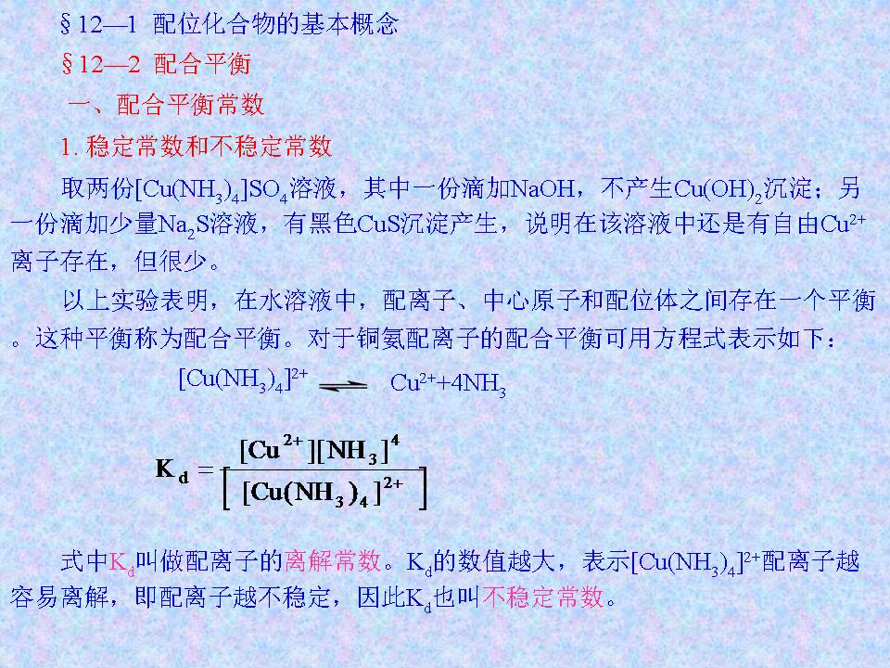 | 30．  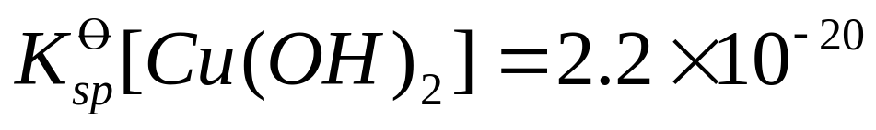  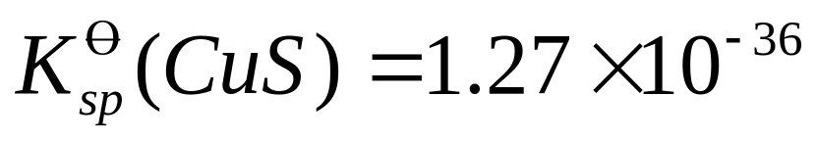
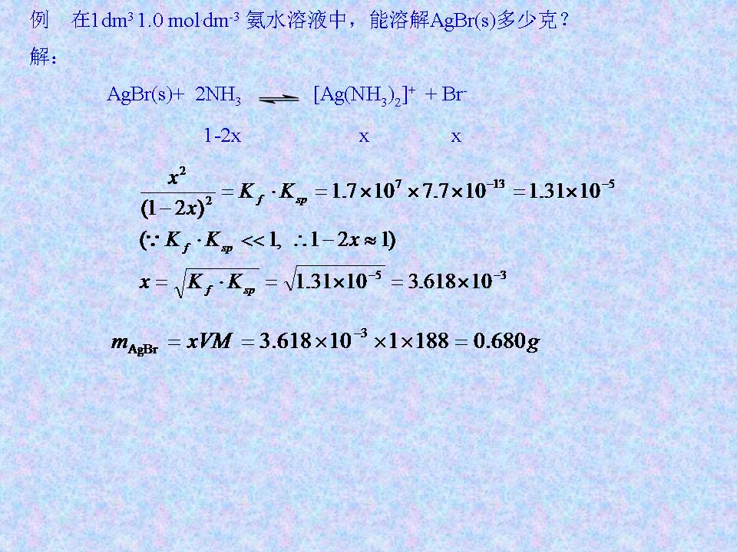 | 40．  (1)AgBr(s)=Ag⁺+Br⁻ 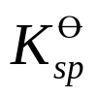  (2)Ag⁺+2NH₃=[Ag(NH₃)₂]⁺ 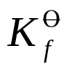  (1)+(2)
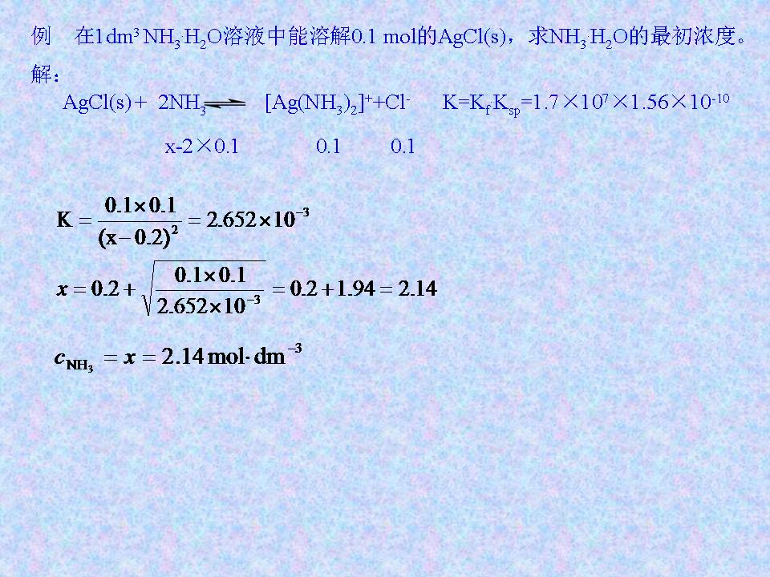 | 41．  (1)AgCl(s)=Ag⁺+Cl⁻  (2)Ag⁺+2NH₃=[Ag(NH₃)₂]⁺  (1)+(2)
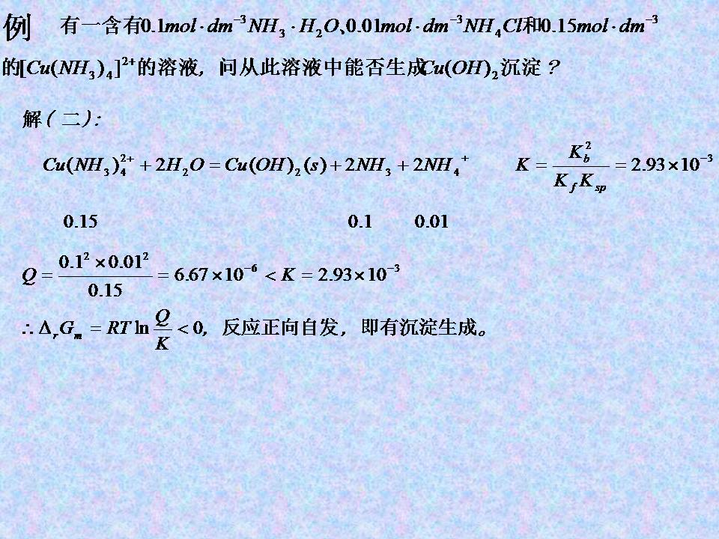 | 46．  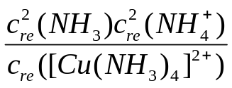=  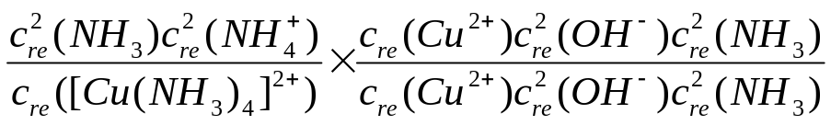  (1)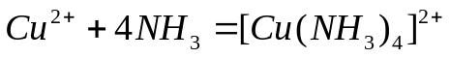 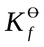  (2)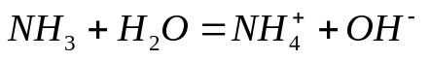 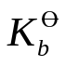  (3)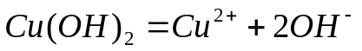 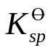  2×(2)-(1)-(3):
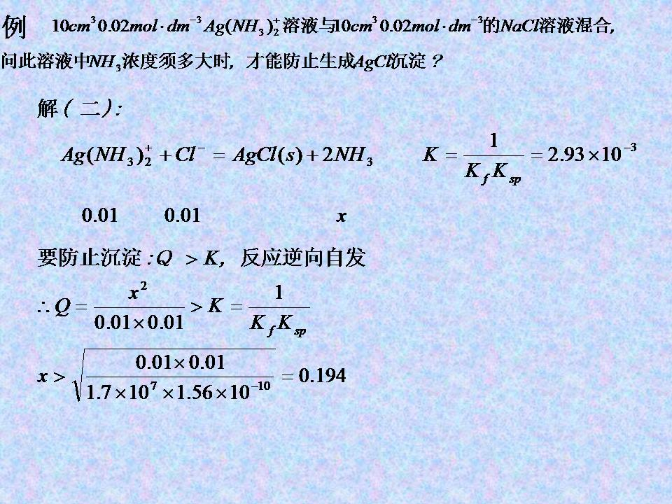 | 48．  (1)AgCl(s)=Ag⁺+Cl⁻  (2)Ag⁺+2NH₃=[Ag(NH₃)₂]⁺  (-1)[(1)+(2)]
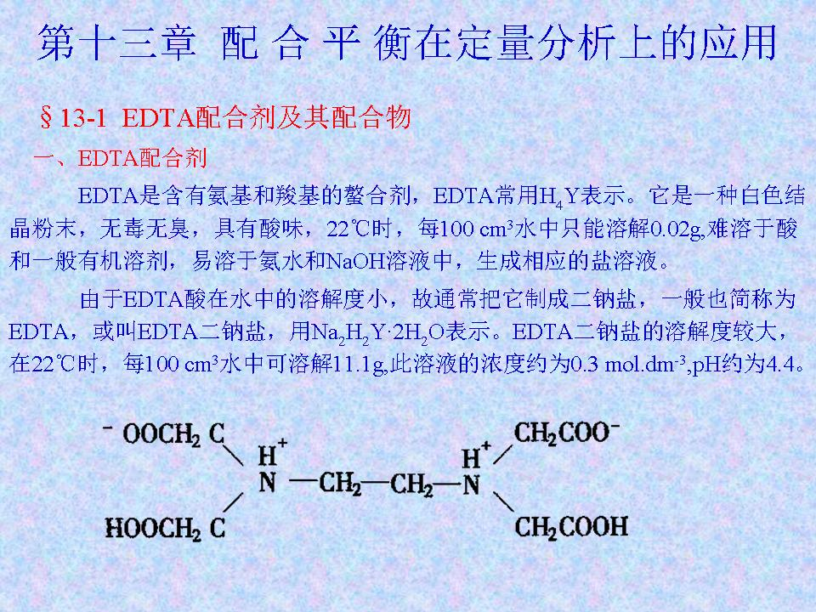 | 3．  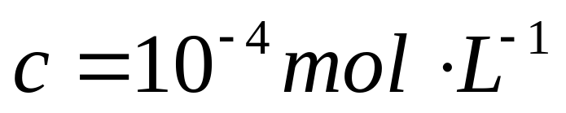  乙二胺四乙酸二钠  双偶极离子结构
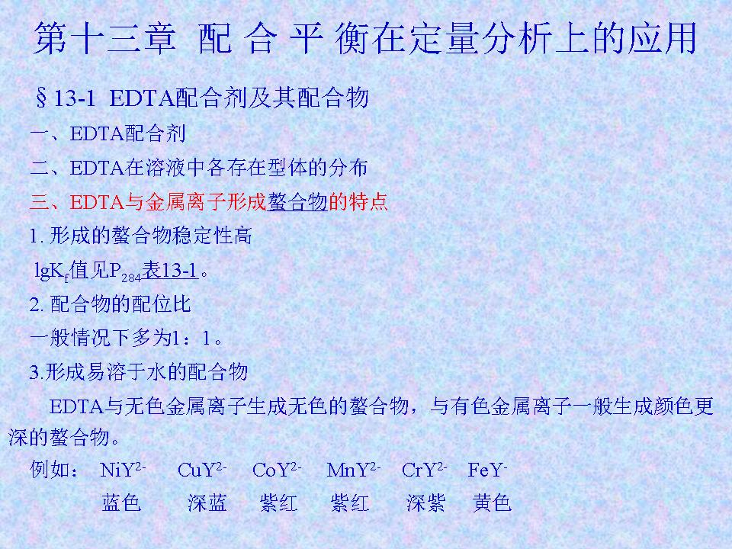 | 7．  P186表8-8
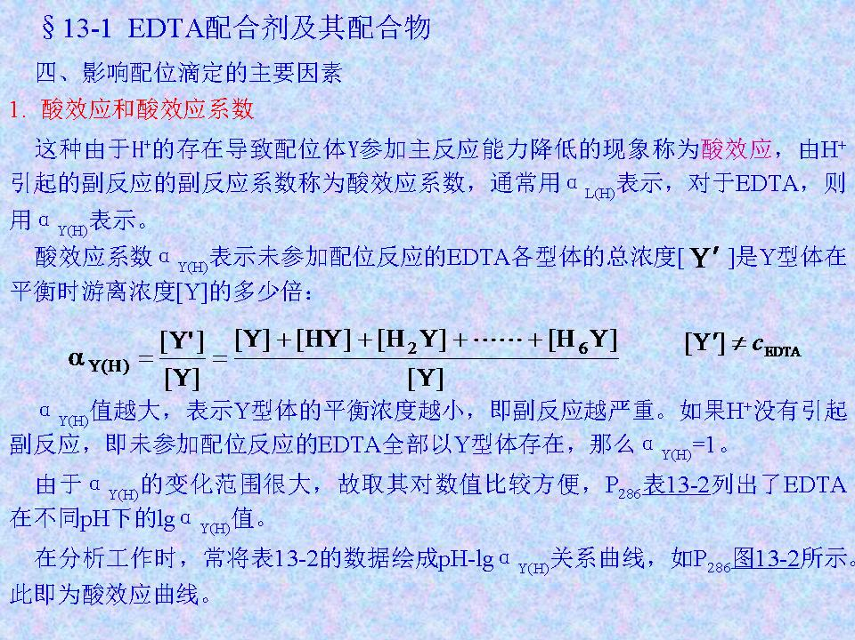 | 11．  P189表8-10  P197图8-7
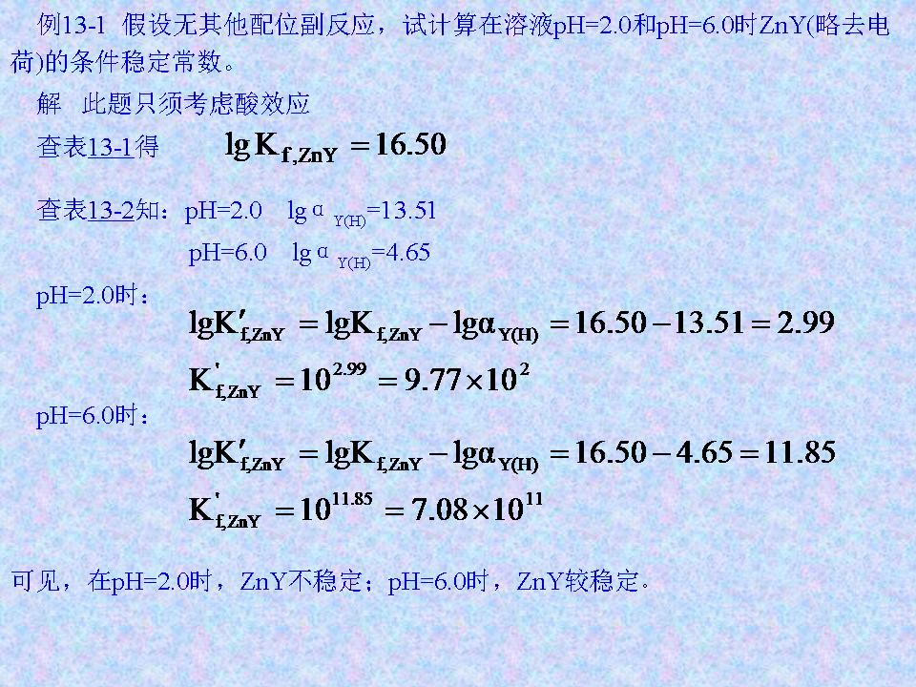 | 16．  P186表8-8  P189表8-10
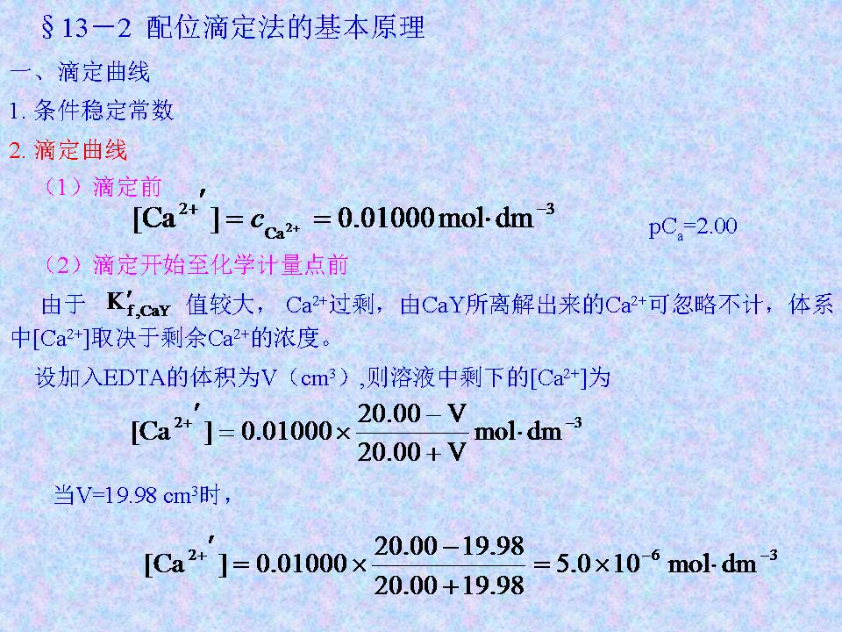 | 19．  pCa=5.30
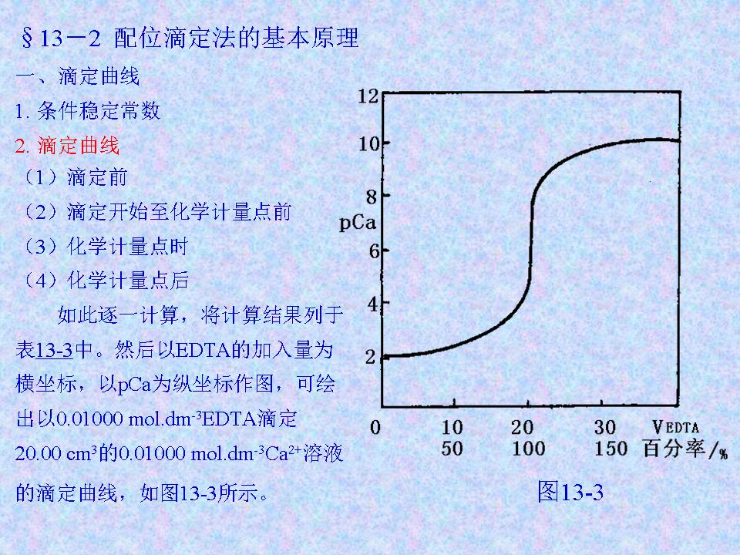 | 22．  滴定突跃范围：PCa5.30～7.24
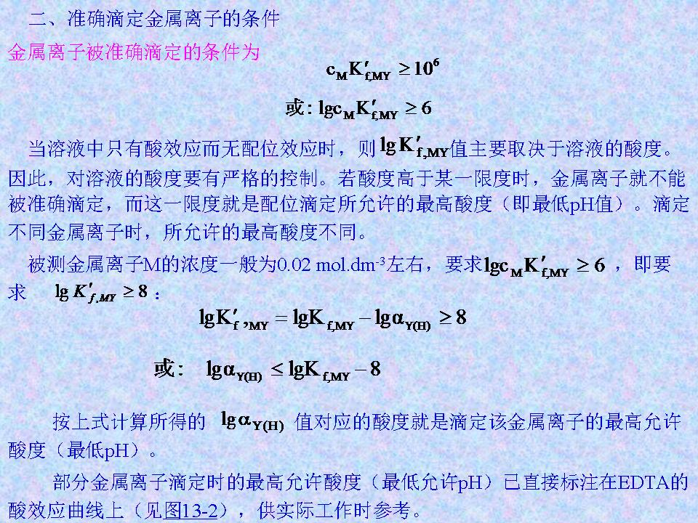 | 27．  P197图8-7
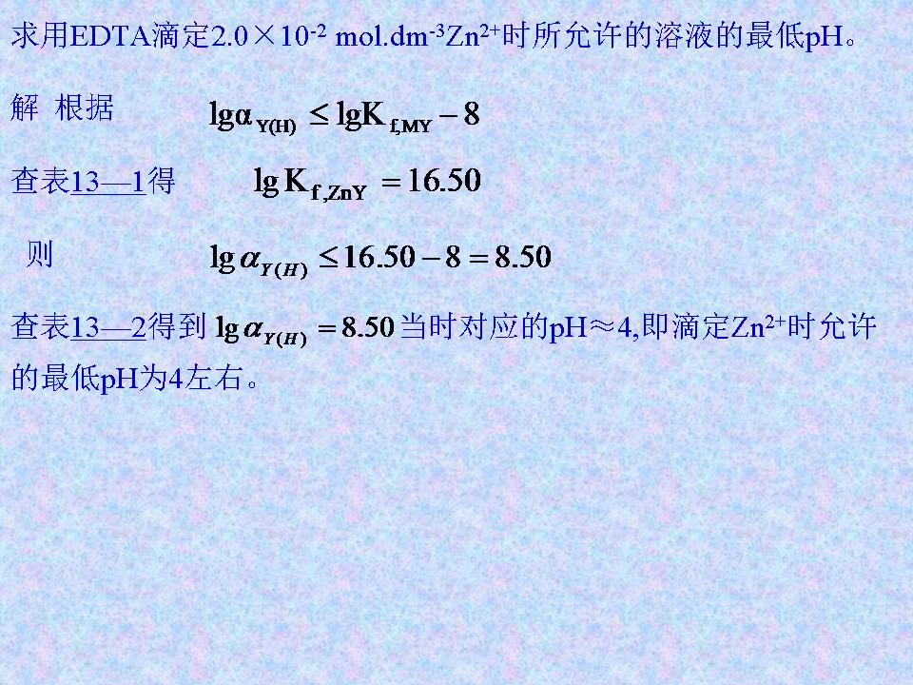 | 28．  P186表8-8  P189表8-10
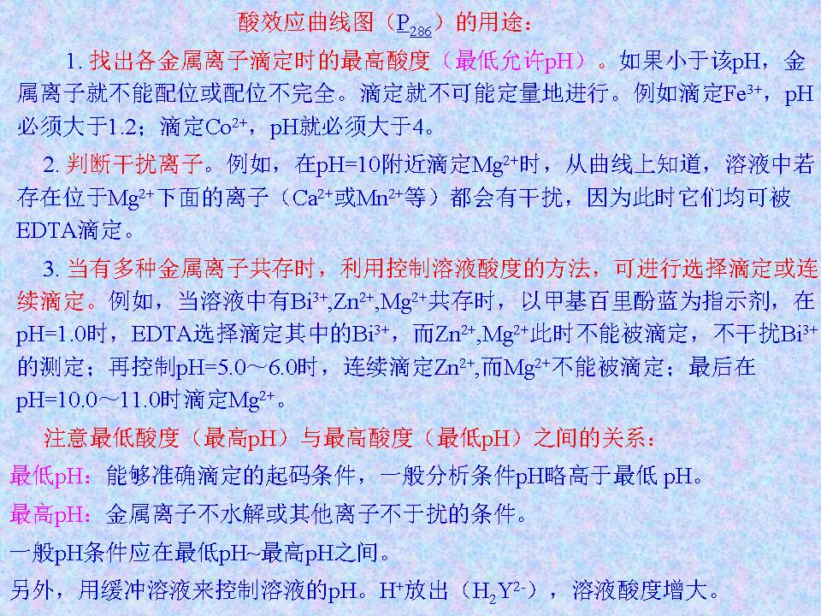 | 29．  P197图8-7  2.最低pH：Ca²⁺7.6，Mn²⁺5.3  3.最低pH：Bi³⁺0.7，Zn²⁺4.0，Mg²⁺9.6  指示剂适宜pH

