1. Use README.md to setup project.

2. Assumed we using OAuth2 for authentication, access token and userinfo.

3. Each REST API will require an Authorization request header bearer token.

4. Assumed REST APIs are similar to a SaaS like Gmail/Outlook.

5. All REST APIs can also throw a HTTP 500 (Internal Server Error) or 401 (Unauthorized).

**Notes on Automated Testing:**

* Testing should be automated and part of the CI/CD pipeline.
* Other testing to be considered is stress testing and integration testing.

**Notes on Automated Deployment:**

* Automated as much as possible (but consider business impact or other development teams).
* Example, once a software engineers branch is merged, this can kick off the automated build, test and deployment.
* We can use tools like Jenkins, AWS ECR, CodePipeline, Elastic Beanstalk.

**Notes on Database:**

* Use JPA, Hibernate implementation.
* Database tables are modelled by the Entities in Java.
* All CRUD operations can be handled here.

**Notes on Future:**

* As the application becomes more demanding, we can horizontal and vertical.
* We can enhance the APIs to work for HTML emails, emails with attachments, etc.

*scroll down for screenshots ……*

**Build and run Docker Image:**

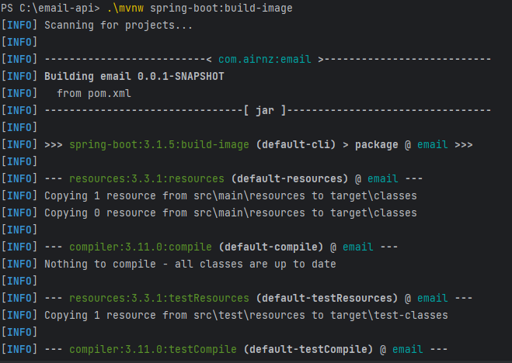

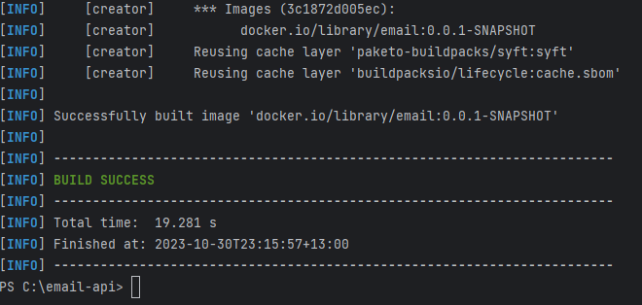





**Functional/Unit Test cases:**

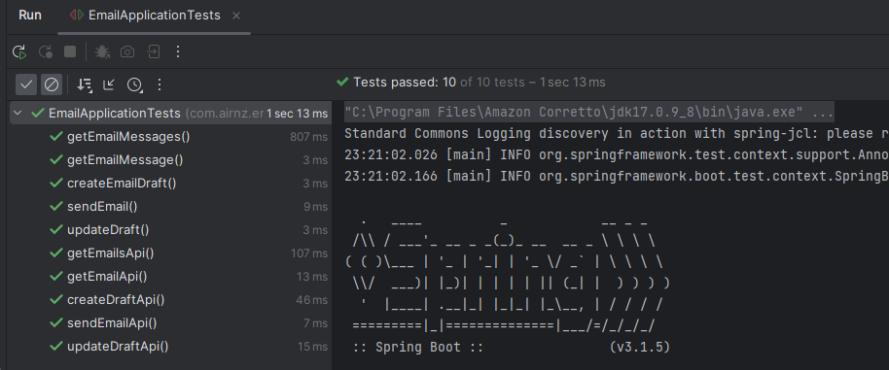

**Swagger:**

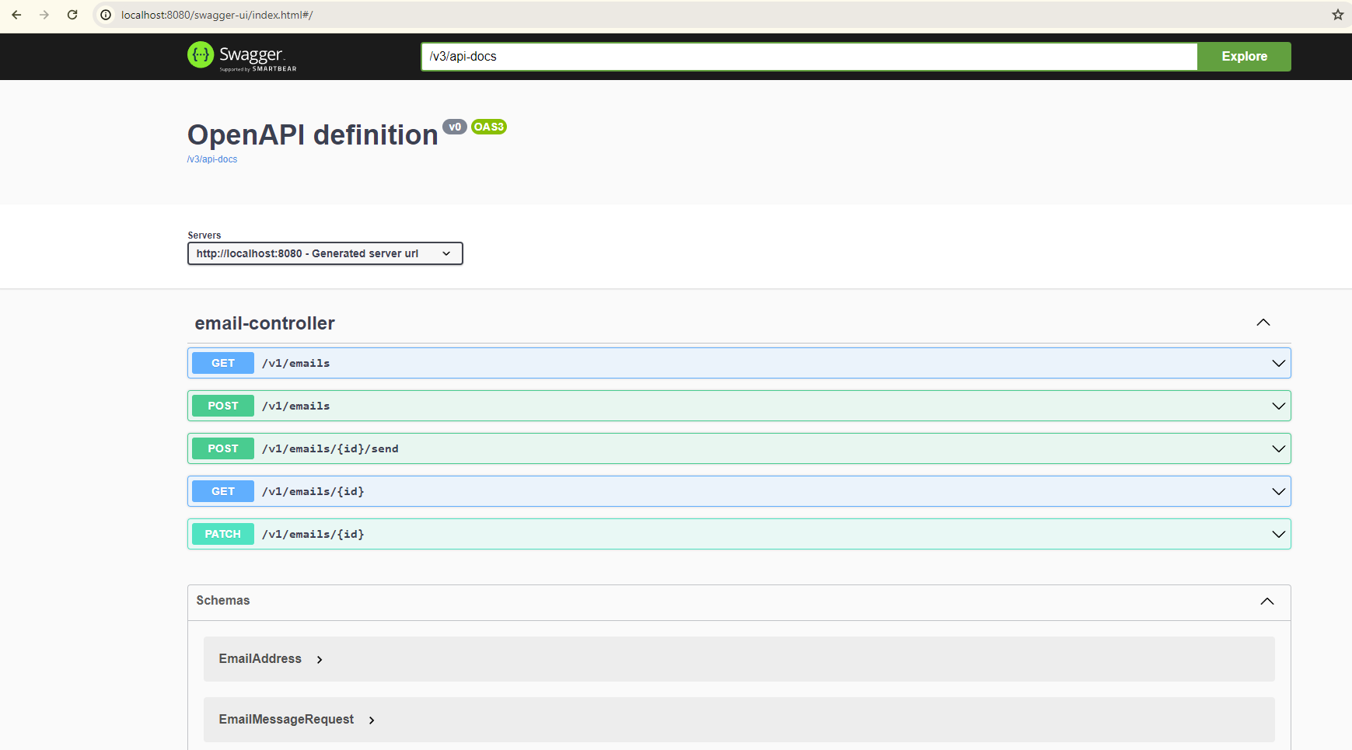

**Postman:**

