**Testing Scala Spark Sales App**

This will clean, compile and package the Scala application into sales-1.0-SNAPSHOT.jar:

mvn clean package

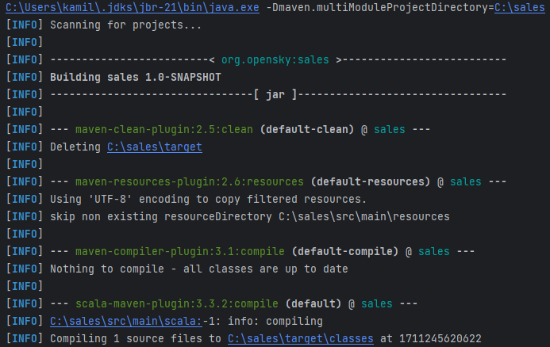

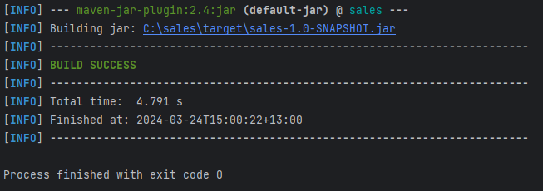

This will start the Spark container:

docker-compose up -d

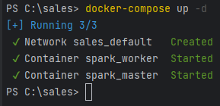

This will copy the required file files to the container:

docker cp target/sales-1.0-SNAPSHOT.jar spark_master:/opt/bitnami/spark/.

docker cp pre_file_operations.sh spark_master:/opt/.

docker cp post_file_operations.sh spark_master:/opt/.

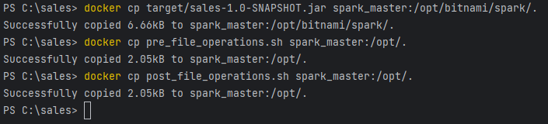

This will unzip the provided file:

docker exec -it spark_master /bin/sh -c /opt/pre_file_operations.sh



This will submit the job to Apache Spark:

docker exec -it spark_master spark-submit --master spark://spark:7077 --class org.opensky.App sales-1.0-SNAPSHOT.jar

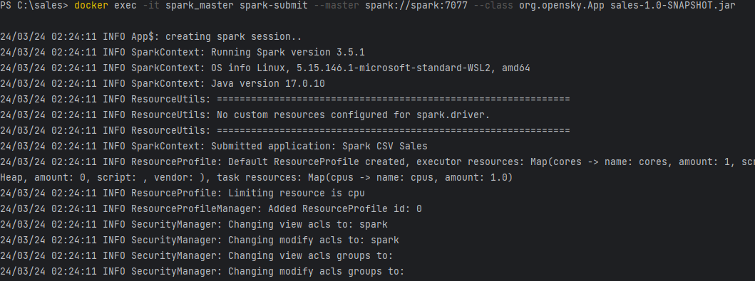

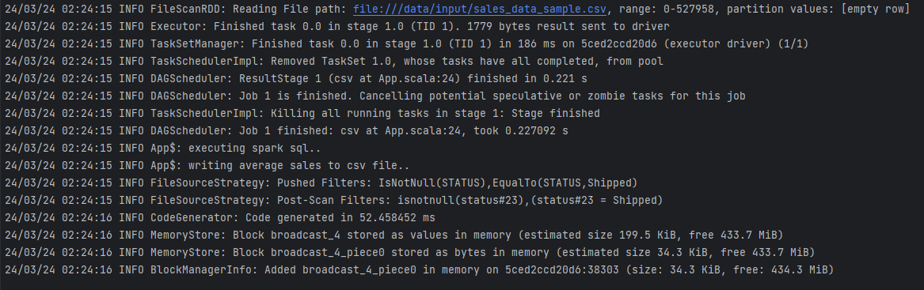

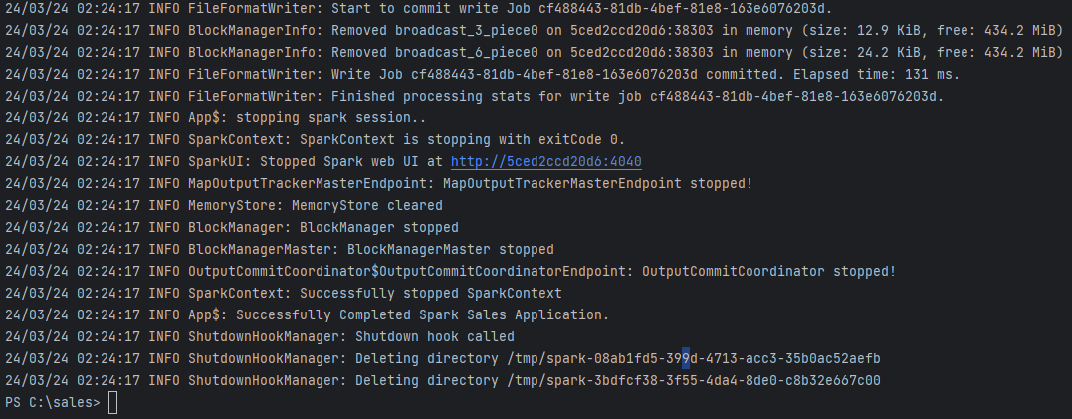

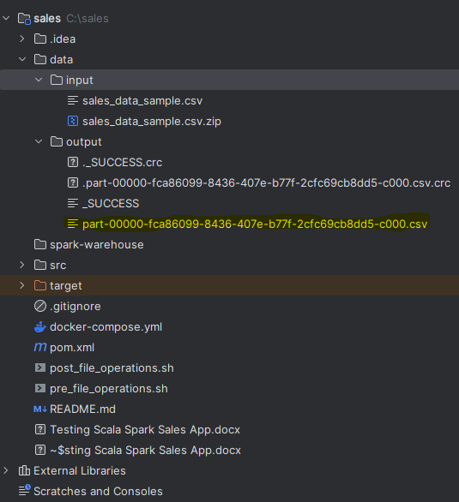

This will rename to output.csv and cleanup:

docker exec -it spark_master /bin/sh -c /opt/post_file_operations.sh



This will stop the Spark container:

docker-compose down

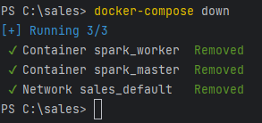

**output.csv**

YEAR_ID,PRODUCTLINE,AVERAGE_SALES_AMT  
2003,Classic Cars,4055.45  
2003,Motorcycles,3402.71  
2003,Planes,3211.68  
2003,Ships,3021.62  
2003,Trains,2600.08  
2003,Trucks and Buses,3809.12  
2003,Vintage Cars,2962.95  
2004,Classic Cars,4006.76  
2004,Motorcycles,3417.96  
2004,Planes,3123.68  
2004,Ships,2954.78  
2004,Trains,3095.6  
2004,Trucks and Buses,3689.2  
2004,Vintage Cars,3210.93  
2005,Classic Cars,4180.63  
2005,Motorcycles,3884.96  
2005,Planes,3450.16  
2005,Ships,3394.41  
2005,Trains,2828.08  
2005,Trucks and Buses,3553.44  
2005,Vintage Cars,3334.48