**Improved Student Issue Reporting and Resolution**

Project Monitoring and control

Actual project planning parameters against the project plan

Many parts of the project have been completed out of order I do not believe this breaks with the waterfall model as the steps are still in the correct order. While researching Ruby on Rails I started building parts of the website. These parts where generated based on commands that Ruby on Rails uses. It created a form for a sign in and registration. These will probably be changed and a style sheet added but the layout is how a form is presented so few changes may happen there. In other words, looking forward and testing ideas informed the previous step, to its completion but previous step will still be completed first prior to the next step in the life cycle. At present some of the functional parts do not do as I intended them to do and in the planning stage will have to be changed prior to moving on to the next stage.

The project timings where unrealistic as available time for the project manager and team member (myself) to work on the project at the end of the last year was little as other commitments kept them occupied.

Monitor commitments against those identified in the project plan

In my project plan I presented my commitments in the form of a project charter. In the charter I stated that I did not want to spend anything getting the project working, I have kept within my budget of £0 and used open source software to complete what I have done so far. Ruby on Rails host itself and does not require a WAMP server as stated in the resources part of the plan.

At present the website currently does not meet the objectives or the main success criteria outline in the project charter but has achieved some of the milestones towards there completion. I have followed the approach stated of following a waterfall lifecycle model. I have completed documentation on my decision of the language and explained part of how it works and how it will be used towards building the server side of my website. I have created a design for my website that I am in the process of implementing.

Monitor risks against those risks identified in the project plan

In my project plan I determined that data loose, could be a risk to my project and as such I intended to keep a regular back up of my project both on my computer and on GitHub. I have not done this and I intend to fix this shortly.

In my project plan I cover the waterfall model and that one of its disadvantages was that if everything is not planned in the planning stage it could become a problem in the later stages of the project. When an implementation doesn’t follow the current the plan it is clearly a problem one I thankfully can fix at this early stage of development but the reviewed Gantt chart shows I am running out of time to be changing things so this could become a serious risk going forward.

Monitor the management of project data against the project plan

I have used GitHub for storing documents and reports, however the actual project is being built in Amazon Web Services Cloud 9 and the files to do with project are currently stored there. I should be making backups of it on my computer as well as on GitHub as stated in my project plan I will have to download a copy of my work and upload it to the GitHub repository soon.

This is unlike me to not have made a backup sooner but as I am using an online virtual environment to run my server and create my project the reduced access compared to having it on my computer seems to have caused this oversight in trusting it to stay safe on the AWS server.

Monitor stakeholder involvement against the project plan

In my plan the stakeholders will be able to more easily can access assistance in resolving issues and creating SSCS reports. The project is yet to reach the point where anyone can test these features therefore involvement has been non-existent so far.

Review the project’s progress, performance, and issues

The project is behind schedule because of other commitments, and underestimation of completion times of certain task.

For example, choosing the language took longer that I estimated.

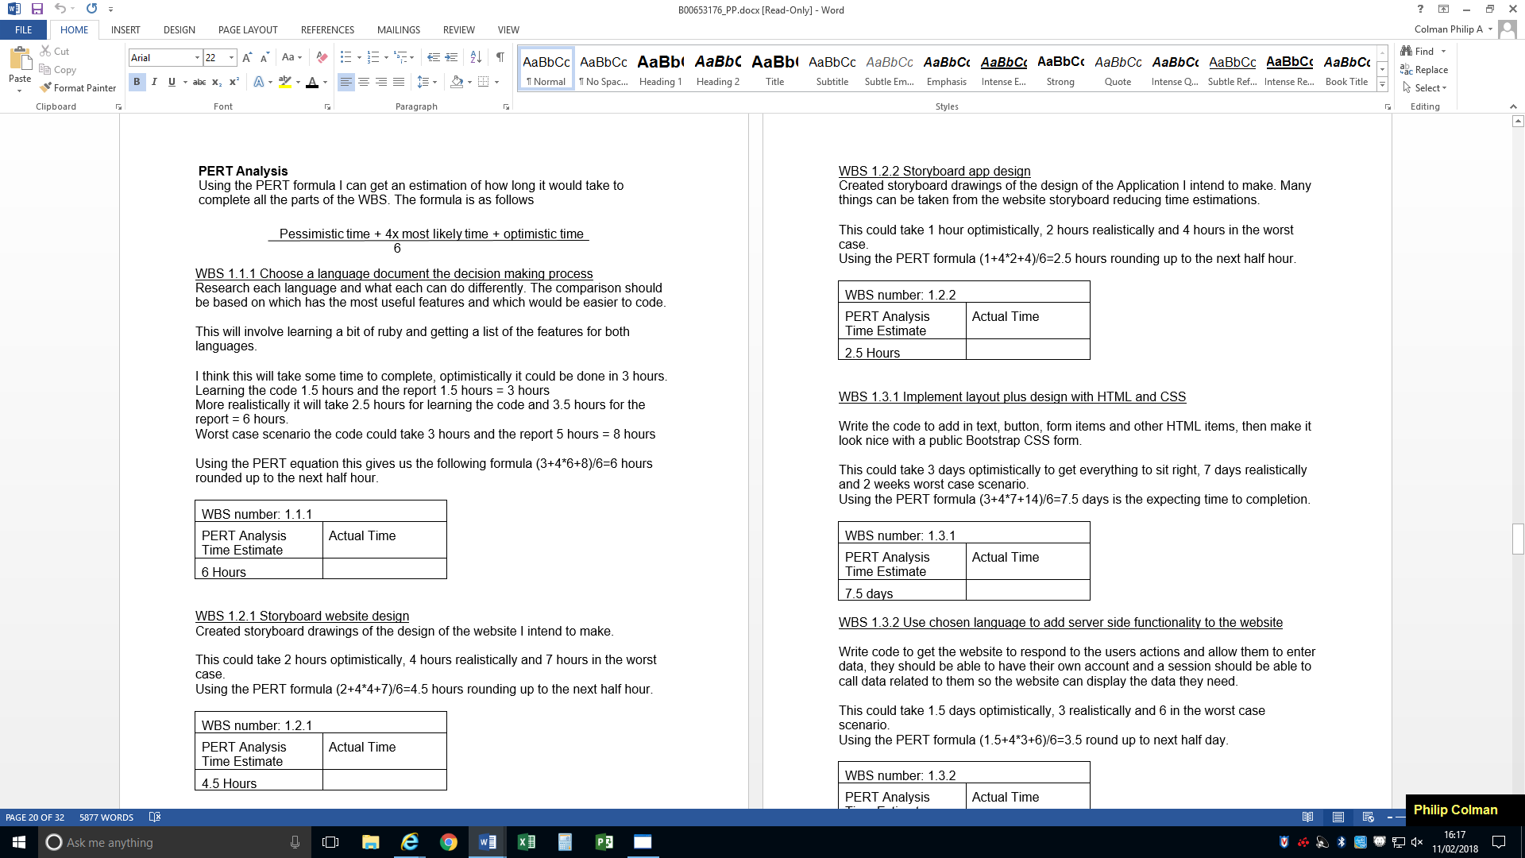

The above is taken from the project plan I estimated that worst case scenario it would take 8 hours.

Deciding on what language I would use took longer than expected. Ruby was a similar enough language to other that I have used previously. However the rails framework took longer for me to get an understanding off. While it is convenient that it generates and manages a lot of the code for the developer, it took some time figure out what it was doing with the code. It uses controllers to determine what happens on that page. It decides what views should be called, this is useful for navigating the website.

Compared to PHP which I have used in previous years, navigation would work by links on the page, while this is still the case in ruby on rails every page loaded goes through the controller which can white or blacklist certain events like loading a page depending on the characteristic of an object like ‘current user’. A signed in user would still be presented with a sign in page if they navigated to that page in PHP, where as in ruby the controller would recognize the person has access and load the homepage instead and more importantly the other way around as well preventing access to pages without permission. There is ways to do this in PHP as well (redirects based on conditions) but require the developer program them into every web page, with the controller managing this in the Ruby on Rails framework it is easier to meet best practices.

This is one of the concepts that took me longer than I estimated to get an understanding off. My performance in this was limited by my approach of trying to learn Ruby on Rails. I learn best by breaking apart existing code that I know the function of and putting it back together. To improve my performance in future I should aim to get many different example programs and start from there.

Review the project’s accomplishments and results at selected project milestones.

Due to being behind and the way I find easiest to learn I have mostly set up the server side of the website at different point than was planned in the project plan. While researching Ruby on Rails and comparing it to PHP I have mostly set up a registration and sign in system. This will mostly be redone however as the students will not be making their accounts but will be signing in with a there student email given to them, passwords generated similar to how they are generated for block 16 this will be a mock up for demonstration purposes. The idea is they are tied to their class so their account will be in a predefined group.

I have given the home page on the website the focus in the storyboard as the other pages will be simple forms with some basic styling. The aim is that the homepage will work well regardless of the device that it is on, so some of the links are behind images, like the VOIP being behind the image of a phone.

I have created a database for storing user data it is a SQLite database as is the default for Ruby on Rails. You can set up an adapter for a MySQL server however at present the only thing the database will be doing is authenticating that the sign in details are correct and SQLite is meeting the requirements for this. I will be reviewing this decision going forward particularly when I set up the password generating system and the contacts system.

Ruby on Rails automatically protects the input in text boxes from malicious code by using strong parameters in the input of data. It makes sure that the input has all escapes converted into “plain text” so that it is read that way instead of as a command. I go into more detail on this in my Ruby on Rails compared to PHP report that will be submitted with my project.

I currently am writing the html and CSS with ruby to design the homepage and the other pages for reports and calls.

The original plan called for the completion of the entire project by this point. I however did not get started on the project until after the New Year due to a busier period in my other commitments. I am still behind schedule even taking that into consideration. I have however managed to complete many tasks in unison reducing the time taken to complete the task. I foresee being able to do this again with VOIP integration and text messages as well as creating a large part of the public report issue functionality built into the homepage as I designed in my storyboard.

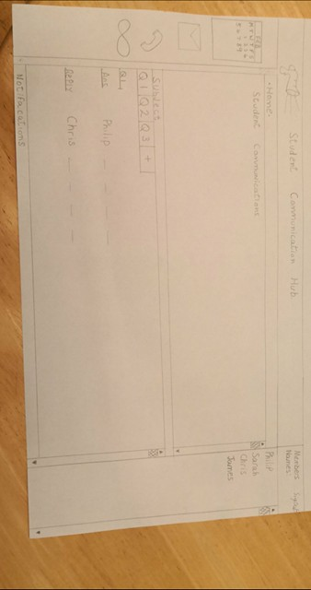

I believe I will still be able to complete the project on time as I will lay out in a new Gantt chart that will be at the end of this report as well as the original.

Analyze issues and determine corrective actions to address them

One of the main issues with my project so far is that currently users can create their own account. This is a problem because the user should be assign directly into a group that is their class, we could give the option to choose the class registration number to a form however this would give them the option to join the wrong group and add confusion that they may not be aware of what the class registration number is or how to find out. It will be much easier if an administrator sets up the account and the user only needs to be able to sign in and change/reset passwords. While this could be done in SQLite it makes a lot more sense to be done in a MySQL environment. In the MySQL environment the administrator will be able to add large groups of users at a time compared to manually having to enter the data one at a time.

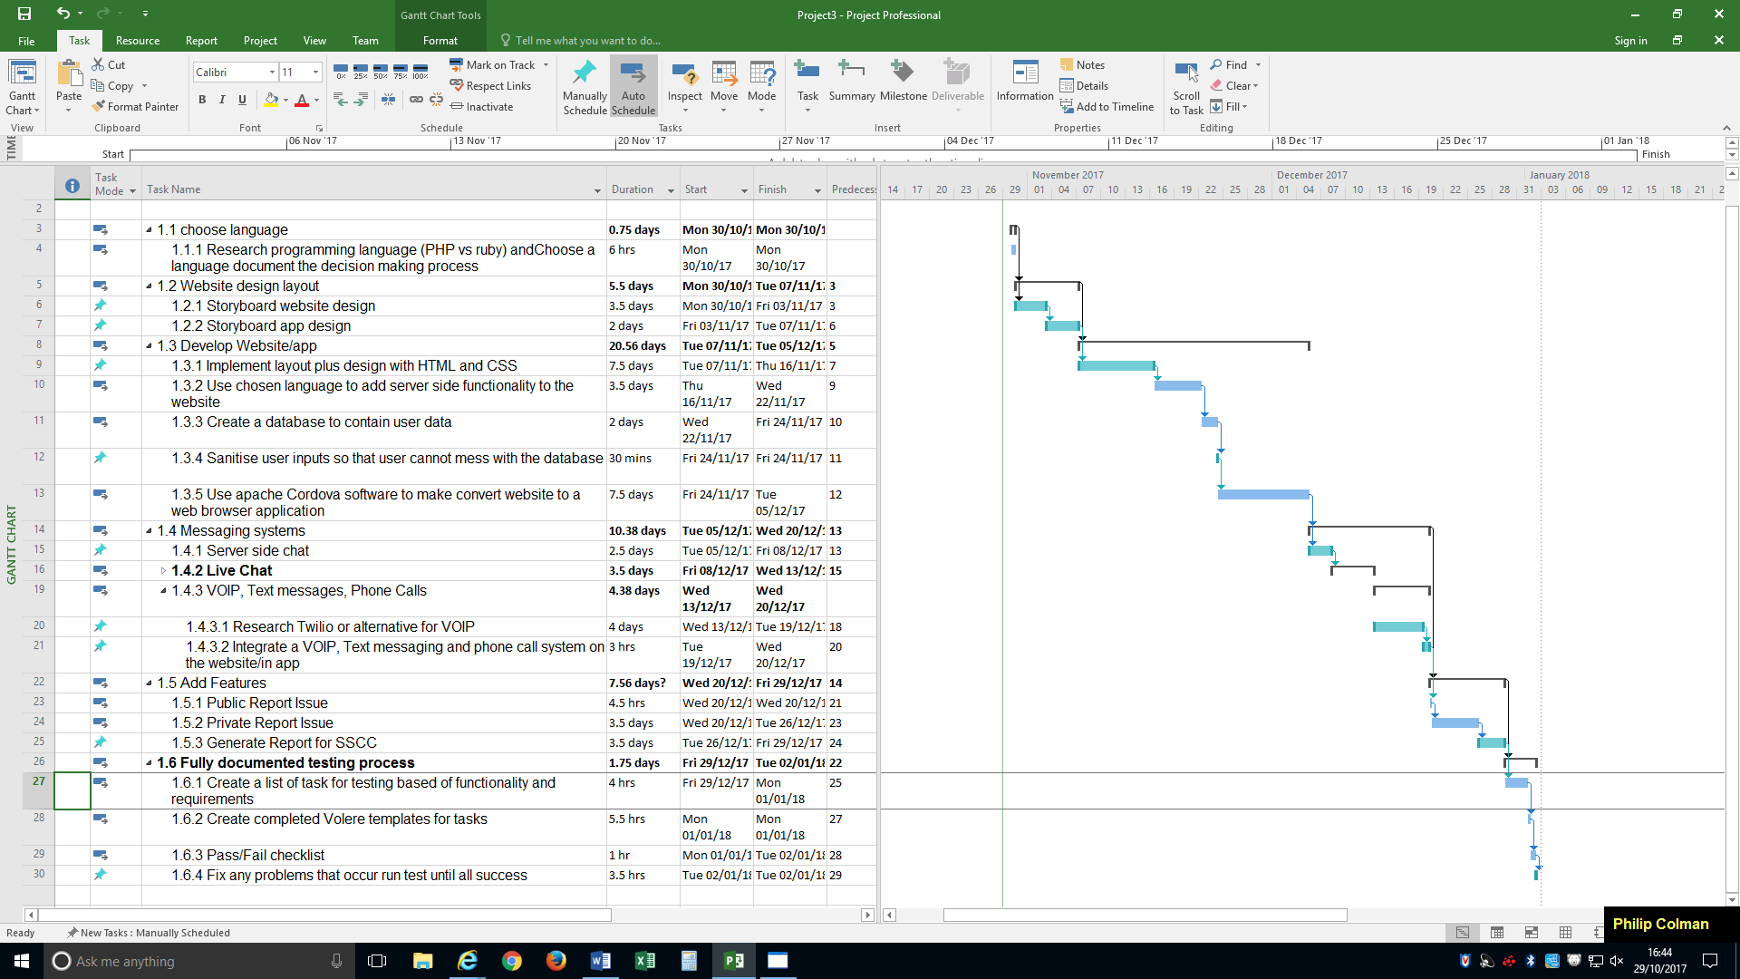Old Gantt chart

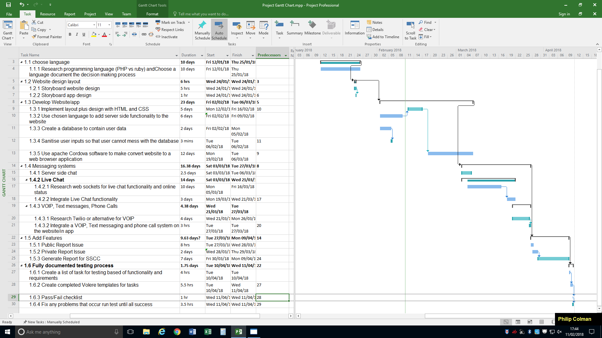New Gantt chart