**COM547 - Computing Systems Project**

**Improved Student Issue Reporting and Resolution by effective communication with the Course Representative through a Website or an Application**

**The Project Plan**

**Philip Colman**

**B00653176**

**Supervisor: Dr Dewar Finlay**

**Date: October 2017**

Contents

1.0 Purpose of the project and its context Pages 3

1.1 Purpose

1.2 Current System

1.3 Context

2.0 Aim and Objectives of the project Pages 4-5

2.1 Project Aim

2.2 Objectives for the project

2.3 Project Scope

2.4 Stakeholders

2.5 involvement of identified stakeholders

3.0 Lifecycle to be used in the project Pages 6-12

3.1 What is a project lifecycle?

3.2 Waterfall

3.3 Iterative

3.4 Spiral

3.5 Agile

3.6 Life cycle chosen and why

3.7 Plan for the management of project data

4.0 Estimate the project’s effort for tasks Pages 13-29

4.1(WBS) top-level work breakdown

4.2 WBS Dictionary

4.3 PERT Analysis

4.4 Gantt Chart

4.5 WBS Table form

5.0 Commitments page 30

References and Bibliography page 31-32

1.0 Purpose of the project and its context

**1.1 Purpose**

The Purpose of the project is to create a dedicated website or an app for students in the university to communicate as a class with the intention of resolving issues and being more informative about issues student face than simple asking during class or posting a request for feedback on a Facebook group.

**1.2 Current System**

Are class currently uses a Facebook group chat for communicating. This is obviously very effective as Facebook maintains and update the service. The Service allows for everyone who has a Facebook account who has been added to the group to share, receive, respond, and like things that they or others have chosen to share with the group. When this happens the application notifies the other members that there has been a post in group. This is a very important feature as it allows all members of the group to remain informed of any developments.

**1.3 Context**

While the current method we are using as a group is excellent a more targeted system could allow for greater involvement and easier resolution to issues for students within the university.

Recognizing that the target audience is the students we can design specific features for that group. One example of the common behaviors of a group is that one person usually finds dates for things like first day of the semester or dates for exams and then post that information to the group or others ask when a deadline for an assignment is and someone responds.

Given awareness of this we can add a calendar to the website and/or** application, that allows people to see this information as it approaches instead of dropping of the screen when other comments are posted after this saving other people searching for it later.

One of the main reasons for this project is to improve feedback from the group and allowing the student representative to remain more up to date on issues involving the group or a member of the group with this in mind we can develop tools to help the student representative to respond better with solutions, add issues for other members to comment on, and develop reports for effective and informed feed back to the SSCC forms.

Not everyone in group has a Facebook account or wants to be added to the group by separating it from the social media experience and potentially combining it with the university account we can get around any issues they may have. We can also set up their account so they are automatically in the group with member from the same course. This will probably will be a mock up in my project.

**2.0 Aim and Objectives of the project.**

**2.1 Project Aim**

The aim of the project is to create a means for a class to effectively communicate information about the running of the course with each other and report any problems that they may have. These website/app should then have tools for resolving the problems and creating a report. The website/app should also allow for social communications also.

**2.2 Objectives for the project.**

1. A conversation should be created for the group to discuss the issue notifying all students in the class of the issue. This part not only allow other students to answer but also indicate they have the same issue. If the issue is resolved all individuals who had the issue should indicate the issue is resolved and the course representative should sign off on it, writing a report if necessary.
2. A one to one with the course representative, text or voice in app or on the web page with email available also.
3. Some way to communicate with the course tutors on the website or in app if necessary.
4. Some way to communicate with the course co-ordinator on the website or in app if necessary.

Steps to complete objectives

1. Chose language
2. Design website and app
3. Implement design and functionality
4. Implement messaging systems
5. Implement reporting systems
6. Complete testing

**2.3 Project Scope**  
The Project will be able to allow user to communicate by several different means 1 to 1 chat group chat, issue reporting where a check system will indicate resolution of the issue and VOIP chat. There will be a well-designed front end to the website and a database will have user information like sign in details and history available.

Resources

The resource I have are:

* My own laptop as well as the use of desktops in the university.
* A text editor
* WAMP server
* A web browser
* A Smartphone
* Apache Cordova

**2.4 Stakeholders**

The people or groups of people who have an interest in this project would be other students as it will improve their communication with the course representative and other members of the class. The course representatives should be able to collect more useful information and have tools available to make reporting or resolving an issue easier.

3.0 Lifecycle to be used in the project

**3.1 What is a project lifecycle?**

A software development lifecycle is used to create a product in a cost-efficient manor, at high quality within the shortest period of time. I have analyzed several different lifecycle models to determine the one most effective for my project.

**3.2 Waterfall**

The waterfall model is a Lifecycle where you complete one stage before moving on to the next, for example you would have to complete the planning stage before moving onto the design stage. It is called the waterfall model because it is generally drawn as steps going down from the first stage at the top and the last stage at the bottom. During development, you then flow down the steps from one stage onto the next like water going down a waterfall. You cannot skip any steps as each step is has tasked that are required to be completed to start the following step.

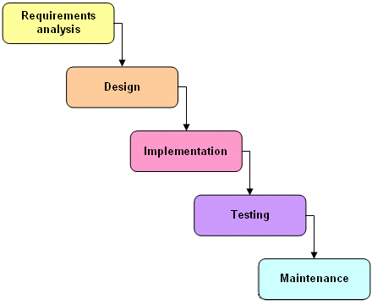

(Technologyuk.net, 2017)

**3.2 Waterfall Continued**

**Advantages**

* Thoughtful analysis is put into the development of the project in the early stages determining what is going to be needed and what needs to be done. This allows for research to be done in the early planning stages and this can allow for identifying issues that may occur so they can be resolved before continuing.
* This model is a linear process which is easier to understand.
* This model generally gets lots of documentation as the early stages are all about the planning for the later stages.

**Disadvantages**

* Requires an upfront understanding of the entire project.
* Changes in the later stages are difficult to implement. Developers may use change control procedures to define what can be changed which still will not be easy to perform.
* Many issues will not be identified in the earlier stages, changing things later would prove difficult.
* Sample pieces cannot be put together as the project requires early stages to be completed before any attempt at implementation.

**3.3 Iterative**

The Iterative model goes through iterations or version of the software build. There is an initial planning stage which is then followed up by stages that are repeated until the software is fully developed, the project is incrementally built up over each iteration.

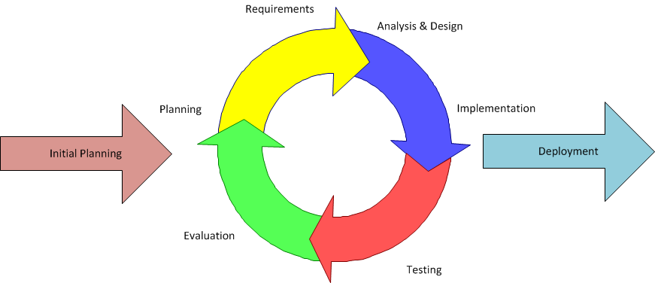

(Inflectra.com, 2017)

**Advantages**

* Any problems that occur can be worked out during the next iteration by the time you get to the final iteration the problems will be worked.
* Any changes that get requested can be made during the next iteration.
* Each iteration builds on the last so you do not need to fully implement the whole project on the first iteration like waterfall.

**Disadvantages**

* Requires engagement of the stakeholder the project is being designed for throughout the project as feedback will be required after every iteration.
* As a result of this continuous feedback the user may continually request new feature which can quickly lead to a runaway of scope, time and cost.

**3.4 Spiral**

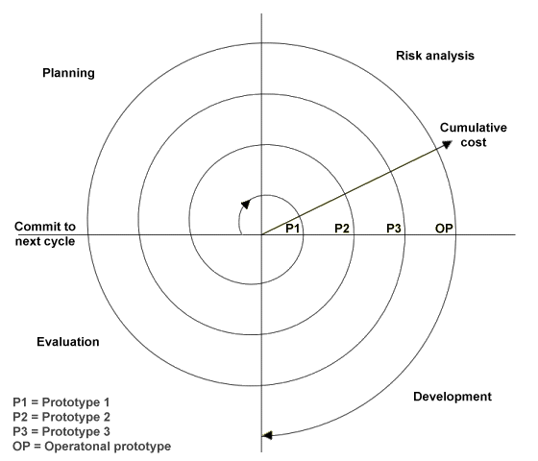The Spiral model also has an iterative approach however it puts emphases on risk analysis. The biggest difference is that the iteration is broken up into 4 key phases. Which are define objectives, Identify and resolve risk, developing the project and testing it and then planning the next iteration.

**Advantages**(Wells, 2017)

* There is an emphasis on risk analysis
* Good for larger or critical projects

**Disadvantages**

* The model has larger cost involved with development as well as being more time consuming making it not practical for smaller scale projects

**3.5 Agile**

There are several kinds of agile development cycles each with slightly different ways of doing things. The general concept is that a team member will be able to take and complete an individual task from the product backlog. Completing these task is called a sprint. A scrum master watches over the development of the project to ensure that it can be put together at the end as a finished product. Given its nature it is a team exercise.

[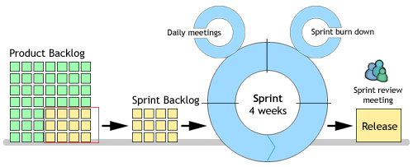](http://www.google.co.uk/url?sa=i&rct=j&q=&esrc=s&source=images&cd=&cad=rja&uact=8&ved=0ahUKEwiaptClqZbXAhUDWRoKHY1pBUMQjRwIBw&url=http://www.agile-tools.net/scrum.asp&psig=AOvVaw20CHP9oA44IJ9upCMMKyPU&ust=1509383335726249)

(Agile-tools.net, 2017)

**Advantages**

* The project has a completed work product at the end of each sprint that can be interacted with allowing for changes to be made when they are needed.

**Disadvantages**

* Documentation related to the development is minimum if any as the developers can jump straight in to produce their work.
* All stake holders need to remain in constant communication.

**3.6 Life cycle chosen and why**

The waterfall method lends itself to my kind of project well. My project is small and defined so little will change as the project gets to the later stages, the scope is big enough that new ideas will not be need to added later. On top of this most of the technology I will be using I already have used which should limit unforeseen problems and anything I done not understand can be researched up front before implementation. Agile is great for teams but a more defined system with lots of documentation will be more important for my project as I alone will work on it.

**3.7 Plan for the management of project data**

I intend to GitHub to keep all the files in one place and will be able to roll back in accidental deletion, I will also keep periodic backups of my work on my memory stick

4.0 Estimate the project’s effort for tasks

1. Fully Functional Website

1.1.1 Research programming language (PHP vs ruby)

1.1.2 Choose a language document the decision making process

1.6 Fully documented testing process

1.6.1 Create a list of task for testing based of functionality and requirements

1.6.2 Create completed Volere templates for tasks

1.4 Messaging systems

1.4.1 Server side chat system

1.4.2.1

Research web sockets for live chat functionality and online status

1.4.2.2 Integrate Live Chat functionality

1.4.3.1

Research Twilio or alternative for VOIP

1.4.3.2 Integrate a VOIP, Text messaging and phone call system on the website/in app

1.4.2 Live Chat

1.4.3 VOIP, Text messages, Phone Calls

1.2.1 Storyboard website design

1.2.2 Storyboard app design

1.2 Website design layout

1.3.1 Implement layout plus design with HTML and CSS

1.3.4 Sanitise user inputs so that user cannot mess with the database

1.3 Develop Website/app

1.3.5 Use apache Cordova software to convert website to a web browser application

1.3.2 Use chosen language to add server side functionality to the website

1.3.3 Create a database to contain user data

1.5 Add Features

1.5.1 Public Report Issue

1.5.2 Private Report Issue

1.5.3 Generate Report for SSCC

1.6.3 Pass/Fail

Checklist

1.6.4 Fix any problems that occur run test until all success

1.1 choose language

**4.1(WBS) top-level work breakdown**

**4.2 WBS Dictionary**

|  |
| --- |
| Project Title: Improved Student Issue Reporting and Resolution by effective communication with the Course Representative through a Website or an Application |
| WBS Number: 1.1.1 |
| WBS Item Name: Research programming language (PHP vs ruby) |
| Description: Research each language and what each can do differently. |

|  |
| --- |
| Project Title: Improved Student Issue Reporting and Resolution by effective communication with the Course Representative through a Website or an Application |
| WBS Number: 1.1.2 |
| WBS Item Name: Choose a language document the decision-making process |
| Description: weigh the pros and cons of each language and explain the decision I come to for which to use the choice will be used in the server side stage of the development. |

|  |
| --- |
| Project Title: Improved Student Issue Reporting and Resolution by effective communication with the Course Representative through a Website or an Application |
| WBS Number: 1.2.1 |
| WBS Item Name: Storyboard website design |
| Description: create designs for the website |

|  |
| --- |
| Project Title: Improved Student Issue Reporting and Resolution by effective communication with the Course Representative through a Website or an Application |
| WBS Number: 1.2.2 |
| WBS Item Name: Storyboard app design |
| Description: create designs for the application |

|  |
| --- |
| Project Title: Improved Student Issue Reporting and Resolution by effective communication with the Course Representative through a Website or an Application |
| WBS Number:1.3.1 |
| WBS Item Name: Implement layout plus design with HTML and CSS |
| Description: Create the website designed in 1.2.1 |

|  |
| --- |
| Project Title: Improved Student Issue Reporting and Resolution by effective communication with the Course Representative through a Website or an Application |
| WBS Number:1.3.2 |
| WBS Item Name: Use chosen language to add server side functionality to the website |
| Description: User accounts, Sessions etc |

|  |
| --- |
| Project Title: Improved Student Issue Reporting and Resolution by effective communication with the Course Representative through a Website or an Application |
| WBS Number: 1.3.3 |
| WBS Item Name: Create a database to contain user data |
| Description: Create a MySQL database that will contain data on users. |

|  |
| --- |
| Project Title: Improved Student Issue Reporting and Resolution by effective communication with the Course Representative through a Website or an Application |
| WBS Number: 1.3.4 |
| WBS Item Name: Sanitise user inputs so that user cannot mess with the database |
| Description: When reading a text field and using it in query’s for the database make sure the code is checked for anything malicious and does not run any unintended commands |

|  |
| --- |
| Project Title: Improved Student Issue Reporting and Resolution by effective communication with the Course Representative through a Website or an Application |
| WBS Number:1.3.5 |
| WBS Item Name: Use apache Cordova software to make convert website to a web browser application |
| Description: I knew about web browser applications from the mobile development module, it uses HTML, CSS and JavaScript, instead of java and xml in a native android application. These languages are the same ones used in a website so it should be possible to create an application based on the code created for the website research indicates that apache Cordova can do this. I need to implement this to get an application. |

|  |
| --- |
| Project Title: Improved Student Issue Reporting and Resolution by effective communication with the Course Representative through a Website or an Application |
| WBS Number: 1.4.1 |
| WBS Item Name: Server side chat |
| Description: A simple post on wall system for leaving messages. |

|  |
| --- |
| Project Title: Improved Student Issue Reporting and Resolution by effective communication with the Course Representative through a Website or an Application |
| WBS Number: 1.4.2 |
| WBS Item Name: Live Chat |
| Description: Identify a more involved method of communication than just post on a wall. |

|  |
| --- |
| Project Title: Improved Student Issue Reporting and Resolution by effective communication with the Course Representative through a Website or an Application |
| WBS Number: 1.4.2.1 |
| WBS Item Name: Research web sockets for live chat functionality and online status |
| Description: |

|  |
| --- |
| Project Title: Improved Student Issue Reporting and Resolution by effective communication with the Course Representative through a Website or an Application |
| WBS Number: 1.4.2.2 |
| WBS Item Name: Integrate Live Chat functionality |
| Description: Have a live chat functionality like messenger group chat on Facebook where other users can see who is online and who is typing. |

|  |
| --- |
| Project Title: Improved Student Issue Reporting and Resolution by effective communication with the Course Representative through a Website or an Application |
| WBS Number: 1.4.3 |
| WBS Item Name: VOIP, Text messages, Phone Calls |
| Description: Establish several other means for communication beyond messaging. |

|  |
| --- |
| Project Title: Improved Student Issue Reporting and Resolution by effective communication with the Course Representative through a Website or an Application |
| WBS Number: 1.4.3.1 |
| WBS Item Name: Research Twilio or alternative for VOIP |
| Description: I discovered Twilio for making phone calls or internet calls from inside a website or application. I need to identify and explain how I will get this to works in a report and find alternative services and compare them. |

|  |
| --- |
| Project Title: Improved Student Issue Reporting and Resolution by effective communication with the Course Representative through a Website or an Application |
| WBS Number: 1.4.3.2 |
| WBS Item Name: Integrate a VOIP, Text messaging and phone call system on the website/in app |
| Description: Add software to the website and the application that will allow the users to call or message each other through other methods. |

|  |
| --- |
| Project Title: Improved Student Issue Reporting and Resolution by effective communication with the Course Representative through a Website or an Application |
| WBS Number: 1.5.1 |
| WBS Item Name: Public Report Issue |
| Description: A public post of an issue giving all the other students a chance to respond with an answer. An option to sticky the post to the top of the page will be available to the course representative, the course representative will be able to add things to a calendar specific to their course. An option will exist to state if the problem has been resolved. |

|  |
| --- |
| Project Title: Improved Student Issue Reporting and Resolution by effective communication with the Course Representative through a Website or an Application |
| WBS Number: 1.5.2 |
| WBS Item Name: Private Report Issue |
| Description: If a student wants to report an issue to the student representative without posting it public. This feature will have option for allowing the student and course representative to state if the problem has been resolved. |

|  |
| --- |
| Project Title: Improved Student Issue Reporting and Resolution by effective communication with the Course Representative through a Website or an Application |
| WBS Number: 1.5.3 |
| WBS Item Name: Generate Report for SSCC |
| Description: A piece of code that will use the public and private reports to help the course representative create the Staff/Student consultative committees report |

|  |
| --- |
| Project Title: Improved Student Issue Reporting and Resolution by effective communication with the Course Representative through a Website or an Application |
| WBS Number: 1.6.1 |
| WBS Item Name: Create a list of tasks for testing based of functionality and requirements |
| Description: To make sure the website works as intended we need to test all the functionality of the website, we also need to make sure all the requirement for the project have been met. For this purpose I will create a list of things to test. |

|  |
| --- |
| Project Title: Improved Student Issue Reporting and Resolution by effective communication with the Course Representative through a Website or an Application |
| WBS Number: 1.6.2 |
| WBS Item Name: Create completed Volere templates for tasks |
| Description: Use a Volere template or something similar, to explain each test, how it is going to be performed and what purpose it has in the project. |

|  |
| --- |
| Project Title: Improved Student Issue Reporting and Resolution by effective communication with the Course Representative through a Website or an Application |
| WBS Number: 1.6.3 |
| WBS Item Name: Pass/Fail checklist |
| Description: create check list of all the tasks created in 1.6.2. for the purpose of mark of the task as a pass of fail after the test is run. |

|  |
| --- |
| Project Title: Improved Student Issue Reporting and Resolution by effective communication with the Course Representative through a Website or an Application |
| WBS Number: 1.6.4 |
| WBS Item Name: Fix any problems that occur run test until all success |
| Description: If any of the test failed correct the error and run all test again to make sure you didn’t break anything else, keep doing until a test past. |

**PERT Analysis**

Using the PERT formula I can get an estimation of how long it would take to complete all the parts of the WBS. The formula is as follows

Pessimistic time + 4x most likely time + optimistic time

6

(Mindtools.com, 2017)

WBS 1.1.1 Choose a language document the decision making process

Research each language and what each can do differently. The comparison should be based on which has the most useful features and which would be easier to code.

This will involve learning a bit of ruby and getting a list of the features for both languages.

I think this will take some time to complete, optimistically it could be done in 3 hours. Learning the code 1.5 hours and the report 1.5 hours = 3 hours

More realistically it will take 2.5 hours for learning the code and 3.5 hours for the report = 6 hours.

Worst case scenario the code could take 3 hours and the report 5 hours = 8 hours

Using the PERT equation this gives us the following formula (3+4*6+8)/6=6 hours rounded up to the next half hour.

|  |  |
| --- | --- |
| WBS number: 1.1.1 | |
| PERT Analysis Time Estimate | Actual Time |
| 6 Hours |  |

WBS 1.2.1 Storyboard website design

Created storyboard drawings of the design of the website I intend to make.

This could take 2 hours optimistically, 4 hours realistically and 7 hours in the worst case.

Using the PERT formula (2+4*4+7)/6=4.5 hours rounding up to the next half hour.

|  |  |
| --- | --- |
| WBS number: 1.2.1 | |
| PERT Analysis Time Estimate | Actual Time |
| 4.5 Hours |  |

WBS 1.2.2 Storyboard app design

Created storyboard drawings of the design of the Application I intend to make. Many things can be taken from the website storyboard reducing time estimations.

This could take 1 hour optimistically, 2 hours realistically and 4 hours in the worst case.

Using the PERT formula (1+4*2+4)/6=2.5 hours rounding up to the next half hour.

|  |  |
| --- | --- |
| WBS number: 1.2.2 | |
| PERT Analysis Time Estimate | Actual Time |
| 2.5 Hours |  |

WBS 1.3.1 Implement layout plus design with HTML and CSS

Write the code to add in text, button, form items and other HTML items, then make it look nice with a public Bootstrap CSS form.

This could take 3 days optimistically to get everything to sit right, 7 days realistically and 2 weeks worst case scenario.

Using the PERT formula (3+4*7+14)/6=7.5 days is the expecting time to completion.

|  |  |
| --- | --- |
| WBS number: 1.3.1 | |
| PERT Analysis Time Estimate | Actual Time |
| 7.5 days |  |

WBS 1.3.2 Use chosen language to add server side functionality to the website

Write code to get the website to respond to the users actions and allow them to enter data, they should be able to have their own account and a session should be able to call data related to them so the website can display the data they need.

This could take 1.5 days optimistically, 3 realistically and 6 in the worst case scenario.

Using the PERT formula (1.5+4*3+6)/6=3.5 round up to next half day.

|  |  |
| --- | --- |
| WBS number: 1.3.2 | |
| PERT Analysis Time Estimate | Actual Time |
| 3.5 days |  |

WBS 1.3.3 Create a database to contain user data

The database will need to be able to store all the data relevant to the user and the user’s actions.

Optimistically this could take 1 day, 1.5 realistically and 3.5 worst case.

Using the PERT formula (1+4*1.5+3.5)/6=2 rounded up the next half day.

|  |  |
| --- | --- |
| WBS number: 1.3.3 | |
| PERT Analysis Time Estimate | Actual Time |
| 2 days |  |

WBS 1.3.4 Sanitise user inputs so that user cannot mess with the database

This is important but should not take long as it should be just adding a line of code to each input to make sure it is not treated as a command.

This could take 0.05 hours optimistically, 0.15 hours realistically and 1 hour in the worst case.

Using the PERT formula (0.05+4*0.15+1)/6=0.5 hours rounded to the next half an hour.

|  |  |
| --- | --- |
| WBS number: 1.3.4 | |
| PERT Analysis Time Estimate | Actual Time |
| 30 minutes |  |

WBS 1.3.5 Use apache Cordova software to make convert website to a web browser application

This may not be easy, the idea is that the code from the website will use the smart phones web browser technologies like DOM and BOM to run and layout out the application, these technologies are the similar to the desktop versions but fundamentally they read HTML, CSS, JavaScript, JQuery, JSON and other languages, they connect to the server and the server runs the server side languages like PHP, and Ruby. They act like an offline webpage but the content will be altered to work better with the screen size and the interface and show up on the device like any other application.

Presuming all goes well it should be a quick redesign to make it sit right could take 2 days optimistically, realistically it might take 5 days and worst case scenario a complete recoding for the application and maybe having to use android studio with the Java and XML could take 3 weeks.

Using the PERT formula (2+4*5+21)/6=7.5 days rounded up to the next half day.

|  |  |
| --- | --- |
| WBS number: 1.3.5 | |
| PERT Analysis Time Estimate | Actual Time |
| 7.5 days |  |

WBS 1.4.1 Server side chat

Post that will appear on a while for all user to see

This could optimistically take 0.25 days, realistically 2 days and worst case 6 days.

Using the PERT formula (0.25+4*2+6)/6=2.5 days rounded up to the nearest half day.

|  |  |
| --- | --- |
| WBS number: 1.3.5 | |
| PERT Analysis Time Estimate | Actual Time |
| 2.5 days |  |

WBS 1.4.2.1 Research web sockets for live chat functionality and online status

Research and document an understanding of web sockets and how they work. Develop a testing piece of software and include the code with the report.

This could optimistically take 0.5 days, realistically 2 days and in the worst case scenario 1 week.

Using the PERT formula (0.5+4*2+7)/6=3 days rounded up to the next half day.

|  |  |
| --- | --- |
| WBS number: 1.4.2.1 | |
| PERT Analysis Time Estimate | Actual Time |
| 3 days |  |

WBS 1.4.2.2 Integrate Live Chat functionality

If the research is done correctly this should not prove too difficult and this stage should not start until that is finished.

This could take 0.33 hours optimistically, with a few difficulties realistically this might take 2 hours and worst case scenario it might take 8 hours.

Using the PERT formula (0.33+4*2+8)/6=3 hours rounded up to the next half hour.

|  |  |
| --- | --- |
| WBS number: 1.4.2.2 | |
| PERT Analysis Time Estimate | Actual Time |
| 3 Hours |  |

WBS 1.4.3.1 Research Twilio or alternative for VOIP

Research and document an understanding of Twilio or alternative and how they work. Develop a testing piece of software and include the code with the report.

This could optimistically take 1 days, realistically 3 days and in the worst case scenario 9 days.

Using the PERT formula (1+4*3+9)/6=4 days rounded up to the next half day.

|  |  |
| --- | --- |
| WBS number: 1.4.3.1 | |
| PERT Analysis Time Estimate | Actual Time |
| 4 days |  |

1.4.3.2 Integrate a VOIP, Text messaging and phone call system on the website/in app

If the research is done correctly this should not prove too difficult and this stage should not start until that is finished.

This could take 0.33 hours optimistically, with a few difficulties realistically this might take 2 hours and worst case scenario it might take 8 hours.

Using the PERT formula (0.33+4*2+8)/6=3 hours rounded up to the next half hour.

|  |  |
| --- | --- |
| WBS number: 1.4.3.2 | |
| PERT Analysis Time Estimate | Actual Time |
| 3 Hours |  |

WBS 1.5.1 Public Report Issue

Add HTML forms for the posting of this comment and PHP or ruby features for checking completion. The posting system should have been created in 1.3.1 this should not take very long to add.

This could take 1 hour optimistically, 2 hours realistically and 5 hours worst case scenario.

Using the PERT formula (1+4*2+5)/6=2.5 hours rounded up to the next half hour.

|  |  |
| --- | --- |
| WBS number: 1.5.1 | |
| PERT Analysis Time Estimate | Actual Time |
| 2.5 Hours |  |

WBS 1.5.2 Private Report Issue

This should only be available between the student reporting the issue and the student representative. This will require a new part of the website to be created to see this report as it will not be posted on the wall.

This could take 1 day to complete optimistically, 3 day realistically and 7 days worst case scenario.

Using the PERT formula (1+4*3+7)/6=3.5 days rounded up to the next half day.

|  |  |
| --- | --- |
| WBS number: 1.5.2 | |
| PERT Analysis Time Estimate | Actual Time |
| 3.5 days |  |

WBS 1.5.3 Generate Report for SSCC

This report will generate the data from the public and private reports as a template that the student representative will then be able to review and comment on, the student union guide to raising concerns with the tutors/course director will be available. The student representative will as always have to ensure that the reports are fair, unbiased and make since to be reported.

This could to take 1 day optimistically, 3 days realistically and 1 week in the worst case scenario.

Using the PERT formula (1+4*3+7)/6=3.5 days rounded up to the next half day.

|  |  |
| --- | --- |
| WBS number: 1.5.3 | |
| PERT Analysis Time Estimate | Actual Time |
| 3.5 days |  |

WBS 1.6.1 Create a list of task for testing based of functionality and requirements

The list could be large for a website of this scope.

Optimistically this could take 2 hours to collect all the data, 3.5 hours realistically, 6 hours worst case scenario.

Using the PERT formula (2+4*3.5+6)/6=4 hour rounded up to the next half hour.

|  |  |
| --- | --- |
| WBS number: 1.6.1 | |
| PERT Analysis Time Estimate | Actual Time |
| 4 hours |  |

WBS 1.6.2 Create completed Volere templates for tasks

Using the list created in 1.6.1 and a Volere template or Volere template like table detail each of the task that need to be tested.

Optimistically this could take 1.5 hours, realistically 5 hours and worst case scenario 10 hours.

Using the PERT formula (1.5+4*5+10)/6=5.5 hours rounded up to the next half hour.

|  |  |
| --- | --- |
| WBS number: 1.6.2 | |
| PERT Analysis Time Estimate | Actual Time |
| 5.5 Hours |  |

WBS 1.6.3 Pass/Fail checklist

Creating a checklist from list created in 1.6.1 should be a simple table with a box beside each test to mark pass or fail

Optimistically this could take 0.33 hours, realistically 0.5 hours and worst case 1.5 hours.

Using the PERT formula (0.33+4*0.5+1.5)/6=1 hour rounded up to the next half hour.

|  |  |
| --- | --- |
| WBS number: 1.6.3 | |
| PERT Analysis Time Estimate | Actual Time |
| 1 Hour |  |

WBS 1.6.4 Fix any problems that occur run test until all success

If the previous stages all went well this should be a quick run through of the checklist. If not then the problems should be documented and fixed then all test ran again.

Optimistically if all the test succeed this might only take 10 minutes (0.166. hours), realistically 2 hours and worst case scenario it could take 10 hours.

Using the PERT Formula (0.166+4*2+10)/6=3.5 hours rounded up to the next half hour.

|  |  |
| --- | --- |
| WBS number: 1.6.4 | |
| PERT Analysis Time Estimate | Actual Time |
| 3.5 Hours |  |

PERT Analysis results

By determining how long each WBS item will take to complete I have calculated that the project should take 46.5 days to complete.

**4.4 Gantt chart**

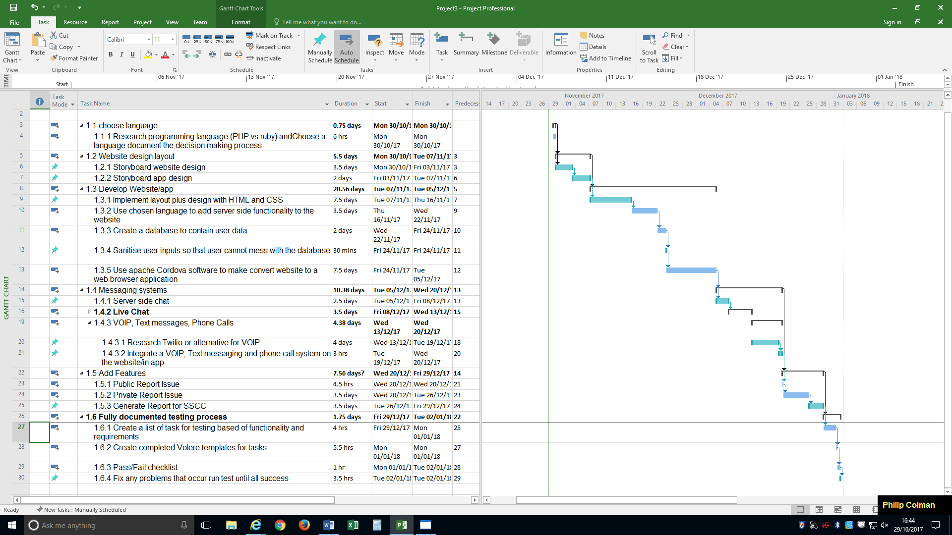

(WBS) Table form

1. Fully Functional Website

1.1 choose language

1.1.1 Research programming language (PHP vs ruby)

1.1.2 Choose a language document the decision making process

1.2 Website design layout

1.2.1 Storyboard website design

1.2.2 Storyboard app design

1.3 Develop Website/app

1.3.1 Implement layout plus design with HTML and CSS

1.3.2 Use chosen language to add server side functionality to the website

1.3.3 Create a database to contain user data

1.3.4 Sanitise user inputs so that user cannot mess with the database

1.3.5 Use apache Cordova software to make convert website to a web browser application

1.4 Messaging systems

1.4.1 Server side chat

1.4.2 Live Chat

1.4.2.1 Research web sockets for live chat functionality and online status

1.4.2.2 Integrate Live Chat functionality

1.4.3 VOIP, Text messages, Phone Calls

1.4.3.1 Research Twilio or alternative for VOIP

1.4.3.2 Integrate a VOIP, Text messaging and phone call system on the website/in app

1.5 Add Features

1.5.1 Public Report Issue

1.5.2 Private Report Issue

1.5.3 Generate Report for SSCC

1.6 Fully documented testing process

1.6.1 Create a list of task for testing based of functionality and requirements

1.6.2 Create completed Volere templates for tasks

1.6.3 Pass/Fail checklist

1.6.4 Fix any problems that occur run test until all success

5.0 Commitments

|  |  |  |  |
| --- | --- | --- | --- |
| Project Title: Improved Student Issue Reporting and Resolution by effective communication with the Course Representative through a Website or an Application  Date of Authorization: 6/10/17  Project start date: 28/9/17  Project Finish date: 22/4/17 | | | |
| Milestones:   * Begin * Planning * Research * Website design * Implement design * Implement messaging capabilities * Implement issue reporting * Documented Testing * end | | | |
| Budget Information: We are allocating £0 as I will be using your personal devices to setup the system and there is free open source software available for use | | | |
| Project Manager: Philip Colman 07412598998 colman-p@email.ulster.ac.uk | | | |
| Project Objectives: The website and application should be able to allow communication by several different methods and allow for the student to report issues to the representative privately or to the group. | | | |
| Main Project Success Criteria: The website should allow for an issue report to be posted and then it should be able to take certain information like title, subject, resolved or not and then display this information in a report for the student representative to comment on. | | | |
| Approach: following the waterfall lifecycle model to design implement and test the website and application with plenty of documentation. | | | |
| Roles | | | |
| Name | Role | Position | Contact information |
| Dewar Finlay | sponsor | Supervisor | D.finlay@ulster.ac.uk |
| Philip Colman | Project Manager | Manager | Colman-p@email.ulster.ac.uk |
| Philip Colman | Team member | Programmer | Colman-p@email.ulster.ac.uk |
| Sign Off Signatures:  Philip Colman | | | |

References:

<https://stackify.com/what-is-sdlc/>

<https://manifesto.co.uk/agile-vs-waterfall-comparing-project-management-methodologies/>

<https://www.technologyuk.net/software-development/sad/images/waterfall_model.gif>

<https://www.technologyuk.net/software-development/sad/other-models.shtml>

<https://airbrake.io/blog/sdlc/iterative-model>

<https://www.inflectra.com/methodologies/waterfall.aspx>

<https://www.mountaingoatsoftware.com/presentations/an-introduction-to-scrum>

<https://www.scrumalliance.org/why-scrum>

<https://www.projectsmart.co.uk/work-breakdown-structure-purpose-process-pitfalls.php>

<https://auth0.com/blog/converting-your-web-app-to-mobile/>

<http://www.agile-tools.net/scrum.asp>

<https://www.mindtools.com/pages/article/critical-path-analysis.htm>

Bibliography:

Schwalbe, Kathy. *Information Technology Project Management*. 1st ed.

Stackify. (2017). *What is SDLC? Understand the Software Development Life Cycle*. [online] Available at: https://stackify.com/what-is-sdlc/ [Accessed 29 Oct. 2017].

Bowes, J. (2017). *Agile vs Waterfall - Comparing project management methods*. [online] Manifesto. Available at: https://manifesto.co.uk/agile-vs-waterfall-comparing-project-management-methodologies/ [Accessed 29 Oct. 2017].

Technologyuk.net. (2017). *Cite a Website - Cite This For Me*. [online] Available at: https://www.technologyuk.net/software-development/sad/images/waterfall_model.gif [Accessed 29 Oct. 2017].

Wells, C. (2017). *Other Life Cycle Models*. [online] Technologyuk.net. Available at: https://www.technologyuk.net/software-development/sad/other-models.shtml [Accessed 29 Oct. 2017].

Powell-Morse, A. (2017). *Iterative Model: What Is It And When Should You Use It?*. [online] Airbrake Blog. Available at: https://airbrake.io/blog/sdlc/iterative-model [Accessed 29 Oct. 2017].

Inflectra.com. (2017). *What is Waterfall & Hybrid Development? | Methodologies | Inflectra*. [online] Available at: https://www.inflectra.com/methodologies/waterfall.aspx [Accessed 29 Oct. 2017].

Cohn, M. (2017). *Introduction to Scrum PPT - Scrum Methodology*. [online] Mountain Goat Software. Available at: https://www.mountaingoatsoftware.com/presentations/an-introduction-to-scrum [Accessed 29 Oct. 2017].

Scrumalliance.org. (2017). *What is Scrum? An Agile Framework for Completing Complex Projects - Scrum Alliance*. [online] Available at: https://www.scrumalliance.org/why-scrum [Accessed 29 Oct. 2017].

Project Smart. (2017). *Work Breakdown Structure (WBS) Purpose, Process and Pitfalls*. [online] Available at: https://www.projectsmart.co.uk/work-breakdown-structure-purpose-process-pitfalls.php [Accessed 29 Oct. 2017].

Kukic, A., Kukic, A. and Peyrott, S. (2017). *Convert your Web App to a Mobile App with Apache Cordova*. [online] Auth0 - Blog. Available at: https://auth0.com/blog/converting-your-web-app-to-mobile/ [Accessed 29 Oct. 2017].

Agile-tools.net. (2017). *Agile Tools | Project Management Open-Source and Free Software*. [online] Available at: http://www.agile-tools.net/scrum.asp [Accessed 29 Oct. 2017].

Mindtools.com. (2017). *Critical Path Analysis and PERT Charts: Planning and Scheduling More Complex Projects*. [online] Available at: https://www.mindtools.com/pages/article/critical-path-analysis.htm [Accessed 29 Oct. 2017].