**Process Areas**

Category 1 - Requirements Development and Management

To Identifying what is required in a project we must understand the needs of the stakeholders from the product. In my project, I identified students as a stakeholder. One of the primary aims of my project is to be able resolve problems that the students may face. The students need this to be possible or the project has no meaningful purpose to them. Therefore, a means of communication between the student and another student or their course representative (another stakeholder) needs to be possible through the website or application. We have therefore determined that a requirement for the project will be at least one means of communication.

After what is needed we can look at wants. To get more requirement for the project. Wants like needs add value to a project, where as a need is a must have in order for the project to be useful, wants can give the project an advantage over other similar products. In the case of my project I am aiming to replace a Facebook group with a dedicated website/application for problem reporting for a group of students. To do this I must add value over the features present on a competing platform.

Facebook currently uses a wall to display all post to the group, it works in chronological order (most recent post first then older) with a dedicated system I could prioritize current issues to appear before resolved issues and latest updates like deadlines, results or just social interaction could be displayed separately. I believe this would be more useful to students. These features can be considered a requirement to the functioning of the project as they are part of the purpose of the project.

Once we have identified the requirement we need to document them. This involves explaining what they are and give them an id. I have typically used a modified Volere template to do this. I give an example of below.

|  |
| --- |
| Project Title: Improved Student Issue Reporting and Resolution by effective communication with the Course Representative through a Website or an Application |
| WBS Number: 1.1.2 |
| WBS Item Name: Choose a language document the decision-making process |
| Description: weigh the pros and cons of each language and explain the decision I come to for which to use the choice will be used in the server side stage of the development. |

Once the requirements have been identified we can develop a Work Breakdown Structure (WBS) and start to plan testing documentation for the requirements. After we have developed the project we can then test are requirements using the testing documentation to see if the requirements are met.

I have done this several times in university and college and was tasked with this in the group work for the advanced website development module. Below is from the minutes taken by the group for that project.

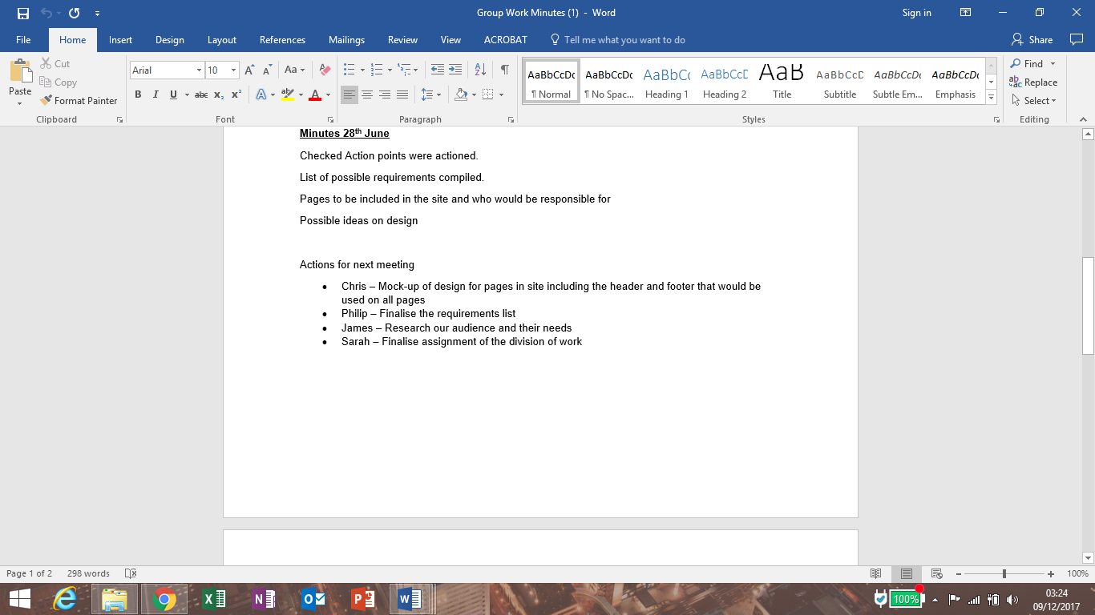

Category 2 - Design & Development

Storyboards, graphics

**Communication**

Category 3 - Listen actively, to others' views and understand their point of view

In my current employment, I am responsible for resolving guest’s problems in work. I must identify the problem and act to resolve it quickly. It is important that I listen to the guest and ensure that they are happy with the actions taken because if our guest have any issues with their order they will leave disappointed and that will give us a bad reputation. Understanding what the issue is, is key to fixing it but understanding the guest needs and how it has affected them is also important. An apology for a mistake is a simple thing that is important and recognising when further recompense is required can be gained from an understanding of the guest situation.

I am also responsible for operation of the restaurant which involves organizing the team. Working effectively with staff isn’t just about getting them to complete the assigned task. Understanding the situation that the crew members are in is important also as a failure to listen to any issues that arise from them could result in incorrectly completed work are undue stress for the crew member.

As part of the group work for the Advanced website development I took part in several meetings that involved listening to the ideas of other members of the group, we discussed who would be most effective and which task this involved understanding the other members of the group.

Effective communication is going to be the main purpose of website/application so it is important that I understand the importance of listening to others and how to make sure the point that they are trying to make is not lost through the medium they are using (my website/application). For example, a report on an issue should be allowed as much data size as it may need to so that the user can go into all the detail that they need compared with a post that is news, update or reminder that can get away with a smaller data size on the main page. This smaller limit should be enough to inform upfront with access to more information via a link to another page.

It will also be important that I use this skill at several stages of the development to get the opinion of others on what I am doing right and wrong.

Category 4 - Present ideas to different audiences using appropriate media

Talking in front of people

Group chats

email

Creating documentation to explain things

Organizing Christmas dinner for work

**Improving own learning and performance**

Category 5 - Manage and prioritize time to meet deadlines  
PERT, ERD, GANTT Charts etc

Category 6 - Reference materials using an appropriate system   
Harvard – Any assignment I ever did uni or tech.

**Problem Solving**   
Category 7 - Initiate, take decisions and act resourcefully

It  
  
As a supervisor I am responsible for many things that happen in the restaurant resolving any issues that a guest may have, resolve any cash discrepancies, manage staff to ensure effective operations of the restaurant, that task are being completed, problems resolved, acquiring resource when they are short, ordering stock etc.  
Supervisor, managing staff, ordering stock, cash handling (petty cash)

Something in the group work maybe

Category 8 - Set down and carry out a systematic sequence of activities  
This basically deciding where to begin and planning where you are going with the activities. It is important to think about this sort of thing as there can be many activities that need completed before the overall task can be considered complete. If you rush in you may not complete everything or may find that you have had to repeat certain activities, or run out of/overuse resources. Where as if you took the time to think you may be able to identify all the task. You may find that you can done certain task earlier or all at once before another task that would otherwise have had to be repeated every time and you may not require as many resources to complete the tasks.

To complete the activity effectively you must first identify what the overall task is and what tasks will be needed to complete that task. We can break the overall task up in to ways, we can picture a completed task and determine what parts where required to make this happen, this would be a top down work break down structure, alternatively we could look at common task and build them up to the finish product, this would be a bottom up work break down structure, using both methods together should allow you to identify many of the tasks required for the overall task. This does require that you can imagine the task either from experience or research if you do not have enough information you will not get all the tasks.

I do this in many places writing this report for an example I identify what points I will need to structure and build my answer. In my project plan, I created a work break down structure to help me identify tasks I am going to need to complete in order to have a website and application that does as I intend by the end of my project. In work, I plan what is required to effectively get ready to open, operate or close the restaurant. In this example, one of the earlier things I do in the morning is prepare the food that is stored in the chiller. If this is left until the last cold food will be put on the burgers, then the burgers get cold before the guests eat them. From this I am already structuring the tasks that I will need to complete and when I will need to complete them.

**Team Work**

Category 9 - Operate in a range of supportive roles within teams  
I have lots of team work experience as I worked for a Reed Recruitment Hospitality and Catering that sent me to different kitchens and restaurants to work, in each place I went to there were lots of difference and the position I was to fill differed everywhere I went.

I also have experience working in several BHS restaurants where I was in both a staff member and sometimes the most senior member at times.

I then moved to Burger King where I have worked in many different restaurants doing many different jobs, eventually getting promoted to supervisor where I have many responsibilities effectively managing staff roles to ensure fast safe and friendly service.   
  
I have worked as part of a group in both university and college for several project the most recent 2 would be embedded electronic systems and Website something – Fix -. In the embedded electronics assignment Sarah and myself took responsibility for the input side of the project and Christopher and James took responsibility for the output both sides of the project had to ensure communication between the devices

Category 10 - Take initiative and lead others  
I was promoted to supervisor in August 2016 in Burger king, which involved many new responsibilities. One of which was the authority to lead other members of staff in operating the restaurant in accordance of my other responsibilities. I would have to demonstrate the initiative to complete tasks and resolve issues.

Course representative – evidence certificate

I have been the representative to my course from second year, I have reported several issues reported from members of my course, provided feedback to the course director through the sscc and attended several students union meeting.

**Security and ethics**Category 11 - Security threats and countermeasures

Covered this throughout university how to make your code less vulnerable

Key holder for work

Category 12 - Social, legal and ethical considerations  
Food safety

Work environment BKU for proof

Covered this in first and second year of uni state things learned and marks I got

2 skills each category

evidence their possession of key skills associated with undertaking a final year capstone project

systematic collection of student work and related material that depicts a student's activities, accomplishments, knowledge and achievements

evidence will be collected from the modules on the course but work experience and other experiences should also be used. Try and balance.

Evidence evidence evidence