**SIS Football Analytics Challenge-Submission Tutorial**

In order to ensure that your work is seen and qualifies for judging, follow the submission guidelines outlined below:

1. Fork the AnalyticsChallenge2020 Repository to your own GitHub Profile:
   * This will create a copy of the repository on your profile

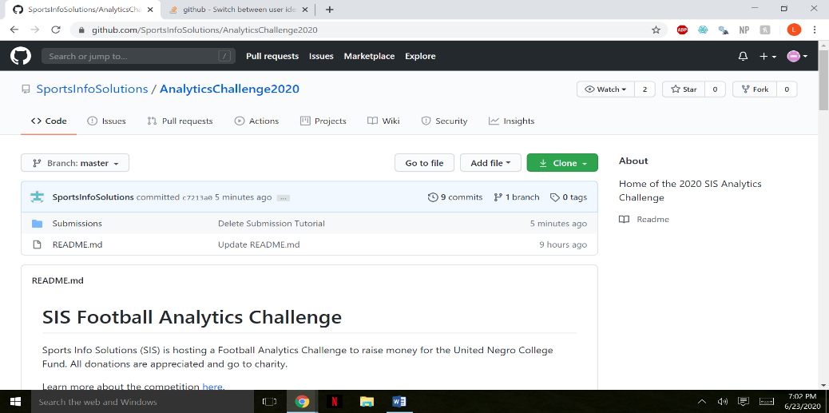

1. Upload any relevant submission materials into a subfolder of the submission folder in the forked repository.
   * The subfolder should be titled in the format ‘example@email.com’ at an address which you can be reached at in the event that your project is selected as a finalist.

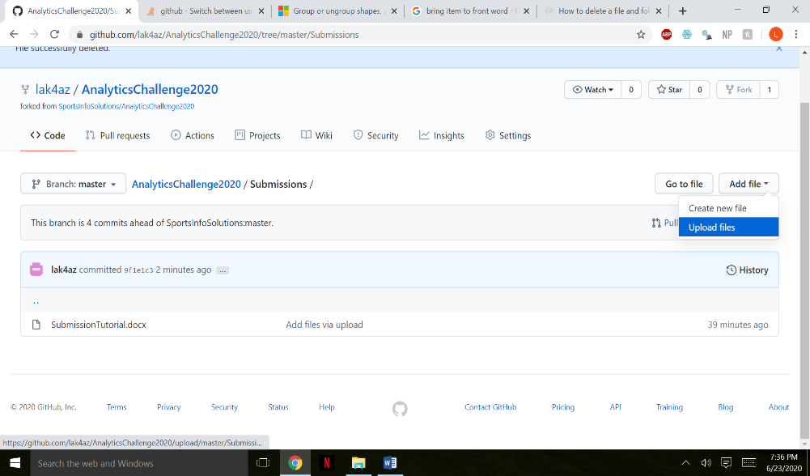

* + An easy way to do this is to save all of your relevant submission materials locally in the folder ‘example@email.com’ and drag the folder into the upload box.

