OPERATING SYSTEMS - LABORATORY EXAM 2
Program Execution Screenshots (Sample Input & Output)

1. First-Come, First-Served (FCFS) [Non-Preemptive]

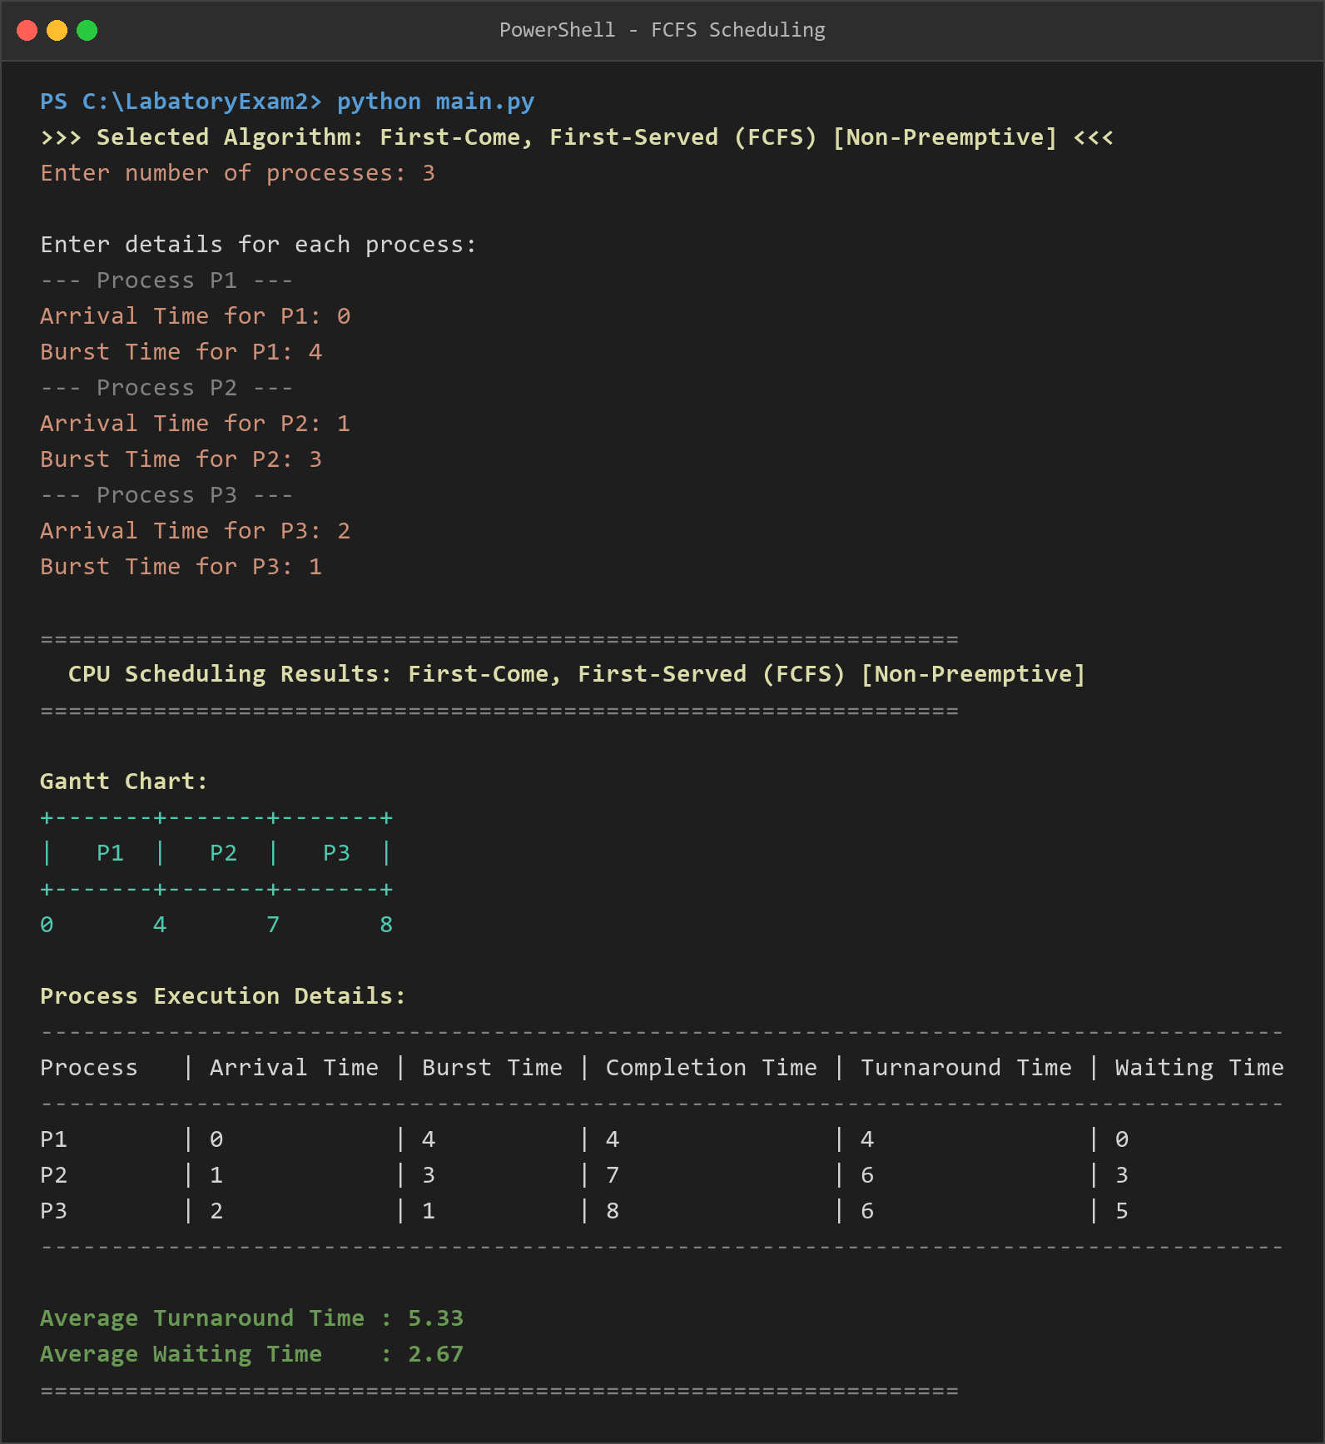

2. Shortest Job First (SJF) [Non-Preemptive]

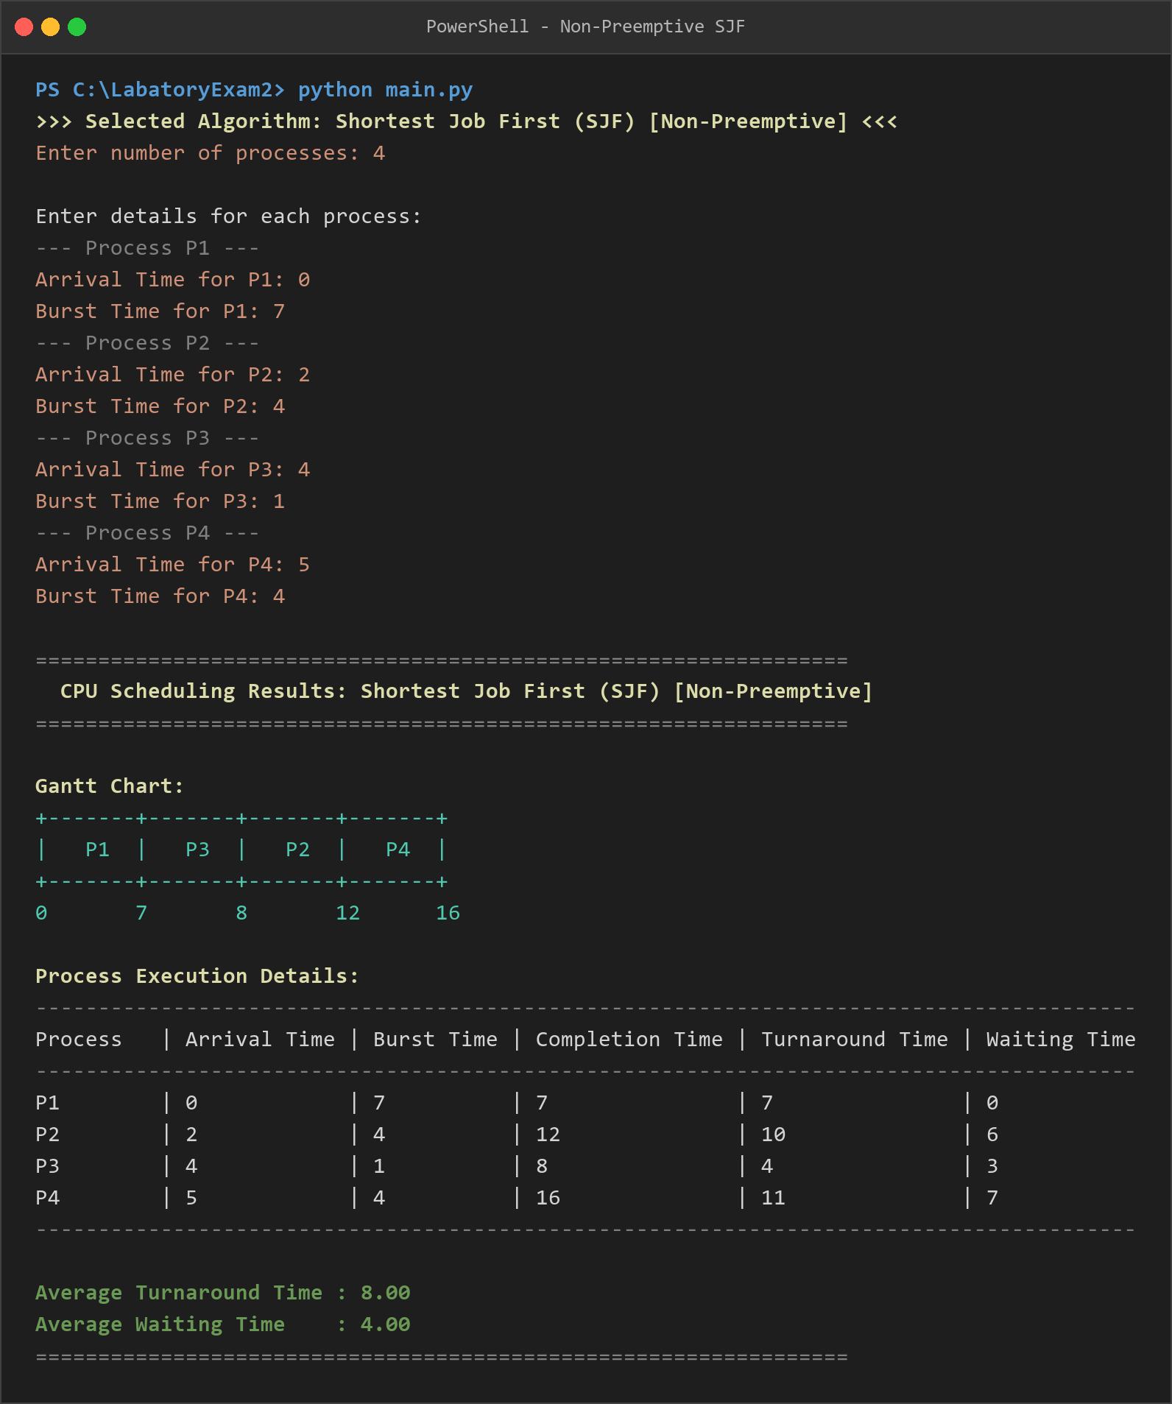

3. Shortest Remaining Time First (SRTF) [Preemptive SJF]

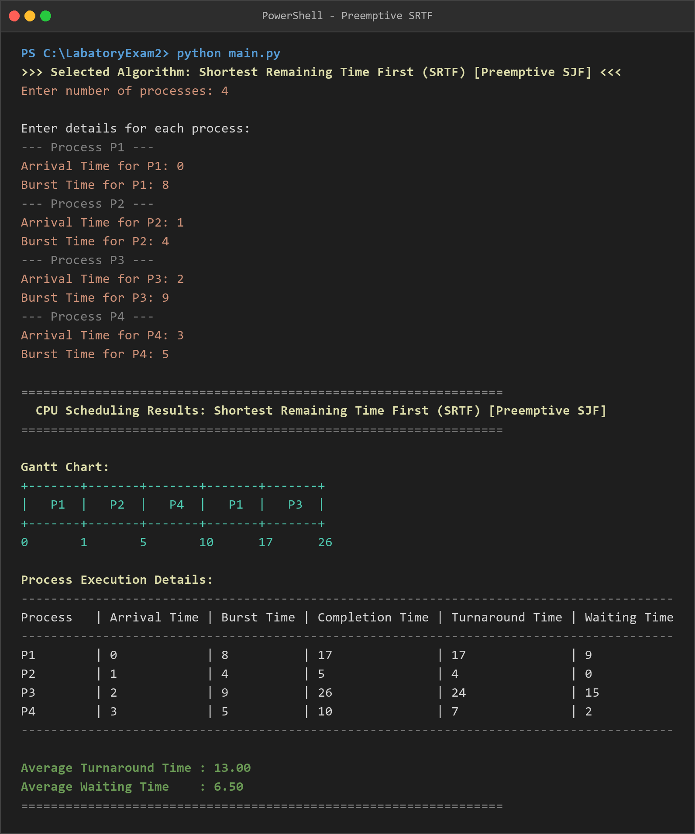

4. Round Robin (RR, Quantum = 2) [Preemptive]

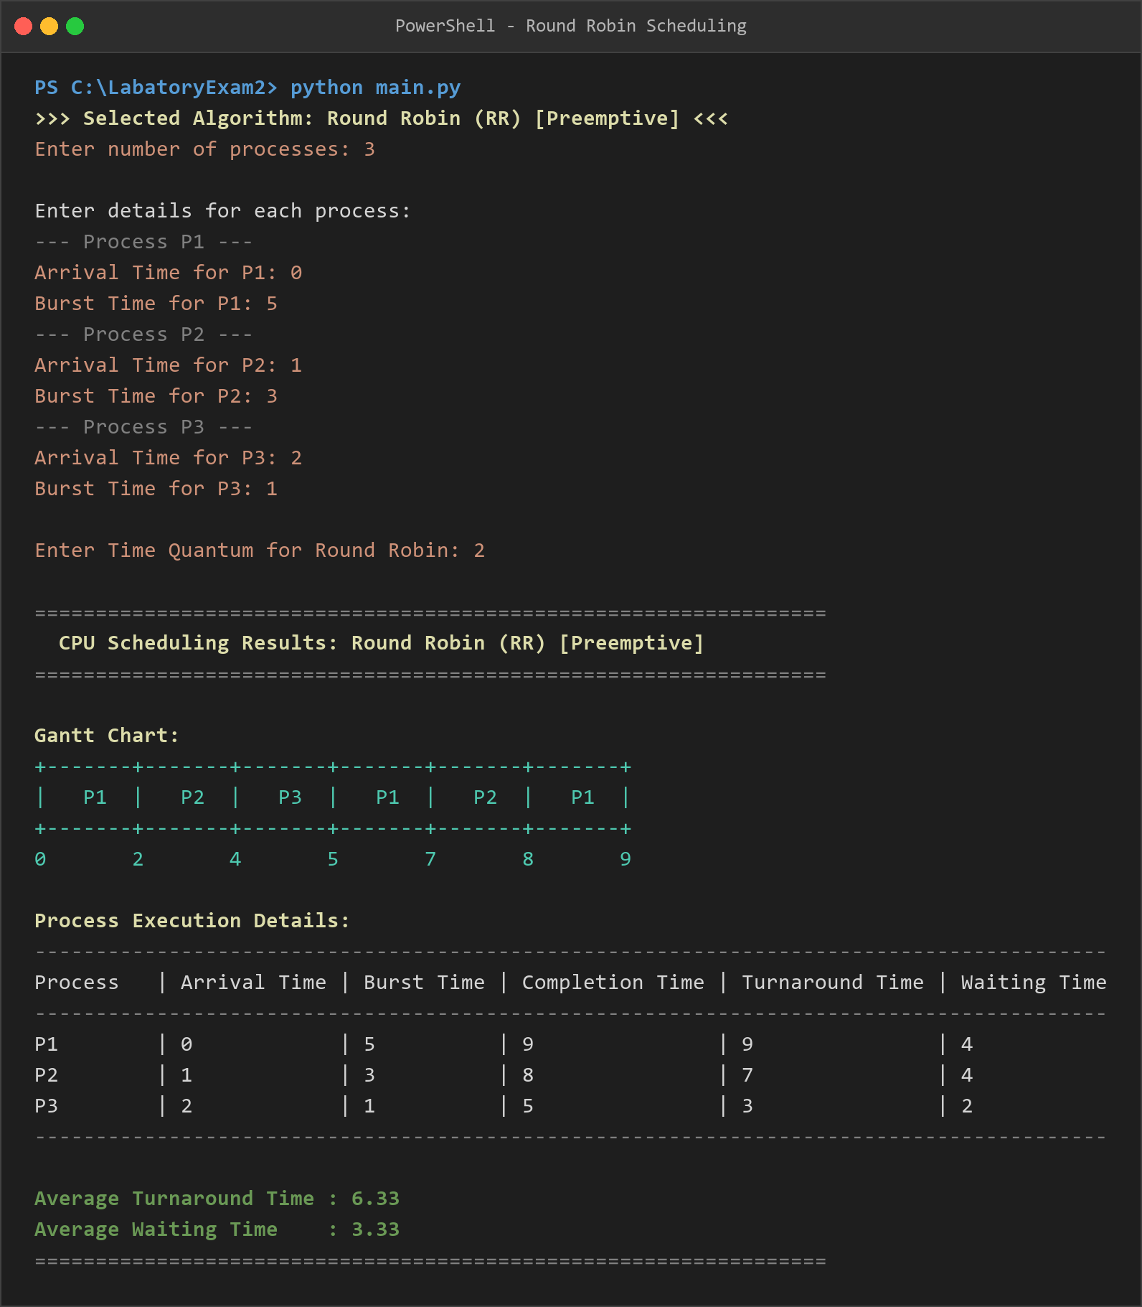

5. Banker's Algorithm (Pre-configured Reference Sample)

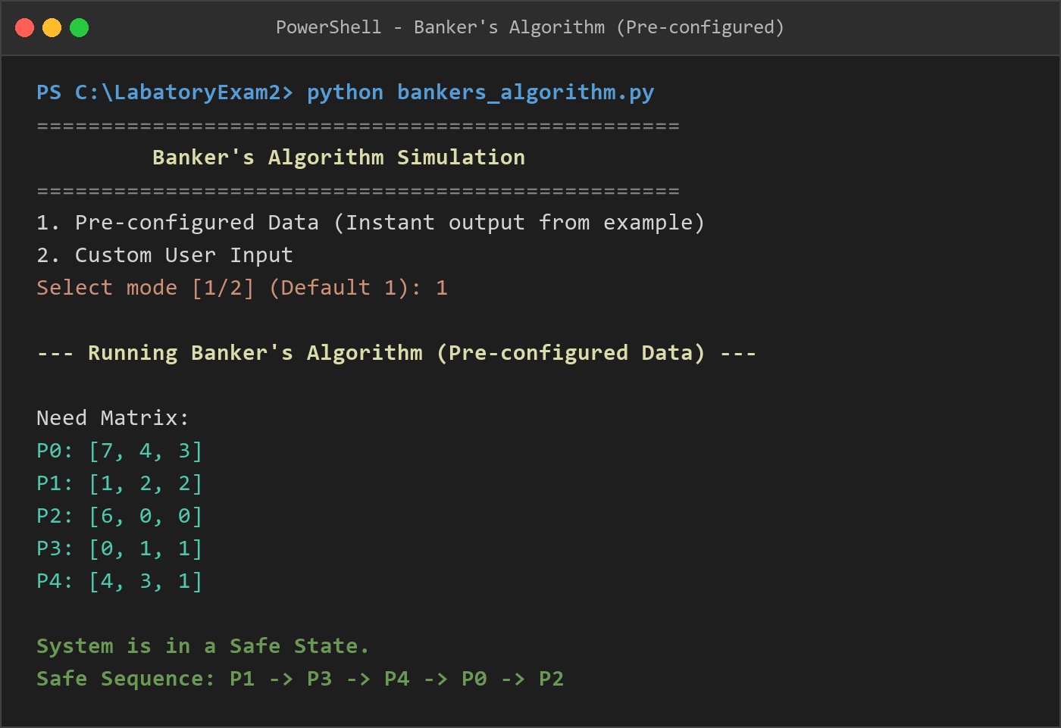

6. Banker's Algorithm (Custom User Matrix Input)

