**Exercise 8.2:**

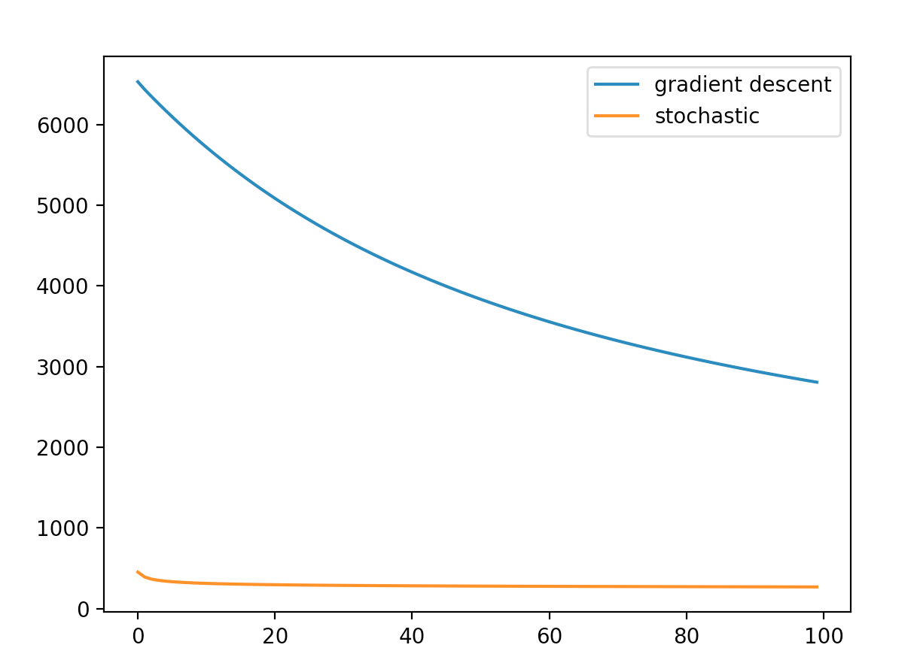

Employ the softmax cost function to fit this data.

**Exercise 9.1:**

1. Please see the source code in the zip file

b)

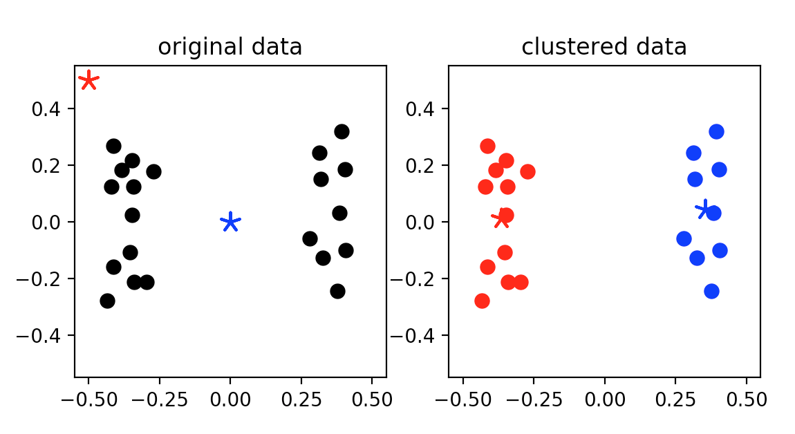

1. Compare with b), here change the location of the initial point, the result also change

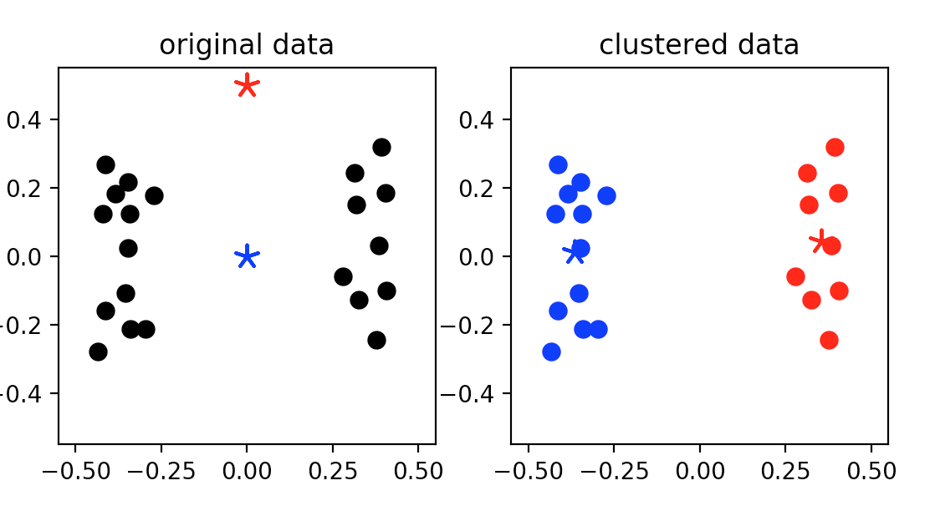

**Exercise 9.2:**

a)

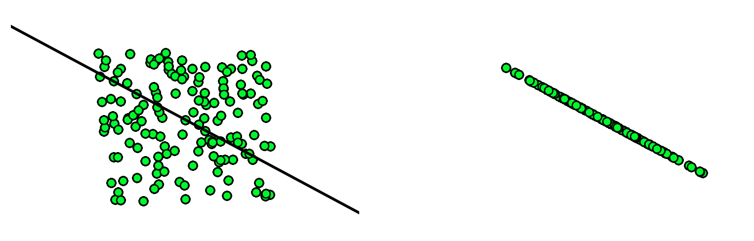

b)

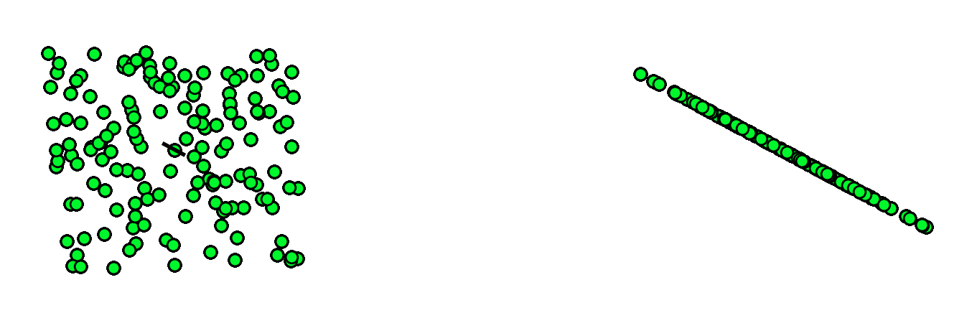

**Exercise 9.4:**

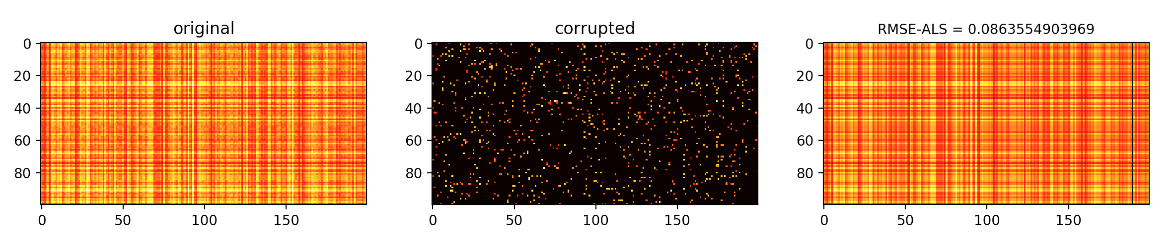

more detail, please see the source code inside zip file