**4.16**

**a)** Using the OvA framework to solve this problem:

The accuracy of trained model on this training set is 92%

**b)** The accuracy of this model on a new test dataset is 91%

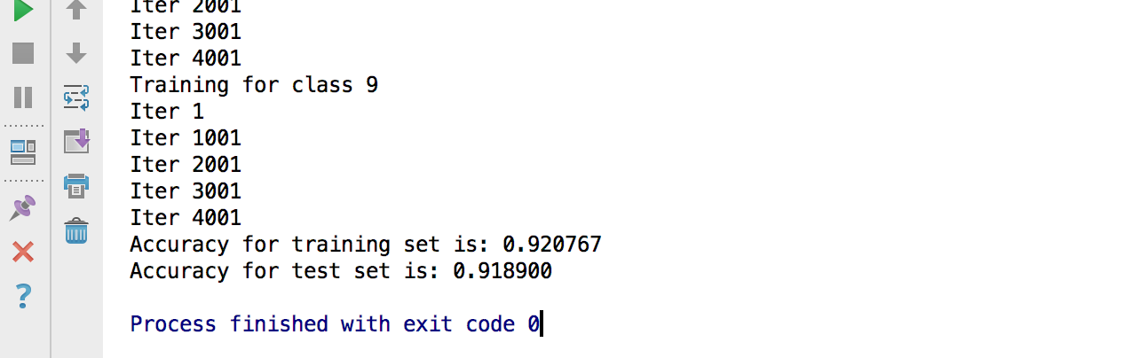

For more detail, please read the code file exercise_4_16_hw.py, running it on the python 3.5+