**PERSONAL EXPENSE TRACKER**

**Batch Members:**

**1.Pattappu prathyusha**

**2.Assifa.A**

**3.Akshaya.k**

**4.Resma.G**

**Question 1:**

Create a bucket in IBM object storage.

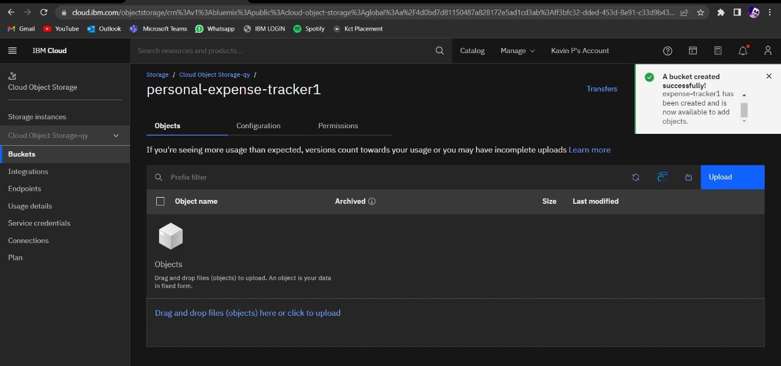

**Question 2:**

Upload any 5 images to IBM object storage and make it public. Write

HTML code to displaying all the 5 images

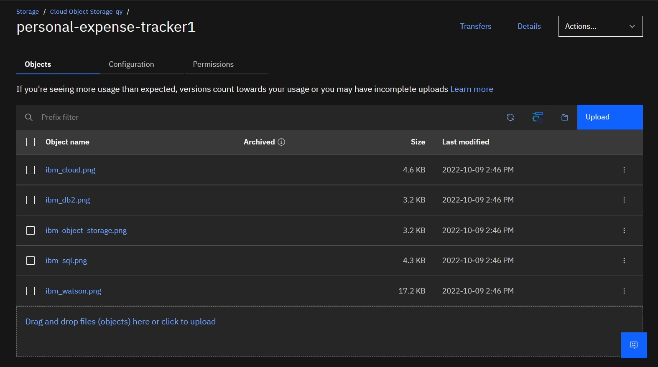

**HTML Codes for displaying images:**

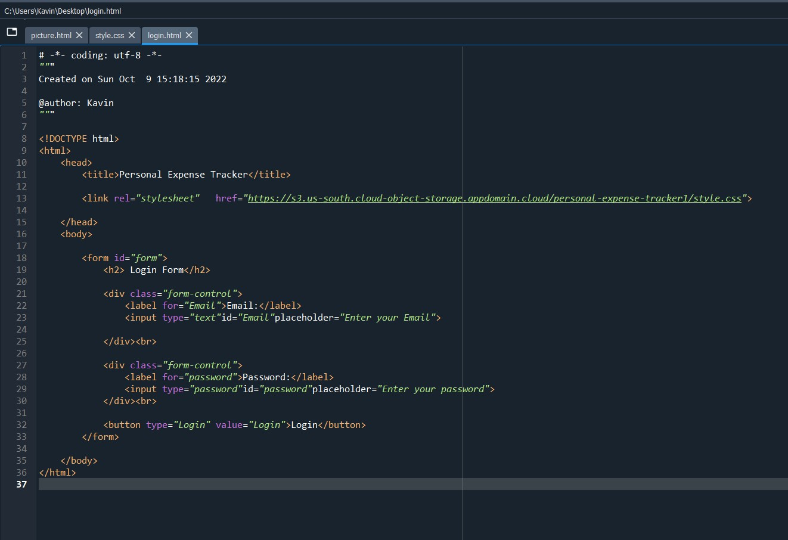

**HTML Output for displaying images from IBM cloud storage:**

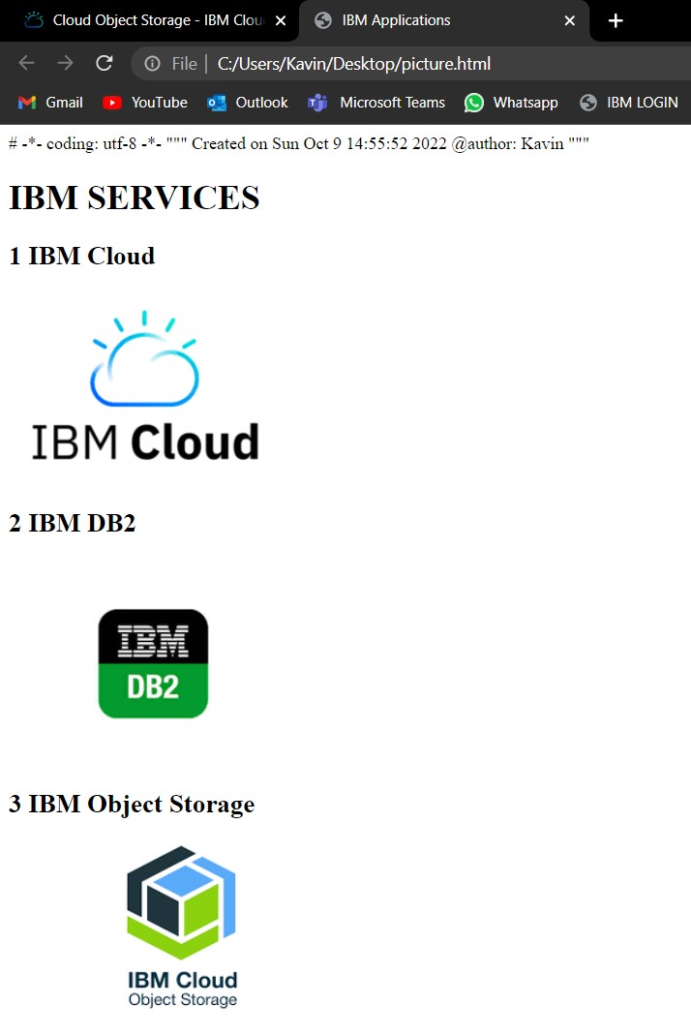

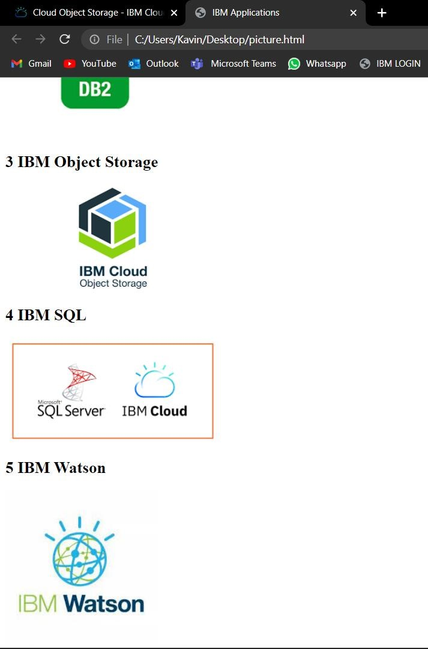

**Question 3:**

Upload a CSS page to the object storage and use the same page in your HTML code.

**HTML code with CSS file present in IBM cloud storage:**

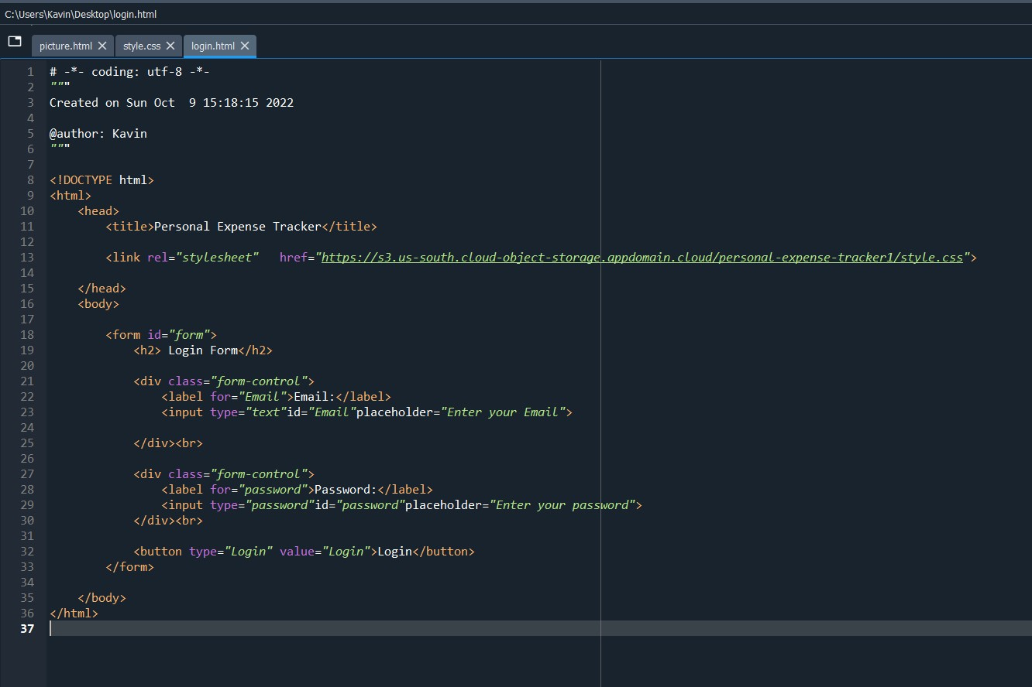

**CSS file in Cloud object storage:**

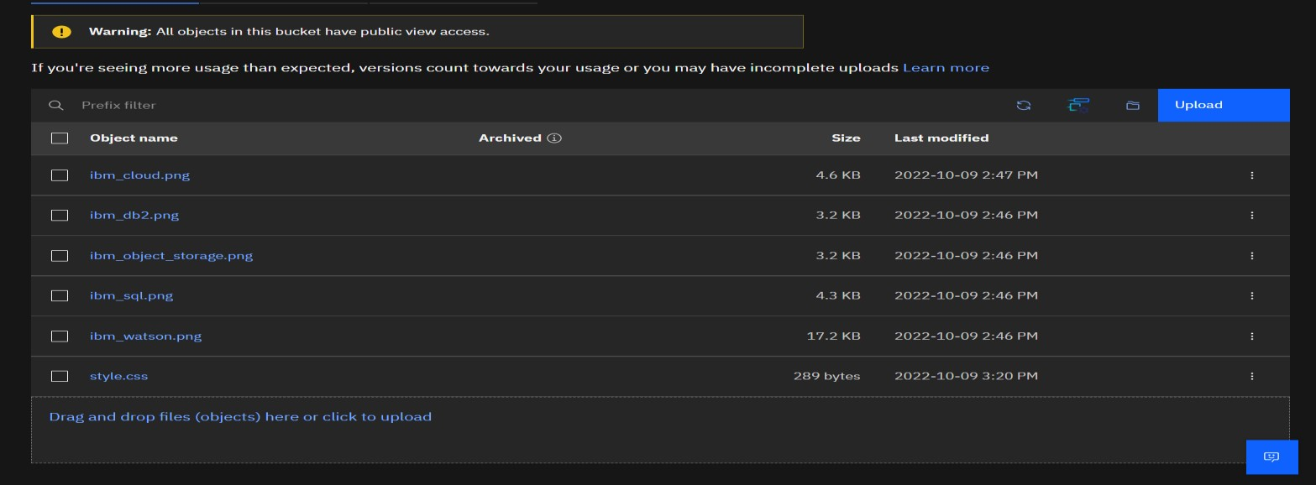

**Login form without linking CSS:**

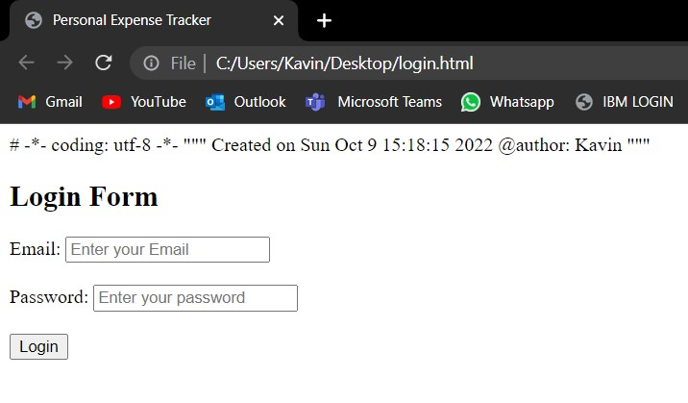

**Login form after linking CSS file from cloud object storage:**

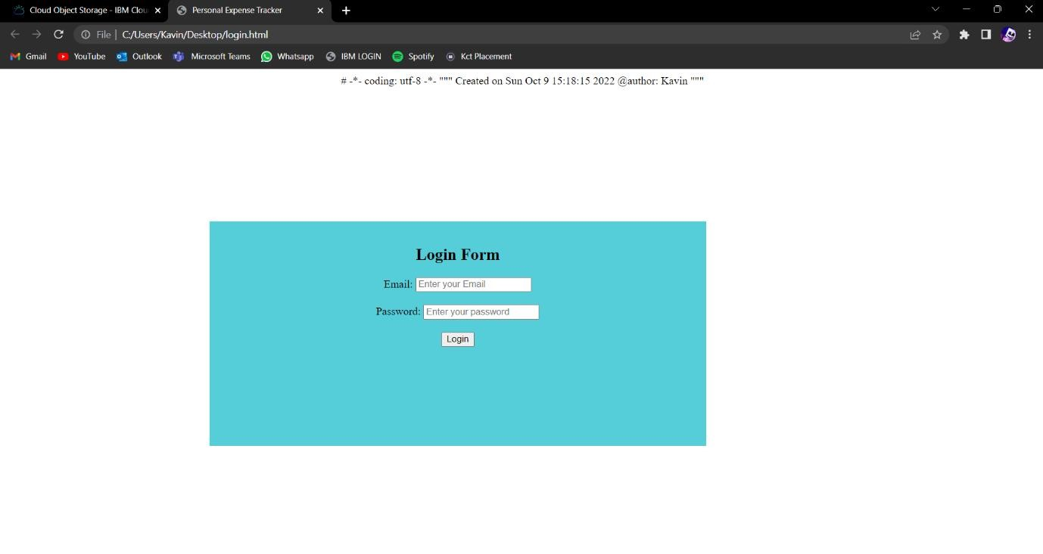

**Question 4:**

Design a chatbot using IBM Watson assistant for hospital. Ex: User comes with query to know the branches for that hospital in your city. Submit the web URL of that chat bot as an assignment.

**Web URL for the chat bot:**

[https://webchat.global.assistant.watson.appdomain.cloud/preview.html?backgroundI mageURL=https%3A%2F%2Fussouth.assistant.watson.cloud.ibm.com%2Fpublic%2Fimages%2Fupx8a33a4e3-e284-45a9-a604-b026f5069724%3A%3A14d9d246-cde448cc-b35a-6bd37df4f7db&integrationID=904b425f-0565-435d-b945d125163837ee&region=us-south&serviceInstanceID=8a33a4e3-e28445a9-a604-b026f5069724](https://web-chat.global.assistant.watson.appdomain.cloud/preview.html?backgroundImageURL=https%3A%2F%2Fus-south.assistant.watson.cloud.ibm.com%2Fpublic%2Fimages%2Fupx-8a33a4e3-e284-45a9-a604-b026f5069724%3A%3A14d9d246-cde4-48cc-b35a-6bd37df4f7db&integrationID=904b425f-0565-435d-b945-d125163837ee&region=us-south&serviceInstanceID=8a33a4e3-e284-45a9-a604-b026f5069724)

**Chat bot on webpage:**

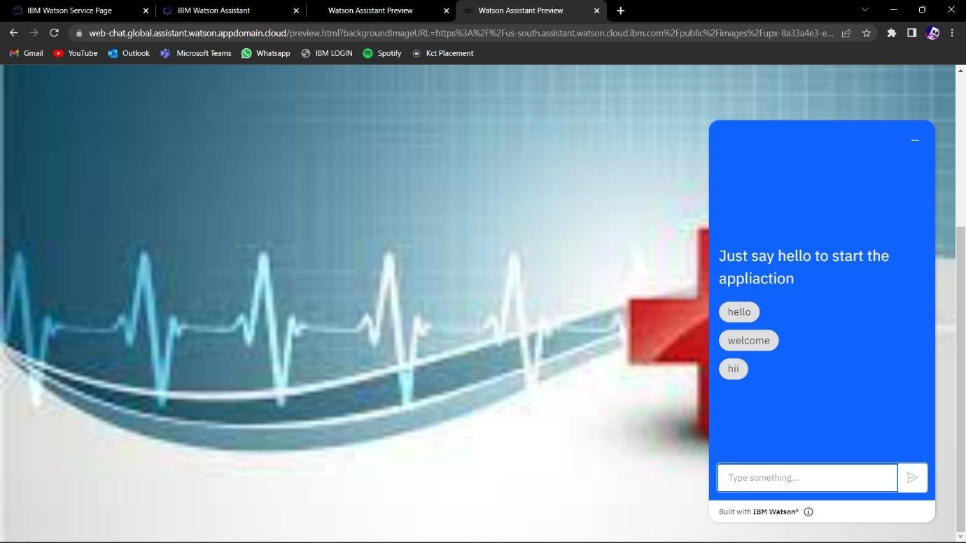

**Question 5:**

Create Watson assistant service with 10 steps and use 3 conditions in it. Load that script in HTML page.

**Script in HTML page:**

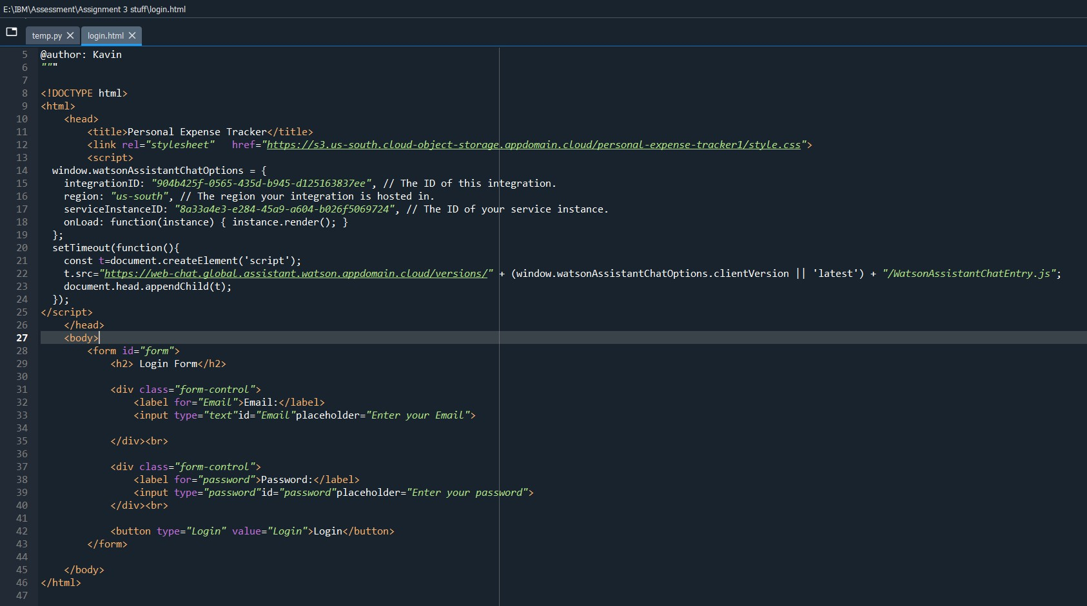

**Watson assistant embedded on webpage:**

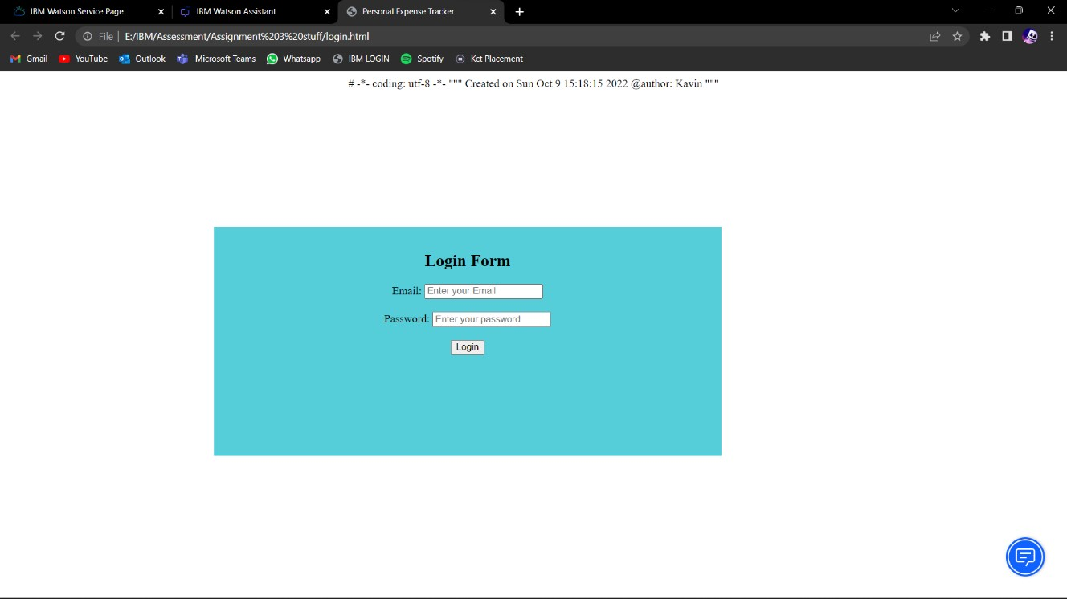

**Interaction with web bot:**