时序图用在线PlantUML工具绘制

网址：[http://www.plantuml.com/plantuml/uml](https://link.jianshu.com/?t=http%3A%2F%2Fwww.plantuml.com%2Fplantuml%2Fuml)

**登录**

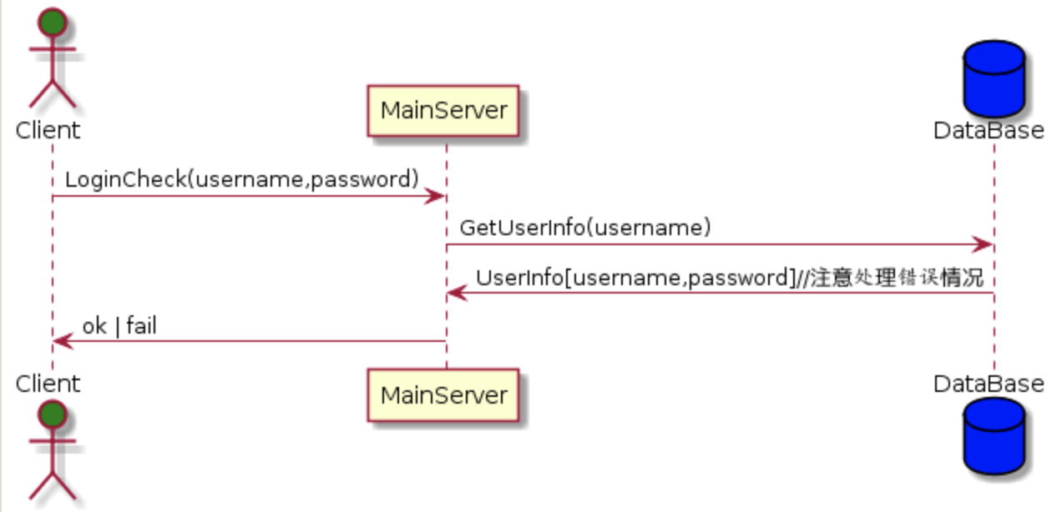

**注册**

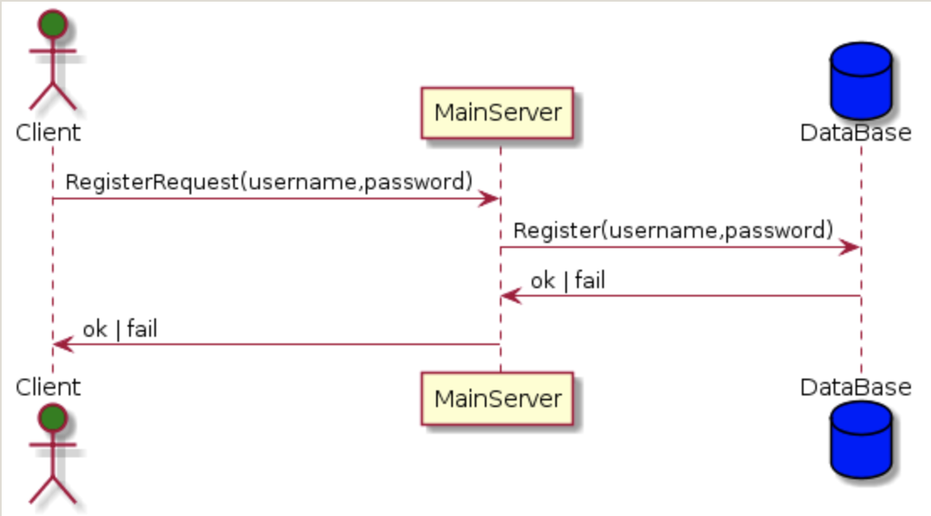

**主界面**

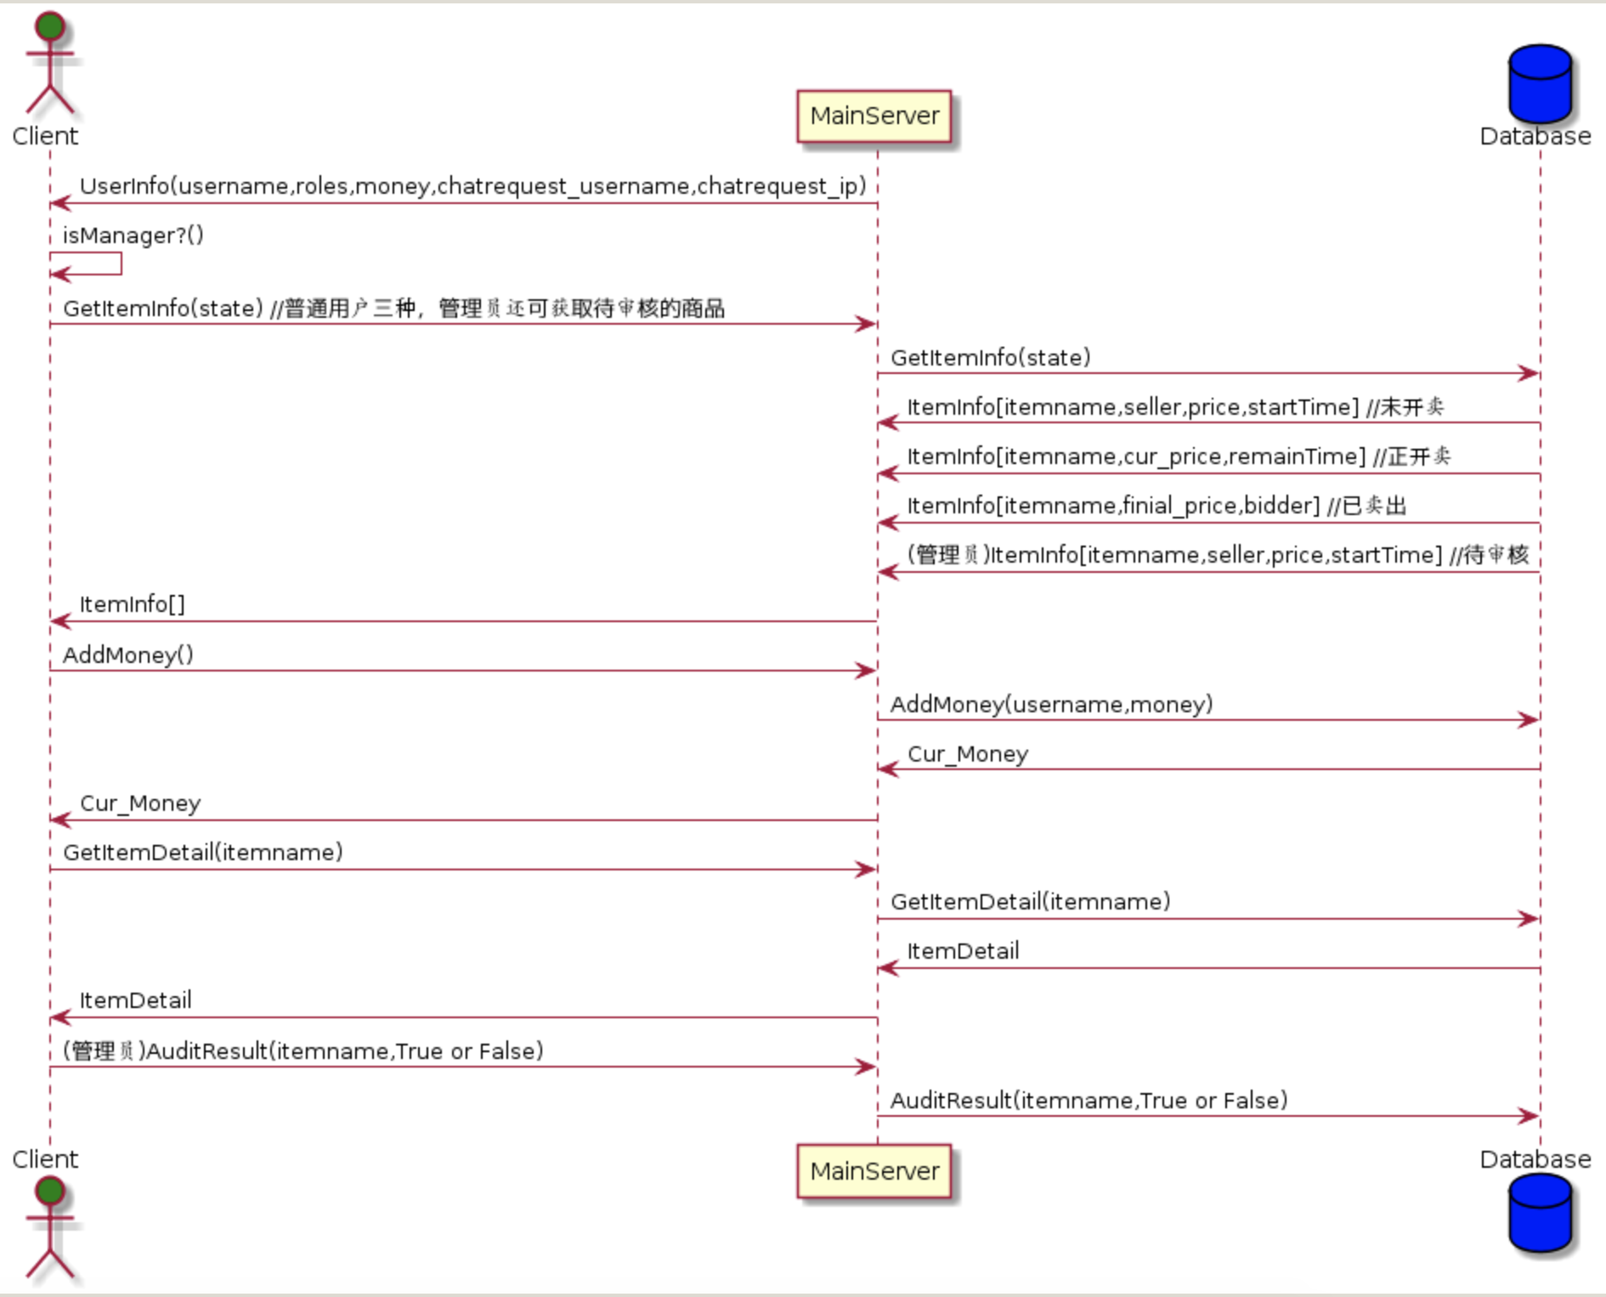

**拍卖**

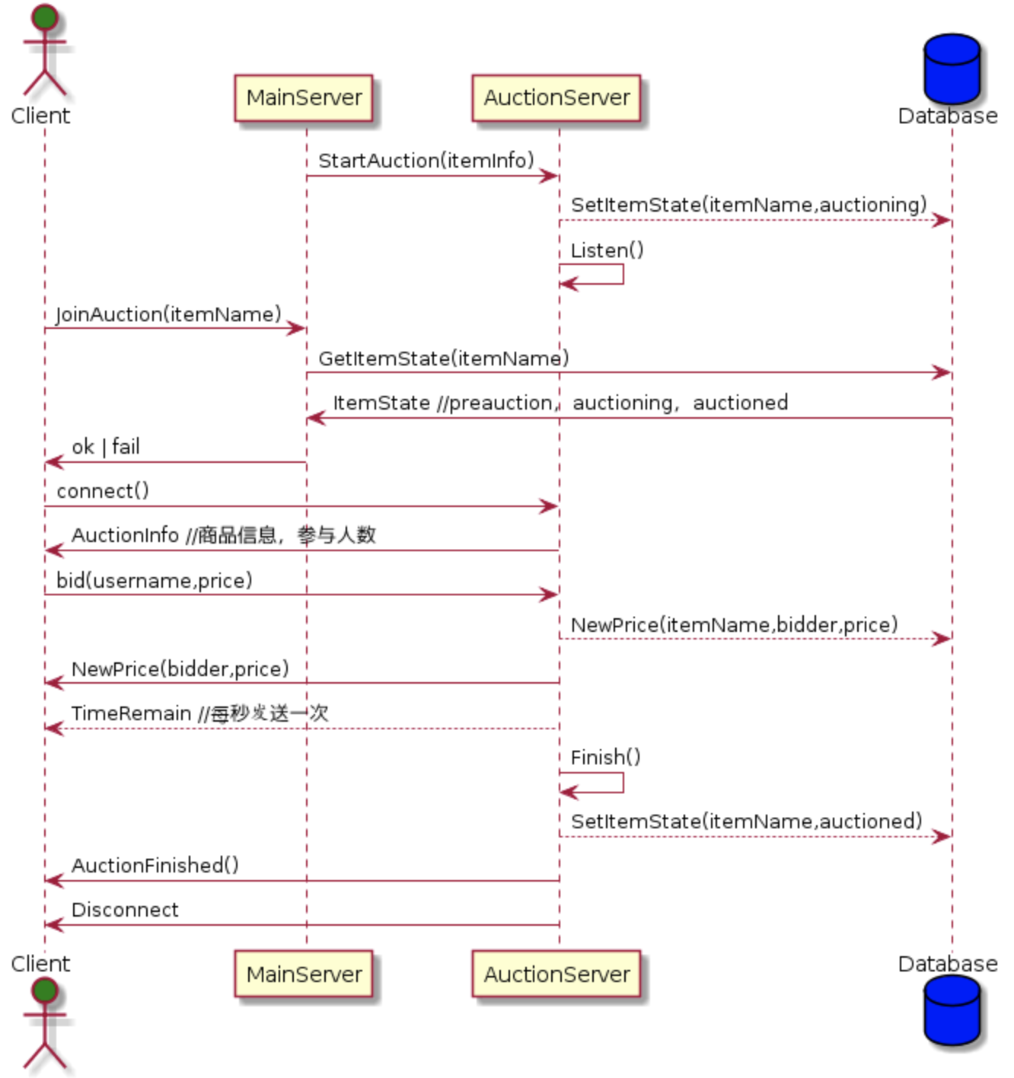

**私聊**

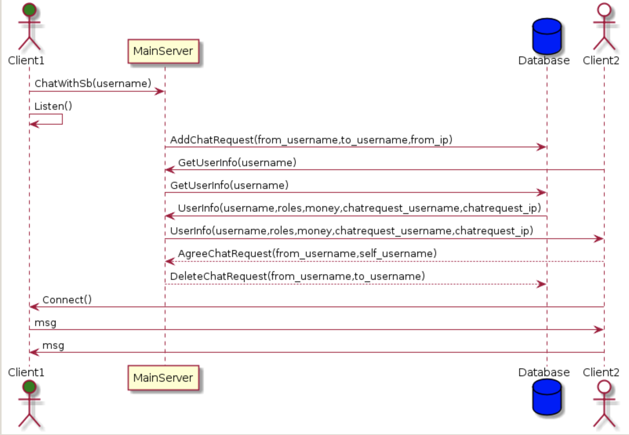

**plantuml代码**

**登录**

@startuml

actor Client #green

Client -> MainServer : LoginCheck(username,password)

database DataBase #blue

MainServer -> DataBase : GetUserInfo(username)

DataBase -> MainServer : UserInfo[username,password]//注意处理错误情况

MainServer -> Client : ok | fail

@enduml

**注册**

@startuml

actor Client #green

Client -> MainServer : RegisterRequest(username,password)

database DataBase #blue

MainServer -> DataBase : Register(username,password)

DataBase -> MainServer : ok | fail

MainServer -> Client : ok | fail

@enduml

**主界面**

@startuml

actor Client #green

MainServer -> Client : UserInfo(username,roles,money,chatrequest_username,chatrequest_ip)

Client -> Client : isManager?()

Client -> MainServer : GetItemInfo(state) //普通用户三种，管理员还可获取待审核的商品

database Database #blue

MainServer -> Database : GetItemInfo(state)

Database -> MainServer : ItemInfo[itemname,seller,price,startTime] //未开卖

Database -> MainServer : ItemInfo[itemname,cur_price,remainTime] //正开卖

Database -> MainServer : ItemInfo[itemname,finial_price,bidder] //已卖出

Database -> MainServer : (管理员)ItemInfo[itemname,seller,price,startTime] //待审核

MainServer -> Client : ItemInfo[]

Client -> MainServer : AddMoney()

MainServer -> Database : AddMoney(username,money)

Database -> MainServer : Cur_Money

MainServer -> Client : Cur_Money

Client -> MainServer : GetItemDetail(itemname)

MainServer -> Database : GetItemDetail(itemname)

Database -> MainServer : ItemDetail

MainServer -> Client : ItemDetail

Client -> MainServer : (管理员)AuditResult(itemname,True or False)

MainServer -> Database : AuditResult(itemname,True or False)

@enduml

**拍卖**

@startuml

actor Client #green

MainServer -> AuctionServer : StartAuction(itemInfo)

database Database #blue

AuctionServer --> Database : SetItemState(itemName,auctioning)

AuctionServer -> AuctionServer : Listen()

Client -> MainServer : JoinAuction(itemName)

MainServer -> Database : GetItemState(itemName)

Database -> MainServer : ItemState //preauction，auctioning，auctioned

MainServer -> Client : ok | fail

Client -> AuctionServer : connect()

AuctionServer -> Client : AuctionInfo //商品信息，参与人数

Client -> AuctionServer : bid(username,price)

AuctionServer --> Database : NewPrice(itemName,bidder,price)

AuctionServer -> Client : NewPrice(bidder,price)

AuctionServer --> Client : TimeRemain //每秒发送一次

AuctionServer -> AuctionServer : Finish()

AuctionServer --> Database : SetItemState(itemName,auctioned)

AuctionServer -> Client : AuctionFinished()

AuctionServer -> Client : Disconnect

@enduml

**私聊**

@startuml

actor Client1 #green

Client1 -> MainServer : ChatWithSb(username)

Client1 -> Client1 : Listen()

database Database #blue

actor Client2 #white

MainServer -> Database : AddChatRequest(from_username,to_username,from_ip)

Client2 -> MainServer : GetUserInfo(username)

MainServer -> Database : GetUserInfo(username)

Database -> MainServer : UserInfo(username,roles,money,chatrequest_username,chatrequest_ip)

MainServer -> Client2 : UserInfo(username,roles,money,chatrequest_username,chatrequest_ip)

Client2 --> MainServer : AgreeChatRequest(from_username,self_username)

MainServer --> Database : DeleteChatRequest(from_username,to_username)

Client2 -> Client1 : Connect()

Client1 -> Client2 : msg

Client2 -> Client1 : msg

@enduml