The Program, was edited, compiled and run with the NetBeans IDE.
I’ve noticed that my programs GUI runs perfectly in Windows XP but does not run properly in Vista & Windows 7… so much for Java being platform independent.
Screen 1.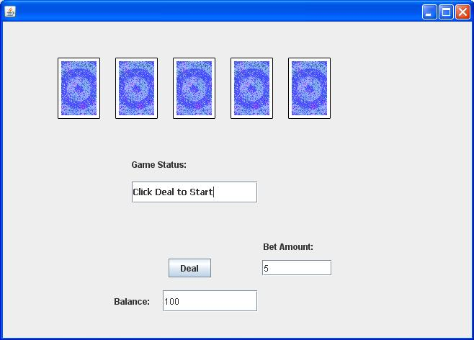Screen 2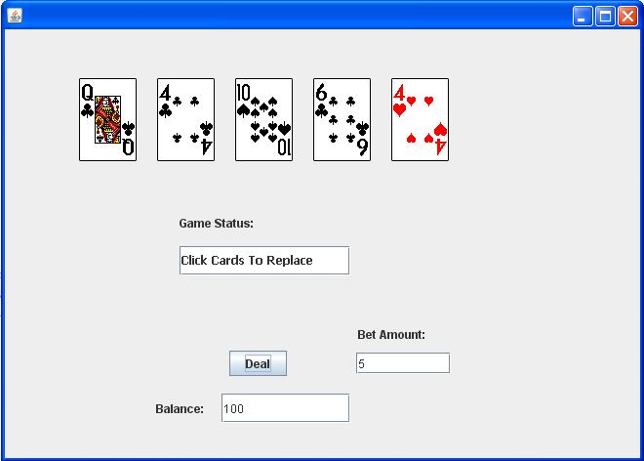
File->Open Project
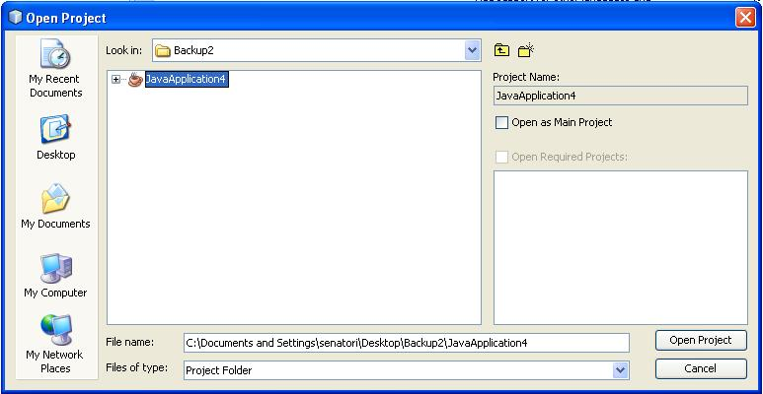
Browse to wherever my JavaApplication4 project folder is saved, select it, and then click Open Project.

Once it has loaded, press F6 key to run.

