Assignment 3.2 : MANUAL TEST PLAN
1. Follow the instructions in the README.txt file to run the website.
You should have it open like this, click on “View Details” for one assignment:
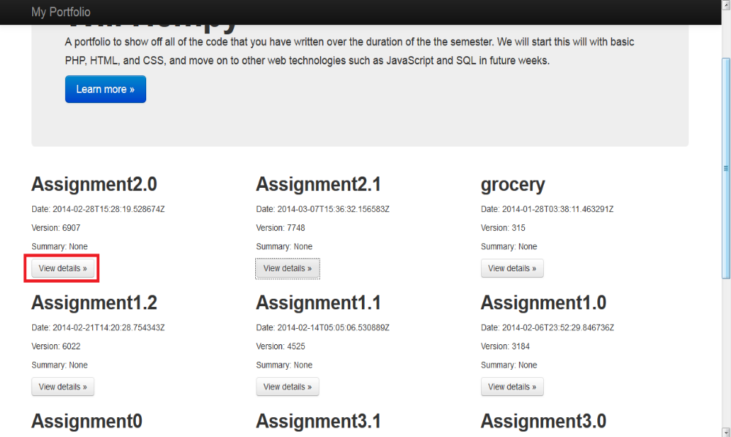
- Click “View File” on one of the files, and verify that you get a screen like this:
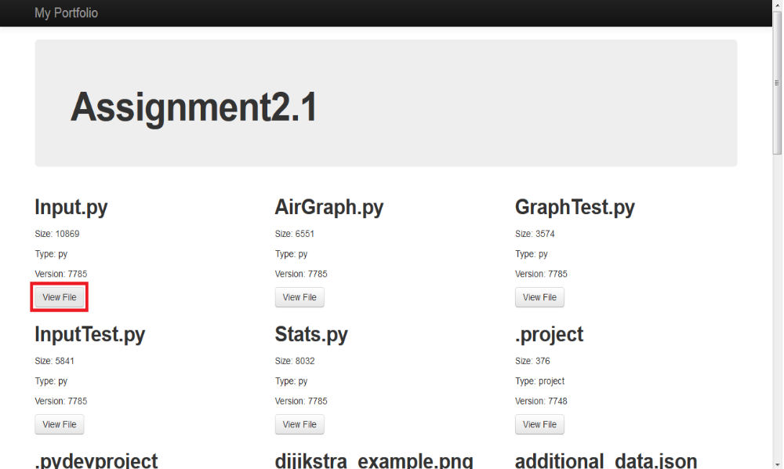
- Make sure that a new iframe shows up displaying the file without reloading the page.
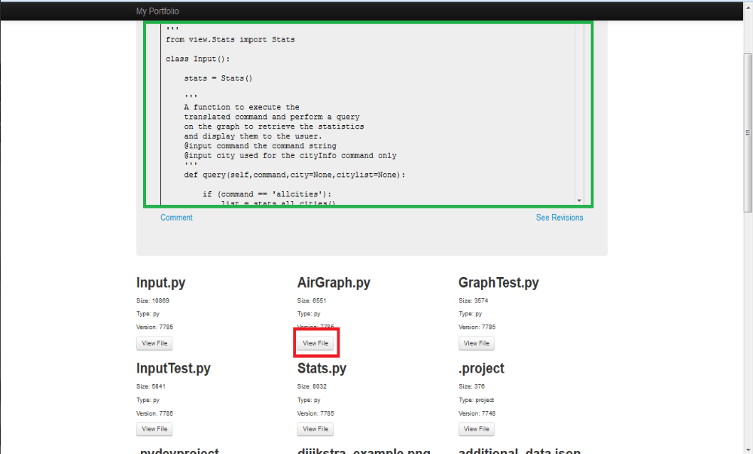
- Now, click another “View File” button. Check that the iframe now displays a different file
without reloading the page.
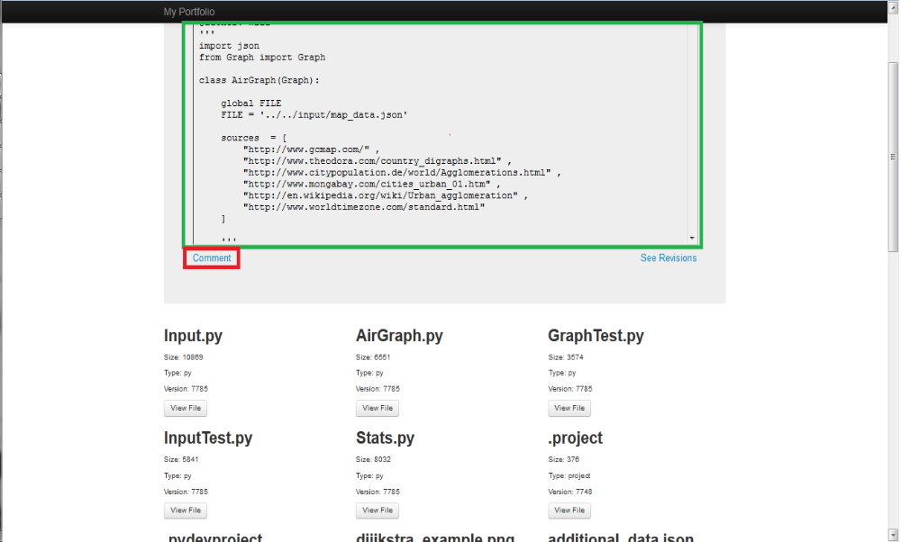

  - Click on the “Comment” button, and verify that a new page loads. Try pasting a comment and verify that it displays without the page reloading.
