MANUAL TEST PLAN: Interactive GUI

1. Open the Platformer project in Eclipse.
2. Run ManualGUITest.java as shown below by right clicking
and selecting "Run As" -> "Java Application"
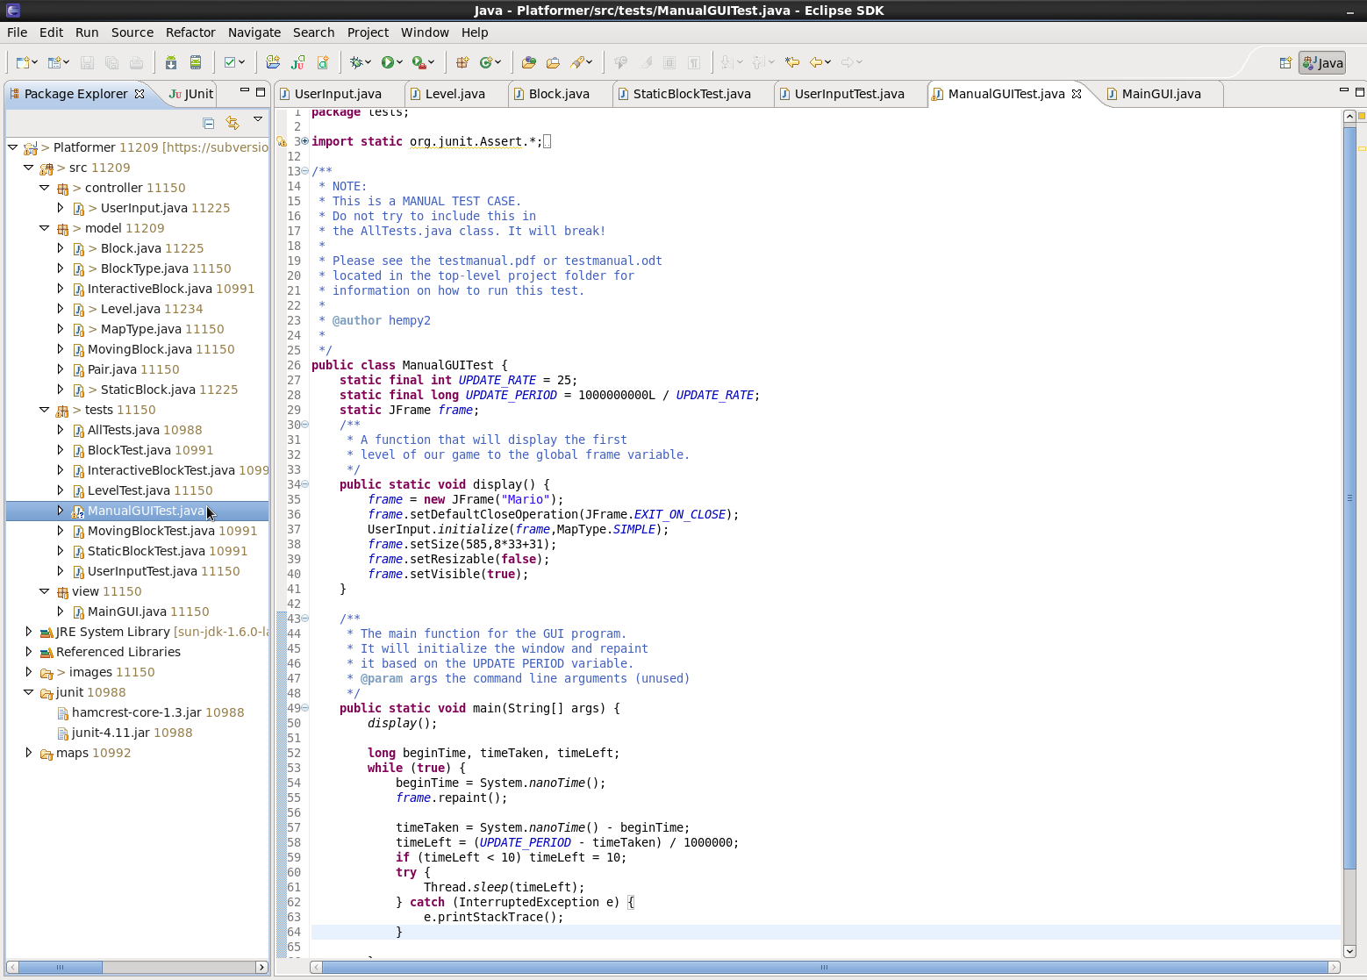
3. Check that the GUI is set up using the SIMPLE map as detailed in the manual test case.
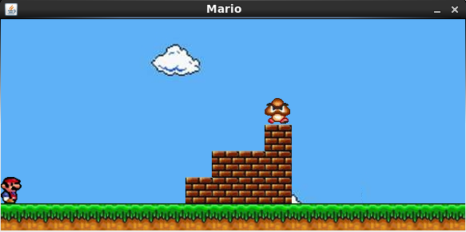
4. Check that by pressing and releasing the right arrow key, mario moves right and does not fall through the ground, get stuck, or generally do anything completely insane.
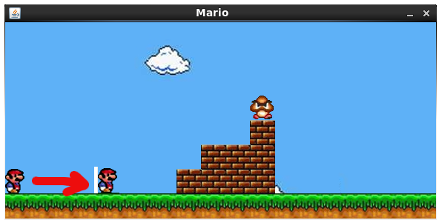
5. Try moving backwards past the edge of the screen, it shouldn't work.
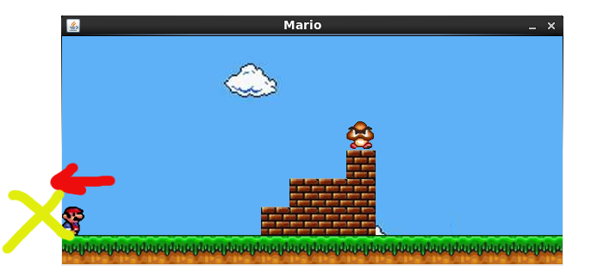
6. Check that pressing the up arrow key allows mario to jump and return to the ground successully.
