MANUAL TEST PLAN: Interactive GUI

1. Open the Platformer project in Eclipse.
2. Run ManualGUITest.java as shown below by right clicking
and selecting "Run As" -> "Java Application"
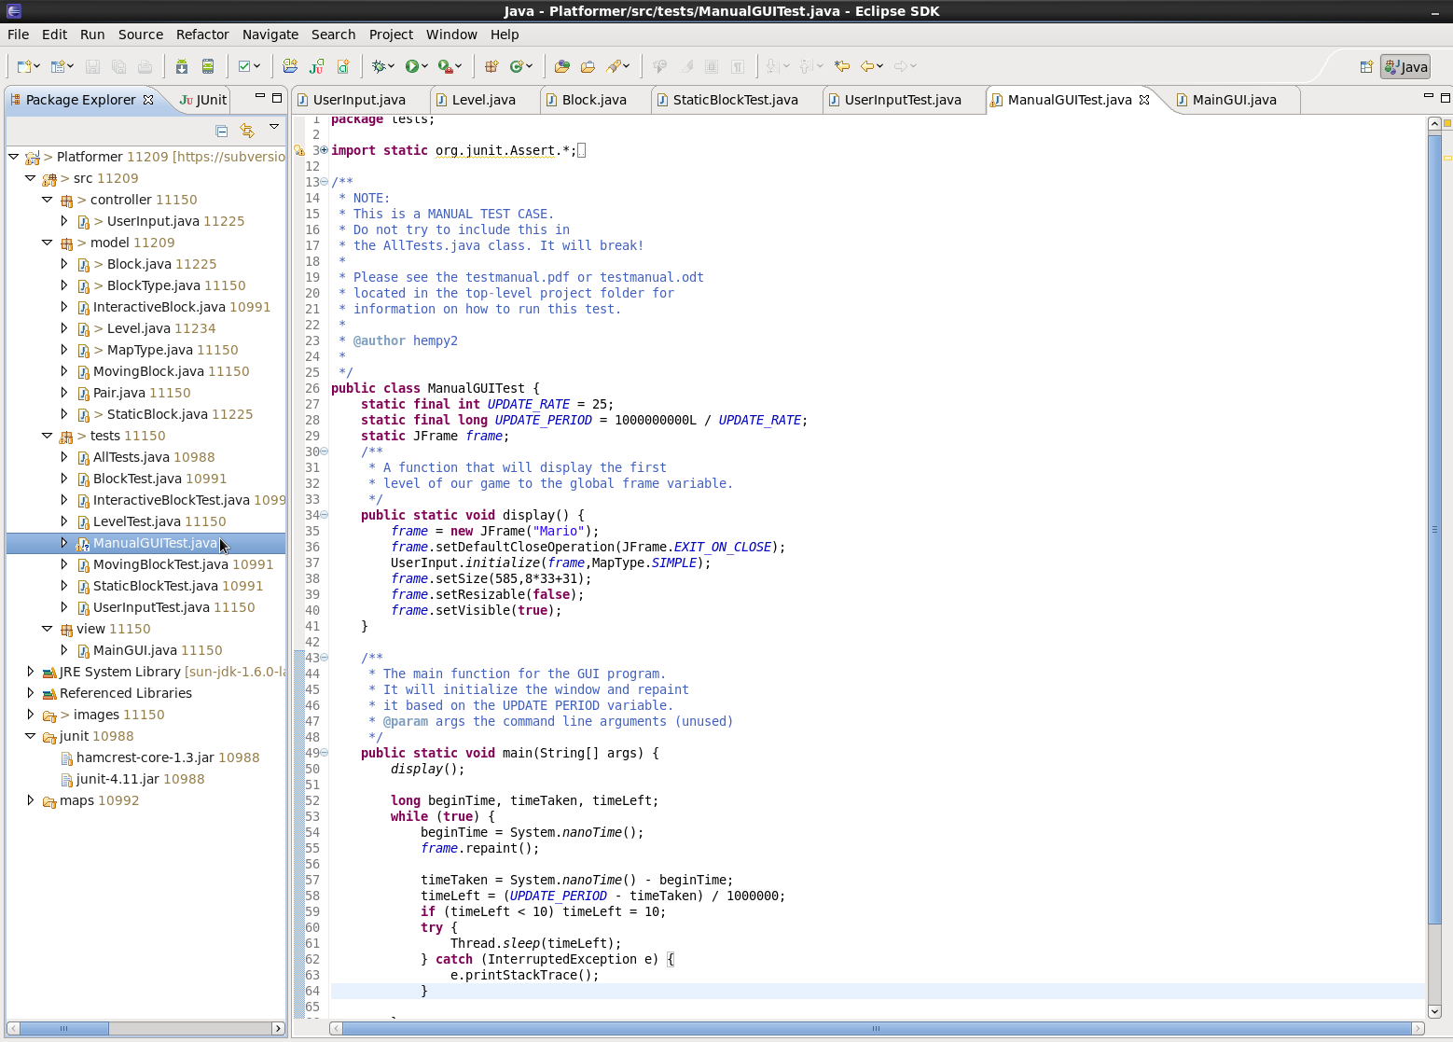
3. Check that the GUI is set up using the SIMPLE map as detailed in the manual test case.
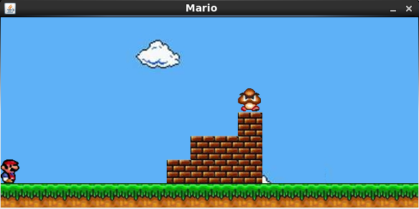
4. Check that by pressing and releasing the right arrow key, mario moves right and does not fall through the ground, get stuck, or generally do anything completely insane.
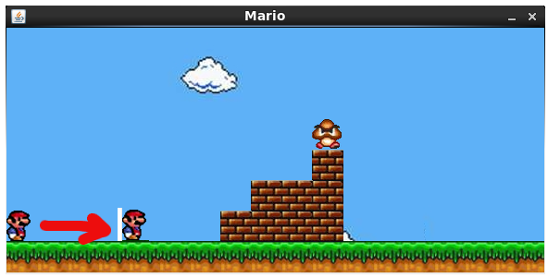
5. Try moving backwards past the edge of the screen, it shouldn't work.
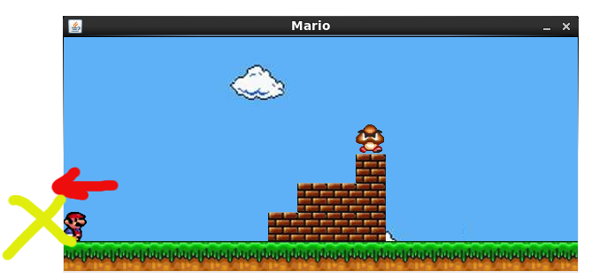
6. Check that pressing the up arrow key allows mario to jump and return to the ground successully.
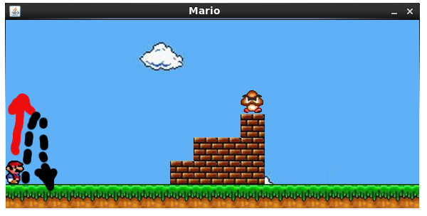
----------------------------------------------WEEK 3 TESTING------------------------------------------------------
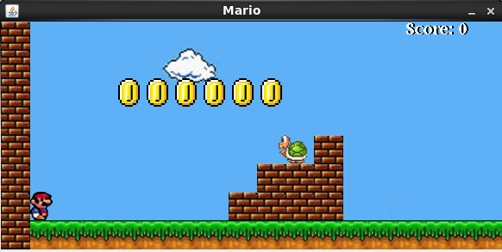
7. Start the game as in Step 1. There should now be collectibles available, including coins and
points from destroying enemies. Verify that the score is displayed at zero in the upper left hand corner, and that coins are visible.

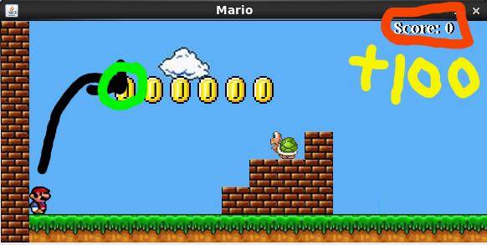
8. Try performing a jump (UP arrow key with RIGHT arrow key) to get a coin. You should see your score increase and the coin disappear.

9. Try to jump on and land on an enemy. You should see the enemy sprite disappear, your score increase, and you should land on the ground below.
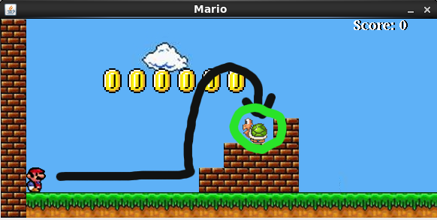

10. Verify that you are now standing on the place where the turtle was, and not floating in the air.
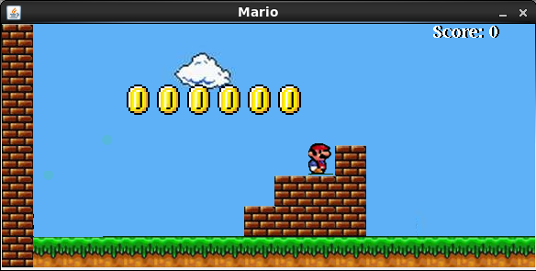
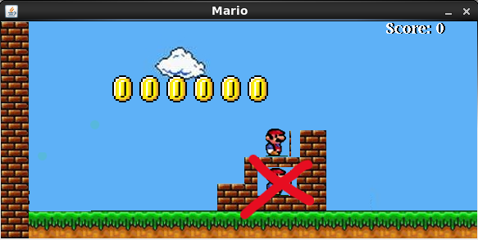
10.a. You should also not be inside any of the bricks! This verifies that collision detection is working!
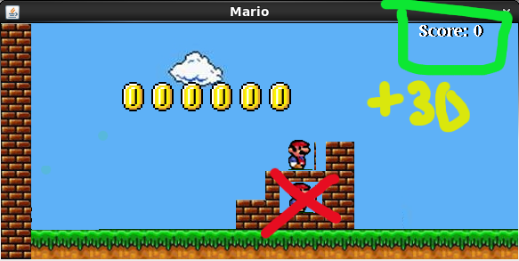
10.b. Your score should also have gone up after you hit the turtle, verify it!

11. Now that you are on a ledge, check that you will fall correctly by jumping up to the top of this little stack of bricks, and walking to the right using the right arrow key. Make sure that you don't float!
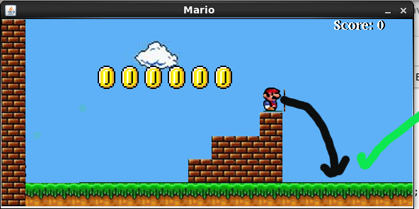
12. Check that the window is also scrolling the landscape along with you as you walk to the right.
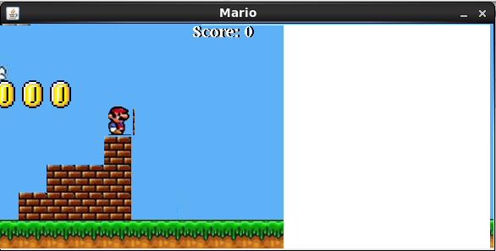

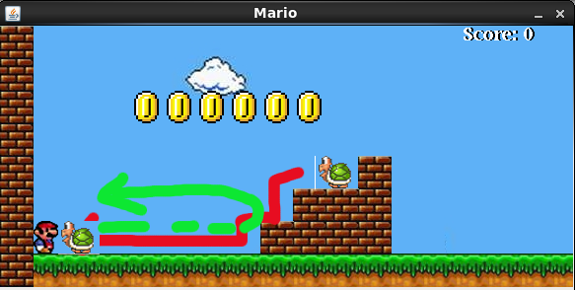
- Verify that the Koopa enemy begins to move and correctly traverses the steps.
It should not turn around after hitting Mario if you let him sit there. You should get a
“game over” screen like below:

  - Now, Mario should have fallen off the screen and you should no longer see him. Nothing else should be moving. The screen may repaint, but the enemies will be still.

- Now, try jumping on a turtle while it is moving. This should give you some more score, you should see the turtle disappear and you should land on the ground safely.
- Verify that jumping changes Mario's sprite and that landing will set the sprite back to a non-jumping sprite position.

- Verify that moving right will change the sprites such that it appears Mario is walking.
- Verify the same thing for the enemies.
- Verify that turning around and moving backward will flip Mario's sprite. The same should also be true for any of the enemies.

    - Continue on to the end of the level. Verify that you win the game when you pass the flag pole.

- Jump into a canyon. Verify that you die and lose.

