Data Report 1 DC311 – City Service Requests 2018

2/26/19

CSC 430

Introduction to Data Analysis

## Jon Mierzwa

Jarred Cutlip

### Nick Esposito

In 2018, the total population of the District of Columbia was reported to be 702,455 according to the U.S. Census Bureau. With a total of 333,105 service requests put in throughout the year, this comes out to about one request for every two people living in the city. One method of geographically dividing this dense area is into different wards, of which there is 8 in D.C. In the chart below, it is evident that Ward 2 was the busiest of them all, totaling about 60,169 service requests made this past year.

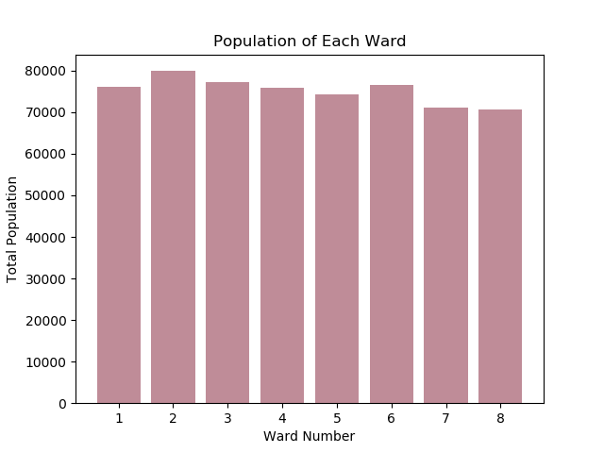

Ward 2 has the highest population of all the wards, which could be one possible reason why such a large amount of service requests stem from this area. Coming in with the next highest number of service requests in 2018 with 54,221 was Ward 6. However, this area did not have the second highest population. This title belonged to Ward 3, which had an abnormally low number of requests for its hefty population of 77,152. With the aid of these data trends, city officials can devise a plan that highlights the busier wards, as opposed to the more populated ones. By stationing employees in higher activity areas, more requests can be completed at faster rates. A larger number of residents does not always result in more service requests.

Of the 333,105 service requests mentioned above, 94% of them were handled by just two organizations – the Department of Public Works and the District Department of Transportation. The Department of Public Works (DPW) handles all the city’s trash collection, while the District Department of Transportation (DDOT) manages street repairs and parking services, amongst other jobs.

The DPW received 211,371 service requests in 2018, with most of them coming in during the warmer part of the year. In the spring and summer months, the DPW dealt with 20,729 more requests than compared to the fall and winter months. In the graph below, there is a very noticeable spike of incoming requests once spring begins. With this being said, the DPW can save a significant amount of money if they hire seasonal workers for the spring and the summer.

Like the DPW, the DDOT received more requests once the warmer months came around. 6,309 more requests were made to this organization during spring and summer, as opposed to the fall and winter. The increase of requests in the DDOT graph is not as noticeable as the spike of the DPW data, but it should still be addressed. By acknowledging this busier part of the year, city officials can become more prepared when this time of the year comes around. By stocking more employees and restocking inventory more frequently during these months, these organizations will be more properly staffed to fulfill this timely influx of service requests.

Diving deeper into the multitude of requests handled by the DPW, one can see that the majority of this organization’s time is spent covering issues related to “Bulk Collection” and “Parking Enforcement”. Combining for over 95,000 requests in 2018, “Bulk Collection” and “Parking Enforcement” appear to be a considerable problem in this area. Below are the top seven most common service requests the DPW received in 2018:

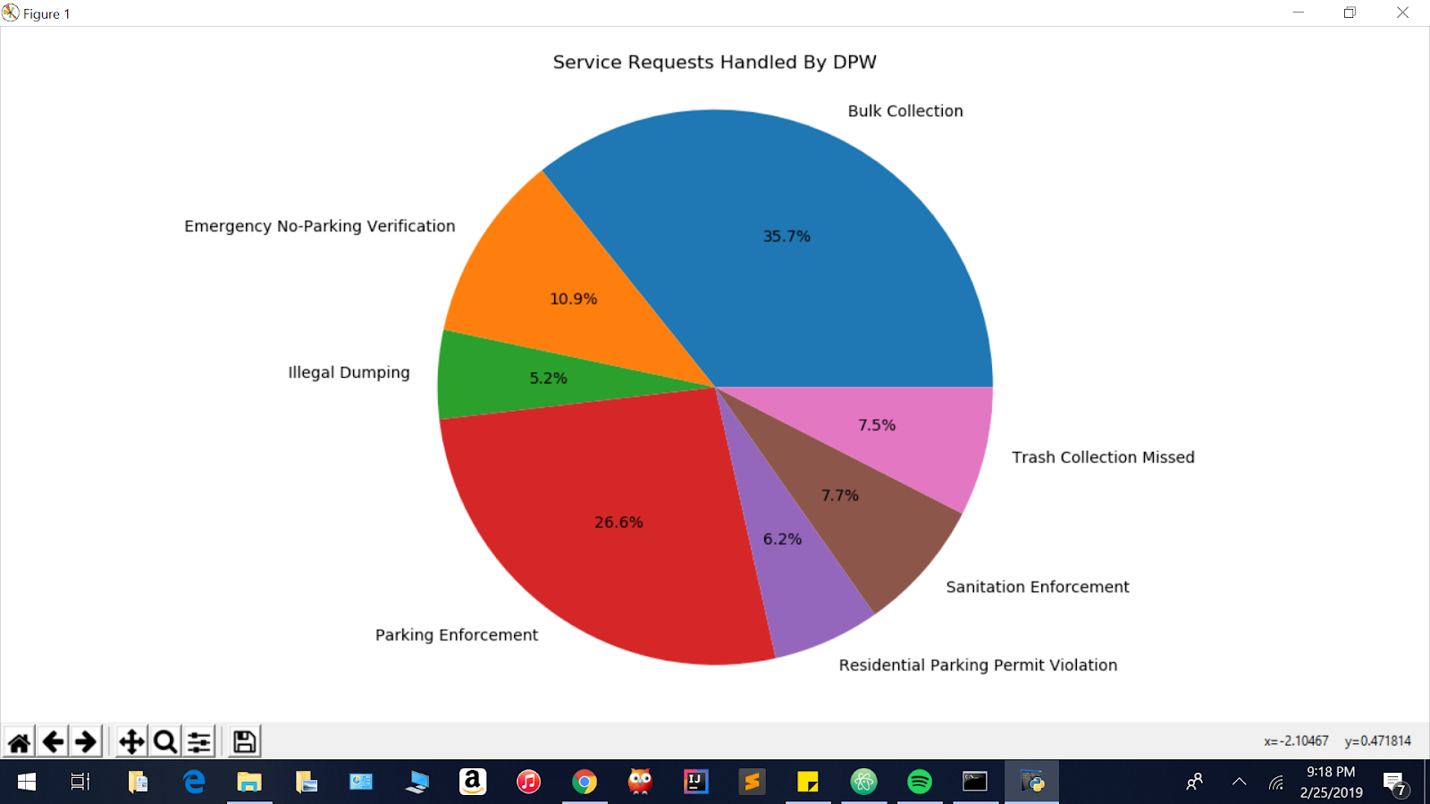

Due to the heavy demand of bulk collection and parking enforcement issues, city officials may want to consider transferring some of the employees from other departments to these two busier ones. Not pictured above are the numbers for the “Graffiti Removal” unit and “Alley Cleaning” branch, which both received less than 3% of all the requests handled by the DPW. Reassigning a portion of employees from the “Graffiti Removal” or “Alley Cleaning” division to the “Bulk Collection” department will benefit these employees and other city goers. With more help to go around the busy “Bulk Collection” office, stray trash will be less of a problem for the city streets.

Due to the changing weather having an impact on the amount of service requests throughout the city, one may wonder why this occurrence happens. During the warmer months, there is a noticeable spike in activity for the Parking Enforcement unit. In the summer and spring months, the number of tourists coming into the area dramatically increases. This boost in population depletes the available parking spots, typically belonging to the residents of the city. As evident in the graph below, Wednesday appears to be the busiest day for Parking Enforcement, as they give out more tickets on this day than any other.

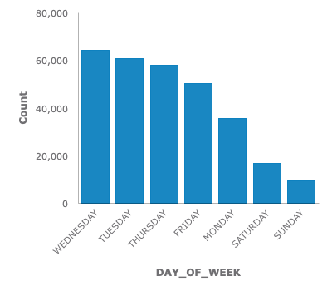

With more people working on weekdays, as opposed to weekends, it seems natural for this trend in the data. Most people tend to be relaxing in their homes on Saturday and Sunday, while scrambling to find parking spots as they are late for work during the week.