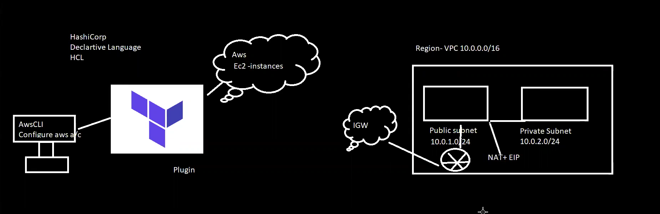

VPC:- virtual private network

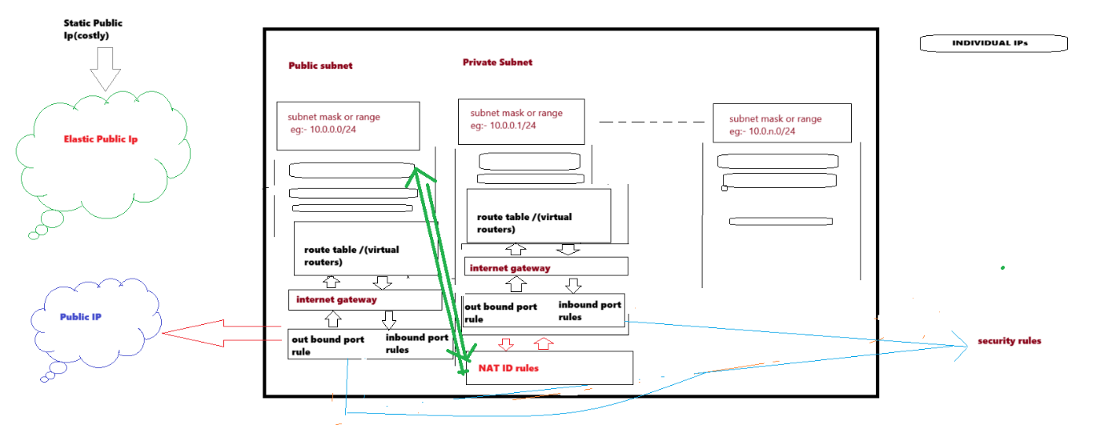

Elastic ips- static ip which charge cost . the ip doesn’t change if the object sthut down or restart, ip doesn’t release.

Route table- it’s a virtual router with mac ids.