**Lab 1 Reflection**

1. Saad Khan – 000369469, Lab 1
2. All functionality, views, controllers, etc. working as expected.
3. Three things I learned from this lab:
   1. How to create an API Controller
   2. User Authentication
   3. Enhanced understanding/utilization of Unit Tests
4. Areas I need to work on based on the lab:
   1. RESTful actions
   2. Further enhancing Unit Testing skills
5. Refer to Screenshots below

**Car Controller (CRUD Screenshots)**

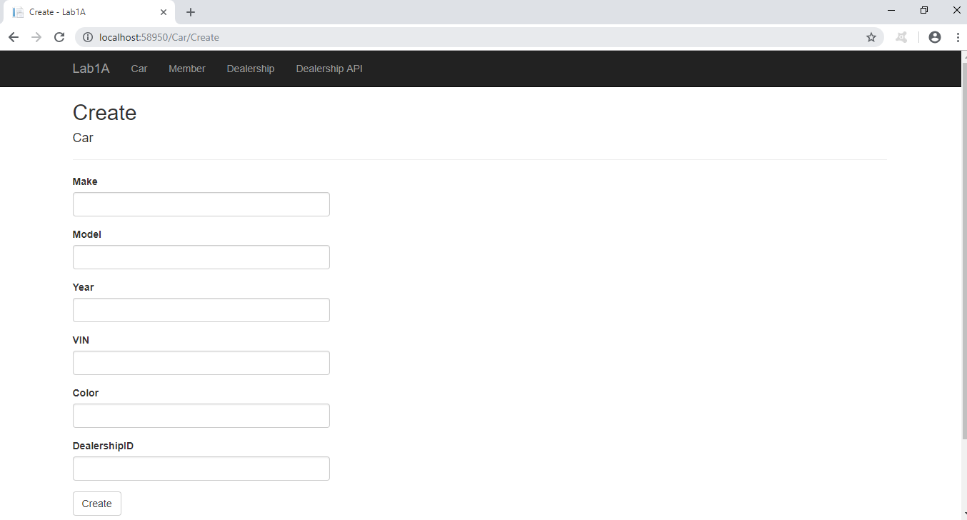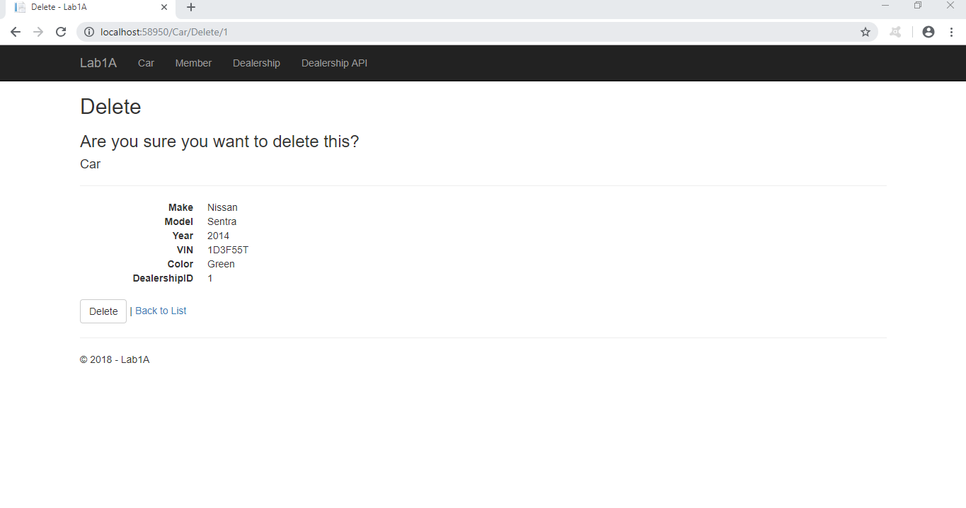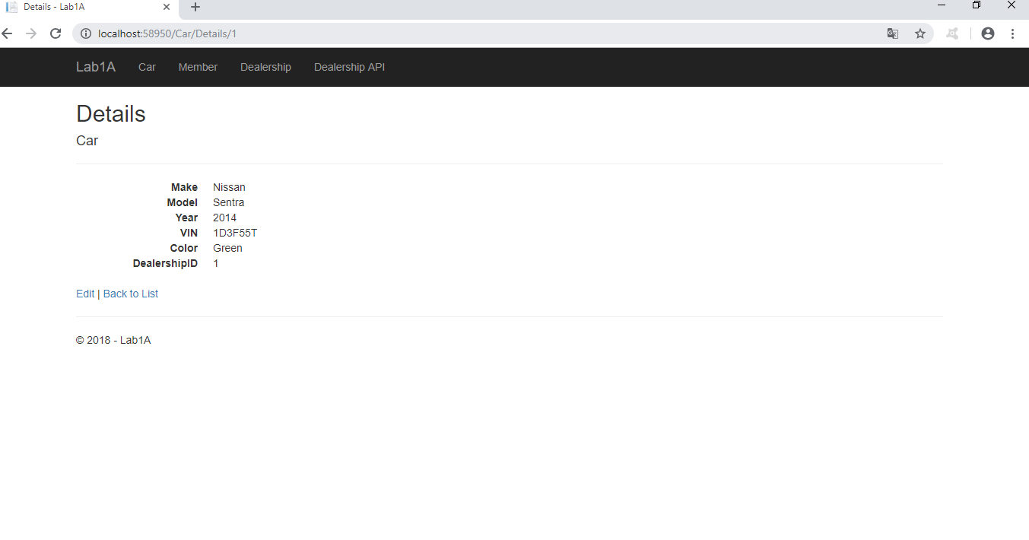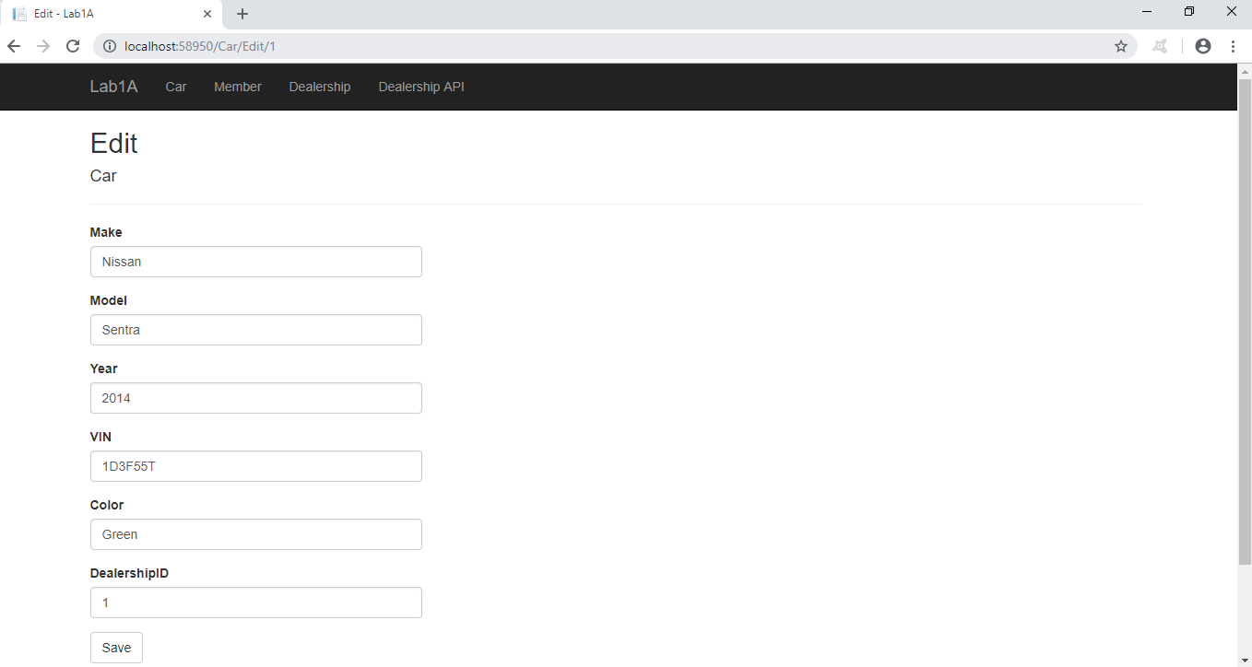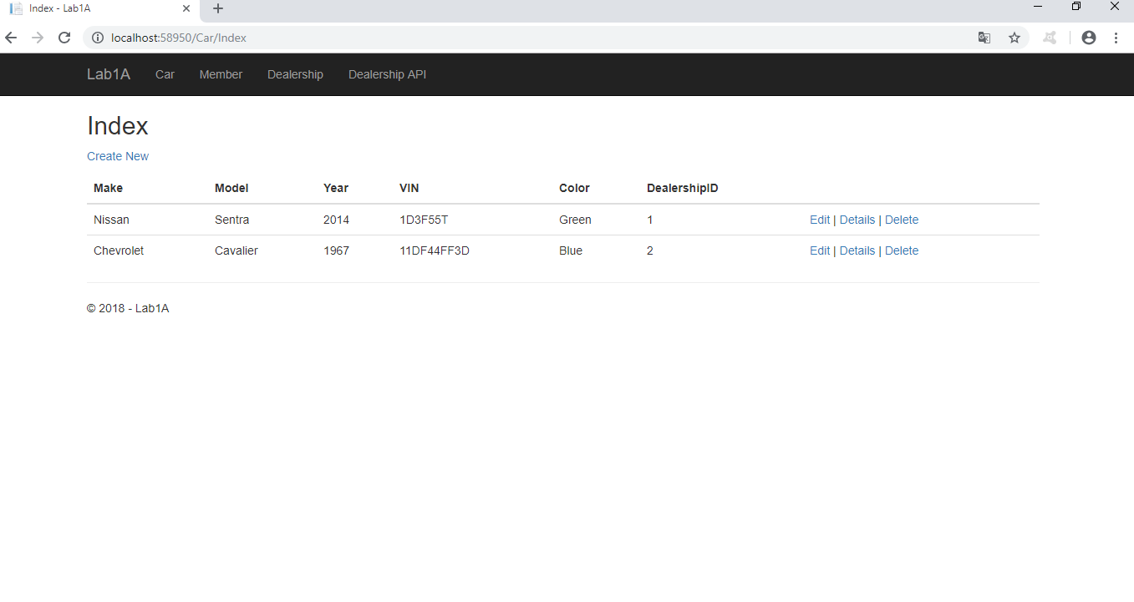

**DealershipApi Controller Screenshot**

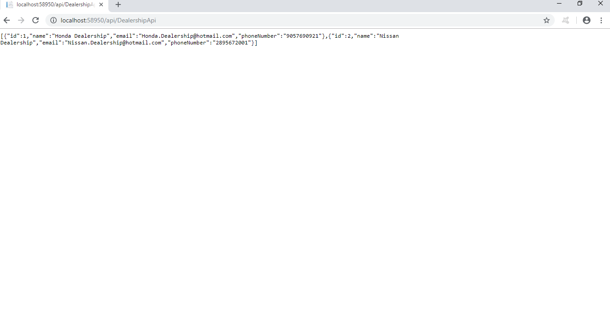

**Dealership Controller (CRUD Screenshots)**

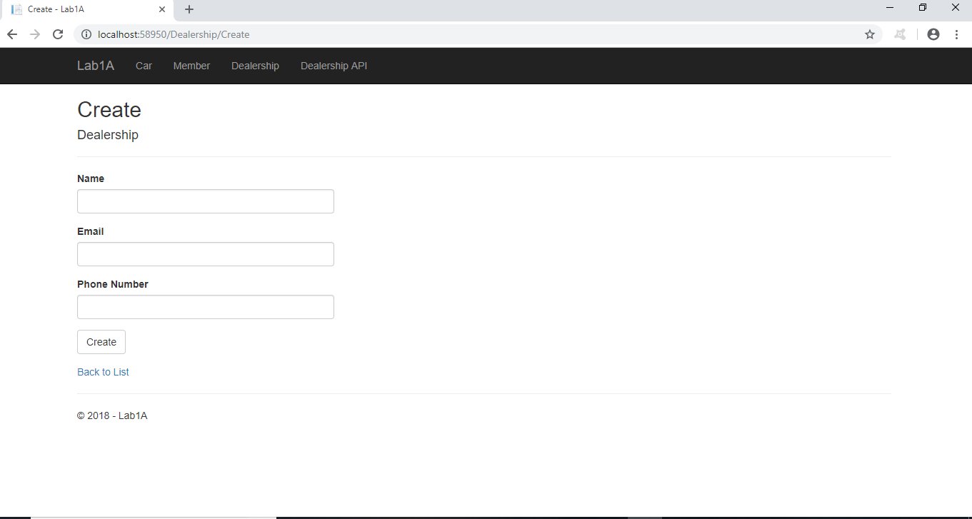

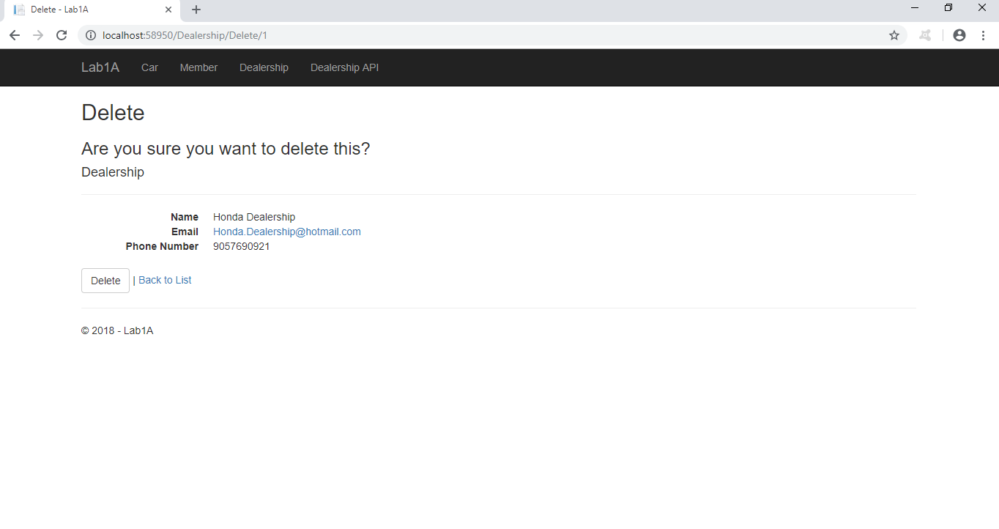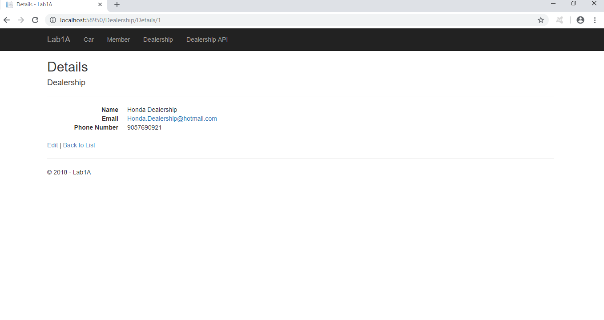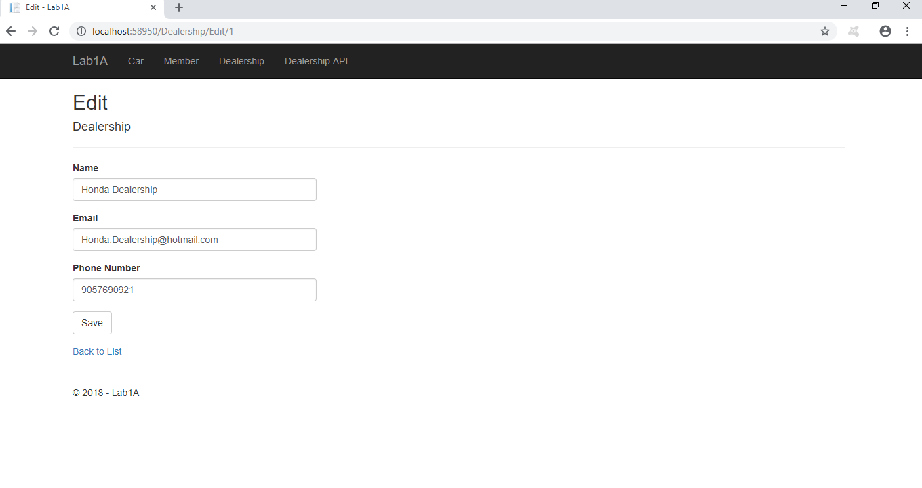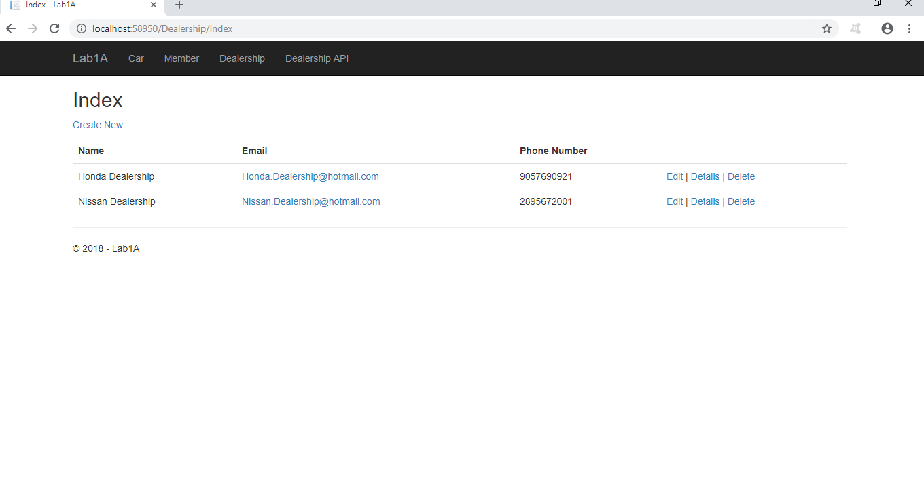

**Member Controller (CRUD Screenshots)**

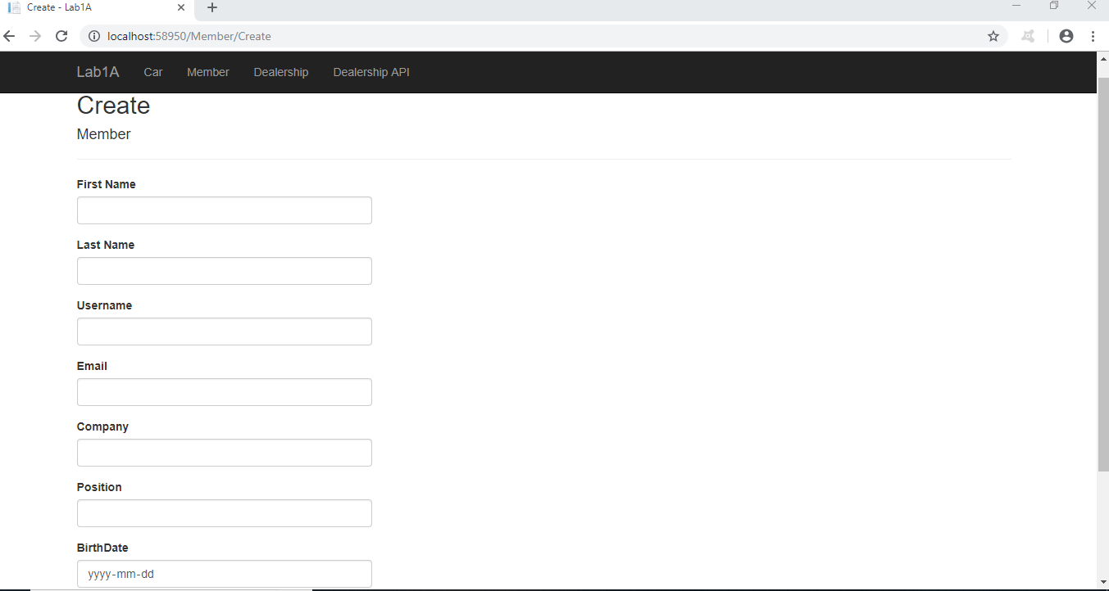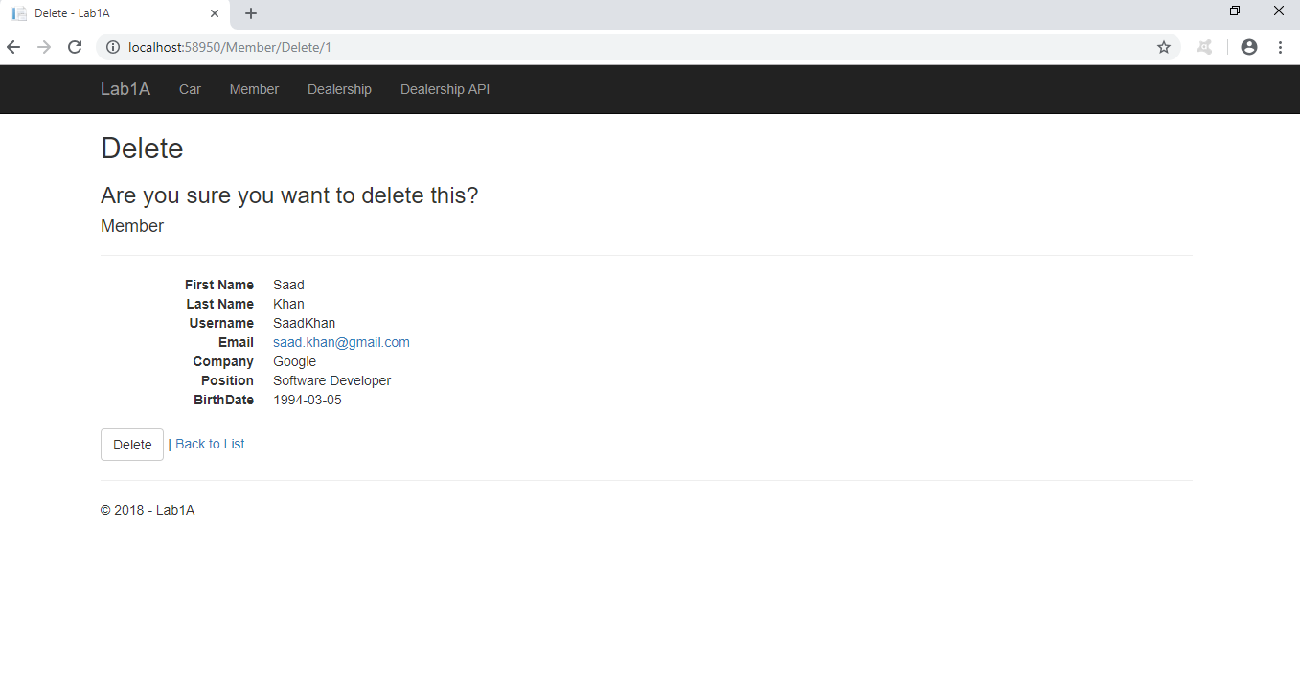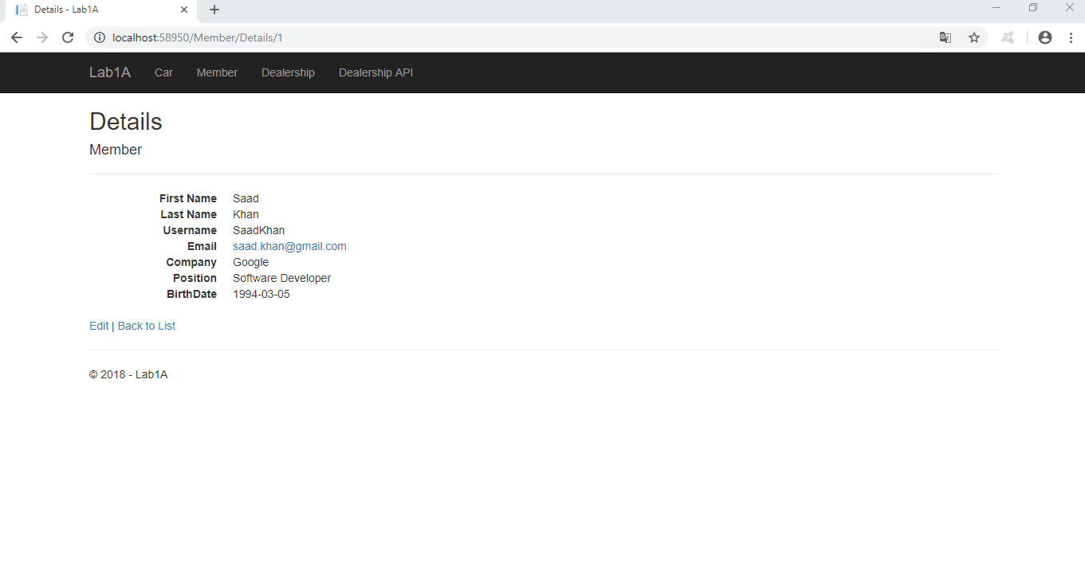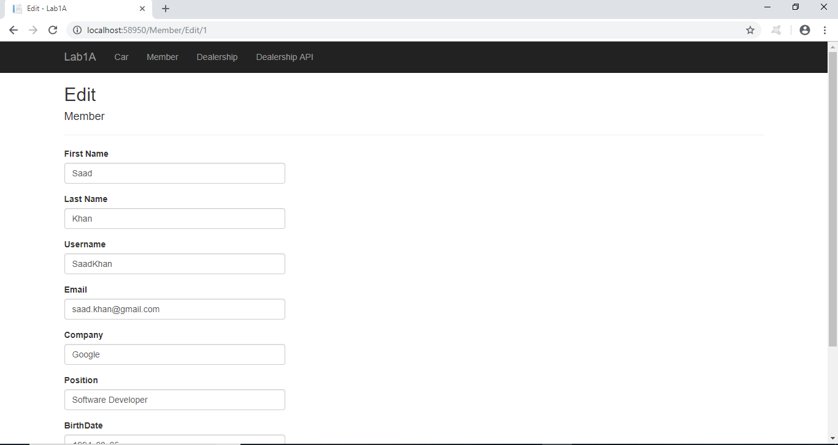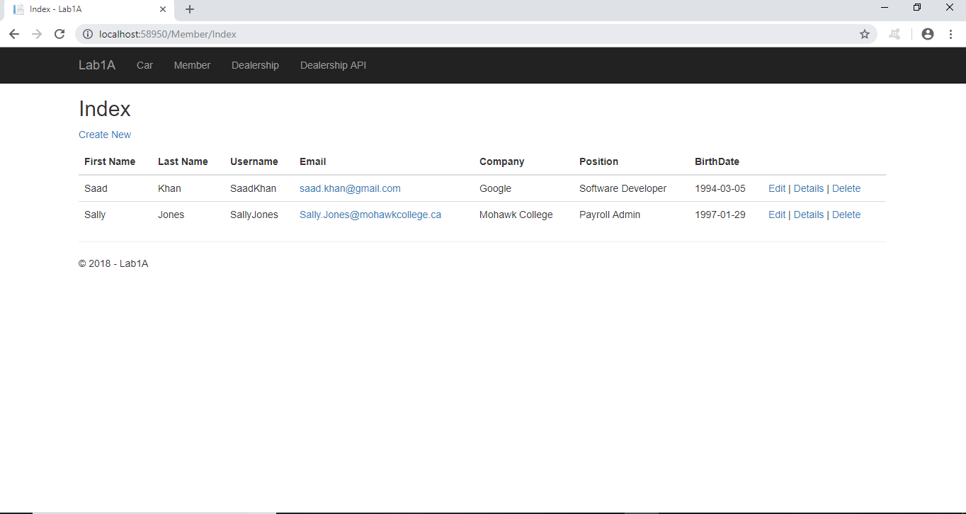

**Lab 1 Unit Test Screenshot**

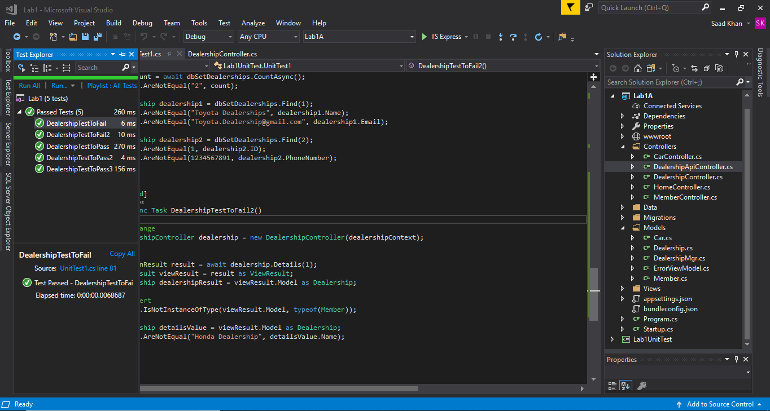

**Lab 1B Dealership Screenshot (Un-authenticated User)**

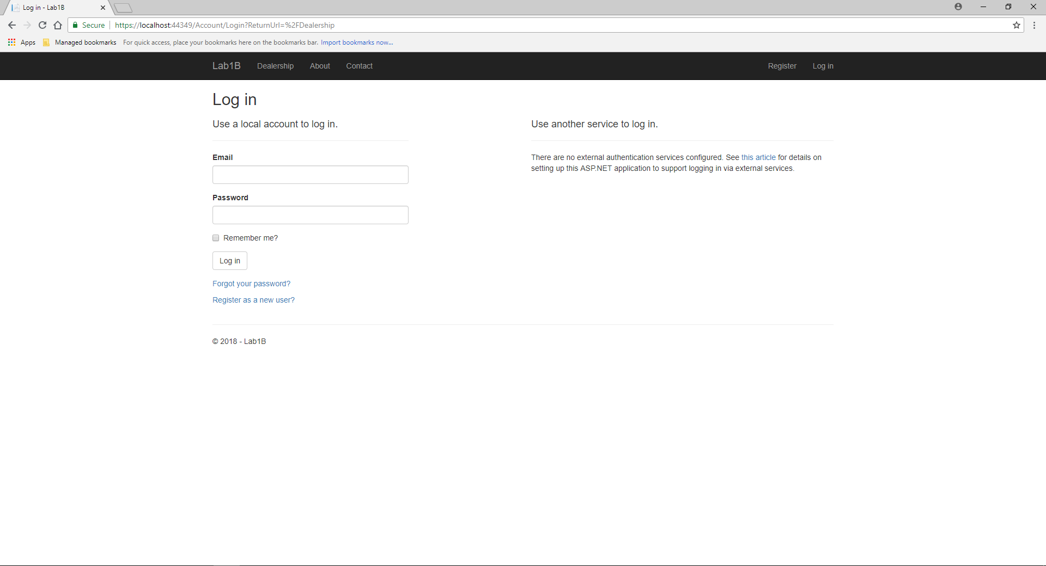

**Lab 1B Dealership Create Screenshot (Employee)**