Controlled Area / Zone Map
Authority: Adopted by Tri-River Regional 911 Center under the authority of Dr. Lisa Park, Director.
Version: 1.0 Effective Date: March 2, 2026 Next Review: March 2, 2027
Owner: Information Security Analyst
Classification: Restricted

1. Purpose
This map shows the Agency’s controlled areas and security zones, the access level required for each, and where critical systems and equipment sit. It supports decisions about who may enter which space and where to place sensitive equipment.

2. Diagram
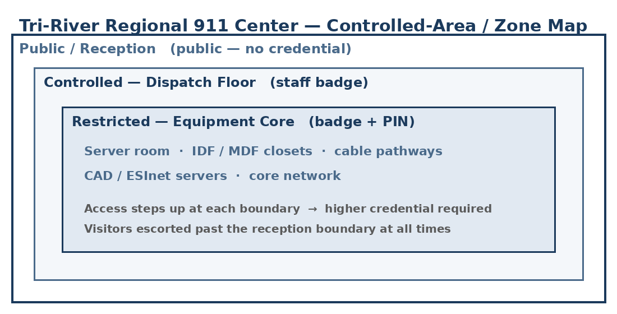

3. Zone / Area Descriptions
Zone / Area | Access Level (who may enter / credential) | Critical Systems Housed | Owner (Role)
Public lobby / reception | Public; no credential | None | Facilities & Security Lead
Dispatch floor | Badge (access group A) | CAD, RMS, GIS, video, ALI workstations | Operations Supervisor
Server / data center | Badge + PIN (group C); logged | CAD / ESInet / RMS servers; core network | IT team
IDF / MDF closets; cable pathways | Badge (group C); logged | Network distribution; transmission lines | IT team

4. Zone Relationships & Adjacency
Access steps up from public reception to the staffed dispatch floor to the restricted equipment spaces, and each boundary requires a higher credential. The server room and IDF/MDF closets sit inside the controlled core and are not reachable from public areas. Visitors are escorted past the reception boundary at all times. Authorization for each zone is recorded in the Access Authorization List, and entries and anomalies are reviewed in the Physical Access Review Records.

Profile Scaling Notes
PSAP Profile | Minimum-viable implementation
Large (25+, dedicated IT/security) | Tri-River maintains a zone map per center, tied to the badge system’s access groups, showing every controlled space and the systems it houses. Facilities and security review it on a set cadence.

Source Authority
NENA-STA-040.2-2024: §6.1.1, §6.1.3
NIST SP 800-53 Rev. 5: PE-2, PE-3, PE-18
CJIS Security Policy v5.9: §5.9.1 (Physically Secure Location; CJIS-regulated data in scope, via IDACS)

Approval Signatures
Role | Name | Signature | Date
Director | Dr. Lisa Park | /s/ Park | March 2, 2026
Information Security Analyst | (on file) | (on file) | March 2, 2026

Change History
Version | Date | Author | Summary of Change
1.0 | March 2, 2026 | Information Security Analyst | Initial issue and adoption

