Controlled Area / Zone Map
Authority: Adopted by Wabash Valley Communications under the authority of Anthony Reyes, Director.
Version: 1.0 Effective Date: March 2, 2026 Next Review: March 2, 2027
Owner: Security Coordinator
Classification: Restricted

1. Purpose
This map shows the Agency’s controlled areas and security zones, the access level required for each, and where critical systems and equipment sit. It supports decisions about who may enter which space and where to place sensitive equipment.

2. Diagram
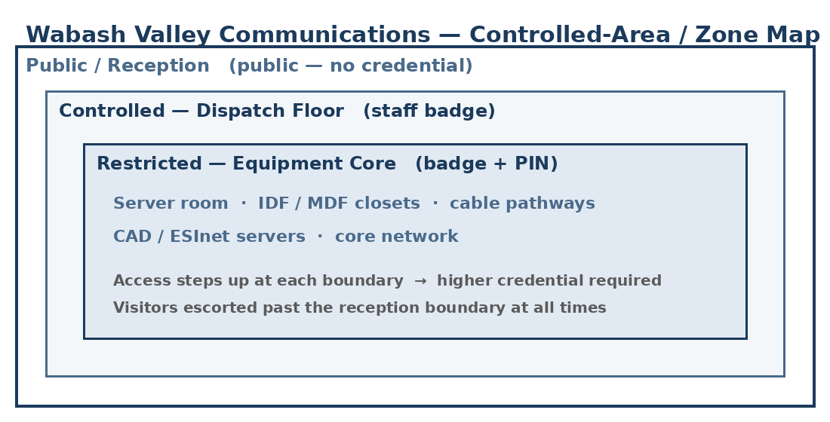

3. Zone / Area Descriptions
Zone / Area | Access Level (who may enter / credential) | Critical Systems Housed | Owner (Role)
Public lobby / reception | Public; no credential | None | Facilities Coordinator
Dispatch floor | Staff badge | CAD / call-handling workstations | Operations Supervisor
Server room | Badge + PIN; authorized staff only | CAD / ESInet servers; core network | County IT team
IDF / MDF closets; cable pathways | Badge; authorized staff only | Network distribution; transmission lines | County IT team

4. Zone Relationships & Adjacency
Access steps up from public reception to the staffed dispatch floor to the restricted equipment spaces, and each boundary requires a higher credential. The server room and IDF/MDF closets sit inside the controlled core and are not reachable from public areas. Visitors are escorted past the reception boundary at all times. Authorization for each zone is recorded in the Access Authorization List, and entries and anomalies are reviewed in the Physical Access Review Records.

Profile Scaling Notes
PSAP Profile | Minimum-viable implementation
Medium (6–25, shared county IT) | Wabash Valley maps each controlled space and its access level across both sites, including IDF/MDF and the server room. The map is kept with the floor plan and updated whenever spaces or access change.

Source Authority
NENA-STA-040.2-2024: §6.1.1, §6.1.3
NIST SP 800-53 Rev. 5: PE-2, PE-3, PE-18
CJIS Security Policy v5.9: §5.9.1 (Physically Secure Location; CJIS-regulated data in scope, via IDACS)

Approval Signatures
Role | Name | Signature | Date
Director | Anthony Reyes | /s/ Reyes | March 2, 2026
Security Coordinator | (on file) | (on file) | March 2, 2026

Change History
Version | Date | Author | Summary of Change
1.0 | March 2, 2026 | Security Coordinator | Initial issue and adoption

