Controlled Area / Zone Map
Authority: Adopted by Hickory County 911 under the authority of Tracy Holloway, Director.
Version: 1.0 Effective Date: March 2, 2026 Next Review: March 2, 2027
Owner: Director
Classification: Restricted

1. Purpose
This map shows the Agency’s controlled areas and security zones, the access level required for each, and where critical systems and equipment sit. It supports decisions about who may enter which space and where to place sensitive equipment.

2. Diagram
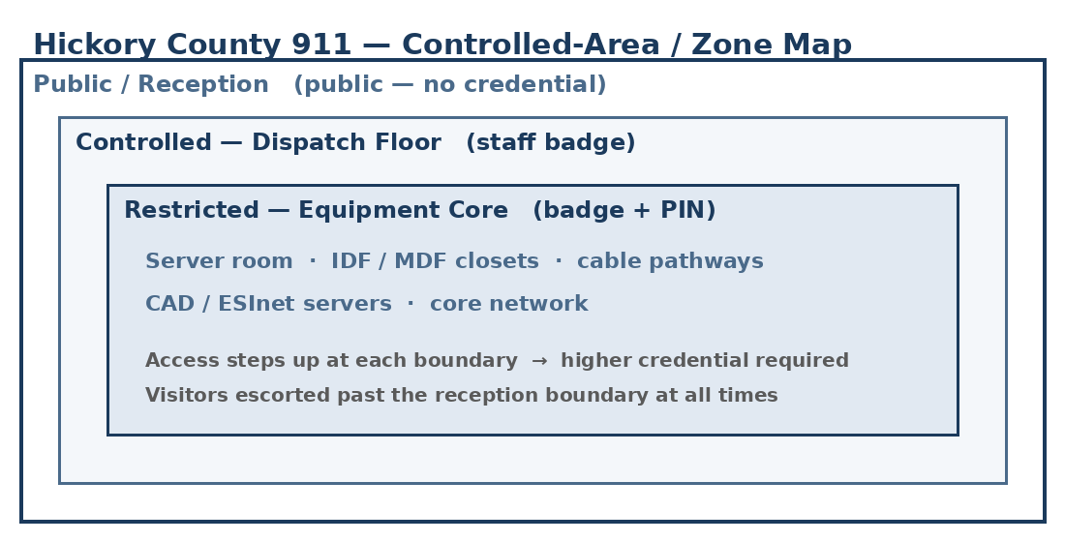

3. Zone / Area Descriptions
Zone / Area | Access Level (who may enter / credential) | Critical Systems Housed | Owner (Role)
Public lobby (shared with Sheriff’s Office) | Public; no credential | None | Director
Dispatch floor | Staff key / badge | CAD and call-handling workstations | Director
Shared equipment closet | Keyed lock; authorized staff only | CAD server; network gear | Hickory County IT

4. Zone Relationships & Adjacency
Access steps up from public reception to the staffed dispatch floor to the restricted equipment spaces, and each boundary requires a higher credential. The server room and IDF/MDF closets sit inside the controlled core and are not reachable from public areas. Visitors are escorted past the reception boundary at all times. Authorization for each zone is recorded in the Access Authorization List, and entries and anomalies are reviewed in the Physical Access Review Records.

Profile Scaling Notes
PSAP Profile | Minimum-viable implementation
Small (1–5 dispatchers, no in-house IT) | Hickory County 911 has three zones: a shared public lobby, the dispatch floor, and a keyed equipment closet. A simple labeled floor sketch is enough; the closet is marked as the highest-access zone.

Source Authority
NENA-STA-040.2-2024: §6.1.1, §6.1.3
NIST SP 800-53 Rev. 5: PE-2, PE-3, PE-18
CJIS Security Policy v5.9: §5.9.1 (Physically Secure Location; CJIS-regulated data in scope, via IDACS)

Approval Signatures
Role | Name | Signature | Date
Director | Tracy Holloway | /s/ Holloway | March 2, 2026
Director | Tracy Holloway | /s/ Holloway | March 2, 2026

Change History
Version | Date | Author | Summary of Change
1.0 | March 2, 2026 | Director | Initial issue and adoption

