Network Architecture Diagram
Authority: Adopted by Tri-River Regional 911 Center under the authority of Dr. Lisa Park, Director.
Version: 1 Effective Date: 2026-01-26 Next Review: 2027-01-26
Owner: Information Security Analyst
Classification: Restricted

1. Purpose
This diagram is the current, dated map of the agency's network: every segment and VLAN, the devices on each, the boundary points, and every external connection. It is the reference the firewall ruleset, segmentation design, external connection inventory, and monitoring records all build on, so it is kept accurate against the Master Asset Inventory.

2. Diagram
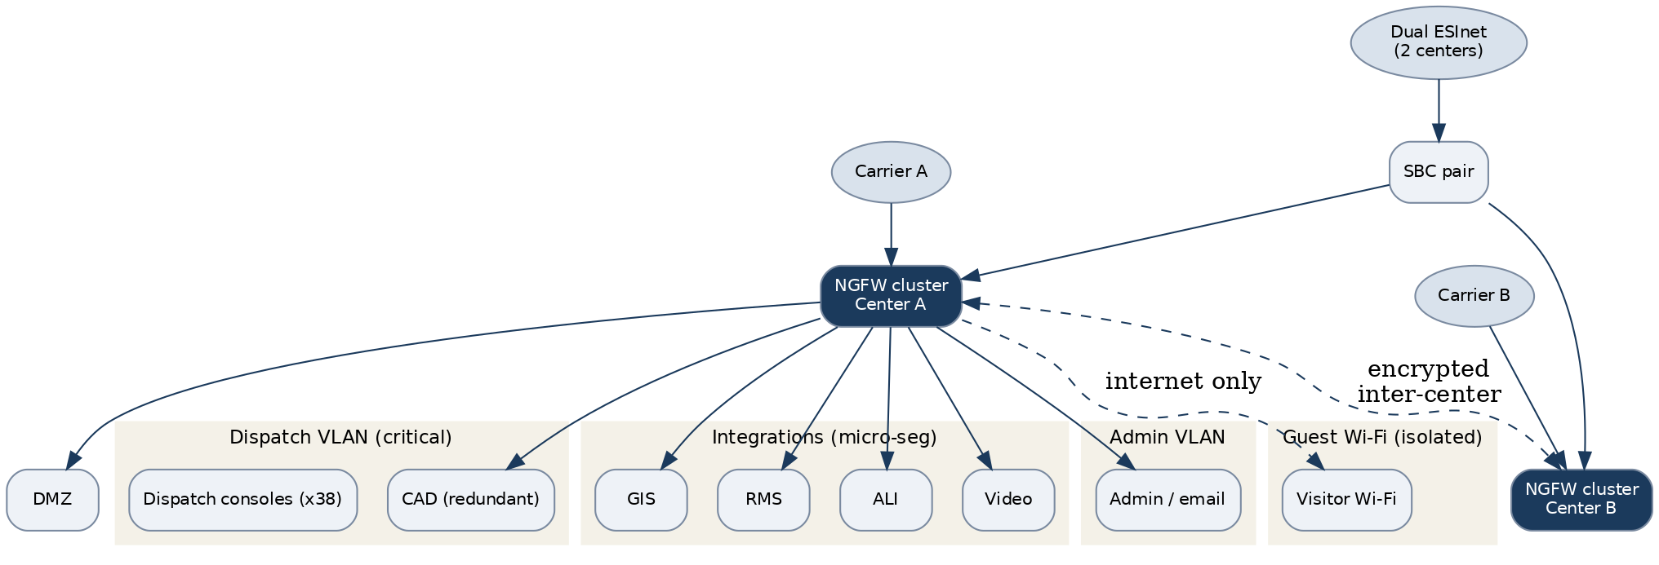

3. Segments & Devices
Node / device | Segment / VLAN | Role / function | Trust boundary
NGFW clusters (Center A/B) | Perimeter | Boundary control, IPS, default-deny | Perimeter
Session border controllers (pair) | Voice VLAN | SIP boundary to dual ESInet | Perimeter
CAD (redundant) | Dispatch VLAN | Call-handling and dispatch | Internal, critical
GIS / RMS / ALI / video | Integration VLANs | NG911 integrations (micro-segmented) | Internal, critical
Dispatch consoles (x38) | Dispatch VLAN | Call-taking and dispatch | Internal, critical
Admin workstations | Admin VLAN | Administration and email | Internal
DMZ services | DMZ | Partner and public services | Perimeter
Guest Wi-Fi | Guest | Visitor internet only | Untrusted, isolated

4. Relationship Notes
Traffic is denied by default across both centers. Dispatch and the NG911 integrations (GIS, RMS, ALI, video) are micro-segmented on critical VLANs; the two centers are joined by an encrypted inter-center link. Public services sit in the DMZ and guest Wi-Fi is fully isolated. This diagram was last verified against the Master Asset Inventory on 2026-01-26, separate from the document review date. The Firewall Ruleset Documentation carries the as-built rules and the Network Segmentation Design Document sets the intended zoning.

Profile Scaling Notes
PSAP Profile | Minimum-viable implementation
Large (25+, dedicated IT/security) | A managed topology, often exported from a network-management or diagramming tool, covering all segments, integrations, and boundary points across both centers. Reviewed through the change process and re-verified on a regular schedule.

Source Authority
NENA-STA-040.2-2024: §6.7.3, §6.9, §6.11, §6.13
NIST SP 800-53 Rev. 5: AC-4, CA-3, CA-9, PL-8, SC-7

Approval Signatures
Role | Name | Signature | Date
Director | Dr. Lisa Park | /s/ Dr. Lisa Park | 2026-01-26
Information Security Analyst | Raymond Osei | /s/ Raymond Osei | 2026-01-26

Change History
Version | Date | Author | Summary of Change
1 | 2026-01-26 | Raymond Osei | Initial adoption

