Network Architecture Diagram
Authority: Adopted by Wabash Valley Communications under the authority of Anthony Reyes, Director.
Version: 1 Effective Date: 2026-02-09 Next Review: 2027-02-09
Owner: IT Support Lead
Classification: Restricted

1. Purpose
This diagram is the current, dated map of the agency's network: every segment and VLAN, the devices on each, the boundary points, and every external connection. It is the reference the firewall ruleset, segmentation design, external connection inventory, and monitoring records all build on, so it is kept accurate against the Master Asset Inventory.

2. Diagram
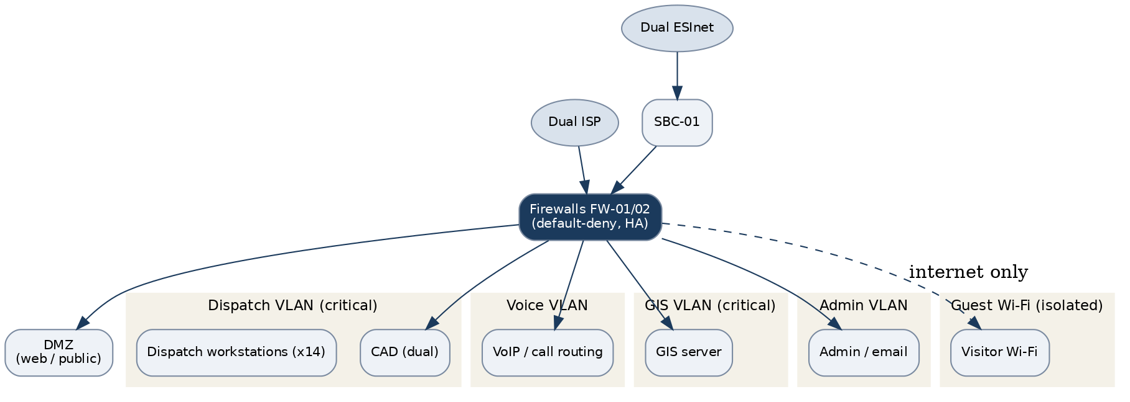

3. Segments & Devices
Node / device | Segment / VLAN | Role / function | Trust boundary
Firewalls (FW-01/02, HA) | Perimeter | Boundary control, default-deny | Perimeter
Session border controller (SBC-01) | Voice VLAN | SIP boundary to dual ESInet | Perimeter
CAD servers (dual) | Dispatch VLAN | Call-handling and dispatch | Internal, critical
VoIP / call routing | Voice VLAN | Voice call routing | Internal, critical
GIS server | GIS VLAN | Mapping and location | Internal, critical
Admin workstations (x14) | Admin VLAN | Administration and email | Internal
DMZ web host | DMZ | Public information service | Perimeter
Guest Wi-Fi | Guest | Visitor internet only | Untrusted, isolated

4. Relationship Notes
All inter-segment traffic is denied by default; only defined flows are allowed through the firewall pair. Dispatch, voice, and GIS sit on their own critical VLANs, public services live in the DMZ, and guest Wi-Fi is internet-only and isolated. Dual ISP and dual ESInet provide redundancy. This diagram was last verified against the Master Asset Inventory on 2026-02-09, separate from the document review date. The Firewall Ruleset Documentation carries the as-built rules and the Network Segmentation Design Document sets the intended zoning.

Profile Scaling Notes
PSAP Profile | Minimum-viable implementation
Medium (6–25, shared county IT) | A maintained diagram covering all VLANs or both sites, the boundary devices, and each external connection. Kept under version control and re-verified against the asset inventory on a set cadence.

Source Authority
NENA-STA-040.2-2024: §6.7.3, §6.9, §6.11, §6.13
NIST SP 800-53 Rev. 5: AC-4, CA-3, CA-9, PL-8, SC-7

Approval Signatures
Role | Name | Signature | Date
Director | Anthony Reyes | /s/ Anthony Reyes | 2026-02-09
IT Support Lead | Priya Nair | /s/ Priya Nair | 2026-02-09

Change History
Version | Date | Author | Summary of Change
1 | 2026-02-09 | Priya Nair | Initial adoption

