Network Architecture Diagram
Authority: Adopted by Hickory County 911 under the authority of Tracy Holloway, Director.
Version: 1 Effective Date: 2026-02-16 Next Review: 2027-02-16
Owner: County IT Contact
Classification: Restricted

1. Purpose
This diagram is the current, dated map of the agency's network: every segment and VLAN, the devices on each, the boundary points, and every external connection. It is the reference the firewall ruleset, segmentation design, external connection inventory, and monitoring records all build on, so it is kept accurate against the Master Asset Inventory.

2. Diagram
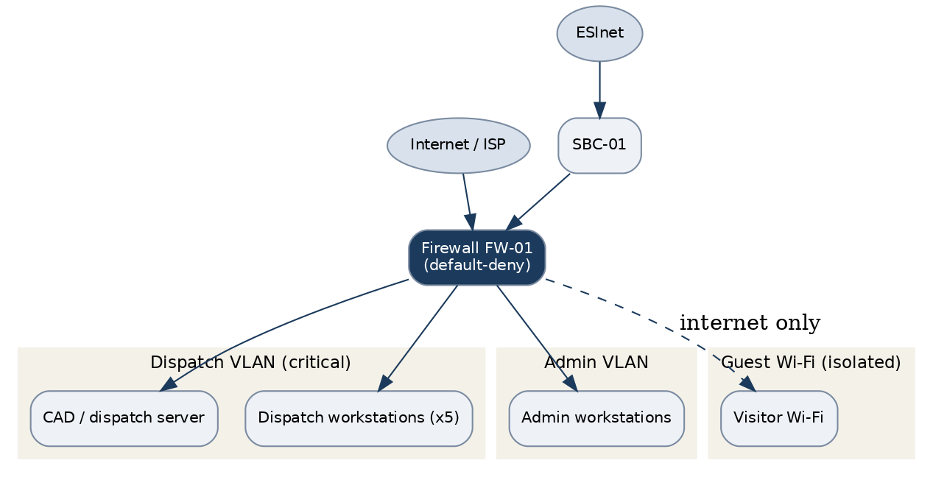

3. Segments & Devices
Node / device | Segment / VLAN | Role / function | Trust boundary
Firewall (FW-01) | Perimeter | Boundary control, default-deny | Perimeter
Session border controller (SBC-01) | Voice / edge | SIP boundary to the ESInet | Perimeter
CAD / dispatch server | Dispatch VLAN | Call-handling and dispatch | Internal, critical
Dispatch workstations (x5) | Dispatch VLAN | Call-taking and dispatch | Internal, critical
Admin workstations | Admin VLAN | Administration and email | Internal
Guest Wi-Fi access point | Guest | Visitor internet only | Untrusted, isolated

4. Relationship Notes
Traffic between segments is denied by default. The dispatch and admin VLANs reach the internet only through the firewall on 443, and the guest Wi-Fi is internet-only and fully isolated. The ESInet enters through SBC-01 to the firewall. This diagram was last verified against the Master Asset Inventory on 2026-02-16, separate from the document review date. The Firewall Ruleset Documentation carries the as-built rules and the Network Segmentation Design Document sets the intended zoning.

Profile Scaling Notes
PSAP Profile | Minimum-viable implementation
Small (1–5 dispatchers, no in-house IT) | One page is enough: a simple diagram showing the internet or ESInet link, the firewall, the dispatch and admin segments, and the CAD and phone systems. Update it whenever the network changes and re-verify once a year.

Source Authority
NENA-STA-040.2-2024: §6.7.3, §6.9, §6.11, §6.13
NIST SP 800-53 Rev. 5: AC-4, CA-3, CA-9, PL-8, SC-7

Approval Signatures
Role | Name | Signature | Date
Director | Tracy Holloway | /s/ Tracy Holloway | 2026-02-16
County IT Contact | Marcus Reed | /s/ Marcus Reed | 2026-02-16

Change History
Version | Date | Author | Summary of Change
1 | 2026-02-16 | Marcus Reed | Initial adoption

