Network Segmentation Design Document
Authority: Adopted by Tri-River Regional 911 Center under the authority of Dr. Lisa Park, Director.
Version: 1 Effective Date: 2026-01-26 Next Review: 2027-01-26
Owner: Information Security Analyst
Classification: Restricted

1. Purpose
This document sets the agency's network segmentation model: the zones and VLANs, what each isolates, the DMZ and inter-segment rules, and the reasons behind them. It is the design the Firewall Ruleset Documentation implements as-built, and it keeps critical services such as GIS and call routing separated from general-use systems.

2. Diagram
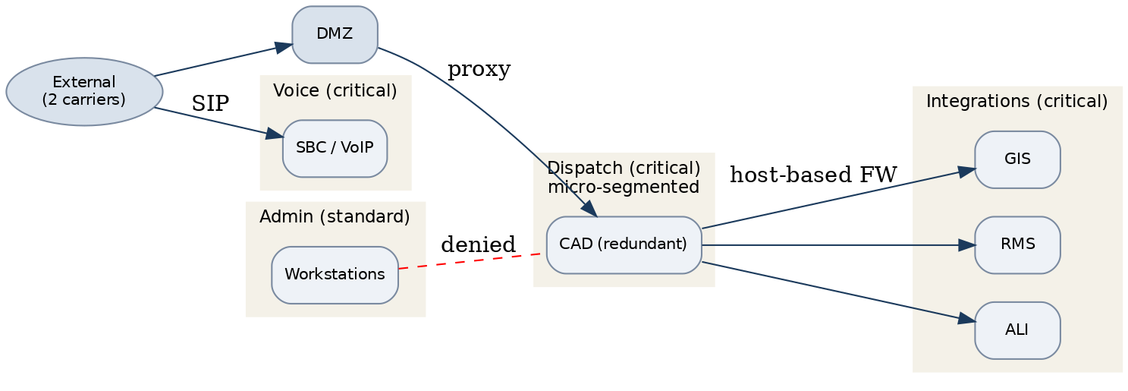

3. Segmentation Zones
Zone / VLAN | Purpose / systems in zone | Trust level | Isolated from | Inter-segment rule
Dispatch VLAN | Call-handling and dispatch (redundant) | Critical | Admin, guest, DMZ | Deny by default; micro-segmented
Integration VLANs | GIS, RMS, ALI, video | Critical | General-use, guest | Host-based FW; allow from dispatch only
Voice VLAN | SBC / VoIP | Critical | Guest, admin | Allow to SBC only
Admin VLAN | Workstations, email | Standard | Critical VLANs | Deny to critical VLANs
DMZ | Partner and public services | Untrusted | All internal VLANs | Ingress/egress filtered
Guest Wi-Fi | Visitor internet access | Untrusted | All internal | Internet-only; isolated

4. Inter-Segment Rules & Traffic Policy
All inter-zone traffic is denied by default across both centers; only defined flows pass, each through a next-generation firewall or the DMZ proxy. Critical services are micro-segmented with host-based firewalls, and the admin VLAN cannot reach the critical VLANs. Enforced as-built in the Firewall Ruleset Documentation and carried into the System Configuration Baselines.

5. Critical Service Isolation
Call routing (the CPE and CAD path) and the NG911 integrations (GIS, RMS, ALI, video) are micro-segmented on their own critical VLANs across both centers, reachable only over the defined flows. A compromise on the administrative or guest network cannot reach these services. Isolation is verified on change and during periodic review.

Profile Scaling Notes
PSAP Profile | Minimum-viable implementation
Large (25+, dedicated IT/security) | A full zoned design with micro-segmentation for critical services, DMZ and internal separation across both centers, and inter-segment rules managed and monitored as part of the security program.

Source Authority
NENA-STA-040.2-2024: §6.9, §6.12, §6.13, §6.16
NIST SP 800-53 Rev. 5: AC-4, CA-9, SC-7

Approval Signatures
Role | Name | Signature | Date
Director | Dr. Lisa Park | /s/ Dr. Lisa Park | 2026-01-26
Information Security Analyst | Raymond Osei | /s/ Raymond Osei | 2026-01-26

Change History
Version | Date | Author | Summary of Change
1 | 2026-01-26 | Raymond Osei | Initial adoption

