Network Segmentation Design Document
Authority: Adopted by Wabash Valley Communications under the authority of Anthony Reyes, Director.
Version: 1 Effective Date: 2026-02-09 Next Review: 2027-02-09
Owner: IT Support Lead
Classification: Restricted

1. Purpose
This document sets the agency's network segmentation model: the zones and VLANs, what each isolates, the DMZ and inter-segment rules, and the reasons behind them. It is the design the Firewall Ruleset Documentation implements as-built, and it keeps critical services such as GIS and call routing separated from general-use systems.

2. Diagram
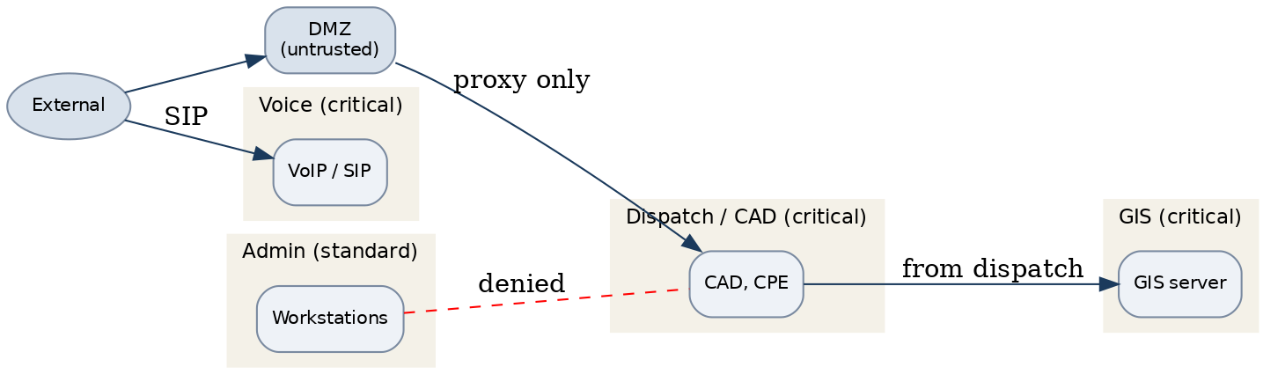

3. Segmentation Zones
Zone / VLAN | Purpose / systems in zone | Trust level | Isolated from | Inter-segment rule
Dispatch / CAD VLAN | Call-handling and dispatch | Critical | Admin, guest, DMZ | Deny by default
Voice VLAN | VoIP / SIP media and signaling | Critical | Guest, admin | Allow to SBC only
GIS VLAN | GIS and map data services | Critical | General-use, guest | Allow from dispatch only
Admin VLAN | Workstations, email | Standard | Critical VLANs | Deny to critical VLANs
DMZ | Public or partner-facing services | Untrusted | All internal VLANs | Ingress/egress filtered; no direct internal
Guest Wi-Fi | Visitor internet access | Untrusted | All internal | Internet-only; isolated

4. Inter-Segment Rules & Traffic Policy
All inter-zone traffic is denied by default; only the defined flows are allowed, each through a firewall or the DMZ reverse proxy. The DMZ is ingress/egress filtered and no DMZ host reaches an internal VLAN directly. Peer-to-peer between endpoints is blocked except one approved, logged file-share path. Enforced as-built in the Firewall Ruleset Documentation and carried into the System Configuration Baselines.

5. Critical Service Isolation
Call routing and GIS run on their own critical VLANs, isolated from general-use and guest systems and reachable only over the defined flows above. A failure or compromise on the administrative or guest network cannot reach these services. Isolation is verified when the segmentation design changes and during periodic review.

Profile Scaling Notes
PSAP Profile | Minimum-viable implementation
Medium (6–25, shared county IT) | Separate VLANs for dispatch, voice, GIS, and administration, with a DMZ for any public-facing service and default-deny rules between zones. Reviewed when the network changes.

Source Authority
NENA-STA-040.2-2024: §6.9, §6.12, §6.13, §6.16
NIST SP 800-53 Rev. 5: AC-4, CA-9, SC-7

Approval Signatures
Role | Name | Signature | Date
Director | Anthony Reyes | /s/ Anthony Reyes | 2026-02-09
IT Support Lead | Priya Nair | /s/ Priya Nair | 2026-02-09

Change History
Version | Date | Author | Summary of Change
1 | 2026-02-09 | Priya Nair | Initial adoption

