Network Segmentation Design Document
Authority: Adopted by Hickory County 911 under the authority of Tracy Holloway, Director.
Version: 1 Effective Date: 2026-02-16 Next Review: 2027-02-16
Owner: County IT Contact
Classification: Restricted

1. Purpose
This document sets the agency's network segmentation model: the zones and VLANs, what each isolates, the DMZ and inter-segment rules, and the reasons behind them. It is the design the Firewall Ruleset Documentation implements as-built, and it keeps critical services such as GIS and call routing separated from general-use systems.

2. Diagram
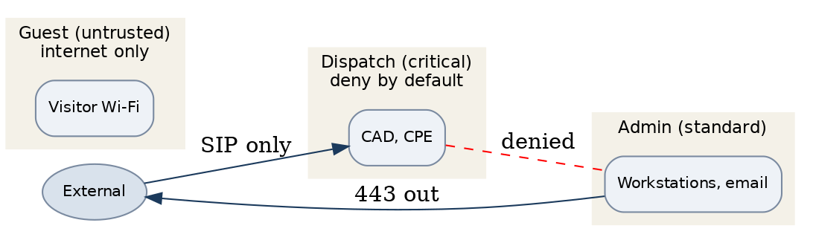

3. Segmentation Zones
Zone / VLAN | Purpose / systems in zone | Trust level | Isolated from | Inter-segment rule
Dispatch VLAN | Call-handling and dispatch: CAD, CPE | Critical | Admin, guest | Deny by default; allow only defined flows
Admin VLAN | Workstations and email | Standard | Dispatch | Deny to dispatch; 443 out only
Guest Wi-Fi | Visitor internet access | Untrusted | All internal | Internet-only; fully isolated

4. Inter-Segment Rules & Traffic Policy
All inter-zone traffic is denied by default; only the flows in the table above are allowed, each through the firewall. The guest Wi-Fi is internet-only and cannot reach any internal segment, and peer-to-peer connections between endpoints are blocked. This design is enforced as-built in the Firewall Ruleset Documentation and carried into the System Configuration Baselines so changes run through change management.

5. Critical Service Isolation
The CAD and call-handling path runs on the dispatch VLAN, isolated from the admin and guest networks and reachable only over the defined flows above. A problem on the admin or guest network cannot reach dispatch. Isolation is checked whenever the segmentation changes and at the annual review.

Profile Scaling Notes
PSAP Profile | Minimum-viable implementation
Small (1–5 dispatchers, no in-house IT) | A basic split is enough: keep dispatch and voice on one protected segment, put guest Wi-Fi on a separate internet-only network, and keep the two apart. The county or vendor IT contact enforces it on the firewall.

Source Authority
NENA-STA-040.2-2024: §6.9, §6.12, §6.13, §6.16
NIST SP 800-53 Rev. 5: AC-4, CA-9, SC-7

Approval Signatures
Role | Name | Signature | Date
Director | Tracy Holloway | /s/ Tracy Holloway | 2026-02-16
County IT Contact | Marcus Reed | /s/ Marcus Reed | 2026-02-16

Change History
Version | Date | Author | Summary of Change
1 | 2026-02-16 | Marcus Reed | Initial adoption

