System Redundancy Design Documentation
Authority: Adopted by Tri-River Regional 911 Center under the authority of Dr. Lisa Park, Director.
Version: 1.0 Effective Date: 2026-01-15 Next Review: 2026-07-15
Owner: IT Team
Classification: Restricted

1. Purpose
This document maps Tri-River Regional 911 Center's redundancy: two staffed centers with dual CAD, dual NG911 BCF/ESRP edges, diverse carriers, and automatic failover between sites, so no single failure or vendor outage stops call handling.

2. Diagram
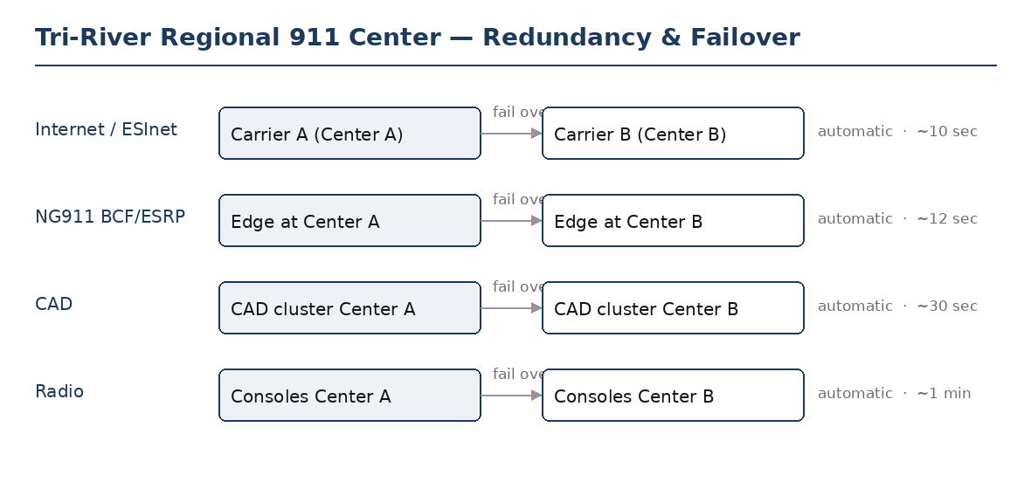

3. Redundant Components
Service / component | Primary and diverse counterpart | Failover mechanism (auto / manual) | Expected shift time
Internet / ESInet path | Carrier A at Center A; Carrier B at Center B (diverse) | Automatic | ~10 sec
NG911 BCF / ESRP | Edge at Center A; edge at Center B | Automatic | ~12 sec
Computer-aided dispatch (CAD) | CAD cluster Center A; CAD cluster Center B | Automatic | ~30 sec
Radio / dispatch console | Consoles at Center A; consoles at Center B | Automatic | ~1 min

4. Diversity & Failover Notes
Tri-River Regional 911 Center runs two staffed centers with full geographic and vendor diversity: dual CAD clusters, dual NG911 BCF/ESRP edges, and diverse carriers, all with automatic failover between sites. The remaining single points of failure, the shared GIS data source and the ALI database, are carried into the Single-Point-of-Failure Assessment Record. Each failover path is tested in the Failover Test Records; certificate renewal is tracked with the Certificate Inventory so a failover keeps valid certificates.

Profile Scaling Notes
PSAP Profile | Minimum-viable implementation
Small (1–5 dispatchers, no in-house IT) | Redundancy is basic but real: a second carrier or a wireless backup for internet, a documented manual fallback for CAD, and a backup radio console. Test the failover once a year and keep the result.

Source Authority
NENA-STA-040.2-2024: §5.3, §6.14, §6.15
NIST SP 800-53 Rev. 5: CP-2, CP-7, CP-8
Indiana statutes and administrative code:
IC 36-8-16.7: Statewide 9-1-1 Services (redundancy)

Approval Signatures
Role | Name | Signature | Date
Director | Dr. Lisa Park | /s/ Lisa Park | 2026-01-15
IT Team | Sam Whitfield | /s/ Sam Whitfield | 2026-01-15

Change History
Version | Date | Author | Summary of Change
1.0 | 2026-01-15 | IT Team | Initial issue

