System Redundancy Design Documentation
Authority: Adopted by Wabash Valley Communications under the authority of Anthony Reyes, Director.
Version: 1.0 Effective Date: 2026-01-15 Next Review: 2027-01-15
Owner: Shared County IT
Classification: Restricted

1. Purpose
This document maps Wabash Valley Communications' redundancy: dual CAD and dual ESInet with automatic failover across two sites, a backup radio console, and UPS-plus-generator power, so a single failure or vendor outage does not stop call handling.

2. Diagram
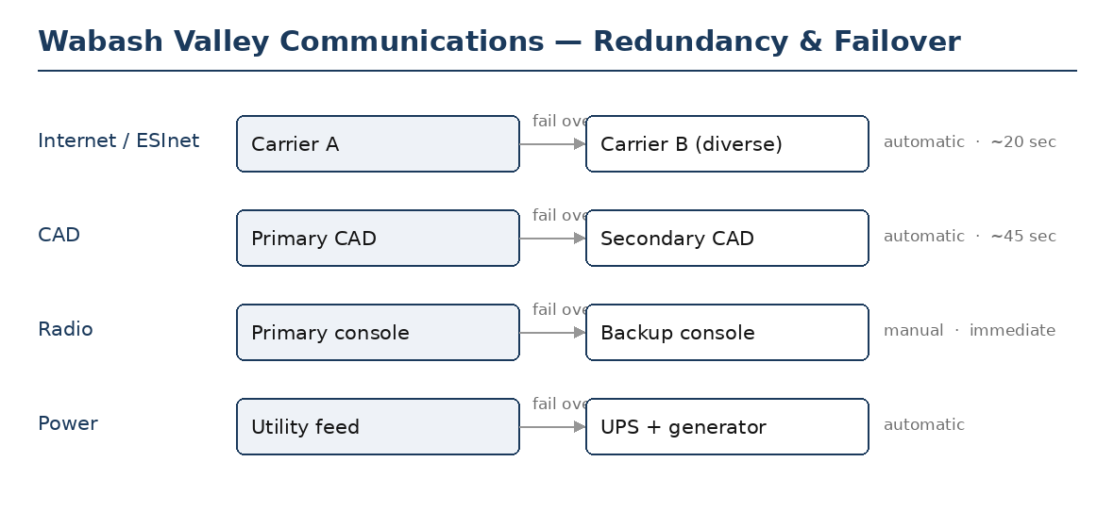

3. Redundant Components
Service / component | Primary and diverse counterpart | Failover mechanism (auto / manual) | Expected shift time
Internet / ESInet path | Carrier A (primary); Carrier B (diverse) | Automatic | ~20 sec
Call routing / CPE | Primary CPE; redundant CPE node | Automatic | ~1 min
Computer-aided dispatch (CAD) | Primary CAD; secondary CAD (hot standby) | Automatic | ~45 sec
Radio / dispatch console | Primary console; backup console | Manual | immediate

4. Diversity & Failover Notes
Wabash Valley Communications runs dual CAD and dual ESInet with automatic failover, plus a backup console and UPS-plus-generator power. Primary and secondary systems sit in separate equipment rooms across two sites. The remaining single point of failure, the shared radio backhaul, is carried into the Single-Point-of-Failure Assessment Record. Each failover path is tested in the Failover Test Records; certificate renewal is tracked with the Certificate Inventory so a failover keeps valid certificates.

Profile Scaling Notes
PSAP Profile | Minimum-viable implementation
Small (1–5 dispatchers, no in-house IT) | Redundancy is basic but real: a second carrier or a wireless backup for internet, a documented manual fallback for CAD, and a backup radio console. Test the failover once a year and keep the result.

Source Authority
NENA-STA-040.2-2024: §5.3, §6.14, §6.15
NIST SP 800-53 Rev. 5: CP-2, CP-7, CP-8
Indiana statutes and administrative code:
IC 36-8-16.7: Statewide 9-1-1 Services (redundancy)

Approval Signatures
Role | Name | Signature | Date
Director | Anthony Reyes | /s/ Anthony Reyes | 2026-01-15
Shared County IT | Priya Nair | /s/ Priya Nair | 2026-01-15

Change History
Version | Date | Author | Summary of Change
1.0 | 2026-01-15 | Shared County IT | Initial issue

