System Redundancy Design Documentation
Authority: Adopted by Hickory County 911 under the authority of Tracy Holloway, 911 Director.
Version: 1.0 Effective Date: 2026-01-15 Next Review: 2027-01-15
Owner: County IT Administrator
Classification: Restricted

1. Purpose
This document maps Hickory County 911's redundancy. As a small rural center it runs mostly manual fallbacks: one internet carrier with a cellular backup, one CAD platform with a manual call-card fallback, backup portable radios, and UPS-plus-generator power. For each, it records the failover mechanism so a single failure does not stop call handling.

2. Diagram
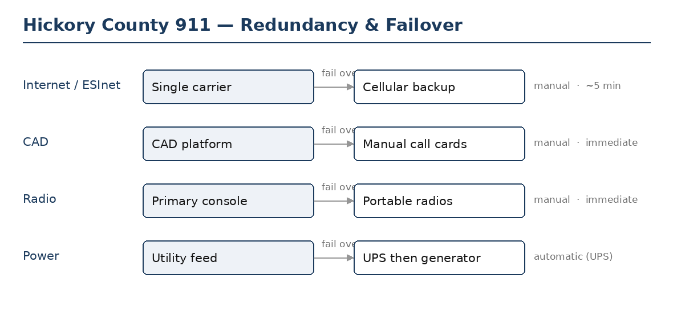

3. Redundant Components
Service / component | Primary and diverse counterpart | Failover mechanism (auto / manual) | Expected shift time
Internet / ESInet path | Single carrier (primary); cellular / wireless backup | Manual | ~5 min
Call routing / CPE | Single CPE; no hot standby (vendor restore) | Manual | vendor-dependent
Computer-aided dispatch (CAD) | Single CAD; manual call-card fallback | Manual | immediate (cards)
Radio / dispatch console | Primary console; backup portable radios | Manual | immediate

4. Diversity & Failover Notes
Hickory County 911 has limited redundancy and no second facility. The single carrier, single CPE, and single CAD are known single points of failure and are carried into the Single-Point-of-Failure Assessment Record. The cellular internet failover and the manual CAD fallback are tested each year and recorded in the Failover Test Records. Certificates are held by the CAD and ESInet vendors; their renewal is tracked with the Certificate Inventory so a failover keeps valid certificates.

Profile Scaling Notes
PSAP Profile | Minimum-viable implementation
Small (1–5 dispatchers, no in-house IT) | Redundancy is basic but real: a second carrier or a wireless backup for internet, a documented manual fallback for CAD, and a backup radio console. Test the failover once a year and keep the result.

Source Authority
NENA-STA-040.2-2024: §5.3, §6.14, §6.15
NIST SP 800-53 Rev. 5: CP-2, CP-7, CP-8
Indiana statutes and administrative code:
IC 36-8-16.7: Statewide 9-1-1 Services (redundancy)

Approval Signatures
Role | Name | Signature | Date
Director | Tracy Holloway | /s/ Tracy Holloway | 2026-01-15
County IT Administrator | Marcus Reed | /s/ Marcus Reed | 2026-01-15

Change History
Version | Date | Author | Summary of Change
1.0 | 2026-01-15 | County IT Administrator | Initial issue

