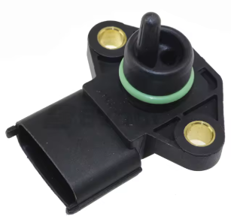
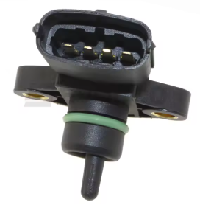

Manifold Air Pressure and Temperature sensor for Hyundai (H100, H-1, etc.) and KIA.
OEM #: 3920042030
EAN: 4059191686698
Pressure sensor core type: Piezoelectric capacitance (?)
Origin: Aliexpress, no brand, China generic

The pins are numbered on the top of the housing, from right to left in the right picture.
- GND, for power and signal reference
- MAT output: NTC
Measured: 2.2 kOhm to pin #1 at 20 degC
Measured: approx 330 Ohm to pin #1 at approx. 95 degC.
Measured values fit with NTC Beta = 2800
(measured: 7.08 kOhm to pin #3 at 20 degC, with 0 mV at pin #3)
Measured: 0.0 mV to pin #1 with 5000 mV at pin #3.
- 5 V power input
Measured: Very low current (<0.001 mA ?!!!) at 5000 mV.
Can it be used at 3.3 V power input? (That would interface easier with a STM32.)
- MAP output, analog, linear, 11 – 254 kPa absolute = 250 – 4759 mV
Measured: 1849 mV at 97 kPa and 5000 mV power input,
vs. teoretical: 250 + (97-11)/(254-11) * (4759-250) = 1846 mV
Measured: 1213 mV at 97 kPa and 3300 mV power input,
vs teoretical 1846 mV * 3300/5000 = 1218 mV
The output seems to be proportional to the power voltage.

Electronics HW and SW for MAP-sensor – work in progress (not complete)

HW: I use an old PC and WeActStudio's STM32WB55CoreBoard and STMLinkV3MiniE,
Download from ST: STM32CubeMX, -IDE, -Programmer to the PC.
I also use a phone with Android and the apps “LightBlue” and “ST BLE Toolbox”.

The STM32W MCUs have two cores. Core #2 is a ARM Cortex M0 linked to the radio HW. It runs ST's propriatary firmware, e.g. one with a full and certified BLE interface, or a smaller FW with limited BLE (there are also firmwares for other protocols). Connect the HW and use the STM32CubeProgrammer to check (and maybe also update) the bootloader and flash the FW needed for our project! Follow the instructions in the FW release notes!

Watch Phil's Lab #129 on YouTube.
See https://github.com/aollin/racechrono-ble-diy-device

STM32CubeMX:
STM32_WPAN → BLE Advertising → Advertising Elements → AD_TYPE_COMPLETE_LOCAL_NAME = NinoDAQ
STM32_WPAN → Application and services → Select “Custom Template”
STM32_WPAN → BLE GATT → Number of services = 1
STM32_WPAN → BLE GATT → Long Name = RaceChrono_BLE_DIY
STM32_WPAN → RaceChrono_BLE_DIY → Number of characteristics = 2
STM32_WPAN → RaceChrono_BLE_DIY → Service 1 → UUID = 1F F8
STM32_WPAN → RaceChrono_BLE_DIY → Characteristics 1 → UUID = 00 01
STM32_WPAN → RaceChrono_BLE_DIY → Characteristics 1 properties → CHAR_PROP_READ=Yes, CHAR_PROP_NOTIFY=Yes, other CHAR_PROPs = No
STM32_WPAN → RaceChrono_BLE_DIY → Characteristics 2 → UUID = 00 02

Generate code. In STM32CubeIDE:
Core → Src → main.c → PeriphCommonClock_Config(void) → Add line LL_HSEM_1StepLock(HSEM,5);

STM32_WPAN → App → custom_stm.c → Add #include "usbd_cdc_if.h"

