Lab 3 – Exercise 7 using Floyd-Warshall algorithm

Write a program that, given a graph with costs that has no negative cost cycles and two vertices, finds a lowest cost walk between the given vertices. The program shall use the Floyd-Warshall algorithm.

Example 1:

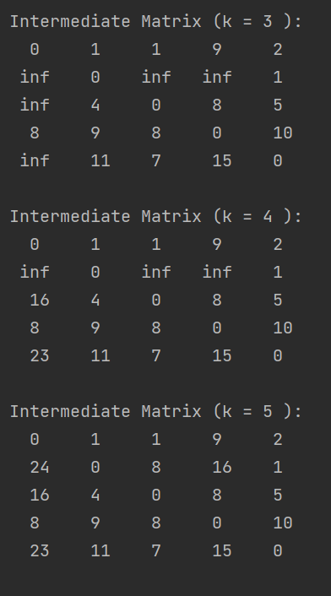

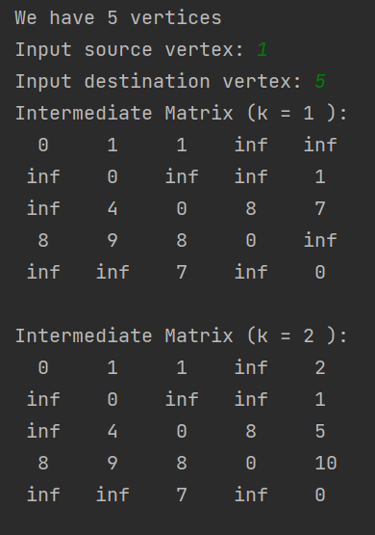



Example 2:



