NAME:G.SAI CHARAN
ROLLNO:2403a51023

SET 2
Q1. Advanced Prompt Engineering – Few-shot (Scenario)
You are developing an AI assistant for school children. Create a few-shot prompt
that helps AI generate Python code for 3 ways to check if a number is even or
odd (modulo, bitwise, repeated subtraction).
(Include docstrings + comments + test cases for the output program.

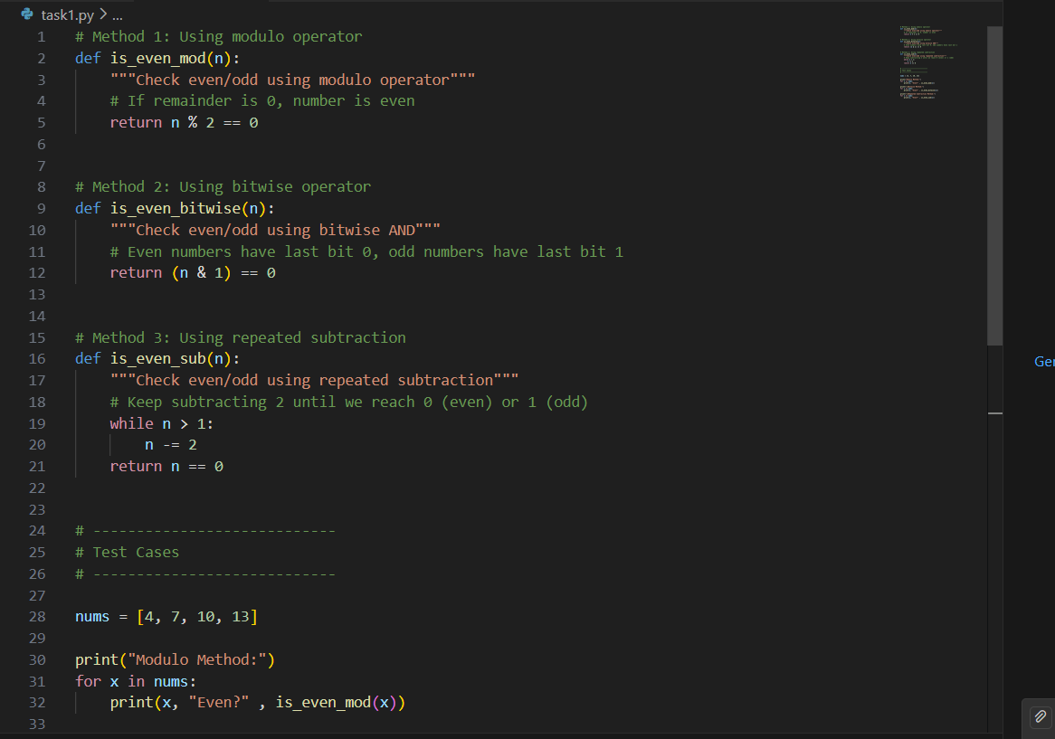

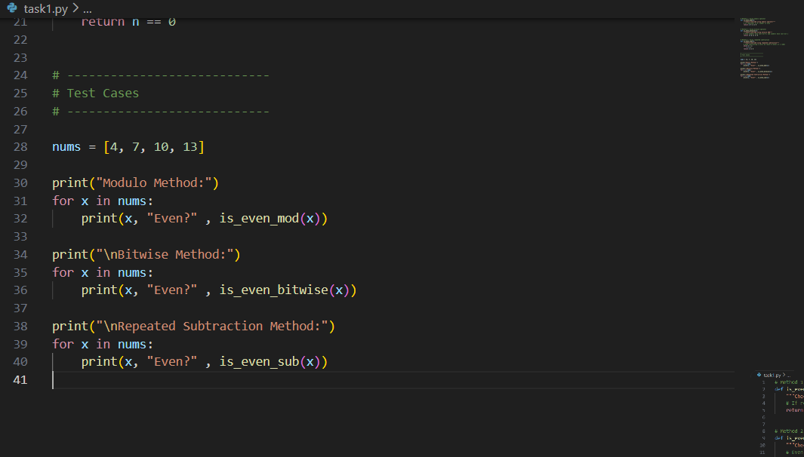

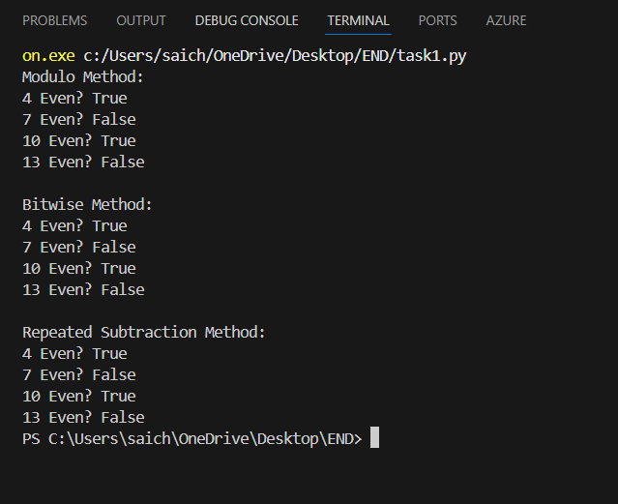’

Q2. Data Structures (Scenario)
A hospital management system needs to maintain a queue of patients waiting for
consultation. Implement a Queue data structure using Python with enqueue,
dequeue, and peek operations.
(Add docs + comments + tests.)

