|  |  |
| --- | --- |
|  | SR UNIVERSITY  Campus Warangal |
| Program: II - B.Tech (CS& AI) |
| Professor(a): Dr. Venkataramana Veeramsetty, Professor |
| Department: Computer Science and AI Semester: I |
| AI Assisted Coding - Lab Test 1 - Set B |
| Instructions:   1. Use AI Tools like VScode+Github Copilot and Cursor AI for code generation 2. This Assignment will be evaluated for 15 Marks (10 Marks for Tasks and 5 Marks for viva based on regular lab activities) 3. Students need to submit assignment through canvas before due date 4. Students who are absent for lab will receive 0 Marks | |

1. Create a Python function that converts an amount from one currency to another using exchange rates stored in a dictionary. Use GitHub Copilot along with VS Code. Use Few shot prompting.

Prompt:write a python function that converts one amount currency to other take input from user use few shot prompting

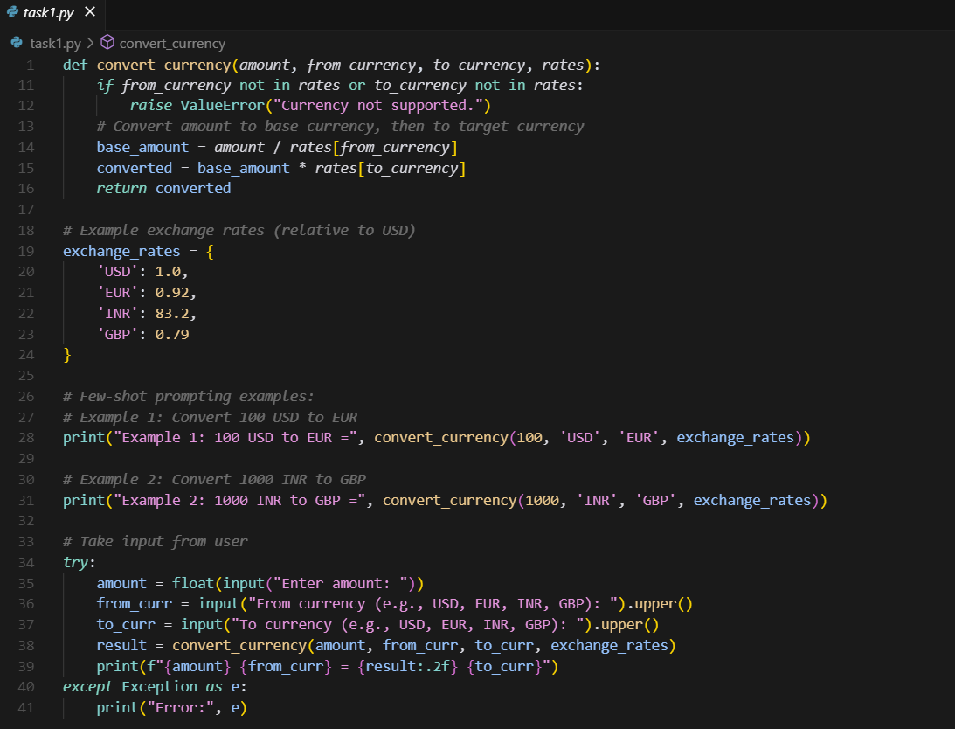

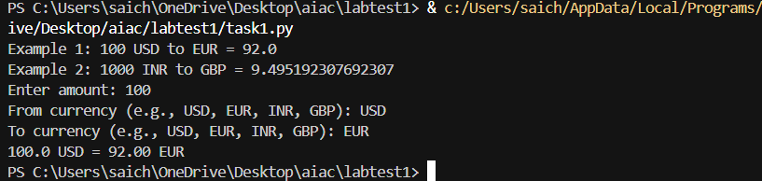

1. Write a Python program to extract all email addresses from a block of text using regular expressions. GitHub Copilot along with VS Code. Use zero shot prompting.

Prompt: Write a Python program to extract all email addresses from a block of text using regular expressions take input from user

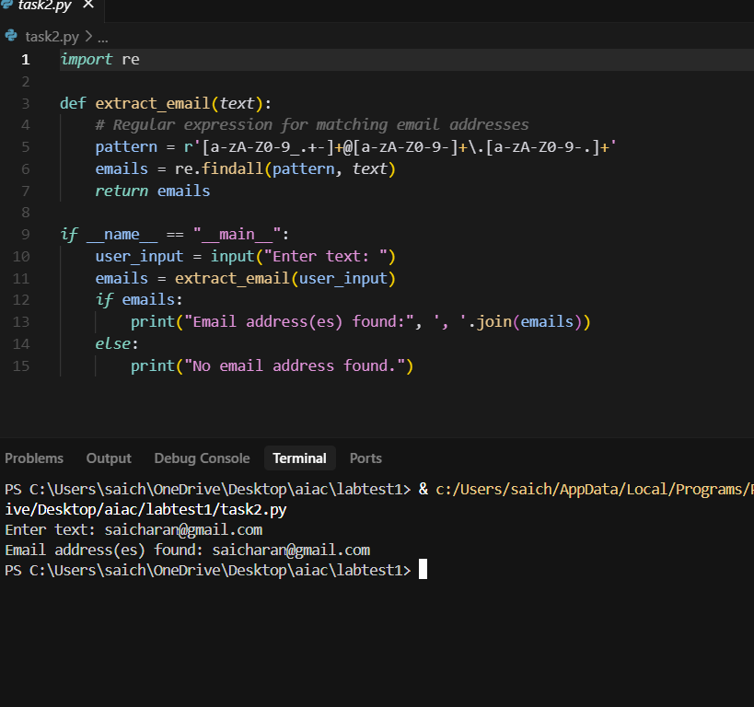

1. Given a list of movies with their genres, Write a Python function that recommends movies based on a user’s preferred genre. Use the Cursor AI tool. Use few shot prompting.

Prompot : Write a Python function that recommends movies based on a user’s preferred genre take input from user

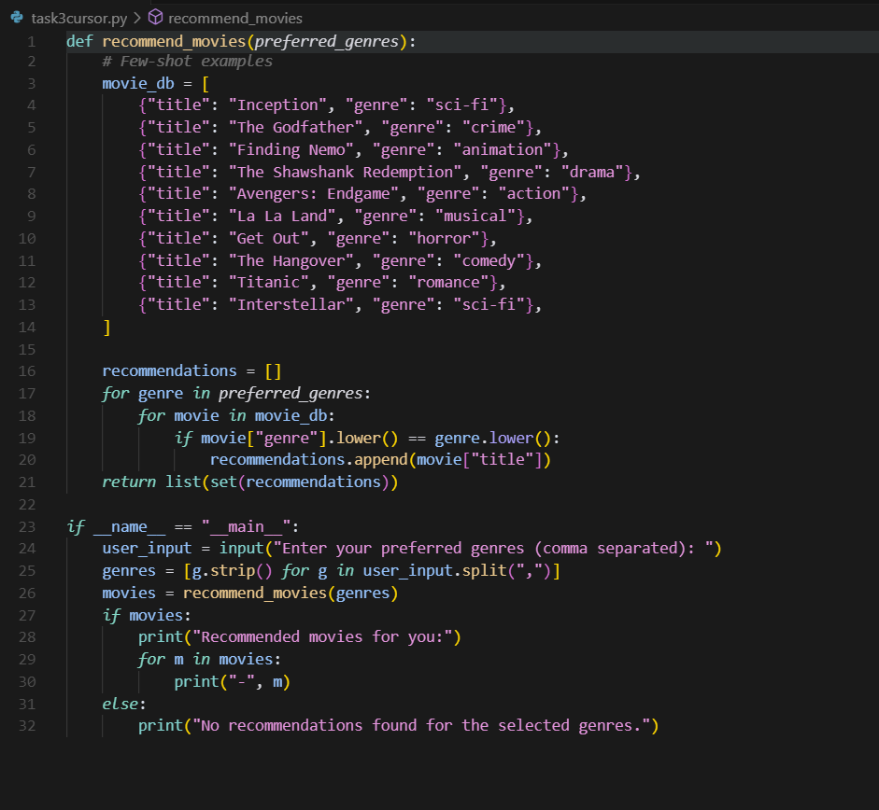

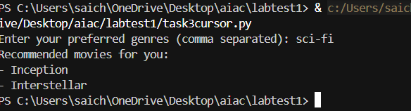

5.Write Python code that reads a CSV file containing student names and marks in 3 subjects. Calculate the total and average marks for each student. Use the Cursor AI tool.

Prompt: Write Python code that reads a CSV file containing student names and marks in 3 subjects. Calculate the total and average marks for each student take inpuit from the user

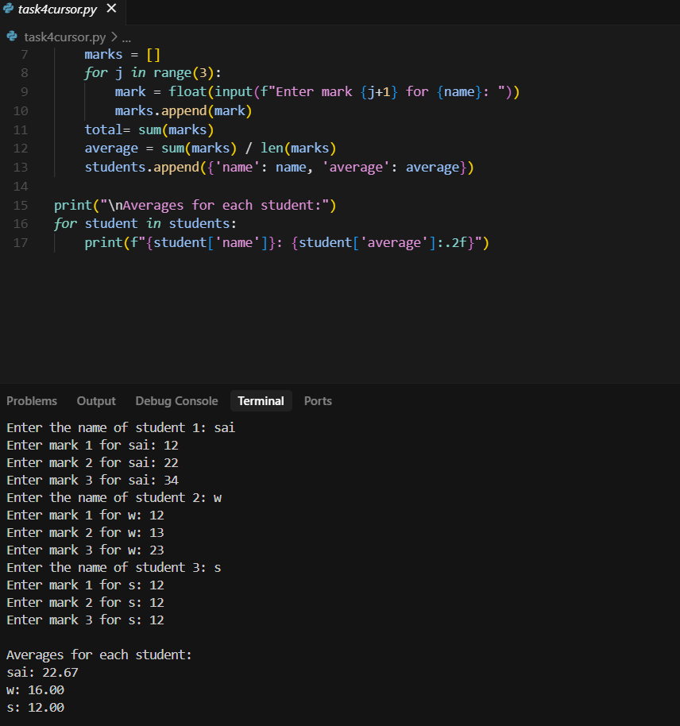

Date: 2025-08-14

©Dr. Venkataramana Veeramsetty, Professor Pag. 1 de 1