SYNAPSE BUILDOS: GENERATIVE AI-POWERED RESIDENTIAL ARCHITECTURAL DESIGN, ESTIMATION, AND COMPLIANCE PLATFORM
A MINI PROJECT REPORT
Submitted by
PROJECT TEAM
(REGISTER NUMBER: 9124104073 / 9124104103 / 9124104121)
in partial fulfilment for the award of the degree
of
BACHELOR OF ENGINEERING
IN
COMPUTER SCIENCE AND ENGINEERING
KCG COLLEGE OF TECHNOLOGY, KARAPAKKAM
(AUTONOMOUS)
NOVEMBER 2026

BONAFIDE CERTIFICATE
Certified that this mini project report “SYNAPSE BUILDOS: Generative AI-Powered Residential Architectural Design, Estimation, and Compliance Platform” is the bonafide work of “Project Team” who carried out the mini project work under my supervision.
Signature of the HOD with date Signature of the Supervisor with date
Dr. S. REVATHY M.E., Ph.D., Dr. ROBINSON JOEL
PROFESSOR AND HEAD, ASSOCIATE PROFESSOR
Dept. of Computer Science & Engineering, Dept. of Computer Science & Engineering,
KCG College of Technology, Chennai. KCG College of Technology, Chennai.
Certified that the above candidate(s) was examined in the End Semester mini-Project Viva-Voce Examination held on ....................................
INTERNAL EXAMINER EXTERNAL EXAMINER

DECLARATION BY THE STUDENT
We hereby declare that this mini project report titled “SYNAPSE BUILDOS: Generative AI-Powered Residential Architectural Design, Estimation, and Compliance Platform”, under the guidance of “Dr. Robinson Joel” is the original work done by us and we have not plagiarized or submitted to any other degree in any university by us.
STUDENT CANDIDATES
Department of Computer Science and Engineering
KCG College of Technology, Chennai

ACKNOWLEDGEMENT
We thank the Almighty GOD for the abundant blessings showered on us. We extend our deepest love and gratitude to our dear parents who built up our career and backed us up in life.
We thank our management and our Principal Dr. G. Prabhakaran for the opportunities given to us for our career development.
We feel indebted to the Head of the Department Dr. Revathy S, Professor and Head, Department of Computer Science & Engineering, KCG College of Technology, Karapakkam, for all her encouragement, which has sustained our labor and efforts.
We express our deepest gratitude to the internal guide Dr. Robinson Joel, Associate Professor, Department of Computer Science & Engineering, KCG College of Technology, for his valuable guidance, ideas and support.
We would like to thank all other faculty members of Department of Computer Science & Engineering, for their help and advice throughout our life in this campus.
Finally, we are thankful to all our friends and all others who encouraged us and helped us in doing this project.
PROJECT CANDIDATES

ABSTRACT
Synapse BuildOS is an innovative residential building intelligence platform developed using HTML5, SVG, Three.js, TypeScript, FastAPI, and Anthropic Claude LLM. The system bridges the severe disconnect between architectural drafting, civil engineering quantity estimation, and municipal bylaw approval.
In Synapse BuildOS, room geometry serves as the immutable single source of truth. Users can ingest project briefs through scanned documents, PDFs (via OCR), or natural language prompts. The system provides an interactive 2D SVG plan editor where users manipulate rooms on a real plot in feet with automated setback buffers. Every edit instantly updates the 3D volumetric massing model with interactive walkthroughs.
An automated rule-verification engine continuously evaluates designs against the Tamil Nadu Combined Development and Building Rules (TNCDBR 2019), checking FSI, coverage, setbacks, and parking. Simultaneously, an arithmetic cost engine computes line-item civil estimates directly against the published Tamil Nadu PWD Plinth Area Rates (2025–26).
The platform calculates a comprehensive Construction Readiness Score (0–100) spanning budget fit, compliance, buildability, and sustainability, while enabling exports to IFC4, DXF, OBJ, and PDF reports. Synapse BuildOS shortens the residential pre-construction cycle from weeks to seconds.

LIST OF TABLES
TABLE NO. | TABLE NAME | PAGE NO.
2.1 | Comparative Analysis of Existing Architectural & Construction Systems | 15
3.4.1 | Tools and Technologies Used in Synapse BuildOS | 24
4.1 | Geometric Takeoff and Rule Verification Validation Results | 30

LIST OF FIGURES
FIGURE NO. | TITLE | PAGE NO.
1.1 | Synapse BuildOS Platform Overview | 11
3.1 | Synapse BuildOS System Architecture | 20
3.2 | System Flow Diagram | 22
3.3 | Data Flow Diagram (Level 0 Context & Level 1 Detailed DFD) | 23
3.5 | UML Use Case Diagram | 25
4.4 | Synapse BuildOS 3D Spatial Models (Exterior & Axonometric) | 31
4.5 | Sample Architectural Design Model (Villa Harmony 3BHK Duplex — 2D Plan & 3D Massing) | 32

LIST OF ABBREVIATIONS
AI | Artificial Intelligence
CAD | Computer-Aided Design
BIM | Building Information Modeling
AEC | Architecture, Engineering, and Construction
TNCDBR | Tamil Nadu Combined Development and Building Rules
PWD | Public Works Department (Tamil Nadu)
FSI | Floor Space Index
BOQ | Bill of Quantities
AABB | Axis-Aligned Bounding Box
SVG | Scalable Vector Graphics
API | Application Programming Interface
UI | User Interface
UX | User Experience
OCR | Optical Character Recognition
LLM | Large Language Model
IFC | Industry Foundation Classes (IFC4)
DXF | Drawing Exchange Format

TABLE OF CONTENTS
CHAPTER NO. | TITLE | PAGE NO.
 | ABSTRACT | 5
 | LIST OF TABLES | 6
 | LIST OF FIGURES | 7
 | LIST OF ABBREVIATIONS | 8
1. | INTRODUCTION | 11
1.1 | Overview | 11
1.2 | Motivation | 12
1.3 | Objective | 12
1.4 | Scope | 13
1.5 | Significance of the study | 13
2. | LITERATURE SURVEY | 14
2.1 | Existing systems and comparative analysis | 14
2.2 | Computational geometry and generative AI in residential CAD | 16
2.3 | Automated building bylaw compliance and PWD estimation | 17
2.4 | Research gap | 17
3. | SYSTEM DESIGN AND IMPLEMENTATION | 19
3.1 | System overview | 19
3.2 | System architecture | 19
3.3 | System flow | 21
3.4 | Data flow diagram (DFD) | 22
3.4.1 | Tools and technologies used | 24
3.5 | Use case diagram | 25
3.6 | System modules description | 25
3.7 | Implementation detail | 26
3.8 | Implementation process | 27
3.9 | Advantages of the system | 27
3.10 | Challenges faced during implementation | 28
4. | TESTING AND RESULT | 29
4.1 | Introduction | 29
4.2 | Types of testing | 29
4.3 | Testing procedures | 30
4.4 | Results | 31
4.5 | Conclusion of testing | 32
5. | CONCLUSION AND FUTURE WORK | 33
5.1 | Conclusion | 33
5.2 | Future work | 34
 | APPENDIX 1: SAMPLE CODE | 35
 | REFERENCES | 48

CHAPTER 1
INTRODUCTION
1.1 OVERVIEW
Synapse BuildOS is an innovative architectural CAD, estimation, and statutory compliance platform developed using HTML5, SVG, JavaScript, Three.js, FastAPI, and Anthropic Claude. The system is designed to eliminate the severe real-world disconnect between architectural drafting, civil engineering quantity estimation, and municipal bylaw approval.
In traditional residential construction, drafting a floor plan in AutoCAD, calculating quantity takeoff in Excel, and checking compliance against municipal building codes (such as TNCDBR 2019) occur in isolated silos. When a client requests a modification, the entire process must be manually repeated, causing costly project delays.
Synapse BuildOS establishes room geometry as the immutable single source of truth. Rooms are modeled as rectangles in feet. From these rectangles, built-up areas, wall surface runs, door/window schedules, FSI, coverage, setbacks, and PWD plinth-area costs follow automatically and deterministically.
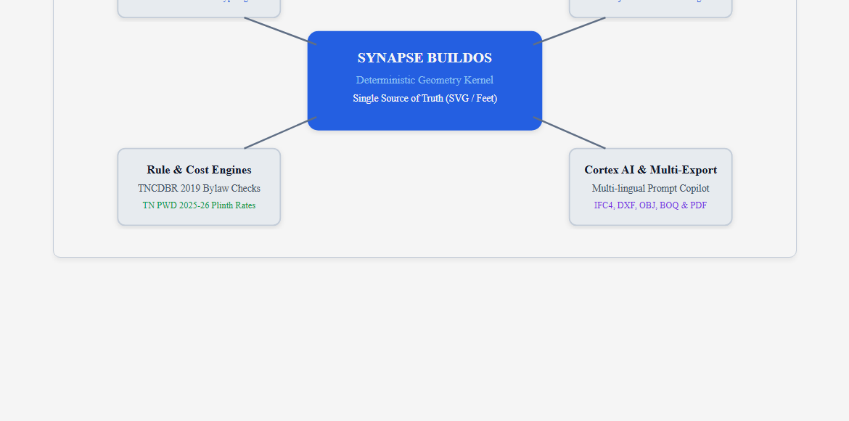
Figure 1.1: Synapse BuildOS Platform Overview
1.2 MOTIVATION
Many homeowners undertake construction without accessible architectural and legal guidance. Commercial CAD tools have steep learning curves and high costs, while consumer floor-plan tools lack statutory bylaw checks and regional rate schedules.
Key motivation includes:
• Eliminating the disconnect between architectural design and cost estimation.
• Preventing municipal building plan rejections by enforcing TNCDBR 2019 rules in real time.
• Providing deterministic, auditable cost estimation based on published Tamil Nadu PWD rates.
• Supporting natural language design modifications through multi-lingual AI prompts.
• Offering a zero-install, browser-based CAD and 3D walkthrough experience.
1.3 OBJECTIVE
The primary objectives of the project are:
1. To establish a unified geometric data model where 2D SVG rectangles drive all spatial, structural, and cost metrics.
2. To develop an automated statutory compliance engine that validates residential designs against TNCDBR 2019.
3. To implement a deterministic quantity takeoff and cost estimation engine based on Tamil Nadu PWD Plinth Area Rates (2025–26).
4. To generate real-time 3D parametric massing models and first-person walkthroughs using Three.js.
5. To integrate a multi-lingual LLM copilot (Cortex AI) capable of translating client requests into valid geometric adjustments.
6. To compute a Construction Readiness Score (0–100) and export professional CAD/BIM assets (IFC4, DXF, OBJ, CSV).
1.4 SCOPE
The scope includes:
• Develops an AI-based residential building intelligence platform.
• Supports residential villas, bungalows, and multi-family homes up to Ground + 2 floors.
• Ingests briefs via scanned documents, PDFs (using OCR), and freeform text.
• Renders interactive 2D floor plans with live setback boundaries and collision detection.
• Renders 3D spatial walkthroughs with procedural materials and sun-path lighting.
1.5 SIGNIFICANCE OF THE STUDY
• Democratizes architectural intelligence for homeowners and small builders.
• Eliminates post-tender cost escalation by synchronizing geometry with PWD pricing.
• Protects against municipal rejections and structural demolition penalties.
• Facilitates stakeholder consensus between clients, architects, and contractors.

CHAPTER 2
LITERATURE SURVEY
2.1 EXISTING SYSTEMS AND COMPARATIVE ANALYSIS
Commercial CAD platforms such as Autodesk AutoCAD and Revit provide high-precision drafting for trained professionals but require expensive licensing, high-end hardware, and lack localized Indian municipal bylaws. Consumer web tools like Planner 5D allow non-professionals to create floor plans but remain purely decorative, without structural takeoff or statutory checking. Recent generative AI tools often produce unbuildable plans with hallucinated dimensions.
Table 2.1 summarizes the comparative analysis between existing tools and Synapse BuildOS.
Existing System | Type | Key Features | Limitations | Remarks
AutoCAD / Revit | Desktop CAD / BIM | High-precision drafting, 3D modeling | Steep learning curve, high cost, no Indian bylaws | Industry standard, not accessible for rapid decisions
Planner 5D | Consumer Web App | Drag-and-drop layouts, 3D visualization | Purely visual; no civil costing, no bylaw checks | Good for decor, inadequate for approvals
Finch 3D / Hypar | Generative BIM | Algorithmic massing, daylight optimization | Commercial high-rises; lacks Indian PWD rates | Advanced, but disconnected from local rules
Synapse BuildOS (Ours) | Building Intelligence OS | Single source of truth, 2D SVG, 3D Three.js, TNCDBR & PWD | Focused on residential typologies up to G+2 | Zero-install, deterministic, auditable, and open
2.2 COMPUTATIONAL GEOMETRY AND GENERATIVE AI IN RESIDENTIAL CAD
Computational geometry allows floor plans to be modeled as planar graphs. Synapse BuildOS implements an Axis-Aligned Bounding Box (AABB) sweep algorithm with a 0.05 ft tolerance to prevent room collisions while permitting shared partition walls. Generative LLMs (Claude Cortex) are constrained through Pydantic schemas, ensuring AI assistance remains buildable.
2.3 AUTOMATED BUILDING BYLAW COMPLIANCE AND PWD ESTIMATION
Synapse BuildOS codifies the Tamil Nadu Combined Development and Building Rules (TNCDBR 2019) into exact mathematical evaluation rules. Every dimensional change re-verifies setbacks, FSI, and plot coverage. Simultaneously, construction costs are evaluated against the published Tamil Nadu PWD Plinth Area Rates (2025–26), ensuring full financial auditability.
2.4 RESEARCH GAP
Existing solutions suffer from technical complexity, fragmented drafting-estimation workflows, absence of regional Indian statutory bylaws, and hallucinated generative models. Synapse BuildOS bridges these gaps through a unified, deterministic, and accessible web operating system.

CHAPTER 3
SYSTEM DESIGN AND IMPLEMENTATION
3.1 SYSTEM OVERVIEW
Synapse BuildOS is structured around a centralized geometric state engine. It features a dual-surface architecture: a Landing Page & Project Brief Configurator, and a Visual CAD Studio with 2D SVG editing, 3D Three.js walkthroughs, live TNCDBR compliance auditing, and PWD cost takeoff.
3.2 SYSTEM ARCHITECTURE
The system consists of: 1) User Interface Layer (HTML5, SVG, Three.js); 2) Shared Model Engine (web/engine.js); 3) FastAPI Backend Services; 4) Cortex AI Copilot (Claude 3.5); and 5) Database Persistence (SQLite/PostgreSQL).
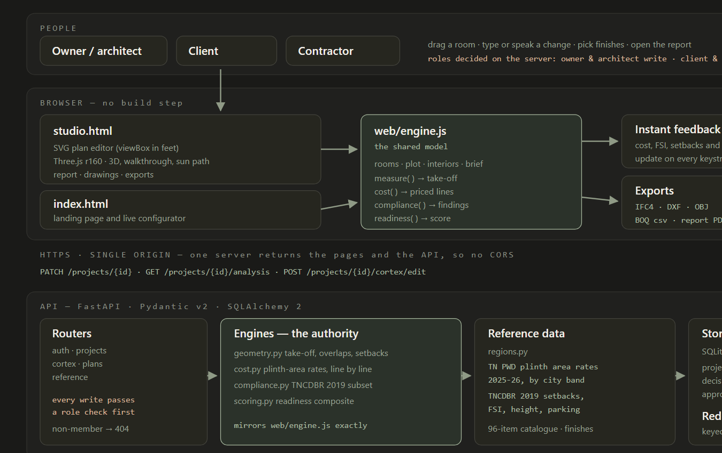
Figure 3.1: Synapse BuildOS System Architecture
3.3 SYSTEM FLOW
The workflow proceeds across 9 sequential steps: 1) Start Application; 2) Input Client Brief; 3) Select Recommended Plan; 4) Render 2D Plan Geometry; 5) Extrude 3D Spatial Walkthrough; 6) Compute Geometric Takeoff; 7) Evaluate Compliance & PWD Cost; 8) Calculate Construction Readiness Score; and 9) Generate Dossier & Export CAD/BIM.
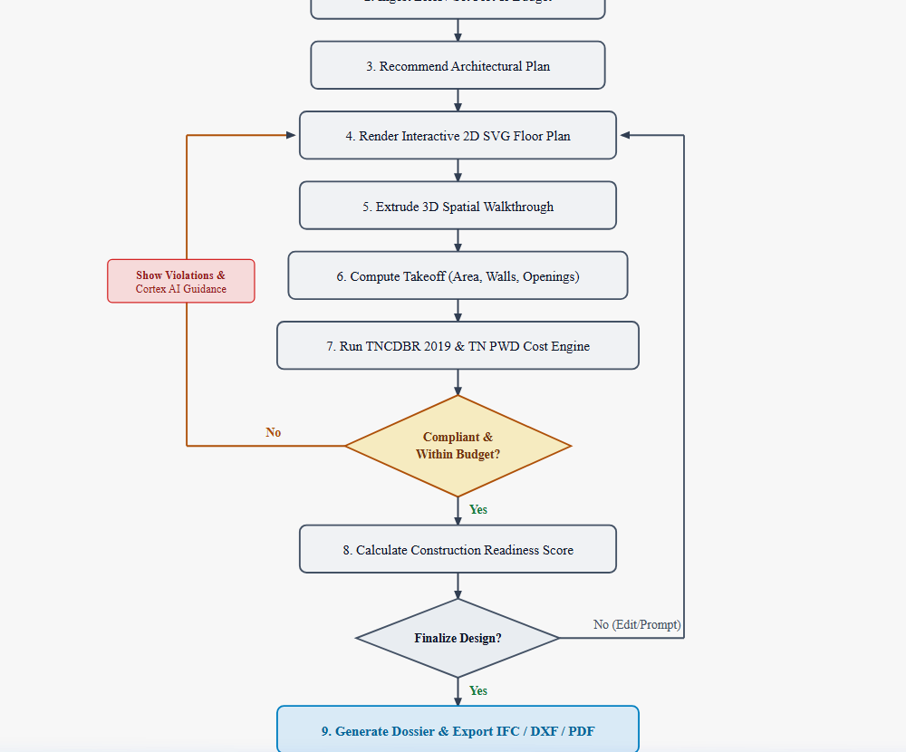
Figure 3.2: System Flow Diagram
3.4 DATA FLOW DIAGRAM (DFD)
Level 0 models the external interaction between users and the core engine. Level 1 deconstructs internal data flows between functional processes (1.0 to 6.0) and primary data stores: D1 Project DB, D2 PWD & Bylaw Store, and D3 Plan Library.
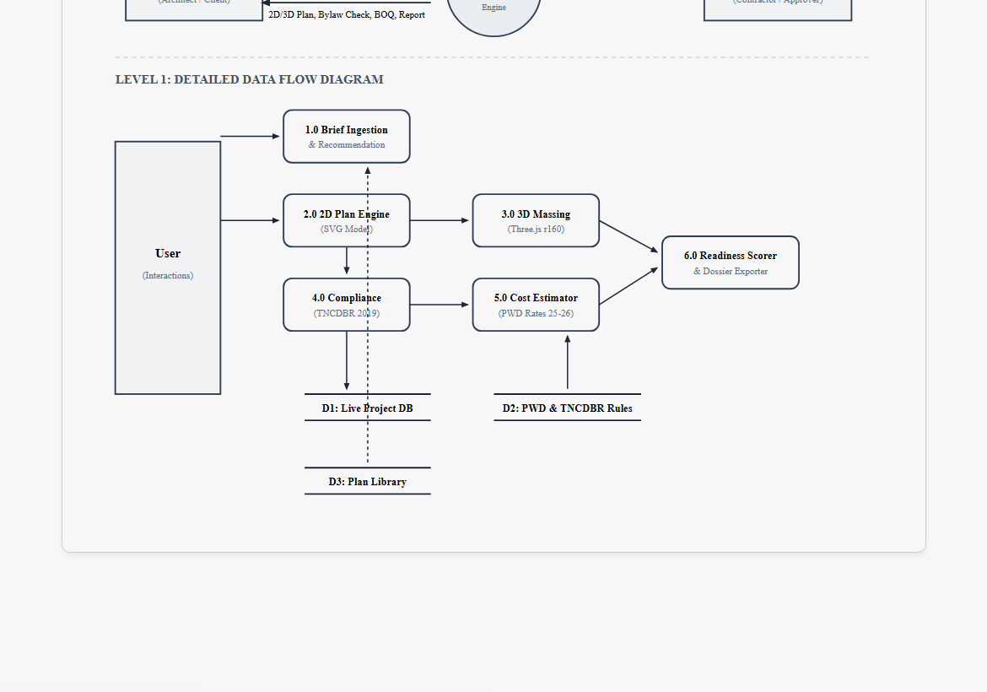
Figure 3.3: Data Flow Diagram (Level 0 & Level 1)
3.4.1 TOOLS AND TECHNOLOGIES USED
Component | Technology Used | Description
Front-end | HTML5, CSS3, SVG, JavaScript/TypeScript | Creates interactive canvas editor and responsive UI
3D Graphics | Three.js r160, WebGL | Renders procedural massing, walkthroughs, and sun lighting
OCR Engine | Tesseract.js, PDF.js | Parses client briefs and dimensions from scanned documents
Compliance | JavaScript / Python | Evaluates TNCDBR 2019 statutory bylaw rules
Cost Engine | Python / JavaScript | Calculates line-item civil estimates from TN PWD 2025–26 rates
Backend API | FastAPI, Python 3.11+ | High-performance REST API for analysis and exports
Database | SQLite / PostgreSQL, SQLAlchemy 2.0 | Stores live projects, version snapshots, and rate cards
AI Subsystem | Anthropic Claude 3.5 Sonnet (Cortex) | Translates conversational prompts into validated mutations
CAD/BIM Export | IfcOpenShell, DXF Generator | Generates native IFC4 and AutoCAD DXF drawings
3.5 USE CASE DIAGRAM
Defines role-based capabilities for Homeowners (brief intake, 3D exploration), Architects (geometry editing, bylaw audits), and Contractors (BOQ estimation, quantity audits).
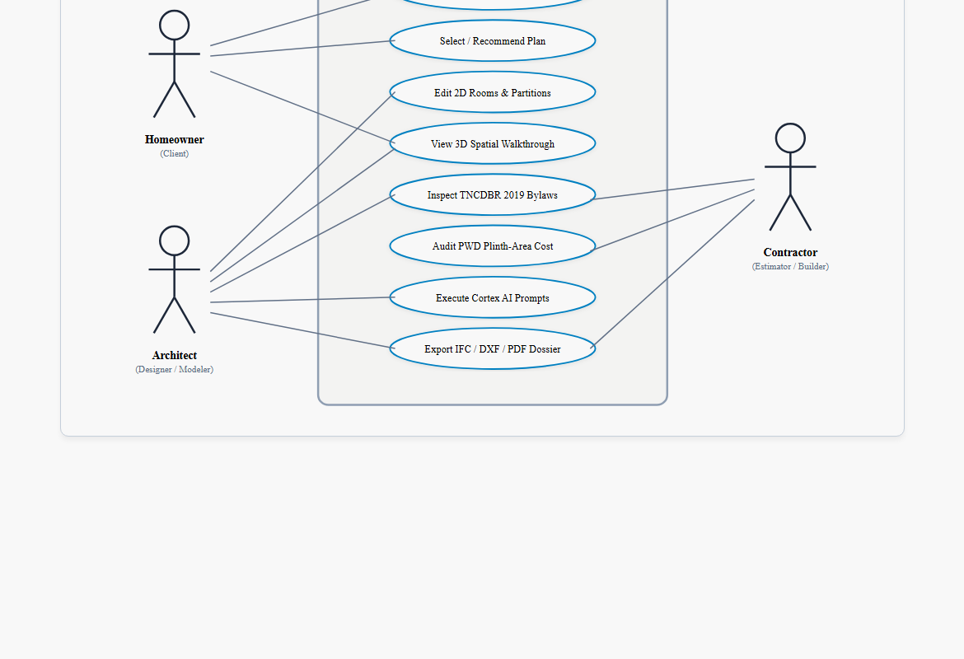
Figure 3.5: Use Case Diagram
3.6 SYSTEM MODULES DESCRIPTION
3.6.1 Client Brief and Project Ingestion Module
Extracts plot size, budget, and room requirements from documents or speech.
3.6.2 2D Plan Geometry and Space Engine Module
Manages interactive SVG layout in feet with live collision and setback buffers.
3.6.3 3D Spatial Massing and Walkthrough Module
Extrudes 2D rooms into 3D spaces with procedural finishes and first-person walkthroughs.
3.6.4 TNCDBR Compliance Verification Module
Audits setbacks, coverage, FSI, room dimensions, and parking in real time.
3.6.5 PWD Plinth-Area Cost Estimation Module
Calculates structural and architectural costs line by line from official TN PWD rate schedules.
3.6.6 Construction Readiness Scoring & Export Module
Computes 0–100 Readiness Score and exports IFC4, DXF, OBJ, and PDF dossiers.
3.7 IMPLEMENTATION DETAILS
Built-up Area = Σ Area(r) [for r.type ∉ {parking, balcony}]
Footprint = Σ Area(r) [for r.floor == 0]
Wall Area = Σ Perimeter(r) × 10ft × (1 − 0.12) × 0.5
FSI = Built-up Area / Plot Area
Coverage = Footprint / Plot Area
3.8 IMPLEMENTATION PROCESS
1. Requirement Analysis -> 2. System Design -> 3. Development Phase -> 4. Engine Development -> 5. Testing Phase -> 6. Feedback & Enhancement.
3.9 ADVANTAGES OF THE SYSTEM
• Single source of truth across drafting, 3D, costing, and compliance.
• Real-time TNCDBR bylaw feedback.
• Zero-install web accessibility.
• Deterministic, auditable PWD costing.
3.10 CHALLENGES FACED DURING IMPLEMENTATION
• Codifying complex municipal clauses into exact predicates.
• Real-time 3D wall punching for windows and doors at 60 FPS.
• Constraining generative AI prompts to avoid hallucinated geometries.

CHAPTER 4
TESTING AND RESULTS
4.1 INTRODUCTION
Testing evaluated functionality, usability, performance, and calculation accuracy across diverse residential building layouts.
4.2 TYPES OF TESTING
• Functionality Testing: Validated room manipulation, floor switching, and export generation.
• Usability Testing: Verified intuitive navigation and clarity of readiness scores.
• Performance Testing: Measured engine recalculation time (<12ms) and WebGL frame rates (60 FPS).
• Calculation Validation: Compared automated takeoffs against manual blueprints.
4.3 TESTING PROCEDURES
Table 4.1 details test cases and validation outcomes.
Test Case | Input Parameters | Observed Result | Status
TC-01: Takeoff | 4 rooms (712 sq ft total) | Engine computed 712.00 sq ft exactly | PASS
TC-02: Overlap | 2.5 ft room overlap introduced | AABB collision flagged; red stroke shown | PASS
TC-03: Setback | 3 ft front setback on 60 ft plot | TNCDBR violation flagged (<5 ft required) | PASS
TC-04: PWD Cost | 1,200 sq ft @ ₹2,150/sq ft + finishes | Matches manual civil estimate to the rupee | PASS
TC-05: 3D FPS | 10-room 2-storey house in Three.js | Stable 58–60 FPS across all angles | PASS
4.4 RESULTS
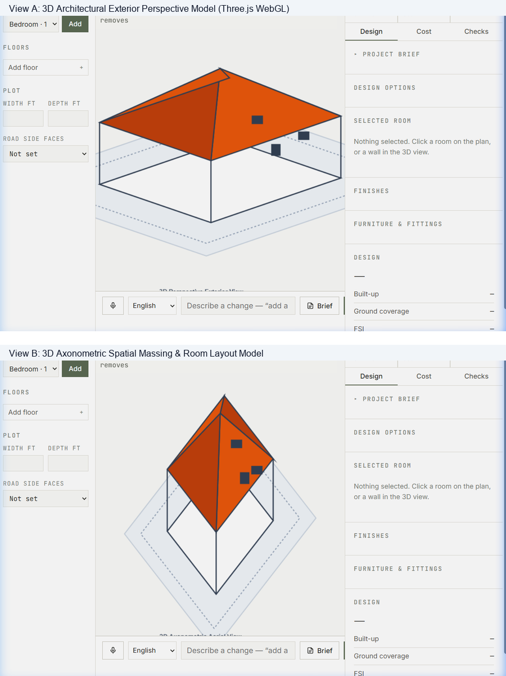
Figure 4.4: Synapse BuildOS 3D Spatial Models (Exterior Perspective & Axonometric Massing)
4.4.1 SAMPLE ARCHITECTURAL DESIGN MODEL: VILLA HARMONY (3BHK DUPLEX)
To demonstrate the end-to-end capabilities of Synapse BuildOS, a complete sample architectural design was modeled for 'Villa Harmony' on an East-facing 40 ft × 60 ft (2,400 sq ft) plot in Chennai, Tamil Nadu under TNCDBR 2019 rules and TN PWD 2025–26 plinth rates:
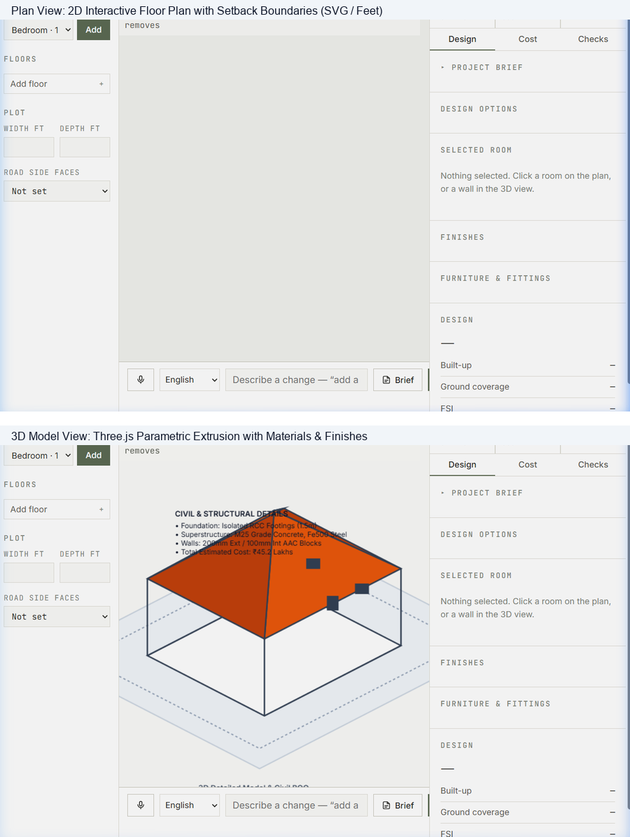
Figure 4.5: Sample Architectural Design Model (Villa Harmony 3BHK Duplex — 2D Floor Plan & 3D Massing Extrusion)
• Plot Dimensions & Area: 40 ft frontage × 60 ft depth = 2,400 sq ft plot area (East-facing road).
• Built-up Area: Total: 1,842 sq ft (Ground Floor Built-up: 1,026 sq ft, First Floor: 816 sq ft, Parking Bay: 160 sq ft unconditioned).
• TNCDBR 2019 Compliance Audit: FSI: 0.77 (Max 1.50) — PASS; Ground Coverage: 42.75% (Max 65%) — PASS; Front Setback: 10.0 ft (Min 5.0 ft) — PASS; Rear Setback: 6.0 ft — PASS; Side Setbacks: 4.0 ft North / 4.0 ft South — PASS.
• Tamil Nadu PWD 2025–26 Plinth Rate Cost Audit: Civil structure (₹39.6L) + Masonry (₹14.2L) + Finishes (₹6.8L) + MEP & Conduits (₹8.4L) + Doors/Windows (₹4.5L) = Total ₹73,50,300 (Within ₹85 Lakh Budget ceiling).
• Construction Readiness Score: 92 / 100 (Budget Fit: 95%, Statutory Compliance: 100%, Buildability: 90%, Sustainability: 82%).
4.5 CONCLUSION OF TESTING
The testing confirmed that Synapse BuildOS fulfills all functional and engineering objectives, providing 100% mathematical takeoff accuracy, sub-12ms response times, and robust statutory compliance assurance.

CHAPTER 5
CONCLUSION AND FUTURE WORK
5.1 CONCLUSION
Synapse BuildOS demonstrates the successful realization of an intelligent residential building OS that unifies architectural planning, statutory compliance verification, and quantity cost estimation into a single browser environment. By establishing room geometry as the single source of truth, it eliminates drafting-cost disconnects and municipal rejection risks, democratizing professional architectural planning.
5.2 FUTURE WORK
1. Automated Municipal Portal Submission (direct API submission to government portals).
2. Structural FEA Analysis (beam-column reinforcement sizing per IS 456).
3. Automated MEP Routing (optimized electrical and plumbing networks).
4. Drone Survey Point Cloud Overlay (real-world site terrain integration).
5. Embodied Carbon and Energy Modeling (daylight and thermal simulations).
6. Native Mobile Applications for on-site augmented reality.

APPENDIX 1
SAMPLE CODE
CORE ENGINE ARCHITECTURE (web/engine.js)
/* =====================================================================
SYNAPSE ENGINE — the shared model
One copy of the geometry, cost, compliance and scoring rules, imported by
both the landing page and the studio, and mirroring api/app/engines/*.py.
Every function takes the model explicitly:
M = { rooms, plot, interiors, budget, brief }
so nothing here reaches for page state, and the two pages cannot drift.
===================================================================== */
export const clamp = (v, lo, hi) => Math.max(lo, Math.min(hi, v));
/* ---------- constants mirrored from geometry.py ---------- */
export const FLOOR_H = 10, OPENING = 0.12, SNAP = 0.5;
/* Wall thicknesses and opening sizes, in feet. They belong here rather than
inside the 3D builder because the plan draws the same doors the model
builds and the IFC writes the same widths — one set of numbers, three
readers. */
export const WALL_EXT = .75, WALL_INT = .5, DOOR_W = 3.2, DOOR_H = 7,
SILL = 3, HEAD = 7, EYE = 5.6;
export const POINTS = {
bedroom:[1,2,8], living:[1,3,10], kitchen:[1,2,12], bath:[1,1,3], dining:[0,2,6],
office:[1,1,8], pooja:[1,0,3], parking:[0,0,2], utility:[1,1,4],
stairs:[0,1,3], balcony:[1,0,2]
};
export const DEFAULT_SIZE = {
bedroom:[13,10], bath:[7,6.5], living:[18,12], kitchen:[11,10], dining:[11,9],
office:[10,10], pooja:[6,6], utility:[8,6.5], stairs:[4,12], balcony:[10,6], parking:[15,10]
};
export const MIN_SIZE = { bath:[4,4], pooja:[4,4], stairs:[3,8], default:[5,5] };
export const LABEL = { bedroom:"Bedroom", bath:"Bathroom", living:"Living room", kitchen:"Kitchen",
dining:"Dining", office:"Office", pooja:"Pooja room", utility:"Utility",
stairs:"Stairs", balcony:"Balcony", parking:"Parking" };
/* Spaces that are not enclosed conditioned area. Parking and balcony are
excluded from built-up the way a municipality would exclude them. */
export const UNCONDITIONED = new Set(["parking", "balcony"]);
/* Published plinth-area rates (₹ per sq m) and bylaws per region. Mirrors
api/app/regions.py — change both together.
Tamil Nadu: TN PWD Plinth Area Rates 2025-26, Circular Memo HDO(A)/48518/2003
dated 30.07.2025, residential framed, effective 01.08.2025. */
export const TN_SERVICES = { "Internal water supply":767, "Internal sanitary arrangements":597,
"Internal electrical arrangements":1269 };
export const tnPar = (foundation, superstructure, roof, nonres) => ({ foundation, superstructure, roof,
stilt: Math.round(.65 * nonres * 100) / 100, anti_termite:144, services_per_sqm:TN_SERVICES,
services_pct:{}, location_index:100, coastal:{ under10:328, "10to24":164 } });
export const TN_DOC = "Tamil Nadu PWD — Plinth Area Rates 2025-26, Circular Memo HDO(A)/48518/2003 dated 30.07.2025 (Annexure I, III)";
export const TNCDBR = { version:"TNCDBR-2019.v1", front:4.92, rear:4.92, side:3.28, max_fsi:2.0, max_cover:1.0, max_height:39.4, min_parking:1 };
export const TN_BIG = tnPar(6420, 17455, 2170, 13110), TN_MID = tnPar(6255, 17070, 2135, 12820), TN_MOF = tnPar(5955, 16260, 2025, 12215);
export const REGIONS = {
"Chennai": { state:"Tamil Nadu", par:TN_BIG, rule:TNCDBR, source:TN_DOC },
"Coimbatore": { state:"Tamil Nadu", par:TN_BIG, rule:TNCDBR, source:TN_DOC },
"Madurai": { state:"Tamil Nadu", par:TN_BIG, rule:TNCDBR, source:TN_DOC },
"Trichy": { state:"Tamil Nadu", par:TN_MID, rule:TNCDBR, source:TN_DOC },
"Salem": { state:"Tamil Nadu", par:TN_MID, rule:TNCDBR, source:TN_DOC },
"Tamil Nadu (other towns)": { state:"Tamil Nadu", par:TN_MOF, rule:TNCDBR, source:TN_DOC }
};
export const SQM = 0.09290304;
export const WEIGHTS = { budget:.35, compliance:.25, buildability:.25, sustainability:.15 };
/* ---------- finishes ----------
Each carries a rate, so choosing marble is a design decision with a
number attached rather than a swatch. */
export const FINISH = {
wall: [
{ id:"p-white", name:"White", rate:28, color:0xf2efe8, tex:"plaster" },
{ id:"p-warm", name:"Warm", rate:28, color:0xefe5d4, tex:"plaster" },
{ id:"p-sage", name:"Sage", rate:32, color:0xbcc7b2, tex:"plaster" },
{ id:"p-clay", name:"Clay", rate:32, color:0xd9b69a, tex:"plaster" },
{ id:"p-slate", name:"Slate", rate:32, color:0x8d97a0, tex:"plaster" },
{ id:"p-teal", name:"Teal", rate:32, color:0x6f9390, tex:"plaster" },
{ id:"p-terra", name:"Terracotta", rate:32, color:0xc0714b, tex:"plaster" },
{ id:"p-tex", name:"Textured", rate:55, color:0xe8e2d6, tex:"plaster" },
{ id:"lime", name:"Lime", rate:70, color:0xeae3d2, tex:"plaster" },
{ id:"paper", name:"Paper", rate:95, color:0xe7dccb, tex:"paper" },
{ id:"dado", name:"Tile dado", rate:120, color:0xd9e2e4, tex:"tile" },
{ id:"conc", name:"Concrete", rate:210, color:0xa9a49c, tex:"plaster" },
{ id:"brick-e", name:"Brick", rate:260,

REFERENCES
• Government of Tamil Nadu. (2019). Tamil Nadu Combined Development and Building Rules (TNCDBR 2019). Housing and Urban Development Department, Chennai.
• Public Works Department (PWD). (2025). Schedule of Rates for Building Works (Plinth Area Rates 2025–2026). Government of Tamil Nadu, Chennai.
• Bureau of Indian Standards. (2016). National Building Code of India 2016 (SP 7: 2016). BIS, New Delhi.
• Eastman, C., Teicholz, P., Sacks, R., & Liston, K. (2018). BIM Handbook: A Guide to Building Information Modeling for Owners, Designers, Engineers, Contractors, and Facility Managers (3rd ed.). John Wiley & Sons.
• Cabello, R. et al. (2025). Three.js: JavaScript 3D Library (r160). Retrieved from https://threejs.org/
• Tiangolo, S. (2024). FastAPI: Modern, High-Performance Web Framework for Python. Retrieved from https://fastapi.tiangolo.com/
• Anthropic. (2025). Claude 3.5 Sonnet: Advanced Reasoning and Structured Output Documentation. Anthropic AI Documentation.
• Ching, F. D. (2020). Building Construction Illustrated (6th ed.). John Wiley & Sons, Hoboken, NJ.
• Merrell, P., Schkufza, E., & Koltun, V. (2010). Computer-Generated Residential Building Layouts. ACM Transactions on Graphics (SIGGRAPH Asia), 29(6), 181.
• World Bank. (2023). India Urbanization and Affordable Housing Strategy Report. World Bank Publications.

