**WEEK 6**

**HANDSON - 1 : WELCOME FIRST SESSION OF REACT**

**App.js:**

import logo from './logo.svg';

import './App.css';

function App() {

   return (

    <div>

      <h1>Welcome First Session Of React</h1>

    </div>

  );

}

export default App;

**Output**

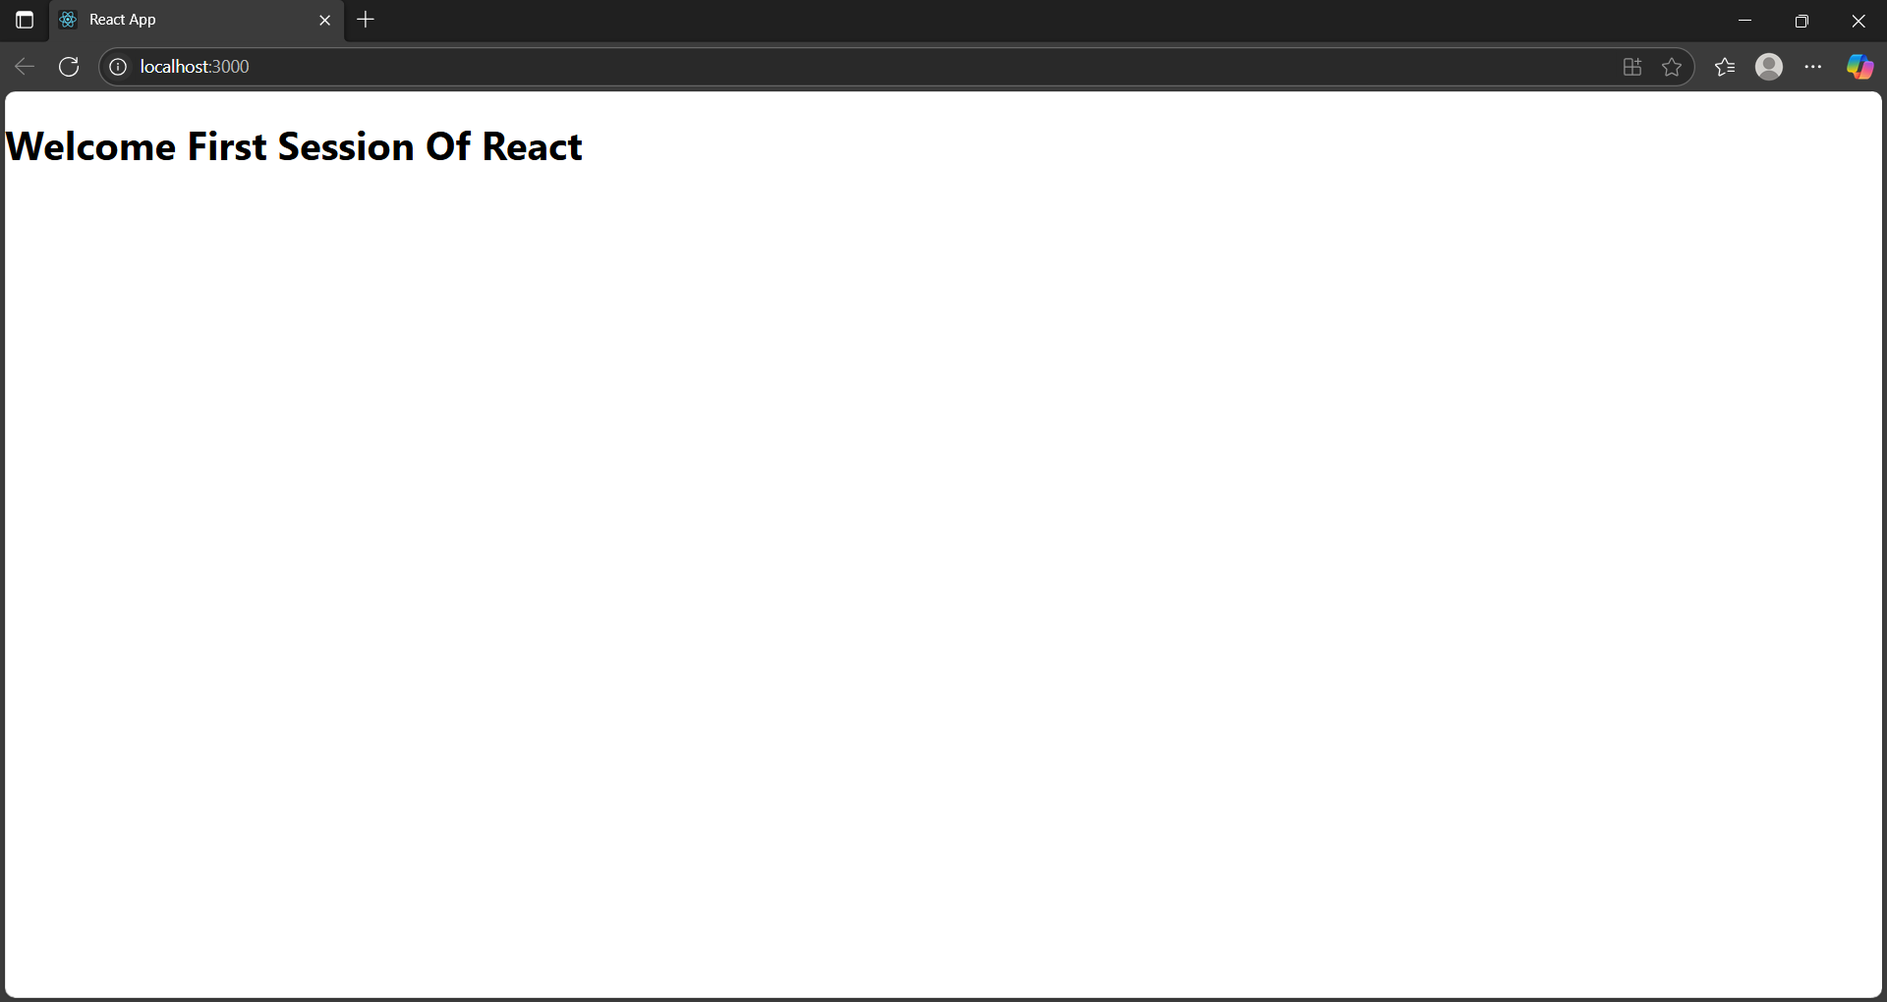

**HANDSON - 2 : STUDENT APP**

**components/Home.js**

import React from 'react';

function Home() {

return (

<div>

<h2>Welcome to the Home page of Student Management Portal</h2>

</div>

);

}

export default Home;

**components/About.js**

import React from 'react';

function About() {

return (

<div>

<h2>Welcome to the About page of the Student Management Portal</h2>

</div>

);

}

export default About;

**components/Contact.js**

import React from 'react';

function Contact() {

return (

<div>

<h2>Welcome to the Contact page of the Student Management Portal</h2>

</div>

);

}

export default Contact;

**App.js**

import React from 'react';

import './App.css';

import Home from './components/Home.js';

import About from './components/About.js';

import Contact from './components/Contact.js';

function App() {

  return (

    <div className="App">

      <Home />

      <About />

      <Contact />

    </div>

  );

}

export default App;

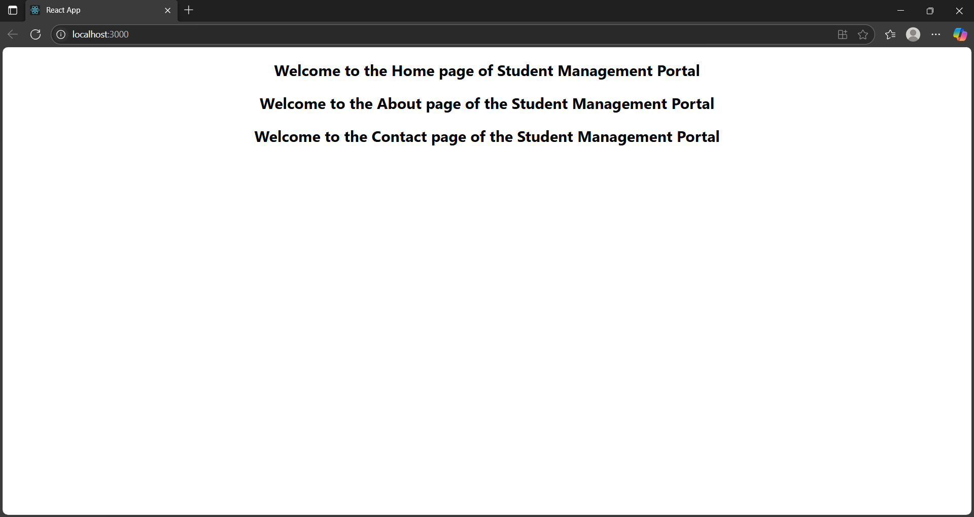

**HANDSON - 3 : CALCULATE SCORE APP**

**components/Calculator.js**

import React from 'react';

import '../stylesheet/mystyle.css';

function CalculateScore(props) {

  const { name, school, total, goal } = props;

  const average = total / goal;

  return (

    <div className="score-card">

      <h2>Student Score Details</h2>

      <p><strong>Name:</strong> {name}</p>

      <p><strong>School:</strong> {school}</p>

      <p><strong>Total Score:</strong> {total}</p>

      <p><strong>Goals:</strong> {goal}</p>

      <p><strong>Average Score:</strong> {average.toFixed(2)}</p>

    </div>

  );

}

export default CalculateScore;

**stylesheet/mystyle.css**

.score-card {

  background-color: #f0f8ff;

  border: 2px solid #4caf50;

  padding: 20px;

  margin: 20px;

  font-family: 'Arial', sans-serif;

  border-radius: 10px;

  width: 350px;

}

.score-card h2 {

  color: #333;

}

.score-card p {

  font-size: 16px;

}

**App.js**

import React from 'react';

import './App.css';

import CalculateScore from './components/Calculator.js';

function App() {

return (

<div className="App">

<CalculateScore

name="Nandhakumar M"

school="Mahatma School"

total={490}

goal={5}

/>

</div>

);

}

export default App;

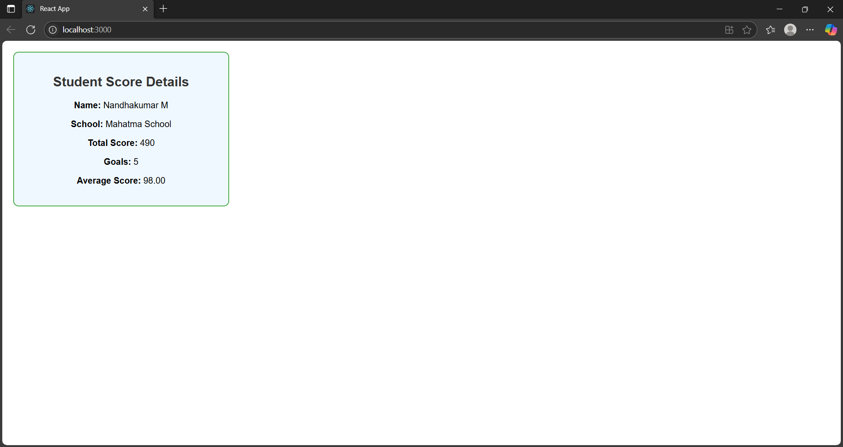

**HANDSON - 4 : BLOG APP**

**Post.js**

class Post {

  constructor(userId, id, title, body) {

    this.userId = userId;

    this.id = id;

    this.title = title;

    this.body = body;

  }

}

export default Post;

**Posts.js**

import React, { Component } from 'react';

import Post from './Post';

class Posts extends Component {

  constructor(props) {

    super(props);

    this.state = {

      posts: [],

      hasError: false

    };

  }

  componentDidMount() {

    this.loadPosts();

  }

  loadPosts() {

    fetch('https://jsonplaceholder.typicode.com/posts')

      .then(response => response.json())

      .then(data => {

        const posts = data.map(item => new Post(item.userId, item.id, item.title, item.body));

        this.setState({ posts });

      })

      .catch(error => {

        console.error("Error fetching posts:", error);

        this.setState({ hasError: true });

      });

  }

  componentDidCatch(error, info) {

    alert('An error occurred while rendering posts.');

    console.error("Caught by componentDidCatch:", error, info);

  }

  render() {

    const { posts, hasError } = this.state;

    if (hasError) {

      return <p style={{ color: 'red' }}>Something went wrong while loading blog posts.</p>;

    }

    return (

      <div style={{ padding: '20px' }}>

        <h1>Blog Posts</h1>

        {posts.slice(0, 10).map(post => (

          <div key={post.id} style={{

            border: '1px solid #ccc',

            padding: '15px',

            marginBottom: '20px',

            borderRadius: '8px',

            backgroundColor: '#f9f9f9'

          }}>

            <h2>{post.title}</h2>

            <p>{post.body}</p>

          </div>

        ))}

      </div>

    );

  }

}

export default Posts;

**App.js**

import React from 'react';

import './App.css';

import Posts from './Posts';

function App() {

return (

<div className="App">

<Posts />

</div>

);

}

export default App;

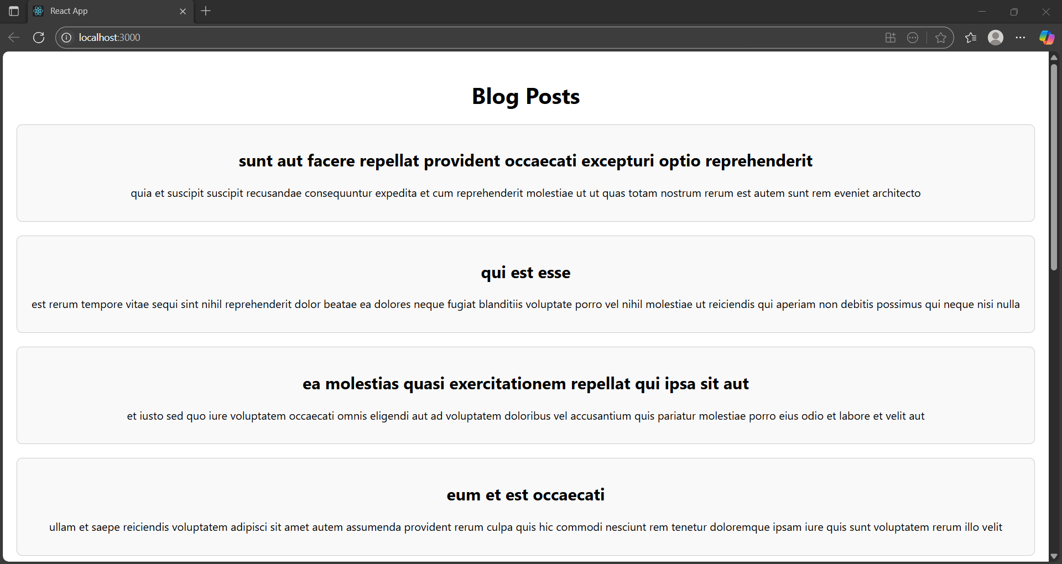

**HANDSON - 5 : COHORT DASHBOARD**

**CohortDetails.module.css**

.box {

width: 300px;

display: inline-block;

margin: 10px;

padding: 10px 20px;

border: 1px solid black;

border-radius: 10px;

}

dt {

font-weight: 500;

}

**CohortDetails.js**

import React from 'react';

import styles from './CohortDetails.module.css';

function CohortDetails({ cohort }) {

const { name, startDate, endDate, status } = cohort;

const statusStyle = {

color: status.toLowerCase() === 'ongoing' ? 'green' : 'blue'

};

return (

<div className={styles.box}>

<h3 style={statusStyle}>{name}</h3>

<dl>

<dt>Start Date:</dt>

<dd>{startDate}</dd>

<dt>End Date:</dt>

<dd>{endDate}</dd>

<dt>Status:</dt>

<dd>{status}</dd>

</dl>

</div>

);

}

export default CohortDetails;

**App.js**

import React from 'react';

import CohortDetails from './CohortDetails';

function App() {

const cohorts = [

{

name: 'React Bootcamp',

startDate: '2025-07-01',

endDate: '2025-08-01',

status: 'ongoing'

},

{

name: 'Angular Mastery',

startDate: '2025-05-01',

endDate: '2025-06-15',

status: 'completed'

}

];

return (

<div className="App" style={{ padding: '20px' }}>

<h1>Cohort Dashboard</h1>

{cohorts.map((cohort, index) => (

<CohortDetails key={index} cohort={cohort} />

))}

</div>

);

}

export default App;

