**ENGLEZA**

**Lecture 1**

**Definitions** are usually found in introductions. The primary reason to include definitions in your writing is to avoid ambiguity or misunderstanding with your audience. Therefore, formal definition is based upon a concise, logical pattern that includes as much information as it can within a minimum amount of space.

|  |  |  |
| --- | --- | --- |
| TERM | CATEGORY/CLASS of object | DIFFERENTIATING CHARACTERISTICS  (feature’s **connective**) |
| A gateway | is a device | **that** connects two networks which use different communication protocols. |
| An integer | is a number | **without** a fractional part. |
| Paging | is the process | **whereby** data is moved to and from virtual memory when needed. |
| Motion blur | Is the artefact | **by which** fast-moving objects appear blurred. |

Connective structures

**Connectives** are words or phrases that link sentences (or clauses) together.

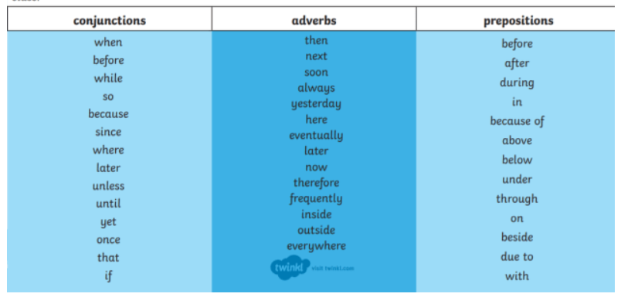

Task 1

1. Monoprogramming is a **protocol** that allows only one program to be in memory at the same time.
2. A magnetic disk is a storage **medium** with random access capability.
3. A histogram is a graphical **representation** of a frequency distribution.
4. A queue is a linear **list** in which data can only be inserted at one end, and deleted from the other end.
5. Depth of a node is a tree **attribute/function** indicating the length of the unique path from the root of the tree to the node.

Task 2

Complete the following definitions by choosing the appropriate **connective structure** (relative clause) for their characteristic features:

1. A register is a stand-alone storage location **which/that holds** data temporarily.
2. Prolog is a high-level programming language **based on** formal logic.
3. Statistical compression is a compression method **in which** encoding is based on the frequency of symbols.
4. Software watermarking is a process **where** information is embedded into a file, enabling authors to control the distribution of and verify ownership of their digital information.
5. Public key encryption is a cryptographic model **consisting of/based on**  two keys, one that is private and one that is public.

Task 3

Study the following examples and identify the definitional linguistic structures used. Comment on the use of each structure in presentations/written papers:

a. (...) The term Input **refers to** the activities required to record data and to make it available for processing.

b. (...) Robotics, in the educational context, **can be defined as** an environment acquisition of concepts through mechanical devices, allowing development of logical reasoning and creativity, besides being a multidisciplinary tool for learning.

c. (...) Coder variance **is associated with** the process of translating the raw or verbatim data obtained from open-ended survey items into a quantitative format that can be analysed by computers.

d. (...) **Although there are many definitions of end-user computing**, for the purposes of this study end-user computing **refers to** "the application of information technology) by individuals who do not normally think of themselves as computing professionals” (Springer, 2012.

e. (...) These connected computers, **called** hosts, communicate using a standard protocol **known as** TCP/IP.

f. (...) A model **comprises** a set of variables describing the present state of the model that contains all the necessary information to determine the state at the next observation point, given a certain random event **which is denoted** as the model factor.

Tips to writing formal definitions

Avoid defining with *"X is when"* and *"X is where"* statements. These introductory adverb phrases should be avoided. These terms may seems overly informal to readers

Avoid defining a word by mere repetition or merely restating the word.

|  |  |  |  |
| --- | --- | --- | --- |
|  | is.. | is (can/may be) defined as ... | deals with... |
| **X** | means ... | is used ... | relates to ... |
|  | describes ... | is concerned/ associated with ... | involves ... |
| (for the purposes of this study/research/demonstration) | refers to | is known as... |  |
|  |  | is called... |  |
|  |  | is denoted as ... |  |

Task 4

Software development cycle refers to a **structured process that enables the production of high-quality, low-cost software, in the shortest possible production time**

Blackbox texting describes **any type of software test that examines an application without knowledge of the internal design, structure, or implementation of the software project**

Memory manager deals with the main memory of a computer, especially RAM.

Open-source software development (OSSD) is the process by which open-source software, or similar software whose source code is publicly available, is developed by an open-source software project.

Some of the methods that are used in giving extended/complex definitions are:

|  |  |
| --- | --- |
| 1. Explanation/Description of a process/operation principle | Is there some process associated with the terms that needs to be described? |
| 2. Causes | Does the reader need to know about the causes related the term being described? |
| 3. Uses | Would it help to discuss uses and applications related to the term? |
| 4. Examples - variety of relevant situations and examples | Would examples contribute to the definition of the term? |
| 5. Comparisons (to elements from the same class) & contrast | Is the term similar/distinct from something else?  Would an analogy help understand it? |
| 6. Category/class words | Are there classes/categories that the term can be divided into? |
| 7. Effects, consequences, results | Does the reader need to know about the effects of the term being described? |
| 8. Etymology (origin and history of the term) | Could the etymology of the word prove interesting or will help expand upon a point? |
| 9. Advantages and disadvantages - | Are there advantages and/or disadvantages related to the term that the reader needs to know? |
| 10. Problem, solution | Does the term being defined represent a problem or a solution? |
| 11. Quotation of a definition from another writer | Would a consensus or popular definition from members of the scientific community bring more insights? |
| 12. Additional definitions | Would unfamiliar terms occurring in the definition also need clarification? |

Task 1

Study the following sentences and decide which of the above mentioned methods is used to express an extended definition:

1. Metaheuristic algorithms, such as fly algorithms, grey wolf optimizers, and crow search algorithms have been used successfully in a variety of engineering problems.

[example] -> **A variety of relevant situations and examples**

1. Virtual reality is spanning divers areas, from medical imaging and reconstruction to designing buildings and submarine spaces.

[…]-> **uses**

1. The fitness function is the assessment of what constitutes a good solution.

[…] -> **problem, solution**

1. Shelby (2013) suggested that Web science encompasses a wide range of emerging technologies, and attempts to measure the effect of large-scale information systems on people.

[…] -> **Quotation of a definition from another writer**

1. During your stay at the restaurant, you can use an RFDI card by swipping the special tag at the corresponding station.

[…] -> **Explanation of a process**

1. Natural language processing allows machines to read and dechipher human language and make decisions based on the information received. A well-known example of this is Amazon’s Alexa. […]

-> **Explanation of a process**

1. Web 2.0, which was first coined in 1999 and later popularised in 2004, is generally defined as today’s interactive internet. […] -> **Etymology**
2. Dynamic programming and memoization go together. The main difference between dynamic programming and divide and conquer is that subproblems are more or less independent in the latter approach. […] -> **comparisons** & **contrast**
3. The consensus as to the etymology of the term spam seems to be that it was derived from the widely popular [Viking Spam skit](https://vimeo.com/329001211) from Monty Python. The anecdotal evidence behind this analogy lies in the fact that apart from reducing the spam load, anti-spam measures are also undermining the email system in terms of reliability and usability.

[…] -> **Etymology + Explanation of a process**

Task 2

Read the following paragraph on big data. The writer has missed the opportunity to add three definitions. Which words would you have defined? Add the definitions below.

(...) Big data can be defined as large volumes of both structured and unstructured data sets which come from a variety of sources at an incredibly fast rate. In analytics, some of its main uses can be found in machine learning and predictive maintenance.

**Task 3**

**Work with a partner and think about a key innovation or discovery in yor field. For example, this could be a process, an approach to doing something, or a device. Include the following information in your presentation of an extended definition:**

* A sentence definition of the innovation;
* When the innovation came about;
* The importance of the innovation;
* The problem that the innovation addressed;
* Some discussion of how the innovation changed your field;

A phone refers to a device that uses either a system of wires along which electrical signals are sent or a system of radio signals to make it possible for you to speak to someone in another place who has a similar device. It first came around the year 1850, and it proved to be the perfect way to stay connected with others and provide the user with a sense of security. Although it had a huge impact on society, and still continues to do so, it doesn’t necessarily mean that this impact is of a good nature. Cell phones can cause a distraction for children in classrooms, drivers on the road, and they can be addictive. Another negative effect is cell phones disconnect us from the social world.

**Lecture 2**

Task 1

Correct the mistakes in the following sentences. The mistakes are in: grammar, style, and meaning.

1. Computer science is the science of doing things with computers.

-> **Computer science refers to the field of study which deals with computers.**

1. Generically, it could be argued that cloud technology denotes everything that is Web- and Internet-related.

 -> **Generically, cloud technology denotes everything that is Web and Internet related.**

1. E-businesses can be define as the process of doing business electronically.

-> **E-businesses can be defined as the processes dealing with commercial activities done in the Internet space.**

1. E-mail is the most popular program on the Internet.
2. -> **E-mail is the most popular service on the Internet**.
3. In recent years, most consumers have taken an interest in smartphone features that include rugged mobile computing devices, a tendency which clearly indicates how ratings of energy efficiency have entered the public understanding.

Task 5

Work with a partner and imagine you need to create a podcast episode dedicated to commonly misunderstood computer science terms.

Suggestions:

You may choose the following structure to plan you podcast:

**Setup**  (introduce the topic)

**Confrontation** (develop on public misconception and challenges posed by terminology)

**Resolution** (provide definition and closure)

* Use diverse definitional linguistic structures
* Make sure you provide enough specific detail to distinguish your term from other members of its class.

The Internet is a global network of networks while the Web, also referred formally as World Wide Web (www) is a collection of information that is accessed via the Internet. (setup)

The public has the tendency to use these words as synonyms, which creates confusion when trying to converse about these terms. (confrontation)

Another way to look at this difference is; the Internet is infrastructure while the Web is a service on top of that infrastructure. Alternatively, the Internet can be viewed as a big bookstore while the Web can be viewed as a collection of books on that store. (resolution)

**Task 1**

Study the diagram below and using the information provided, try to list each stage in the operation of this computerised speed trap to make an explanation of how it operates.

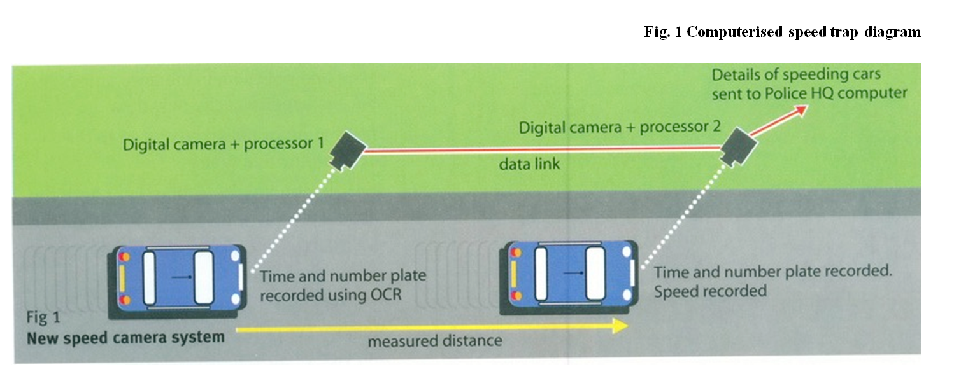

1. Camera 1 records the time each vehicle passes.

2. The time and number plate is recorded by the first camera using OCR.

3. The two cameras are digitally linked, making it possible for the details captured by the first camera to be passed on to the second one.

4. Camera 2 records the time and the number plate of the car just like the first one did.

5. Based on the distance between the cameras and the time difference between the 2 moments in which the car was recorded by the 2 cameras, the speed is computed and recorded.

6. If the recorded speed exceeds the legal limit, the fetched data (car’s speed and its license plate) are sent to the police HQ.

ACTIVE VS PASSIVE VOICE

In the active voice, the subject acts upon its verb: (*The dog chases the ball.)*

In the passive voice, the subject receives the action from the verb: (*The ball is being chased by the dog. )*

**PASSIVE FORMS**

The basic formation is *be+ past participle*. All tenses and continuous forms are possible.

**Present Simple Passive**: The machines **are controlled** by computer.

**Present Continuous Passive**: The software **is being made** available for airline companies.

**Will Passive** The program **will be executed** on a new platform.

**Past Simple Passive**: The algorithm **was developed** by a Dutch computer scientist.

**Past Continuous Passive** The search **was being logged**, **videotaped and sound recorded**.

**Present Perfect Passive** The college board makes no warranty for the resources that **have not been endorsed**.

Task 2

Fill in the sentences using the appropriate form of the verbs:

1. The part of the processor which controls data transfers between the various input and output devices (call) **is called** the control unit.
2. The address bus (use) **is used to** send address details between the memory and the address register.
3. The pixel positions (pass on) **are passed on** to the computer’s pattern recognition software.
4. An operating system (store) **is stored** on disk.
5. Instructions written in a high-level language (transform) **are transformed** into machine code.
6. In the star configuration, all processing and control functions (perform) **are being performed** by the central computer.

Task 3

Describe the operations of the new speed trap by converting each of these statements into the Present Passive. Add information on the agent where necessary.

a. The first unit records the time each vehicle passes. -> **The time each vehicle passes is recorded by the first unit**

b. It identifies each vehicle by its number plates using OCR software. -> **The vehicle is identified by its number plates using OCR software**

c. It relays the information to the second unit. -> **The information is relayed to the second unit**

d. The second unit also records each time a vehicle passes. -> **The time each vehicle passes is also recorded by the second unit.**

e. The microprocessor calculates the time it takes to travel between the units. -> **The time taken to travel between units is calculated by the microprocessor.**

f. It relays the registration numbers of speeding vehicles to police headquarters. -> **The registration numbers of speeding vehicles are relayed to the police hq.**

g. A computer matches each number with the DVLC database -> **Each number is matched by a computer with the DVLC database.**

**Why use passives?**

* **to move important information to the beginning of the sentence**

eg. The new version of Java **has just been released** 6 months after the previous one.

* **to describe a scientific or technical process**

eg. First, the node’s key **is compared** with the key of the tree’s root (the top-most node). If it is less, the new node **will be placed** in the left subtree, otherwise the right. The appropriate subtree **is** recursively **searched** until an available space **is found** on one of the tree’s leaves (bottom-most nodes).

* **when the performer of the action is general/not considered important**

eg. Only the indentation made before the first letter **is deleted** because it is considered accidental.

* **(hearsay) reporting**

used to describe what people say, think, report, believe, consider, know etc. This is often used in news reporting.

eg. The company **is known** to be selling its products online only.

The code **is reported** to be open-source.

PASSIVE REPORTING STRUCTURES

* In news, reports or other more formal writing, this idea is often expressed with a structure based on a passive reporting verb. We use these reporting structures when the speaker is unknown or unimportant. This has the effect of distancing information.
* Information is introduced by a passive form of the report verb, either in present simple or past simple form with a *to*- infinitive. The report can refer to the present, past, or to a time before the moment of reporting.

**Examples of reporting verbs used in the passive voice**

|  |  |
| --- | --- |
| allege …It *is alleged to* be… assume …It *is assumed to* be … believe …This *is believed to*… claim … It *was claimed to* …  consider  declare discover estimate expect feel find  intend | know… This *is known to* ..  observe  presume prove report reveal  say … It *is said to* act as … see … This *is seen to* result … show … It *was shown to* reduce  suppose think understand |

* **present verb, present reference**

(We use a present reporting verb and we refer to a state or action in the present)

*The bus is known to be a collection of wires through which data is transmitted.*

*If the first rule is observed, the database is said to be in "first normal form."*

*It is believed that NP is not equal to co-NP.*

* **present verb, past reference**

(we use a present reporting verb to refer to a state or action in the past)

* *The World-Wide Web Worm was developed by the University of Colorado and it is claimed to have been created in September 1993, at which time there did not exist any crawler-based search engine.*
* *The hackers are believed to have been able to breach the organizations by tampering with an update server of a SolarWinds network.*

**See next page**

1. **Rewrite each sentence so that it does not contain the words underlined.**

a. Computers have made life easier and more convenient, some people say. -> **It’s being said that computers have made life easier and more convenient.**

b. People believe the misplaced notion that computers will replace radiologists. -> **It is wrongly believed that computers will replace radiologists.**

c. Facebook suggested it was rebuilding the underlying infrastructure so users who were on only one of its apps could connect to other users using different Facebook apps. -> **It had been suggested that the underlying Facebook infrastructure was being rebuilt so users that were on only one of its apps could connect to other users using different Facebook apps.**

d. There were opinions saying that gaming was antisocial and now it is the defining socially connected experience. -> **Gaming was often said to be antisocial, but now it is the defining socially connected experience.**

e. A lot of respondents felt that external ROI data was unnecessary and they were using their own data to justify the need for and value of CMMI. -> **it has been widely said that ....**

f. The government believes that the use of Big Data offers opportunities to increase the level of security. -> **It is believed that the use of Big Data offers opportunities to increase security level.**

g. Some tend to view programming as a tool to generate interesting results and inferences. They believe that if you can get results, then there is no need to organise the code. -> **Programming tends to be seen as a tool to generate interesting results and inferences. It is believed that if you can get results, there is no need for code organisation.**

**2. Rewrite each sentence so it begins with the words underlined. Use a reporting passive verb.**

a. Reports indicate that the company’s European division is having a good year. -> **The company’s European division is presumed to have a good year, based on reports**

2. In contrast, the Far East division has been suffering from rising costs. -> **The Far East division, in contrast, it’s presumed to have been suffering from rising costs.**

3. Sources suggest that the company has been talking to a competitor about a possible merger. -> **The company is believed to have been talking to a competitor**

4. People know some directors have been thinking in these lines for quite some time. -> **Some directors are known to have been thinking in these lines for quite some time.**

5. People think the CEO is making an attempt to focus the business more sharply in some areas. -> **the CEO is believed to attempting to focus the business more sharply in some areas.**

6. Current employees believe managers are looking at the possibility of job cuts. -> **Managers are believed to be looking at the possibility of job cuts.**

**Lecture 5**

a model of information flow used to describe processes:

* General introduction – background information on the process: general properties, overall function/purpose, component parts;
* Overview - summary sentence about the specific process – identifies some main features of the process (technical specifications, for example); briefly informs about the stages in (chrono)logical order/about what happens during the process;
* Body: presentation of the stages/steps involved in the process (information may be tabulated, for better visual impact; auxiliary information may be listed in sub steps – especially in technical manuals, for example)
* Conclusion – depending on the purpose, you may review the steps, the functionality and use, applicability etc

**Lecture 7**

**Plotted charts**

**Plotted charts** are data points (usually a cluster of similarly measured data points), that are intended to show correlations or patterns in the data that are not obvious during a descriptive type of research. You can use such diagrams when you have paired numerical data, when your dependent variable may have multiple values for each value of your independent variable or when trying to determine whether the two variables are related, such as trying to identify potential root causes of problems.

**Pie chart**

**Pie chart** is a diagram divided into sectors, illustrating numerical proportion. For such a chart, the arc length of each sector is proportional to the quantity it represents. It is useful to demonstrate overall proportions; it is not, however, acceptable to represent proportions where the relative difference is significant

How to describe a pie chart:

- the vast majority of(90% +),

- 1-3% → a negligible amount of, a very small proportion, a tiny percentage of

**Tables**

**Tables** are used to show many and precise numerical values and other specific data in a concise structured form. When presenting large amounts of information, the data is divided into clear and appropriate categories, titled accurately and descriptively (column heads).

**Line Graphs**

**Line Graphs** can be used to show how information or data change over time. They have an x-axis (horizontal) and y-axis (vertical). Usually the x-axis shows the time period (an independent variable) and the y-axis shows what is being measured (dependent variable). They highlight trends or patterns.

**Bar Charts**

**Bar charts** use either horizontal or vertical bars to show comparisons among categories. One axis shows the specific categories being compared, and the other axis represents a discrete value. Some may clustered in groups of more than one (grouped), and others are divided into subparts to show cumulate effect (stacked). We use a composite version to show two or more than two continuous variables on the same diagram.

**Review the diagrams in A-E and try to describe the data they represent**.

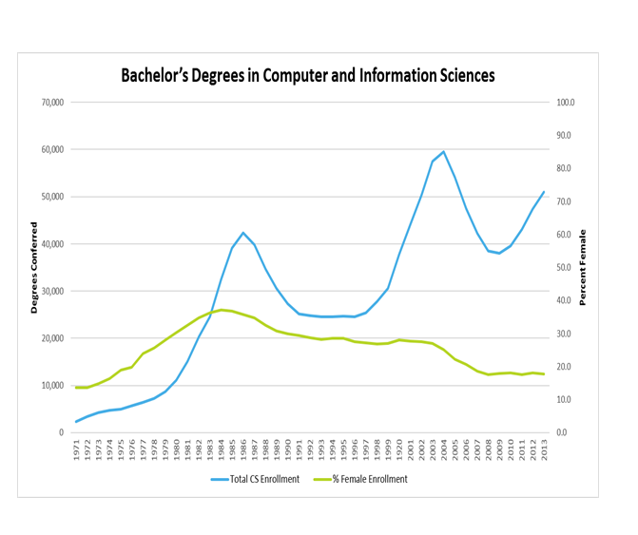

The graph presents the correlation between computer science Bsc enrolment and female enrolment between 1971 and 2013. The first thing that can be observed is that the total number of CS enrolments has not been showing any growth or decrease that could be considered linear, especially looking at the period between 1986 and 2004, and that between 2004 and 2013. On the other hand, the female enrolment percentage indicates a slow decrease which started around the year 1983. Another notable thing which can be observed from this graph is the underlying fact that the people enrolled in CS degrees are predominantly male (aprox. 70-80%) .

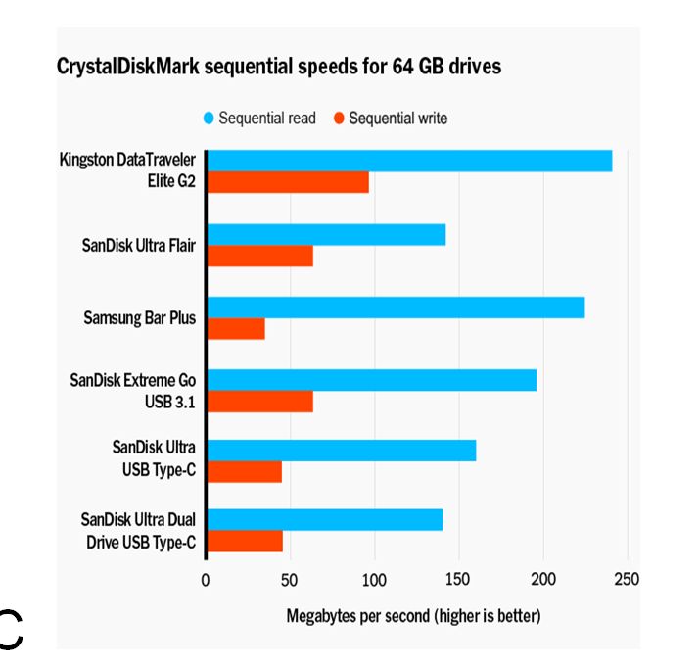

This graph presents comparisons between sequential speeds of various 64 GB drives. The most notable thing is that sequential reading is much faster than writing all across the given list of drives, all exceeding the 100mb/s mark. Writing, on the other hand, is never shown to exceed this mark, the Kingston DataTraveler drive being the only one that almost reaches this threshold, this one being the one with the highest reading speed as well. Another observable fact, besides the discrepancy between the read/write speeds, is that SanDisk is the leading manufacturer of drives presented in this comparison graph, having 4 out of 6 models of drives shown in this comparison.

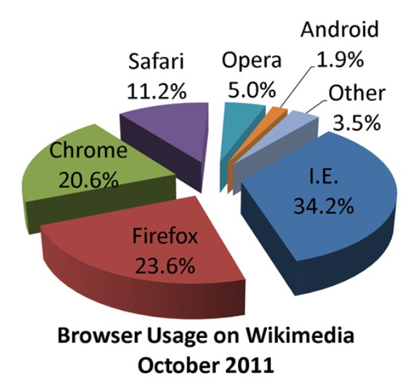

The shown pie chart presents usage percentage of various browsers on Wikimedia, for the month of October of 2011.

Most notable information which can be extracted from it is that, at that time, the majority of Internet users had a preference for a specific browser, that being I.E. (Internet Explorer *nu stiu daca as include the full name al browserului aici pentru ca nu stiu daca trebuie sa ne bazam fully doar pe informatia din grafic sau putem folosi si personal knowldege care e excluded din grafic). The chart therefore suggests that more than a third of all Wikimedia users have accessed it using the fore mentioned browser during that time period. On second place came Firefox, being close to having a quarter of all users.

Secondly, a very small percentage of people chose Android, not even surpassing 2 per 100 total users. (* daca putem sa ne referim la informatii care nu se afla in grafic, aici as mai vorbi despre cum in acea perioada majoritatea persoanelor foloseau internetul prin intermediul calculatoarelor, telefoanele cu acces la internet nefiind la fel de populare precum sunt astazi). Besides the leading browsers, the chart suggests that 3.5% of people who have been using Wikimedia in October 2011 had been accessing it on various other browsers for which the names are not included in this chart.

Task 1

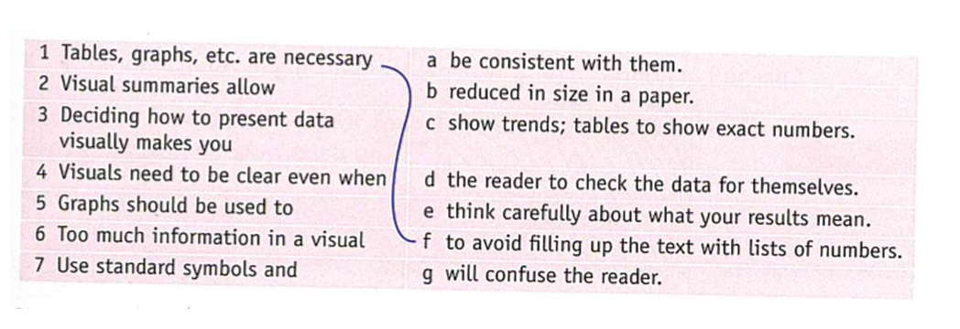

1 – f, 2 – d, 3 – e, 4 – b, 5 – c, 6 – g, 7 – a

**GRAPH VOCABULARY**

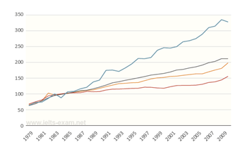 We depict an **upward sloping trend**.

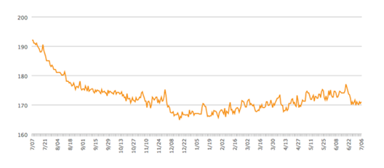 There is a slight dip in numeracy overall

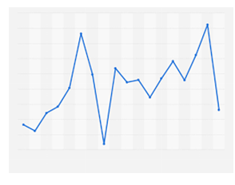 The pitch of A displayed heavy fluctuations

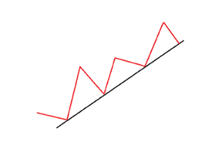 Math scores climbed steadily

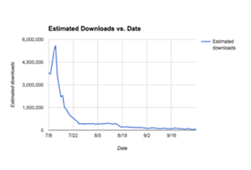 Results indicate a downward trend that plateaued in recent years

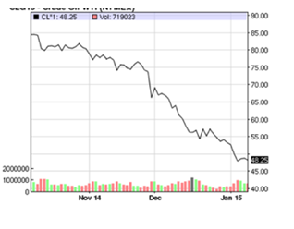 Overall functions show a particularly steep decline

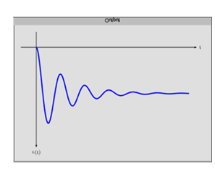 The solid line indicates slowly decaying oscillations of the trend

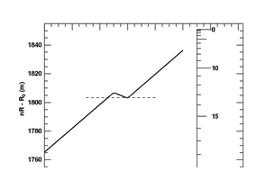 Studies show a plummeting rate of computerized vocational training applications usage.

**Task 4**

**This exercise focuses on some basic language that you need to describe graphs. Look at the graph and complete the statements using the suggested vocabulary :**

*Some vocabulary:

- plateau = to reach a state or level of little or no growth or decline, especially to stop increasing or progressing; remain at a stable level of achievement; level off:

*After a period of uninterrupted growth, sales began to plateau.*

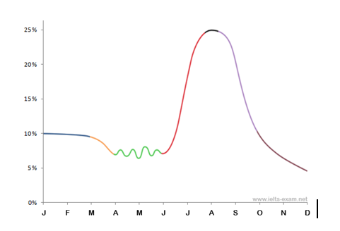

Vocabulary:

**1. remain unchanged, steady, stable, constant, fixed/static, plateau (vb.,n.)**

*From January to March the percentage of customers searching the benefits of cloud computing remained stable*

*The percentage of customers searching the benefits of cloud computing was constant*

**2. fall; decrease ; drop ; plunge; decline; slight (slightly), steady (steadily), gradual (gradually), gentle (gently), slow (slowly) ; downward trend**

*The graph shows a slight decline in the percentage of customers the following month.*

*Cloud computing usage was slowly declining from March to April*

**3. to go up and down/to fluctuate (wildly)**

*Over the next months the graph shows a heavy fluctuation*.

**4.** **Rise (vb, n); grow; climb; shoot up - dramatic (dramatically), sharp (sharply), significant (significantly), rapid (rapidly) ; upward trend**

*The period between June and July saw a significant grow in customers.*

*Between June and August, the percentage of customers significantly increased.*

**5. reach, peak (vb, n)**

*The percentage of customers peaked in August*

*Cloud computing adoption reached its climax in August*

**6. fall; decrease; drop; plunge; decline; reach its lowest point**

*Between October and December, the decrease in cloud computing reached its lowest point.*

*Cloud computing continued to decline at the end of the year.*

STAGES IN DESCRIBING A DIAGRAM (1-4)

1. Introduce your graph

You need to begin with one or two sentences that state what the graph shows. To do this, paraphrase the title of the graph, making sure you put in a time frame if there is one.

*The graph from (source) presents data on (title)…*

*The graph from (source) shows/ illustrates (title)…*

*If we look at this graph on (title) from (source) you can see…*

*The y axis (vertical) is… and the x axis (horizontal) is…*

*(Graph) These lines represent…*

*(Bar) These Columns are…*

*(Pie) These segments are…*

*(Table) These rows are*

2. Give an overview

You need to state what the most prominent trend or trends in the graph are. Do not give detail such as specific data here – you are just looking for something that describes what is happening overall.

|  |
| --- |
| *Overall, there is / has been… / Generally, there is…*  *As can be seen/obtained/depicted from the graph… / From the graph we can see…*  *I would like to focus your attention on…*  *If you look at the…, you will see / notice / understand* |

3. Analyse the graph in more detail (the body paragraph)

The key to organizing your body paragraph(s) is to group data together where there are patterns. To do this you need to identify any similarities and differences.

|  |
| --- |
| *Specifically,*  *A key significant area is … / Two key significant areas are…*  *An important point is… / Two important points I would like to illustrate are…*  *It is noteworthy/important to mention that…*  *An interesting observation is…*  *These findings,* |

* Evaluate the graph (additional, not mandatory, unless specifically required)

|  |
| --- |
| *An analysis of the graph illustrates…*  *Looking at ….*  *This (difference, fluctuation, discrepancy, error, anomaly, lack of statistical significance etc) seems to suggest that…*  *This is possibly/clearly because of…*  *This phenomenon reflects…*  *One reason for this could be…*  *An evaluation of this data suggests / provides evidence for / highlights…*  *To provide evidence to my previous point the graph highlights…*  *Overall, this highlights the significance of…*  *Therefore, this provides evidence that…* |

4. Conclude (restate the most prominent trends / evaluate) using different words

|  |
| --- |
| *To sum up,*  *To conclude (with),*  *Based on the data available,*  *Further research,*  *(All) These findings indicate/show/need to be treated*  *Overall, this graph highlights* |

|  |  |  |  |  |
| --- | --- | --- | --- | --- |
| Nouns | Adjectives | Verbs | Adverbs | Useful phrases |
| a rise (of)  an increase (of)  a growth (of)  a peak (of)  a surge (of) or  a fall (in)  a decrease (in)  a decline (in)  a dip (in) or  a fluctuation (of)  a variation (in) | sharp  sudden  rapid  abrupt  dramatic  steep  significant  considerable  marked  substantial  spectacular  slight  gentle  gradual  steady  consistent  modest  marginal  Example: there was a gradual decline | to rise  to increase  to surge  to grow  to peak  **Large rises:**  to rocket  to soar  to leap (->leapt)  to fall  to decrease  to decline  to dip  to dive  to plunge  **Large falls**:  to plummet or  to collapse  to deteriorate  also  to fluctuate  to vary  **to stay the same**  to plateau  to reach a plateau  to remain steady/fixed /static/ constant  to level out  to stabilize | sharply  suddenly  rapidly  abruptly  dramatically  significantly  considerably  markedly  wildly  slightly  gently  gradually  steadily  modestly  marginally | a small fraction/ number/ minority etc.  a large/ high/ significant portion/percentage/ majority   * nearly a fifth * almost 10% * in region of 40%, * more than a half * over a quarter * around two thirds   roughly/about/approximately two quarters  exactly one in ten, approximately a third  sixfold/threefold higher than  a significantly higher/smaller  an upward/downward trend/tendency |

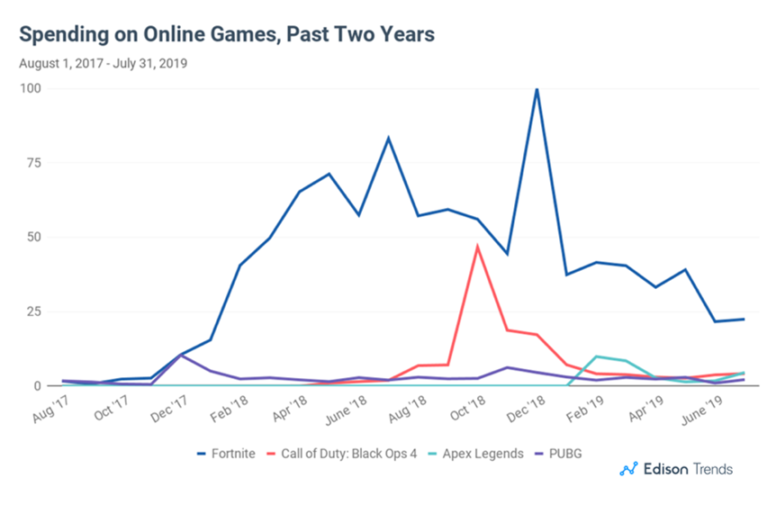

**The graph depicted by Edison Trends illustrates** the amount people spent on online games over the past two years. Specifically, **it is a line graph focusing on** 4 games whose names are specified in the legend below.

**As can be observed from the graph**, the most popular game is Fortnite whose sales registered **a significant rise** during October 2018 and February 2019.

**Another significant area is depicted by the red line** which follows the sales evolution of Call Of Duty: Black Ops 4, the second most popular game which **saw a rise in demand** between September and December 2018 and quickly **plateaued afterwards**.

**The discrepancy between the** games stated above and the remaining others seems to suggest that the most sales occurred during the summer of 2018 and the winter of 2019, regardless of the chosen game. **Overall, this highlights the significance of** the topic of the game which seems to be the determinant factor in their popularity.

**These findings indicate that** spendings of online games have a bigger chance of increasing during holiday seasons such as the winter or summer holiday and rely heavily on the topic of the game and its popularity among the public.

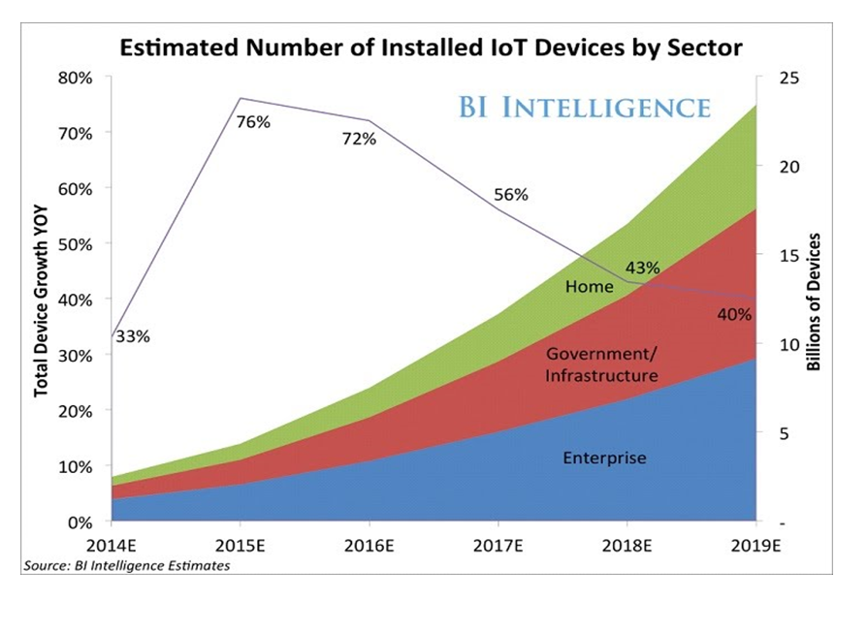

The graph from BI INTELLIGENCE presents data on the estimated number of installed IoT devices by sector. If we take a closer look, we can see that the said sectors are depicted in green, red and blue and all of them illustrate upward trends that evolve in time.

I would like to focus your attention on the purple line annotated with percentages from which we can obtain an estimation of device growth observed during the years. As it can clearly be seen, this growth reached its peak in 2015, reaching a value of 76% which amounts to approximately 25 billions of IoT devices. However afterwards, it began to deteriorate by the year, reaching its lowest in 2019, with only 13 billions of installed devices.

Another key significant area is represented by the coloured stripes I briefly introduced above, as they focus on the said sectors of the graph. The Home sectors registered the highest device growth in time, followed closely by the Government/Infrastructure sector, the Enterprise sector being the one with the slowest surge.

In conclusion ,the graph highlights the evidence that the number of installed IoT devices by sector heavily relies on the nature of the said sector and the year

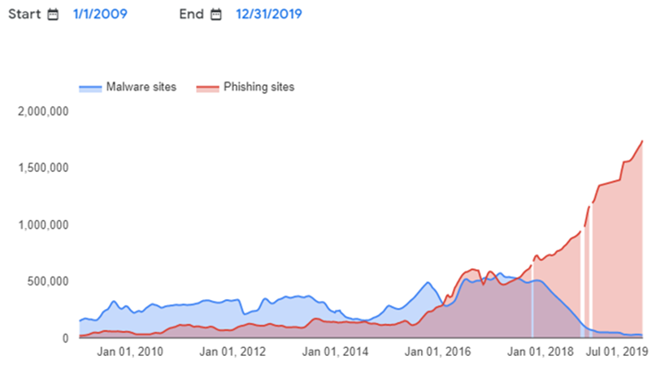

The graph from above illustrated the evolution of malware and phishing sites in a fixed interval of time, over the course of 10 years.

The y axis represents potential numbers of sites while the x axis consists of certain fixed dates during the survey time which help us gain a better understanding of the problem.

As can be seen from the graph, the evolution of the two types of sites differs in time, varying on the category of each one of them.

Two key significant areas are depicted in blue (denoting the evolution of malware sites), respectively in red (referring to the growth of phishing sites). It is noteworthy to mention that, as we approach the end of 2019, there was a consistent decrease in malware sites, accompanied by a dramatic surge in phishing sites, who seemed to have reached a peak by the end of July 2019.

This phenomenon reflects the focus posed on eliminating malware sites which resulted in the neglecting of phishing sites, who follow an upward trends which does not seem to come to an end any soon.

Overall, this graph highlights the evolution of security issues in time and it can be interpreted as a warning signal to both internet users and security researchers.

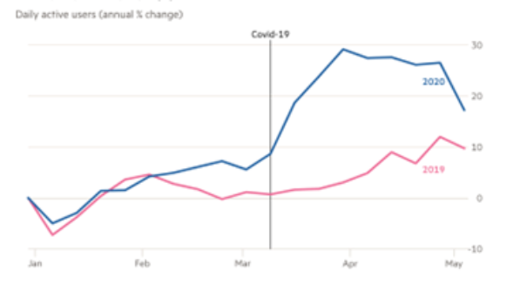

The graph from Unity Technologies presents data on app usage (gaming) on mobile phones during a stretch of five months of 2 years, out of which 2 and a half were heavily influenced by the Covid-19 pandemic.

From the line graph we can easily observe the rapid growth of daily active users in the months following the beginning of the pandemic and, to be more precise, the quarantine.

The important points I would like to illustrate are related to the evolution of active users based on the year. On one hand, we can easily observe that in 2019 (depicted with the pink line), the trend was rather steady, registering a small rise in the month approaching summer. On the other hand, the graph depicts the influence of the first months of quarantine by illustrating a considerable grow in number of daily active users from the second half of March. This was clearly due to the forced stay-at-home period because, as we can observe, there is a downward tendency from the end of the April when the restrictions began to be relaxed.

Overall, this graph highlights the proportion of daily active users on mobile phones over the course of 2 years in the context of the Covid-19 pandemic which marked a turning point in our lives.

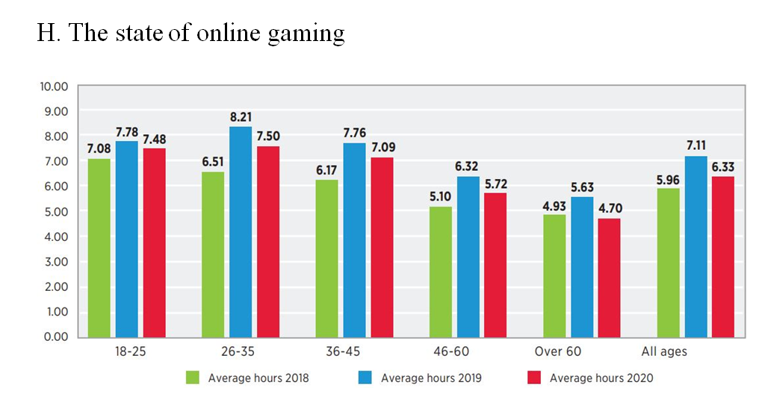

The graph from above illustrates the state of online gaming over the course of three years. The columns mark the number of spent hours based on the year, as it is stated in the legend at the bottom of the bar chart.

Overall, the average number of hours seemed to have reached its peak in 2019, regardless of age category, registering the highest frequency among people with ages between 26 and 35.

I would like to focus your attention on 2 significant areas. The first one consists of gaming time of people aged between 26 and 35, who have the largest number of hours spent on the computer, I contrast, the second significant area refers to the people over 60, who practice gaming, but spend much less time in front of the screen than their younger peers.

In conclusion, this graph highlights the evidence that online gaming reached its peak in 2019 when it registered most hours spent online from all types of people regardless of their age category.

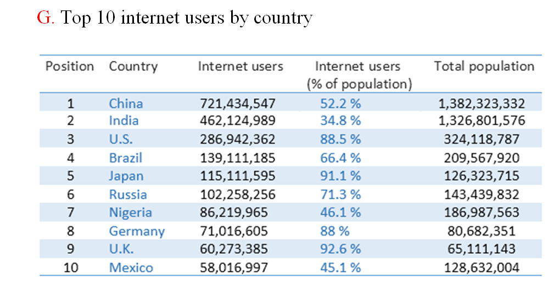

The graph from above is a statistic illustrating the top 10 Internet users ranked by Country. The header consists of the name of the 5 columns, starting with the Position and ending with the Total Population, while the rows contain the relevant data.

As it can be depicted from the graph, the percentage of Internet Users is computed by dividing the Total Population by the number of Internet Users for each country. We can infer that the country with most Internet users is China, but if we were to also refer to the total population, UK leads the ranking with a percentage of 92.6.

An evaluation of the data suggests that the number of Internet Users in a country increases with the total number of people who live in that country. A key area of the graph focuses on countries such as India, Nigeria or Mexico which, in spite of being in the top 10 countries per number of Internet Users, have the smallest percentages of users per population.

To sum it up, it is noteworthy to say that the countries are ranked by the number of Internet users. If we were to do a more proper ranking, we would sort them by the number of Internet users as a percentage of the country’s total population.