

**Hospital Authority**

**Post-Installation**

**WLAN Site Survey Report**

**[Hospital] ([Hospital Code])**

**[Area]**

**Request #: [Ref]**

**Site Representatives**

|  |  |
| --- | --- |
| **HA** | [HA Contact] |
| **Macroview** | [SiteEngineer] |

**Document History**

|  |  |  |  |
| --- | --- | --- | --- |
| **Version** | **Date** | **Prepared by** | **Changes** |
| 1.0 | 01-Jan-2011 | [Engineer] | Initial version |
|  |  |  |  |

**Doc Release v1.11**

**Table of Content**

1 Survey Summary 3

1.1 Survey Information 3

1.2 No. of AP Installed 3

1.3 AP Device Setting 4

1.4 Target Coverage Area & Survey Path 4

1.4.1 Diagram Legend 4

1.4.2 Target Coverage Area and Survey Path 5

2 Physical Installation Location 6

2.1 AP1 6

2.2 AP2 7

3 Equipment Photo 9

3.1 Cabinet Overview 9

4 Survey Result 10

4.1 Survey Tools & Baseline 10

4.1.1 Survey Tools 10

4.1.2 Survey Baseline 10

4.2 Survey Report for 5.0GHz channel 11

4.2.1 Signal to Noise Ratio (S/N Ratio) for 5.0GHz channel 11

4.2.2 Signal Strength for 5.0GHz channel 12

4.2.3 Noise Level for 5.0GHz channel 14

4.3 Survey Report for 2.4GHz channel 15

4.3.1 Signal to Noise Ratio (S/N Ratio) for 2.4GHz channel 15

4.3.2 Signal Strength for 2.4GHz channel 16

4.3.3 Noise Level for 2.4GHz channel 18

5 Verification Test 19

5.1 FTP & Link Test (Controller Reading) 19

5.1.1 Test Location Points 19

5.1.2 Link & FTP Test Result Summary (5.0GHz Channel) 20

5.1.3 Link & FTP Test Raw Result (5.0GHz Channel) 20

5.1.4 Link & FTP Test Result Summary (2.4GHz Channel) 22

5.1.5 Link & FTP Test Raw Result (2.4GHz Channel) 22

# Survey Summary

## Survey Information

|  |  |
| --- | --- |
| Request No.: |  |
| Location: | () |
| Area: |  |
| Installation Date: | 1960-01-01 |
| Site Survey Date: | 1960-01-02 |

## No. of AP Installed

Refer to the given floor plan, the number of WLAN access point installed per floor is listed below:

|  |  |  |
| --- | --- | --- |
| **Location** | **Area** | **No. of AP** |
|  |  | [Qty] |

*Please note that WIFI survey report is used for AP planning reference only while the result may vary due to environment change or client adapter change.*

## AP Device Setting

## Target Coverage Area & Survey Path

### Diagram Legend

|  |  |
| --- | --- |
| **1** | Access Point Location |
| **1** | Access Point Location |
|  | Coverage Area |
|  | Optional Area (if applicable) |

### Target Coverage Area and Survey Path

|  |  |  |
| --- | --- | --- |
| **Location** | **Area** | **No. of AP** |
| [Hospital Code] | [Area] | [Qty] |



**1**

**2**

Add Remark for path not walked

no access right

or obstruction

or other reasons

|  |  |  |
| --- | --- | --- |
| **AP** | **Hostname** | **IP Address** |
| 1 | PYN.MB.6.WA6.AP.01 | 160.19.172.207 |
| 2 | PYN.MB.6.WA6.AP.02 | 160.19.172.208 |
| 3 | PYN.MB.6.WA6.AP.03 | 160.19.172.209 |
| 4 | PYN.MB.6.WA6.AP.04 | 160.19.172.210 |

# Physical Installation Location

## 

# Equipment Photo

## Cabinet Overview

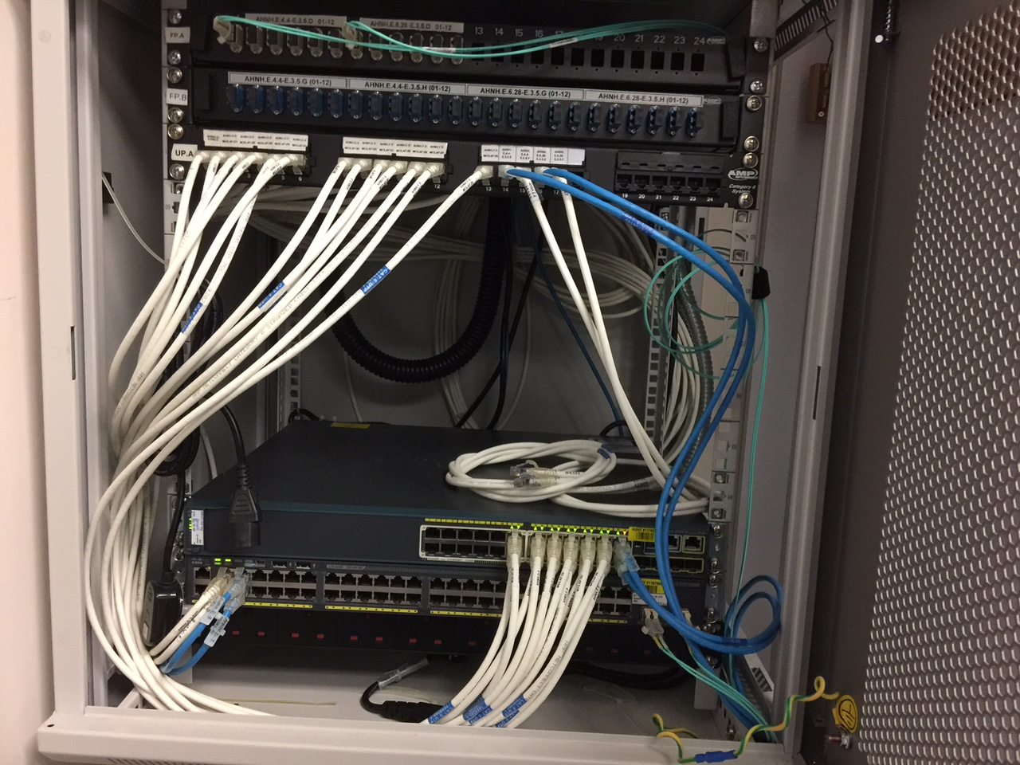

Remarks:

If you need going to Cabinet to patch the LAN cable, please patch the cable according to the data port flat panel side by side. Add a circle and arrow in the picture which LAN cable you have patched.

If there is NO need going to Cabinet to patch the LAN cable, just remark:

(N/A, LAN Cable was patched by Third party)

# Survey Result

## Survey Tools & Baseline

### Survey Tools

|  |  |
| --- | --- |
| **Tools** | **Description** |
| Network Card | Proxim Wireless 8494 802.11a/b/g/n USB Adapter  MAC Address: 00-20-A6-CA-7A-CE |
| Survey Application | AirMagnet Survey Professional Edition v8.7 |

### Survey Baseline

The survey baseline is used to adopt the receive sensitivity of WLAN adapter used by majority HA user.

|  |  |  |
| --- | --- | --- |
| **Parameter** | **Recommended Value** | **Remarks** |
| **Signal Strength** | **> -63dBm** |  |
| Signal to Noise Ratio | > 30dB |  |
| Noise Level | < -90dBm | Reference only  Uncontrollable factor |

Remarks:

For Signal Strength & Signal to Noise Ratio, the recommended value should be referred to the pre-survey value.

## Survey Report for 5.0GHz channel

### Signal to Noise Ratio (S/N Ratio) for 5.0GHz channel

|  |  |  |
| --- | --- | --- |
| **Location** | **Area** | **Min. SNR (dB)** |
| [Hospital Code] | [Area] |  |

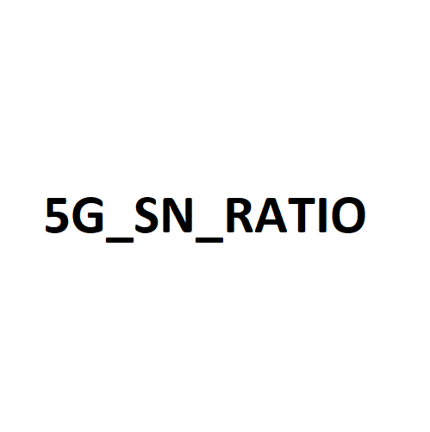

### Signal Strength for 5.0GHz channel

|  |  |  |
| --- | --- | --- |
| **Location** | **Area** | **Min. RSSI (dBm)** |
| [Hospital Code] | [Area] |  |

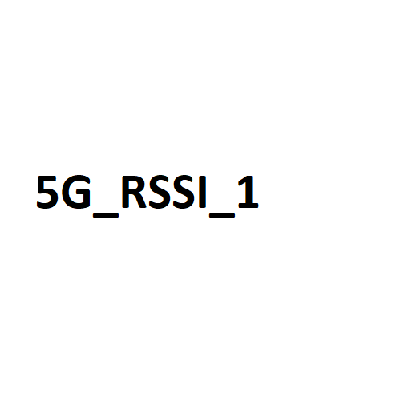

**Signal Strength for 5.0GHz channel (Reverse Selection)**

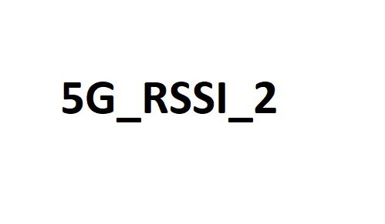

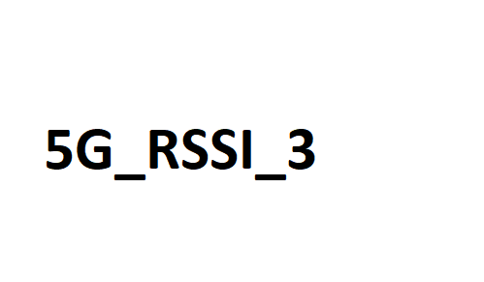

### Noise Level for 5.0GHz channel

|  |  |  |
| --- | --- | --- |
| **Location** | **Area** | **Max. Noise (dBm)** |
| [Hospital Code] | [Area] |  |

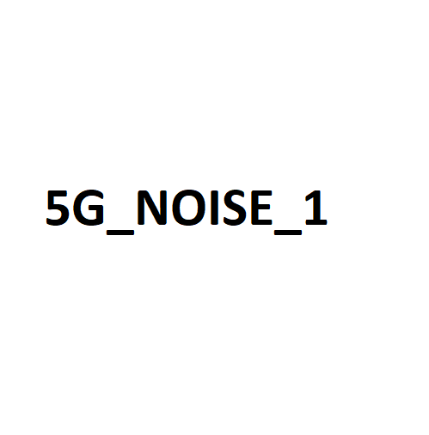

## Survey Report for 2.4GHz channel

### Signal to Noise Ratio (S/N Ratio) for 2.4GHz channel

|  |  |  |
| --- | --- | --- |
| **Location** | **Area** | **Min. SNR (dB)** |
| [Hospital Code] | [Area] |  |

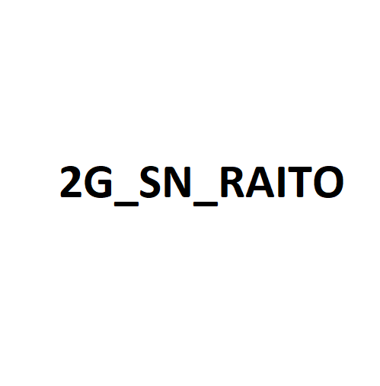

### Signal Strength for 2.4GHz channel

|  |  |  |
| --- | --- | --- |
| **Location** | **Area** | **Min. RSSI (dBm)** |
| [Hospital Code] | [Area] |  |

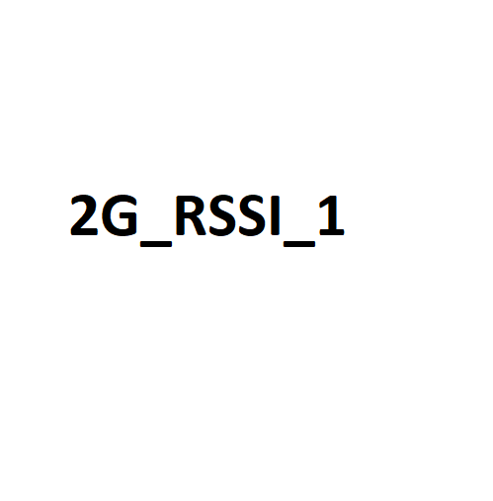

**Signal Strength for 2.4GHz channel (Reverse Selection)**

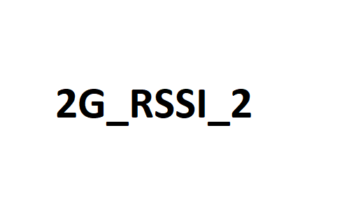

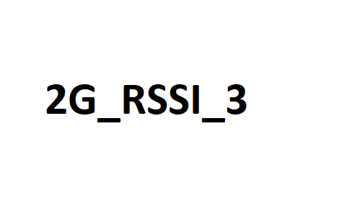

### Noise Level for 2.4GHz channel

|  |  |  |
| --- | --- | --- |
| **Location** | **Area** | **Max. Noise (dBm)** |
| [Hospital Code] | [Area] |  |



# Verification Test

## FTP & Link Test (Controller Reading)

The link test is to capture controller reading with a network adapter provided by HA. (if applicable)

### Test Location Points



**1**

Remarks:

No need to add the remarks for optional areas.

### 

### Link & FTP Test Result Summary (5.0GHz Channel)

### Link & FTP Test Raw Result (5.0GHz Channel)

### Link & FTP Test Result Summary (2.4GHz Channel)

### Link & FTP Test Raw Result (2.4GHz Channel)

**~ END ~**